2027 ODI WORLD CUP
Team & Venue Intelligence Analysis
Data Analyst Portfolio Project

Prepared by Gokul

Tools: Python • Pandas • JSON • Power BI • DAX

1. Executive Summary
This project develops a data-driven team and venue intelligence solution for the 2027 ODI World Cup project scope. The analysis converts ball-by-ball ODI JSON data into team–venue performance measures, applies a weighted scoring framework, and presents the resulting recommendations through an interactive Power BI dashboard.
The workflow covers data extraction, venue standardization, historical performance aggregation, batting and bowling scoring, fallback handling for teams or team–venue combinations without historical observations, recommendation ranking, and dashboard development.
The final analytical scope contains 14 project teams, 12 project venues, and 168 possible team–venue combinations. At the team recommendation level, 11 of 14 recommendations are supported by historical venue data and 3 use the team fallback approach. The strongest recommendation in the final recommendation table is Pakistan at Queens Sports Club with a score of 87.10.

2. Project Snapshot
Metric | Value
Project teams | 14
Project venues | 12
Team–venue combinations | 168
Historical recommendation coverage | 78.57%
Fallback recommendation coverage | 21.43%
Highest recommendation score | 87.10
Highest scoring team | Pakistan
Top recommended venue | Queens Sports Club
Qualifying ODI matches in master dataset | 153
Note: the 153 figure is the number of qualifying match-level records in the Python master dataset. The Power BI 'Historical Matches' KPI is based on team–venue summary observations, where a match can contribute to both participating teams; therefore it should not be interpreted as the number of unique matches.

3. Business Objective
- Identify which project venues are historically favorable for each target team.
- Compare team batting and bowling performance across the selected venues.
- Create a consistent 0–100 style scoring framework for venue suitability.
- Provide fallback recommendations when a team–venue combination lacks historical data.
- Build an interactive Power BI dashboard that supports team and venue exploration.

4. Data Source and Scope
The primary source used in the Python workflow is a collection of 2,565 men's ODI JSON files. Each JSON file contains match metadata and ball-by-ball innings information.
The project filters the source data to men's ODI matches from 1 January 2015 onward and to matches played at the selected project venues. Venue names are standardized so that historical naming variations are treated as the same venue.
The project venue list contains 12 venues:
- Wanderers Stadium
- SuperSport Park
- Newlands
- Kingsmead
- St George's Park
- Mangaung Oval
- Boland Park
- Buffalo Park
- Harare Sports Club
- Queens Sports Club
- Mosi-oa-Tunya International Cricket Stadium
- Namibia Cricket Ground
The 14 project teams are:
Australia, Bangladesh, England, India, Ireland, New Zealand, Pakistan, Scotland, South Africa, Sri Lanka, West Indies, Zimbabwe, Namibia, Afghanistan.

5. Data Preparation and Transformation
JSON ingestion: Read the 2,565 JSON match files and extract match ID, date, venue, teams, winner, gender, and match type.
Scope filtering: Keep men's ODI matches dated from 2015-01-01 onward and matches associated with the standardized project venues.
Venue standardization: Map historical venue-name variations such as different Wanderers, Newlands, SuperSport Park, St George's Park, and other naming forms to a common venue label.
Batting extraction: Parse each delivery to capture batter runs, balls faced, fours, sixes, and dismissals; aggregate these into player-innings and team–venue measures.
Bowling extraction: Parse legal deliveries, runs charged to bowlers, and bowler-credited wickets; aggregate these into team–venue bowling measures.
Match results: Create team-level venue records containing matches, wins, losses, and win percentage.
Master analytical layer: Merge batting, bowling, and result summaries by team and standardized venue.

6. Scoring Methodology
The final recommendation pipeline creates separate batting and bowling scores and then combines them into an overall historical venue score.

6.1 Batting Score
Batting performance is ranked across the analytical population using four components:
Component | Weight
Runs per innings | 40%
Strike rate | 30%
Fours | 15%
Sixes | 15%

6.2 Bowling Score
Component | Weight
Wickets per match | 40%
Economy | 25%
Bowling average | 20%
Bowling strike rate | 15%
For batting metrics, higher values are treated as better. For economy, bowling average, and bowling strike rate, lower values are treated as better. The notebook converts these components into percentile/rank-based scores before applying the weights.

6.3 Overall Historical Venue Score
The final historical venue score used in the final ranking combines the batting and bowling scores equally: 50% batting score + 50% bowling score.
A separate win-percentage-based venue score was explored earlier in the notebook, but the final ranking pipeline uses the batting/bowling 50–50 construction.

7. Fallback Recommendation Logic
Because not every team has historical observations at every project venue, the model creates all 14 × 12 = 168 team–venue combinations. Where a historical overall venue score is available, that score is used. Where it is missing, the team's historical weighted venue score is used as a team-level fallback. If a team has no usable historical venue score, the workflow uses a neutral baseline derived from available historical venue scores.
The final data source field therefore distinguishes 'Historical Venue Data' from 'Team Fallback'.

8. Key Findings
- Pakistan has the highest final recommendation score at 87.10, with Queens Sports Club as the recommended venue.
- South Africa is second in the final recommendation ranking at 85.63, with Buffalo Park recommended.
- Australia is third at 77.20, with Mangaung Oval recommended.
- India is fourth at 76.65, with Newlands recommended.
- The team-level recommendation output contains 11 historical-data recommendations and 3 fallback recommendations, corresponding to 78.57% and 21.43%.
- Across the 12 project venues, Harare Sports Club has the largest historical match volume in the dashboard summary, followed by Queens Sports Club and SuperSport Park.
- The project contains 168 possible team–venue combinations. The dashboard's coverage analysis identifies 68 combinations with historical data and 100 requiring fallback coverage, corresponding to 40.5% and 59.5% respectively.

9. Power BI Dashboard
The final dashboard is organized into three analytical pages: Overview, Team Analysis, and Venue Recommendation Intelligence.
Page 1 — Overview: Summarizes the recommendation ranking, recommended venues, recommendation data sources, and project-level KPIs.
Page 2 — Team Analysis: Provides team selection, venue ranking, score breakdown, top recommended venues, recommendation summary, and historical venue KPIs.
Page 3 — Venue Recommendation Intelligence: Provides the team × venue final-score matrix, historical/fallback coverage, historical match volume by venue, and venue-level intelligence.
Dashboard page 1
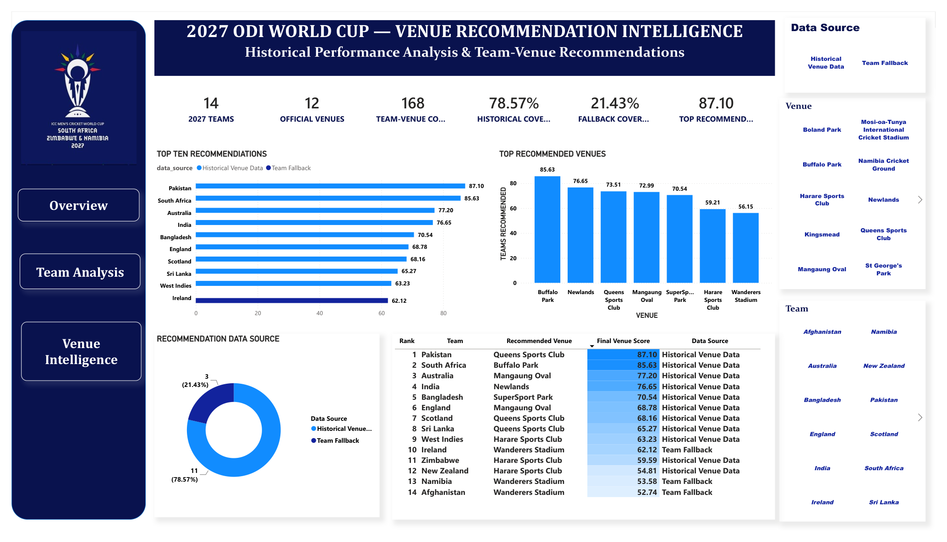

Dashboard page 2
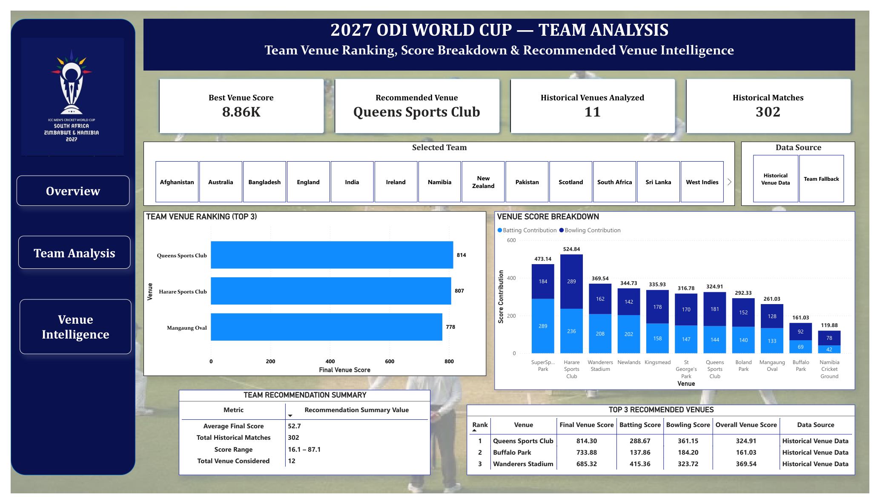

Dashboard page 3
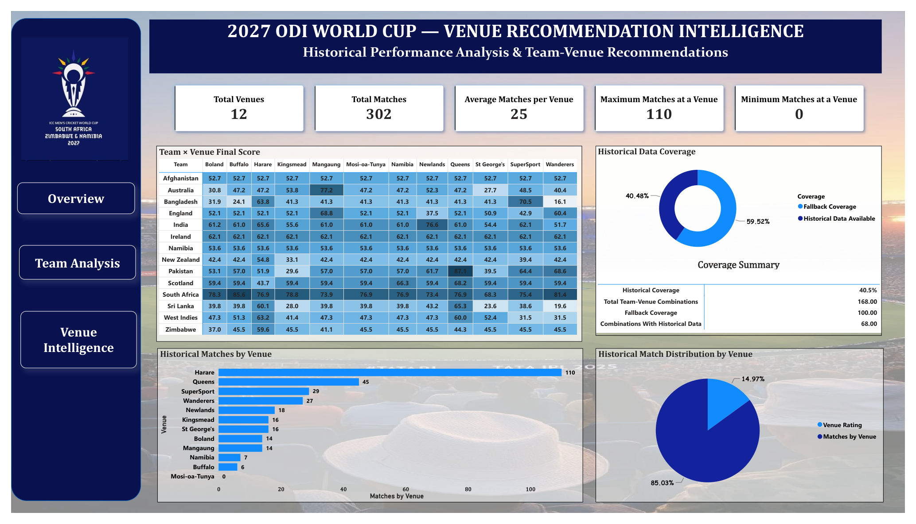

10. Technical Architecture
- Source layer: ODI JSON match files.
- Python processing layer: JSON parsing, filtering, venue standardization, batting extraction, bowling extraction, and match-result aggregation.
- Analytical tables: team–venue batting, team–venue bowling, team–venue results, venue scores, final venue ranking, final recommendations, and historical team–venue summary.
- BI layer: Power BI data model with dimension tables such as DimTeam and DimVenue, plus recommendation and historical summary tables.
- Presentation layer: interactive slicers, KPI cards, ranking charts, score breakdowns, matrix/heatmap, coverage visuals, and navigation buttons.

11. Limitations and Interpretation
- The recommendations are analytical suitability scores, not guaranteed match outcomes.
- Historical availability is uneven across teams and venues; fallback scores are used to avoid leaving combinations unrated.
- Rank-based normalization makes the scores relative to the analytical population rather than absolute measures of cricket quality.
- The dashboard's 302 historical-match KPI is a team–venue summary total and can count a match for each participating team; it should not be interpreted as 302 unique matches.
- The project venue list is the defined analytical scope used for this project; the report does not independently verify tournament scheduling or official fixture allocation.

12. Conclusion
The project demonstrates an end-to-end data analyst workflow: raw JSON data is transformed into structured analytical datasets, performance measures are calculated with transparent weighting rules, missing historical coverage is handled explicitly, and the results are communicated through an interactive Power BI dashboard.
The resulting solution provides a practical way to compare team–venue suitability while keeping the methodology visible and auditable. For portfolio purposes, the project demonstrates skills in Python data preparation, data modeling, analytical scoring, DAX, Power BI visualization, and business-oriented storytelling.

Appendix A — Core Output Tables
Key output tables produced by the Python workflow include final_recommendations, final_venue_ranking, top_3_venue_recommendations, venue_recommendation_summary, and the historical team–venue summary used for Power BI.
The project notebook is the detailed technical record of the transformation and scoring steps.

