

# INTRODUCTION

# Overview

# Chat Connect is a sample project built using the Android Compose UI toolkit. It demonstrate how to create a simple chat app using the Compose libraries. The app allows users to send and receive text messages.

* 1. Purpose

Chatting app allows you to communicate with your friends and family over Internet. It enables you to send and receive messages. Chatting apps make it easier, simpler, and faster to connect with everyone and it is also easy to use.

1. **PROBLEM DEFINITION& DESIGN THINKING**
   1. Empathy Map

|  |  |
| --- | --- |
| **Says**   * 1.They type messages to communicate with others. * 2.They may use emoticons or stickers to express their emotions. * 3.They may initiate or respond to voice or video calls. | **Thinks**  1.Who is this message from?   * 2.What is the message about? * 3.Do I need to respond to this message right away? |
| **Does**   * 1.Types messages to communicate with others. * 2.Uses emoticons or stickers to express emotions. * 3.Initiates or responds to voice or video calls. * Checks messages or notifications frequently. | **Feels**   * 1.Excited to receive messages from friends or colleagues. * 2.Anxious when waiting for an important message. * 3.Frustrated or annoyed by spam messages or notifications. |

* 1. Ideation&BrainstormingMap

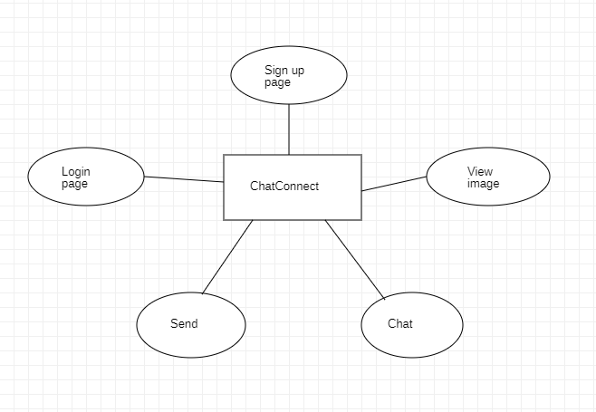

# RESULT

# Data Model

|  |  |
| --- | --- |
| **Object name** | **Fields in the Object** |
| Sign up | |  |  | | --- | --- | | Field label | Data type | | Username | String | | Password | String | | Email | String | |
| Log in | |  |  | | --- | --- | | Field label | Data type | | Username | String | | Password | String | |

# The screenshots of project activity along with the description.

# 

Sign Up :

It is a page where user have to register for creating new account for them , then only they can log in with that details

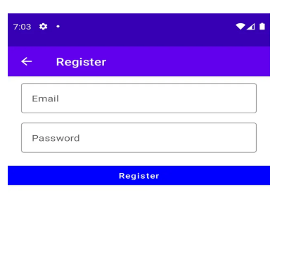

Login :

The user should enter a correct details to login

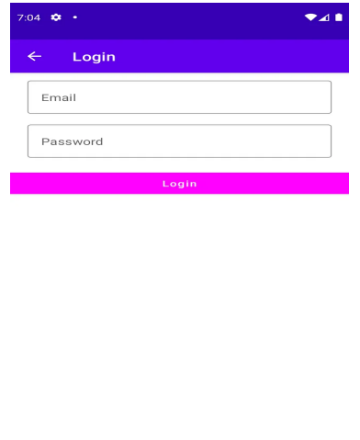

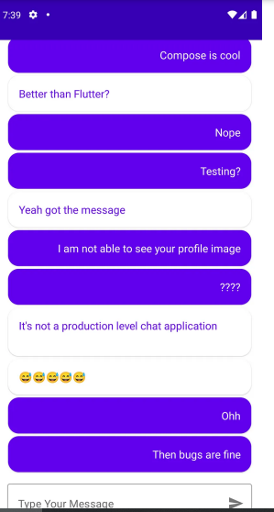

Chat:

The user can now chat with their friends and family.

# GOOGLE DEVELOPER PROFILE PUBLIC URL

# Gokulnath. S (Team Lead) - <https://g.dev/gokul613>

# Kabilan.A(Team member 1) - <https://g.dev/kabi2003>

# Jai.S(Team member 2) -

# <https://developers.google.com/profile/u/112341035251205533394?authuser=3>

# Praveen Kumar.B(Team member 3)

# <https://developers.google.com/profile/u/105104238818609236442?authuser=1>

1. **ADVANTAGES&DISADVANTAGE**

# Advantages :

# It is widely interactive text based communication process that takes places over the Internet.

# The app is developed using android and hence it will be User friendly.

# Disadvantages :

# You never really know who it is you are chatting with really.

# This application’s interface is little bad , we can improve it impressively.

# 

# APPLICATIONS

Chatting app allows you to communicate with your customers in web chat rooms. It enables you to send and receive messages. Chatting apps make it easier, simpler, and faster to connect with everyone and it is also easy to use.

1. **CONCLUSION**

The primary use of a chat room is to share information via text with a group of other users. Generally speaking, the ability to converse with multiple people in the same conversation differentiates chat rooms from instant messaging programs, which are more typically designed for one-to-one communication.

1. **FUTURESCOPE**

We can Extending this application by providing Authorization service, Creating Database and maintaining users, Increasing the effectiveness of the application by providing Voice Chat, Extending it to Web Support.