**Phase 3: Product Sales Analysis**

**Visualization by IBM COGNOS:**

**LINECHART:**

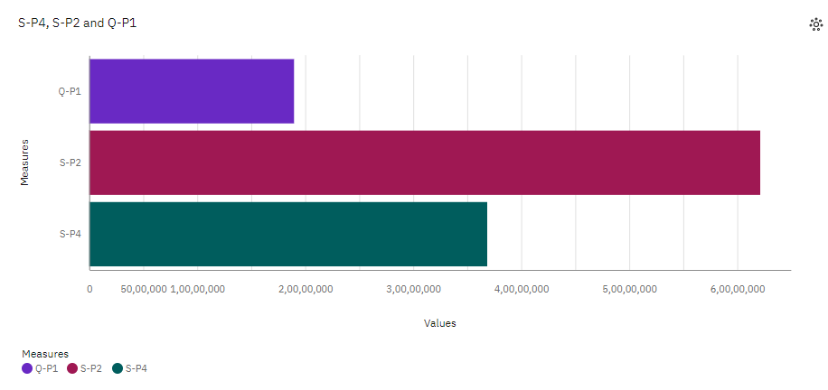

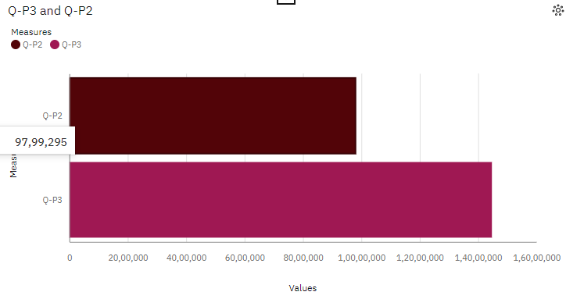

**BARCHART:**

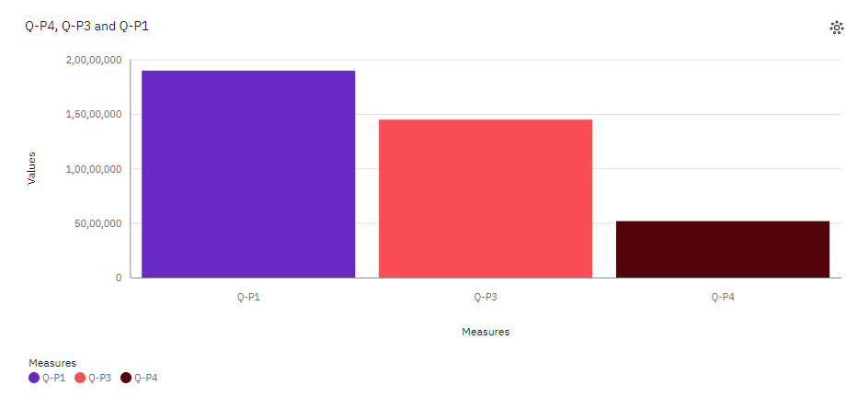

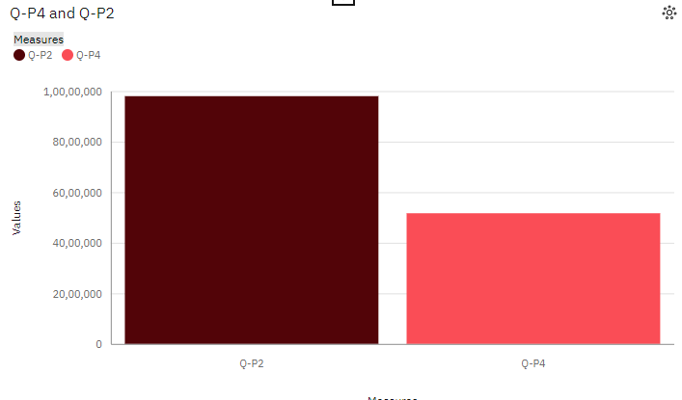

**Preprocessing steps for product sale analysis**:

**1. Data Cleaning**: Handle missing values, outliers, and remove duplicates.

**2. Data Transformation**: Scale or normalize variables, encode categorical variables, and perform feature engineering.

**3. Data Integration**: Merge or join relevant datasets and format the data appropriately.

**4. Data Reduction:** Apply dimensionality reduction techniques if necessary.

**5. Data Splitting**: Split the dataset into training and testing sets.

* **Accuracy and Reliability also done in this process**

**Preprocessing Code(Data Cleaning):**

import pandas as pd

# Read the dataset

df = pd.read_csv('dataset.csv')

# Check for missing values

print(df.isnull().sum())

# Drop rows with missing values

df = df.dropna()

# Remove duplicate rows

df = df.drop_duplicates()

# Save the cleaned dataset

df.to_csv('Tiger.csv', index=False)

**Explanation:**

**1**. First, the code imports the pandas library, which provides powerful data manipulation and analysis tools.

**2**. The dataset is then read into a DataFrame object using `pd.read_csv()`. Adjust the file path and format based on your dataset.

**3**. The `df.isnull().sum()` line checks for missing values in each column and prints the total count of missing values for each column.

**4**. The `df.dropna()` line drops any rows that contain missing values.

**5**. The `df.drop_duplicates()` line removes any duplicate rows from the dataset.

**6**. If needed, you can rename columns using the `rename()` method and passing a dictionary with the old and new column names.

**7**. Unnecessary columns can be removed using the `drop()` function and specifying the column names and axis.

**8**. Additional data cleaning tasks can be performed as needed.

**9.** Finally, the cleaned dataset is saved to a new CSV file using `df.to_csv()`. Adjust the file path and name as desired.

**Analysis objectives of product sales analysis :**

**1. Sales Performance Evaluation:** Assess the overall sales performance of products by analyzing sales data. This includes measuring sales revenue, quantity sold, profit margins, and identifying top-selling products or underperforming products.

**2. Market Segmentation:** Identify different market segments based on customer demographics, geographic locations, or purchasing behaviors. By analyzing product sales data, businesses can understand which products are popular among different customer segments and tailor marketing strategies accordingly.

**3. Trend Analysis:** Identify sales trends over time to understand patterns and seasonal fluctuations. This helps businesses make informed decisions about inventory management, pricing strategies, and promotional activities.

**4. Sales Forecasting:** Use historical sales data to forecast future sales and predict demand for products. This helps businesses optimize production, manage inventory levels, and plan marketing campaigns effectively.

**5. Customer Behavior Analysis:** Analyze product sales data to gain insights into customer behavior, such as repeat purchases, cross-selling opportunities, and customer loyalty. This information can be used to develop targeted marketing campaigns and personalized customer experiences.

**6. Competitor Analysis**: Compare product sales performance with competitors to identify areas of competitive advantage or areas for improvement. This analysis can help businesses identify market gaps, adjust pricing strategies, or differentiate their products.

**7. Channel Analysis:** Analyze sales data across different sales channels (e.g., online, retail, wholesale) to understand channel performance and identify opportunities for optimization. This can involve evaluating sales volume, revenue, and profitability across different channels.

**8. ROI Analysis:** Calculate the return on investment (ROI) for marketing campaigns or promotional activities by analyzing product sales data. This helps businesses evaluate the effectiveness of their marketing efforts and allocate resources more efficiently.

By setting clear analysis objectives, businesses can derive meaningful insights from product sales data and make data-driven decisions to drive growth and improve overall sales performance.