**DATA ANALYSIS WITH COGNOS**

**PRODUCT SALES ANALYSIS**

**Phase 4**

**In this part you will continue building your project.**

**Continue building the analysis by creating visualizations using IBM Cognos and generating actionable insights.**

**Use IBM Cognos to design interactive dashboards and reports that display insights such as top-selling products, sales trends,**

**and customer preferences.**

**Derive insights from the visualizations, such as identifying products with the highest sales, peak sales periods, and customer preferences for specific products**

**STEP 1**: To create a dashboard.

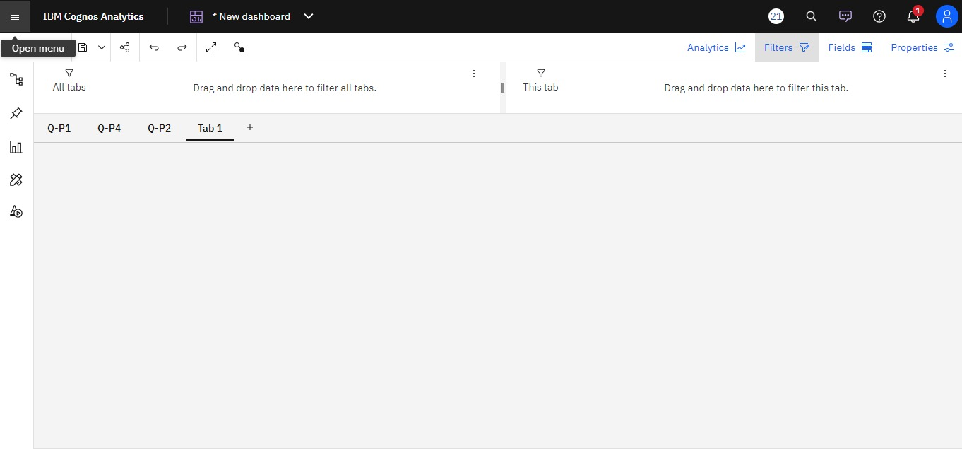

**STEP 2:** By comparing the Total revenue from product 1(S-P1) by Total unit sales of product 1(Q-P1).

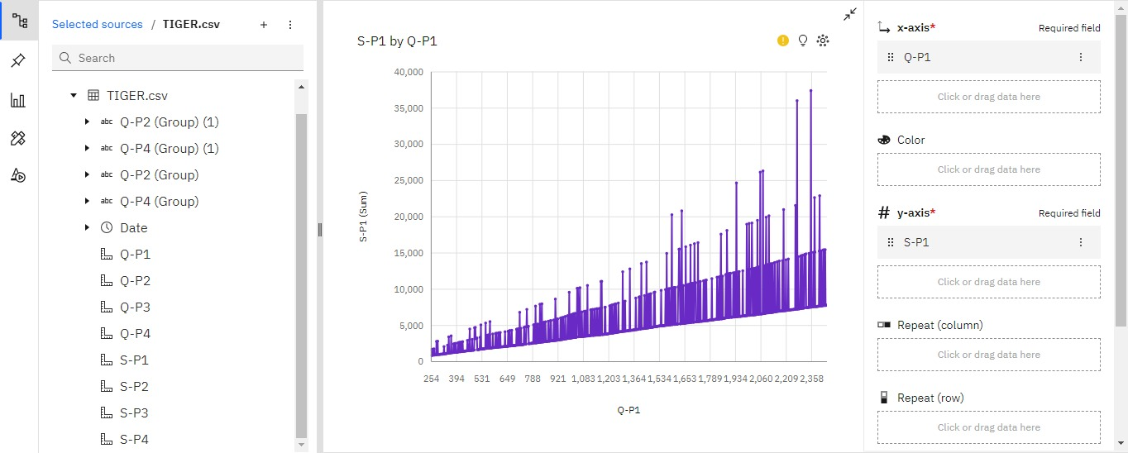

**STEP 3:** By comparing the Total revenue from product 2(S-P2) by Total unit sales of product 2(Q-P2).

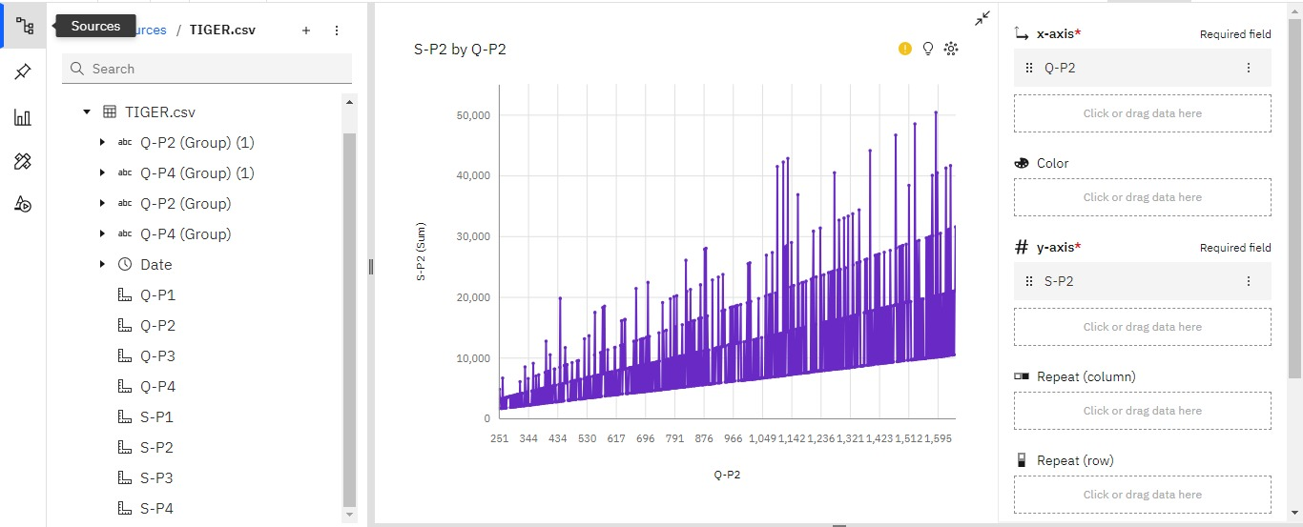

**STEP 4:** By comparing the Total revenue from product 3(S-P3) by Total unit sales of product 3(Q-P3).

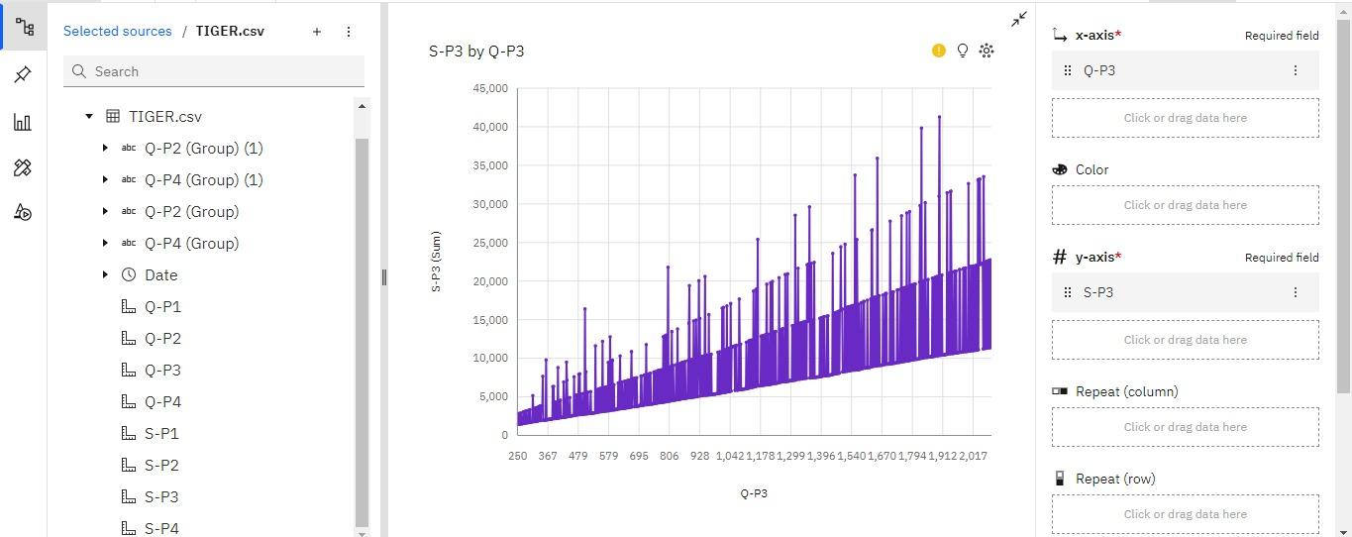

**STEP 5:** By comparing the Total revenue from product 4(S-P4) by Total unit sales of product 4(Q-P4).

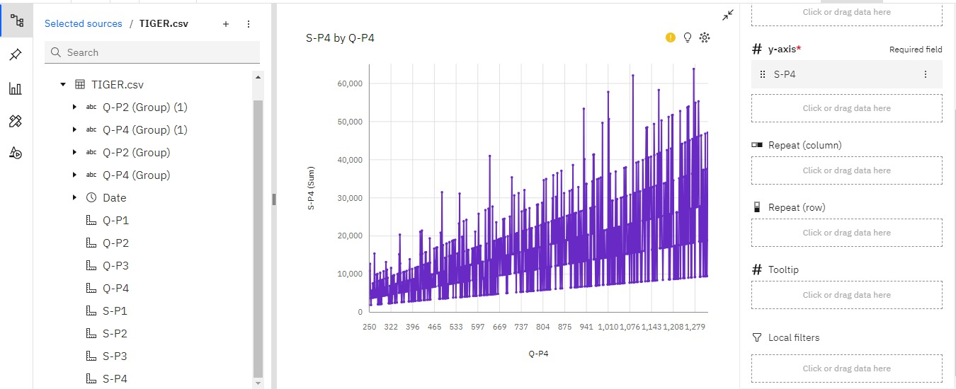

**STEP 6:** The report for the Total unit sales of the product by Total revenue from the products.

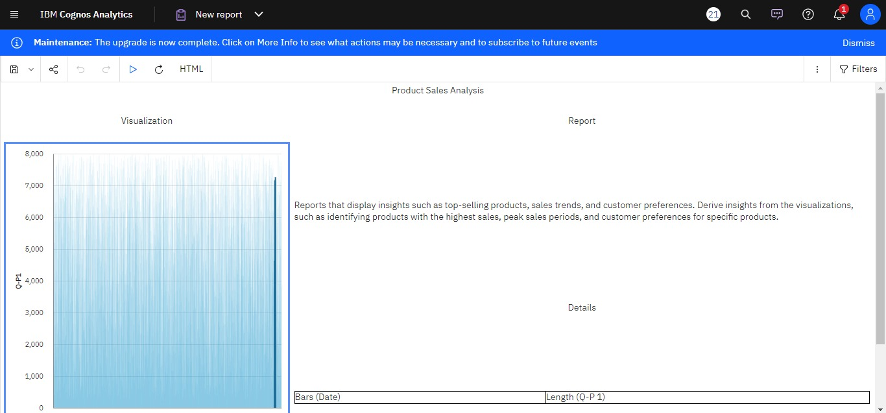

**STEP 7: Top selling product , Sales trends , Customer preference**

**Top selling product**

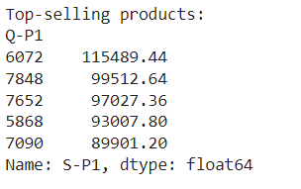

**Sales trends**

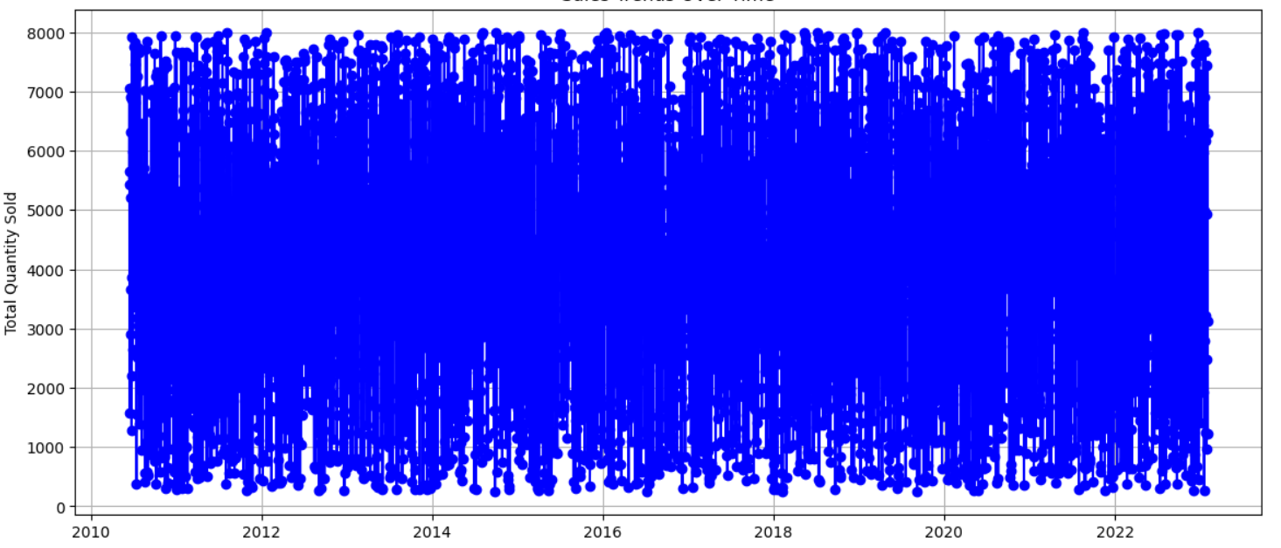

**Customer preference**

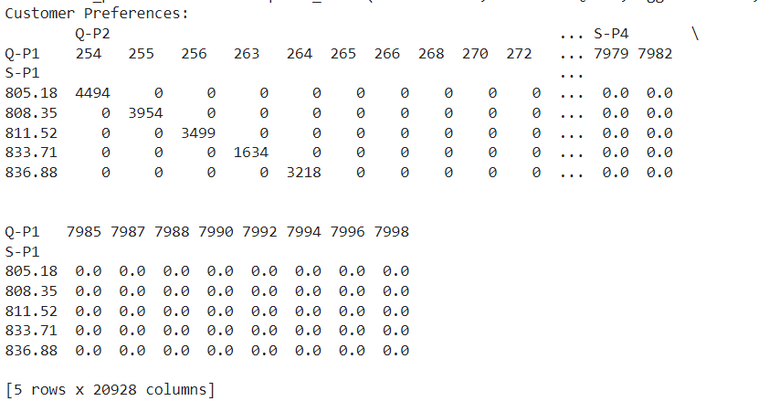

**The matrix you've displayed represents customer preferences over time for various products. Each row corresponds to a date, and each column represents a specific product (identified by the product code in 'Q-P1').**

**The values in the matrix show how many times each product was purchased on a particular date. If there is a value greater than zero in a cell, it indicates that on that date, a purchase was made for the corresponding product. If the cell contains zero, it means no purchase occurred for that product on that date.**

**This matrix is a valuable resource for analyzing customer preferences, tracking which products are popular on specific dates, and identifying trends in product choices over time. You can use this matrix to perform further analysis, such as identifying which products are frequently purchased together or how customer preferences change with time.**