1. Login to <https://community.cloud.databricks.com/login.html>
2. Create userid in Databricks and login
3. Click New cluster to create the cluster

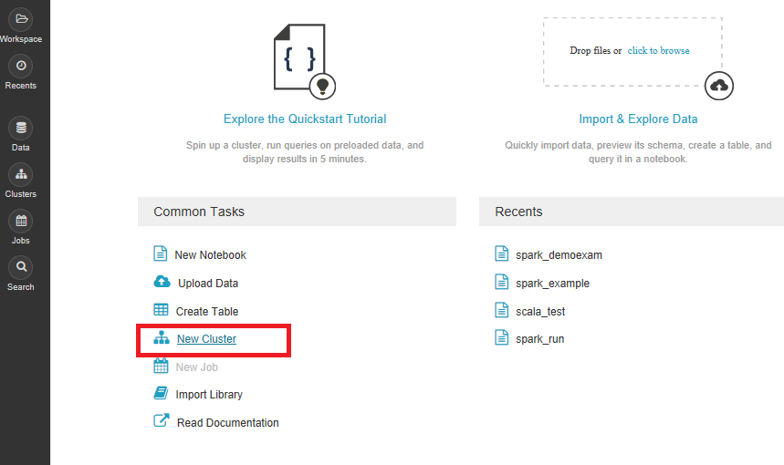

1. Give name to the cluster . The cluster is havig 6GB RAM., 0.88 CPU cores

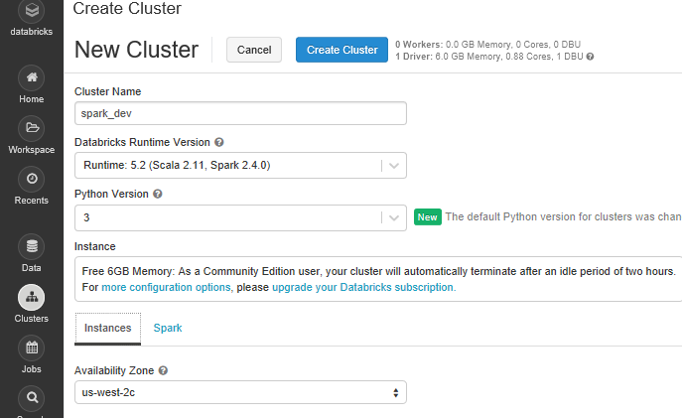

1. Click Create Cluster

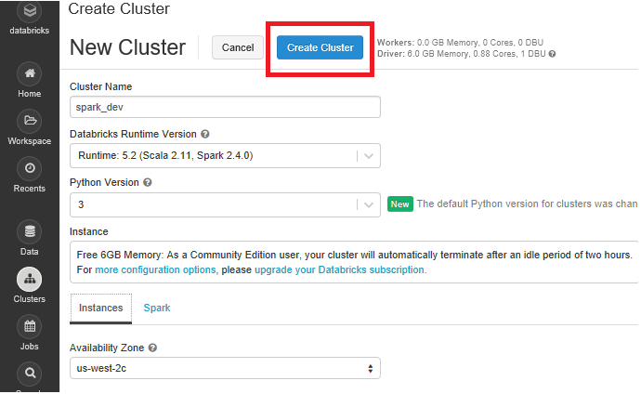

1. Your Spark Cluster is ready now to use

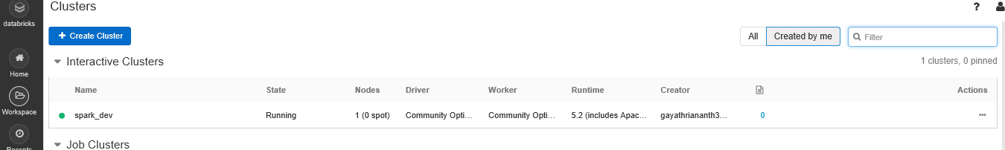

1. To execute spark jobs, click Workspace

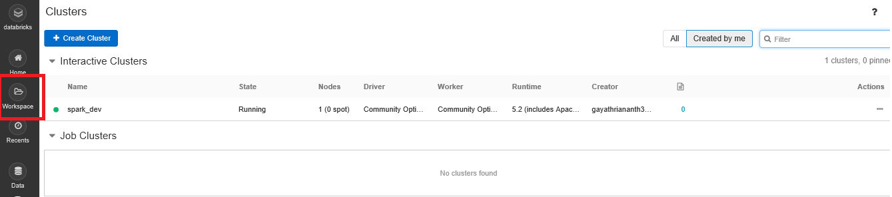

1. Click Workspace->Shared->Create->Notebook

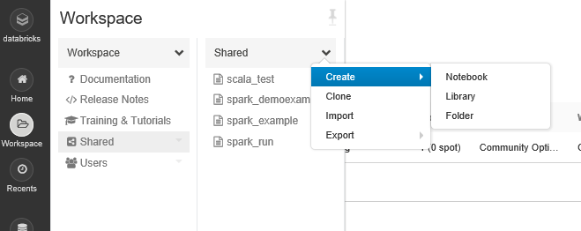

1. In Notebook, provide the name and choose the program you prefer and then click Create

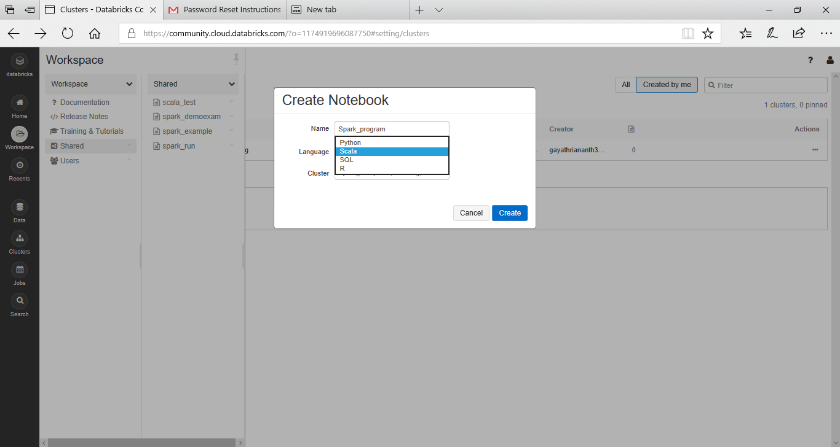

1. Here you can execute your spark program.

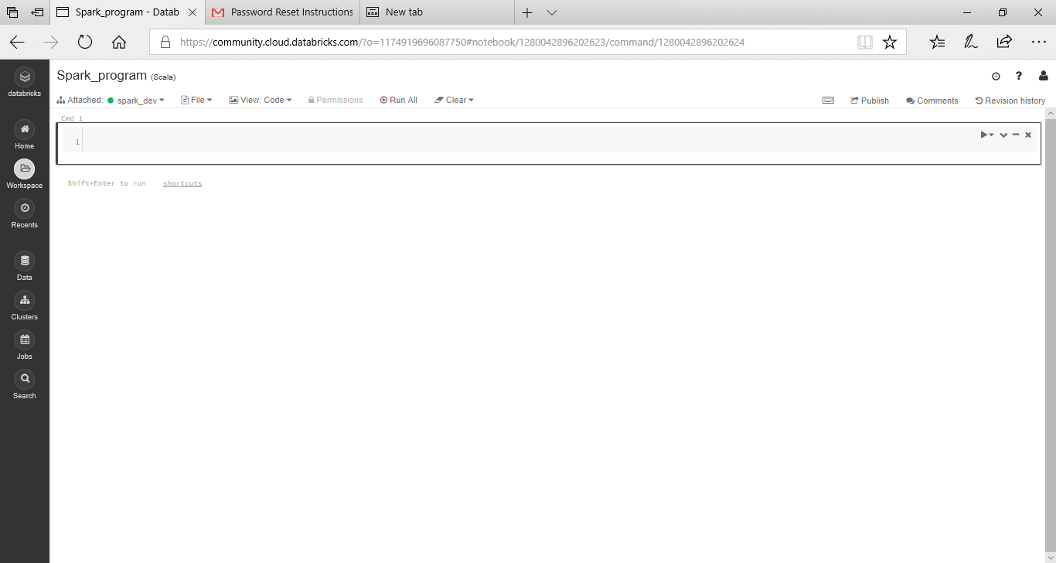

1. Click Run All, to run the program

