NON-DISCLOSURE AGREEMENT

With reference to the discussions I am conducting with and/or the services I am performing for NOKIA SOLUTIONS AND NETWORKS Oy (or any of its affiliated companies), a corporation validly organized and existing under the laws of Finland, having its principal place of business at Karaportti 3, 02610 Espoo, Finland, business identity code 2058430-6 (“Nokia”) relating to business matters of said company and in consideration of disclosure to me by Nokia of technical and/or commercial information and/or information of its employees or other persons regardless of form (hereinafter “Information”) in connection with meetings between me and representatives of Nokia and with visits to Nokia´s offices and other facilities, I hereby agree that

1. I shall hold in confidence and not disclose to any third party any Information disclosed to me by Nokia in whatever form (including but not limited to oral disclosure, written documents and visual observation of Nokia facilities, products, designs, techniques and processes).

2. I shall not use the information for any purpose other than transitioning and delivering AMS services without the prior written permission of Nokia.

3. The foregoing obligations shall continue to bind me in respect of all Information except information which

- was in the public domain at the time of disclosure to me or later becomes part of the public domain through no fault in my part; or
- was in my possession prior to disclosure by Nokia as proven to my written records until such time; or
- is disclosed to me by a third party who did not obtain such Information, directly or indirectly, from Nokia.

4. The obligations set forth in this Non-Disclosure Agreement shall bind me for a period of five (5) years from the date of disclosure.

- Neither this Non-Disclosure Agreement nor disclosure or receipt of Information shall constitute or imply any promise or intention to make any purchase of products or services by Nokia or any commitment, promise or intention by Nokia to enter into any other business arrangement.

- All information shall remain the property of Nokia and shall be returned upon request or upon my determination that I no longer need such Information.

- I am aware that unauthorized disclosure of Information may cause considerable damage to Nokia, and that I may be liable for such damage.

- I also hereby give my consent to Nokia or third parties on behalf and under direct authority of Nokia to process my personal data as deemed appropriate and necessary in the operations of Nokia in connection with this Non-Disclosure Agreement and/or the services I am performing to Nokia. I acknowledge that as a global company, Nokia has international sites throughout the world and consent to that my personal data may be transferred and processed on servers or by third parties located outside of the country where I reside.

- The English version of this Non-Disclosure Agreement shall be deemed the original.

- Finnish law shall govern this Non-Disclosure Agreement.

IN WITNESS WHEREOF, I have signed this Non-Disclosure Agreement in Chennai, India on the 18-03-2021 :

Signature: 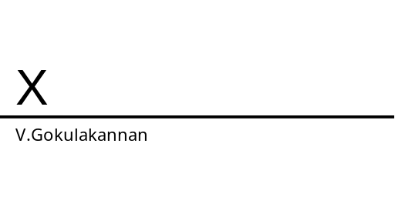
Name: V.Gokulakannan

Date of birth: 22-08-1987

Permanent address: Sri Gokul Nilaiyam, 7/15 Santhanam Street, VGP Pushpa Nagar, Medavakkam Koot Road, Chennai-600100.

