Influencity v1 — Technical Documentation
A Web3 influencer-marketing escrow and marketplace on Polygon — oracle-verified milestones that release USDC automatically and mint soulbound reputation.
Generated 21 September 2026 · repository Influencity_v1 · branch polygon
Web3 influencer-marketing escrow + marketplace on Polygon.
A brand posts a funded campaign listing in USDC. Creators browse it and apply with a pitch. The brand selects one applicant — that selection forms the agreement on-chain. From there an oracle verifies the creator’s real platform metrics (YouTube / Twitch / LinkedIn), and each milestone that clears its threshold automatically releases a USDC tranche to the creator and mints a soulbound reputation NFT. Milestones that expire unmet refund their tranche to the brand. No human approves a payment at any point.
Status (2026-09-21): contracts audited, hardened and covered by 156 passing tests, including an end-to-end run through the real Chainlink wiring against a mock DON router. Backend and frontend are complete. Nothing is deployed yet — see Known gaps.

Table of contents
- System overview
- Technology stack
- External services
- Repository layout
- Smart contract layer
- Off-chain data model (Supabase)
- Backend API (Express)
- Frontend (React + Vite)
- End-to-end flows
- Configuration & environment variables
- Build, test, deploy
- Known gaps & limitations

1. System overview
The system is split across four planes. The rule that shapes the whole architecture: money and truth live on-chain; everything else is a cache.
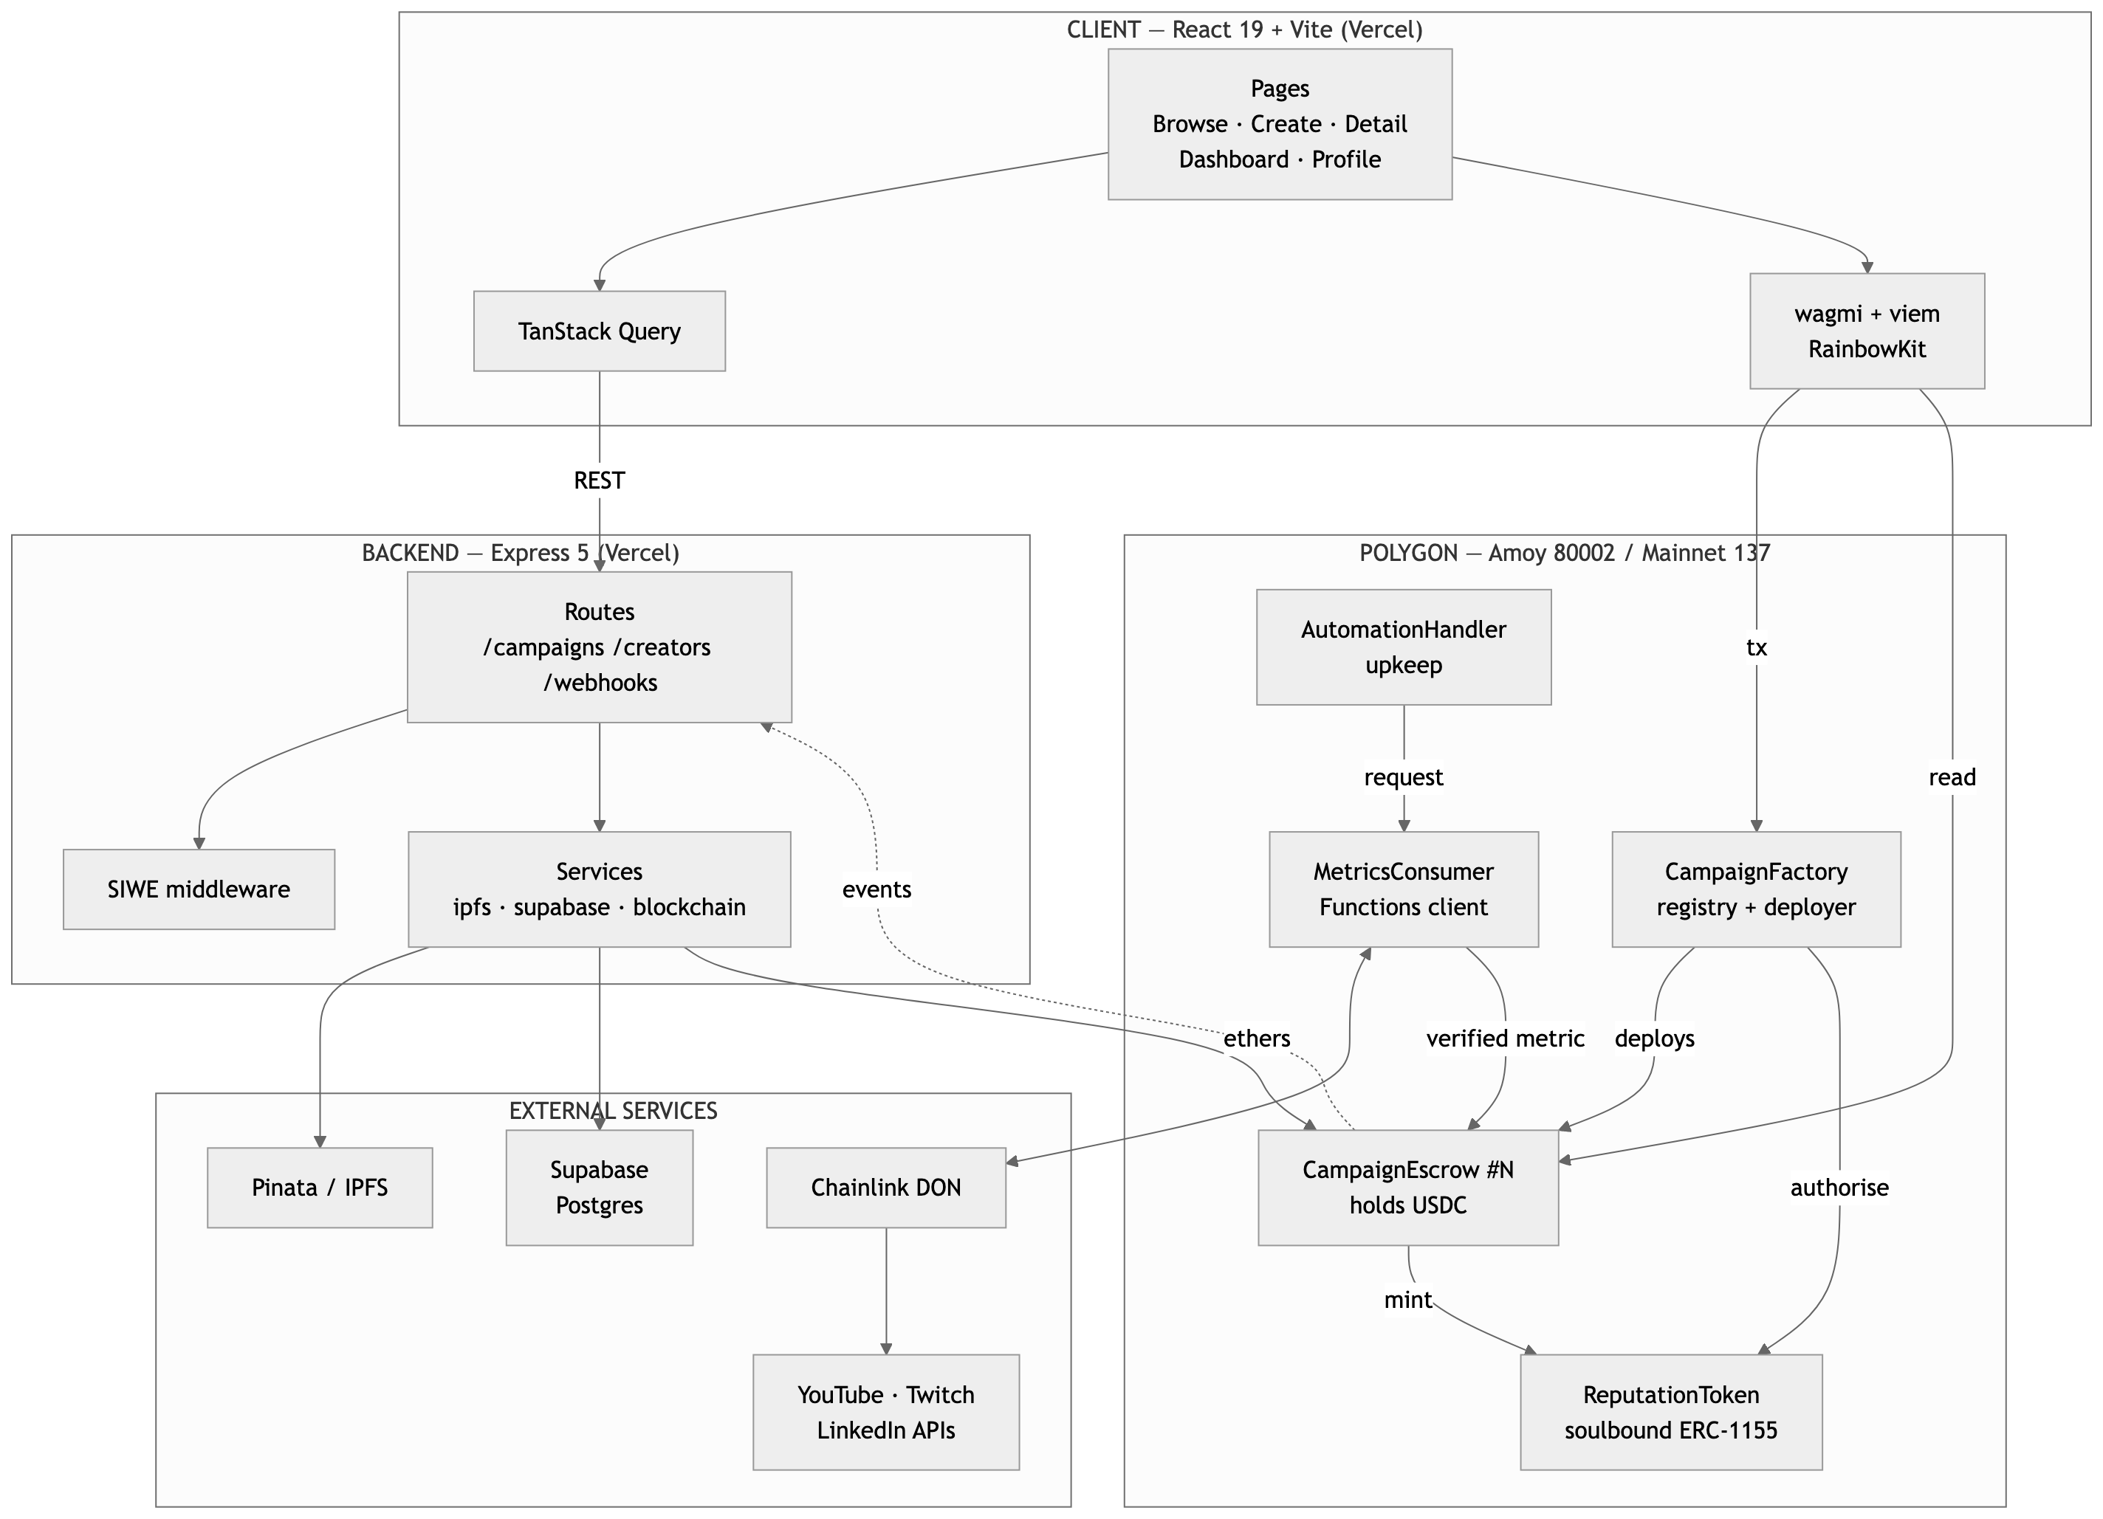
Figure 1 — System architecture across the four planes

Design principles
Principle | How it shows up
Funds never touch a server | USDC sits in a per-campaign CampaignEscrow. The backend has no withdrawal path — it can only read state and relay proof CIDs.
Terms are immutable | The campaign brief is pinned to IPFS and its CID is written into the escrow constructor. The agreed terms can never be edited after deployment.
Payouts are non-discretionary | Only MetricsConsumer can post a metric, and the escrow itself compares it to the threshold. Neither brand nor platform can withhold a met milestone.
Postgres is a cache, not a source of truth | Every write to Supabase happens after the corresponding transaction is confirmed on-chain. If the DB is wiped, the chain still holds all campaigns, balances, and reputation.
Reputation cannot be bought | ReputationToken._update reverts on any transfer, so tokens only ever move from address(0) to a creator.
One escrow per campaign | Blast radius of a bug or a stuck campaign is a single deal, not the protocol.

2. Technology stack

Smart contracts
Item | Version / choice | Notes
Language | Solidity 0.8.24
Framework | Hardhat 3 (ESM config) | hardhat.config.js, type: module
Libraries | OpenZeppelin Contracts 5.x | ReentrancyGuard, Ownable, ERC1155, IERC20
Oracle SDK | @chainlink/contracts 1.5 | FunctionsClient, AutomationCompatibleInterface
Compiler settings | optimizer on, 200 runs, evmVersion: "cancun" | Cancun is live on Polygon post-Ahmedabad; nothing here needs Cancun opcodes, so shanghai is a safe fallback
Test runner | Node test runner via @nomicfoundation/hardhat-node-test-runner + Chai matchers
Verification | hardhat-verify v3 against Etherscan V2 | One multichain API key; standalone Polygonscan V1 keys are deprecated

Backend
Item | Version / choice
Runtime | Node.js, ESM ("type": "module")
Framework | Express 5
Chain client | ethers v6
DB client | @supabase/supabase-js v2 (service-role key)
IPFS client | pinata SDK v2
Other | cors, dotenv, nodemon (dev)

Frontend
Item | Version / choice
Framework | React 19
Bundler | Vite 8 (@vitejs/plugin-react)
Wallet | wagmi 2 + viem 2 + RainbowKit 2
Server state | TanStack Query v5
Routing | react-router-dom 7
Styling | Tailwind CSS 4 (@tailwindcss/vite) + shadcn/ui on Radix primitives
Forms | react-hook-form + zod (@hookform/resolvers)
Motion | framer-motion
Charts / toasts / icons | recharts · sonner · lucide-react
Fonts | @fontsource-variable/geist

Network
Primary | Polygon Amoy testnet — chainId 80002
Configured | Polygon mainnet — chainId 137
Gas token | POL (not ETH)
Settlement asset | USDC, 6 decimals (MockUSDC on Amoy; 0x3c499c542cEF5E3811e1192ce70d8cC03d5c3359 on mainnet)
Confirmations | TX_CONFIRMATIONS = 3 — Polygon PoS has ~2s blocks and routine short reorgs, and every write is followed by a Supabase persist

3. External services
Service | Used for | Where configured
Polygon PoS | Settlement chain for all contracts and USDC transfers | hardhat.config.js, client/src/config/wagmi.js, RPC_URL
Supabase (Postgres) | Off-chain read-model: users, campaigns, milestones, applications, proofs, reputation events. RLS on all tables — public select, writes only via the backend’s service-role key | supabase/migrations/, server/src/services/supabase.js
Pinata (IPFS pinning) | Campaign briefs, creator content proofs, ERC-1155 token metadata | server/src/services/ipfs.js, PINATA_JWT, PINATA_GATEWAY
Chainlink Functions | Decentralised off-chain compute — each DON node independently calls the platform API and the network agrees on the result before it lands on-chain | contracts/oracle/MetricsConsumer.sol, server/src/chainlink-functions/*.js
Chainlink Automation | Time-based upkeep that sweeps campaigns every 24h and triggers metric checks — removes humans from the verification loop | contracts/oracle/AutomationHandler.sol
YouTube Data API v3 | View / subscriber / watch-time counts | fetchYouTubeMetrics.js (runs on DON nodes, key passed as an encrypted DON secret)
Twitch API | Concurrent viewers, followers, views | fetchTwitchMetrics.js
LinkedIn API | Impressions, clicks, followers | fetchLinkedInMetrics.js
WalletConnect | Wallet connection relay behind RainbowKit | VITE_WALLETCONNECT_PROJECT_ID
Alchemy Notify (optional) | Push on-chain logs to POST /webhooks/alchemy for DB sync; the route normalises Alchemy’s payload shape | server/src/routes/webhooks.js, WEBHOOK_SECRET
Etherscan V2 | Contract source verification on Polygon + Amoy | ETHERSCAN_API_KEY
Vercel | Hosting for both the client (static Vite build) and the Express server | client/vercel.json

4. Repository layout
Influencity_v1/
├── contracts/
│ ├── core/ CampaignFactory · CampaignEscrow · ReputationToken
│ ├── oracle/ MetricsConsumer · AutomationHandler
│ ├── libraries/ MilestoneLib
│ ├── interfaces/ ICampaignEscrow · IReputationToken
│ └── mocks/ MockUSDC · MockMetricsOracle
├── scripts/ deploy.js · verify.js · seedTestData.js
├── test/ CampaignEscrow · CampaignFactory · ReputationToken · OracleFlow
├── server/src/
│ ├── index.js Express app — mounts /campaigns /creators /webhooks
│ ├── loadEnv.js dotenv, imported FIRST, resolves <repo>/.env absolutely
│ ├── middleware/ auth.js — SIWE verification
│ ├── routes/ campaigns.js · creators.js · webhooks.js
│ ├── services/ ipfs.js (Pinata) · supabase.js · blockchain.js (ethers)
│ └── chainlink-functions/ JS executed by DON nodes (not by this server)
├── client/src/
│ ├── pages/ Landing · Browse · CreateCampaign · CampaignDetail
│ │ · Dashboard · CreatorProfile · NotFound
│ ├── components/ campaign/ · wallet/ · layout/ · reputation/ · shared/ · ui/
│ ├── hooks/ useCampaign · useMilestones · useReputation · useIPFS · useSIWE
│ ├── config/ wagmi.js · contracts.js · supabase.js
│ └── lib/ constants.js (enum mirrors, USDC formatting) · utils.js
├── supabase/migrations/ 001_initial_schema.sql · 002_open_campaigns.sql
├── hardhat.config.js
├── deployments.json written by scripts/deploy.js
└── ccvs.md internal working notes
Sibling folders outside this directory: Influencity_PRD_v1.pdf (product requirements), influencity-readme.html (styled overview), and video/ (a separate Remotion project for the promo video).

5. Smart contract layer

5.1 Contract map
Contract | Type | Responsibility
CampaignFactory | Singleton | Deploys one escrow per campaign, holds the registry, binds creators
CampaignEscrow | One per campaign | Holds USDC, owns the milestone list, releases/refunds tranches
ReputationToken | Singleton | Soulbound ERC-1155 minted on every milestone met
MetricsConsumer | Singleton | Chainlink Functions client; the only address allowed to post metrics
AutomationHandler | Singleton | Chainlink upkeep; sweeps campaigns and requests fresh metrics
MilestoneLib | Library | Milestone struct, enums, threshold/expiry/validation helpers
MockUSDC | Mock | 6-decimal ERC-20 with an open faucet() for testnet
MockMetricsOracle | Mock | Stands in for MetricsConsumer in tests; injects metric values directly

5.2 MilestoneLib — the shared vocabulary
enum Platform { YOUTUBE, TWITCH, LINKEDIN } // 0,1,2
enum MetricType { VIEWS, CLICKS, FOLLOWERS, WATCH_TIME, CONCURRENT_VIEWERS } // 0..4
enum MilestoneStatus { PENDING, MET, FAILED } // 0,1,2
struct Milestone {
Platform platform; // which platform to measure
MetricType metricType; // what to measure
uint256 threshold; // e.g. 50000 views
uint256 trancheAmount; // USDC released on success (6 decimals)
uint256 deadline; // unix ts; past this, unmet = failed
string contentId; // YouTube video id, Twitch clip slug, …
string ipfsProofHash; // creator's proof CID
MilestoneStatus status;
}
These integer values are mirrored verbatim in client/src/lib/constants.js and in the Postgres check constraints — the three layers must be changed together.
Helpers: isExpired, isPending, isValidMilestone (threshold > 0, tranche > 0, deadline in the future), isThresholdMet (reported >= threshold).

5.3 CampaignFactory
State: campaignCount, campaignEscrows[id], brandCampaigns[addr][], creatorCampaigns[addr][], plus the protocol addresses (usdc, reputationToken, metricsConsumer) passed into every escrow.
createCampaign(ipfsBriefHash, platforms[], metricTypes[],
thresholds[], trancheAmounts[], deadlines[], contentIds[])
→ (campaignId, escrowAddress)
- Validates that all six milestone arrays are the same length and non-empty.
- Increments campaignCount (IDs start at 1).
- Deploys a fresh CampaignEscrow with msg.sender as the brand and no creator.
- Wires the escrow into the rest of the protocol: authoriseMinter on ReputationToken, authoriseEscrow on MetricsConsumer, and registerCampaign on the AutomationHandler when one is set. The last two were missing, which meant a real oracle deployment would have produced campaigns that could never be verified.
- Adds every milestone to the escrow (factory is owner, so onlyOwner passes).
- Emits CampaignCreated(campaignId, escrowAddress, brand, ipfsBriefHash).
assignCreator(campaignId, creator) // caller must be the campaign's brand
Forwards to escrow.assignCreator, pushes the id into creatorCampaigns, emits CreatorAssigned.
Admin: updateProtocolAddresses(usdc, reputationToken, metricsConsumer) for redeploys of the oracle or reputation contract.

5.4 CampaignEscrow — the core
ReentrancyGuard + Ownable (owner = the factory).
Lifecycle states are derived, not a single enum:
OPEN creator == 0 && !isFinalized brand can cancel
BOUND creator != 0 && !isFinalized binding; cancel disabled
FINALIZED isFinalized remainder returned to brand
CANCELLED isCancelled && isFinalized withdrawn before a creator was bound
Function | Guard | Behaviour
deposit(amount) | onlyBrand, notFinalized, nonReentrant | One-shot (totalDeposit == 0). Must cover the sum of all milestone tranches. Pulls USDC via transferFrom — brand must approve first. Emits CampaignFunded.
addMilestone(...) | onlyOwner (factory) | Validates via MilestoneLib; if a deposit already exists, the new tranche must still fit inside it. Capped at MAX_MILESTONES = 20 so the loops in finalizeCampaign and the automation sweep stay bounded.
assignCreator(addr) | onlyOwner, notFinalized | One-shot. Rejects zero address, creator == brand, and an unfunded escrow (totalDeposit > 0) — binding a creator to an empty escrow forms an agreement that can never pay out. Deposit must therefore precede assignment.
submitProof(idx, cid) | creator only, milestone PENDING, before the deadline | Stores the IPFS proof CID on the milestone.
receiveVerifiedMetric(idx, value) | onlyMetricsConsumer, notFinalized, nonReentrant | The only path to a payout. Requires a bound creator and a PENDING milestone.
finalizeCampaign() | brand or owner, nonReentrant | Fails every still-pending expired milestone, then returns the remainder to the brand. Reverts if any milestone is still live — without that guard the brand could sweep a tranche the creator was still earning.
cancelCampaign() | onlyBrand, only while creator == 0 | Refunds the full balance and finalises. Once a creator is bound the agreement is binding.
The decision inside receiveVerifiedMetric:
reported >= threshold ──► _releaseTranche: status = MET
├─ USDC.transfer(creator, trancheAmount)
├─ totalReleased += trancheAmount
├─ ReputationToken.mint(creator, idx, campaignId)
└─ emit MilestoneMet
reported < threshold
└─ deadline passed ──► _failMilestone: status = FAILED
│ ├─ USDC.transfer(brand, trancheAmount)
│ └─ emit MilestoneFailed
└─ deadline ahead ──► stays PENDING, retried on the next upkeep
Events: CampaignFunded, MilestoneAdded, MilestoneMet, MilestoneFailed, MetricVerified, CampaignFinalized, CreatorAssigned, CampaignCancelled. (CampaignInitialised was declared but never emitted and described the old pre-marketplace flow; CampaignFunded replaces it, since deposits were otherwise invisible to event listeners.)
Views: getMilestones, getMilestone(i), getMilestoneCount, getBalance.

5.5 ReputationToken — soulbound ERC-1155
- name = "Influencity Reputation", symbol = "IREP".
- tokenId = uint256(keccak256(abi.encodePacked(campaignId, milestoneIndex))) — every milestone across every campaign is its own token type.
- mint is onlyAuthorisedMinter; escrows are added to authorisedMinters by the factory at creation time (authoriseMinter accepts owner or the registered campaignFactory).
- Per-wallet reputationScore counter plus a full mintHistory[] of {campaignId, milestoneIndex, tokenId, mintedAt} records.
- Soulbound enforcement — _update reverts unless from == address(0), so tokens can be minted but never transferred or burned.
- uri(tokenId) returns the per-token IPFS URI if one was set via setTokenMetadataURI, otherwise falls back to the base URI.

5.6 Oracle layer
MetricsConsumer (FunctionsClient + ConfirmedOwner)
- Stores one JS source string per platform (setSourceCode(platform, code)), the DON subscription id, DON id, and a 500k callback gas limit — a milestone-met fulfillment measures 310,702 gas, so the previous 300k default would have run out mid-callback and silently failed to pay.
- requestMetric(escrowAddress, milestoneIndex, platform, contentId) — callable by an authorised escrow or the automationHandler. The escrow is an explicit parameter: requests are placed by the handler on an escrow’s behalf, so inferring it from msg.sender filed every result against the handler and the metric never reached the escrow at all. Builds an inline-JavaScript Functions request with contentId as args[0], sends it, and records a RequestContext{escrowAddress, milestoneIndex, platform, fulfilled} keyed by requestId.
- fulfillRequest(requestId, response, err) — the DON callback, which never reverts: a revert there burns the callback gas, marks the request failed upstream, and loses the paid-for result. Unknown ids, duplicates, malformed responses and an escrow that refuses the metric all emit MetricDeliveryFailed and return; DON-side errors emit MetricRequestFailed. Only a clean delivery emits MetricFulfilled.
AutomationHandler (AutomationCompatibleInterface)
- Registry of schedules[campaignId] = {escrowAddress, lastCheckedAt, active}.
- checkUpkeep runs off-chain and free — returns up to maxCampaignsPerUpkeep (default 5) campaigns whose checkInterval (default 24 hours) has elapsed.
- performUpkeep runs on-chain, re-validates the interval, and for each campaign requests a fresh metric for every milestone still PENDING with a non-empty contentId. Each request is wrapped — one unrecoverable milestone emits MetricCheckFailed instead of aborting the sweep for every other campaign in the batch.
- Access is gated on the Chainlink forwarder: permissionless until setForwarder is called (necessary before the upkeep is registered and the forwarder is known), restricted afterwards so nobody else can spend the LINK.
- A finalised campaign retires itself on the next sweep, and its id is removed from campaignIds with a swap-and-pop, so checkUpkeep scans live campaigns rather than every campaign ever created.
- forceCheck(campaignId) (owner-only) runs a check immediately, since checkInterval has a one-hour floor that makes live demos impractical.
- deactivateCampaign stops the sweep; callable by the escrow itself or the owner.
The DON-side scripts in server/src/chainlink-functions/ are not run by the Express server — they are uploaded into MetricsConsumer and executed independently by each Chainlink node. They read the API key from encrypted DON-hosted secrets, call the platform API with a ~9s timeout (the DON limit is ~10s), and return a single uint256.

5.7 Trust boundaries
Actor | Can | Cannot
Brand | Create + fund a campaign, pick an applicant, cancel while open, finalize after deadlines | Edit terms, block a met milestone, cancel after binding a creator, touch a released tranche
Creator | Apply, submit proof CIDs | Trigger their own payout, change a threshold, transfer reputation
Backend wallet | Read chain state, relay proof CIDs | Move USDC, mint reputation, post metrics
MetricsConsumer | Post verified metrics | Move funds directly (only the escrow’s own logic transfers)
Factory owner | Repoint protocol addresses for future campaigns | Alter or drain existing escrows

6. Off-chain data model (Supabase)
Postgres with RLS enabled on every table. Policy shape is uniform: public select, no public writes — all inserts and updates go through the backend’s service-role key, which bypasses RLS. An update_updated_at() trigger keeps updated_at fresh on users, campaigns, milestones, and campaign_applications.
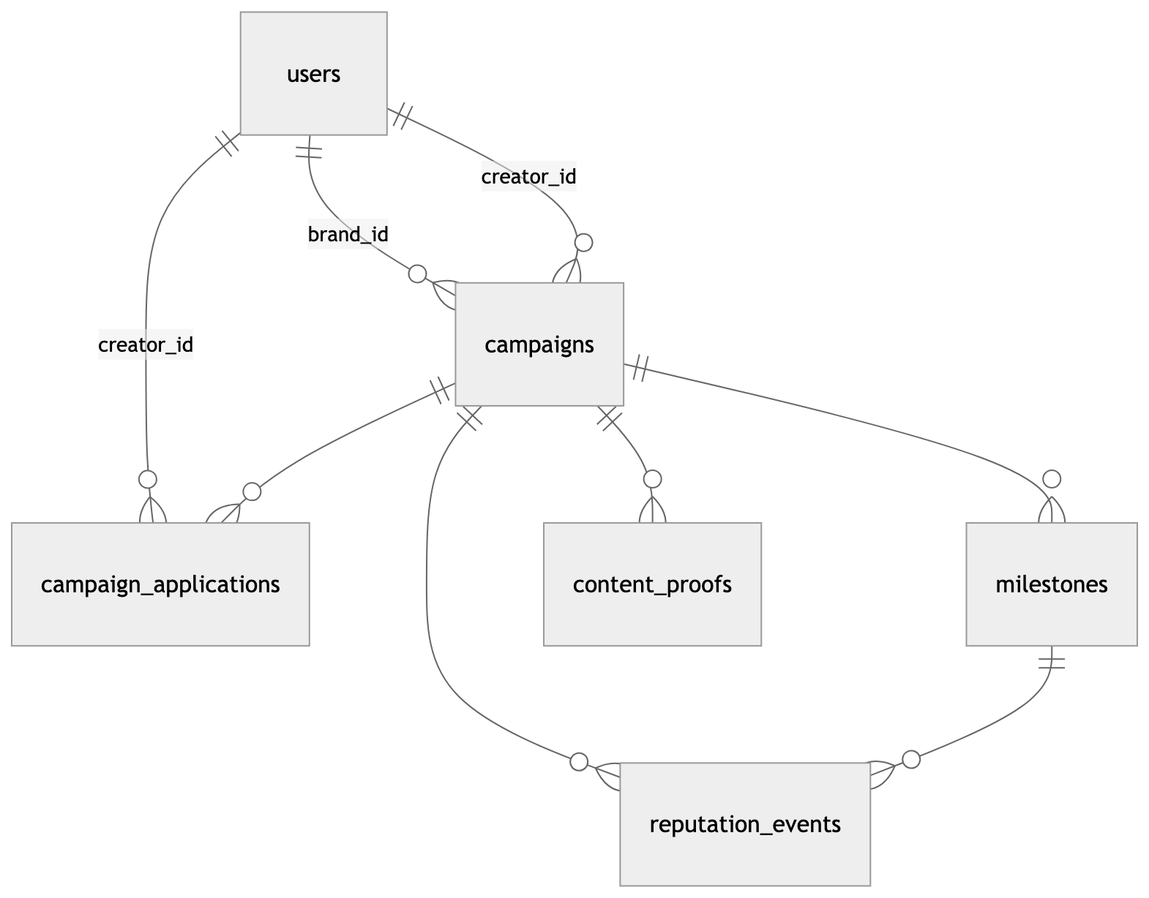
Figure 2 — Supabase entity relationships
Table | Key columns | Purpose
users | wallet_address (unique), role ∈ {brand, creator}, display_name, avatar_url | Wallet is the identity; rows are created lazily on first authenticated action
campaigns | campaign_id_onchain (unique), contract_address (unique), brand_address, creator_address (nullable), ipfs_brief_cid, status, total_deposit_usdc, total_released_usdc | Mirror of escrow state. status ∈ open · pending · active · completed · cancelled, default open
milestones | (campaign_id, milestone_index) unique, platform, metric_type, threshold, tranche_usdc, deadline, content_id, ipfs_proof_cid, verified_value, status | Enum values match MilestoneLib exactly, enforced by check constraints
campaign_applications | (campaign_id, creator_address) unique, pitch_message, social_links (jsonb), status ∈ pending · selected · rejected · withdrawn | The marketplace layer — purely off-chain until the brand selects
content_proofs | milestone_index, ipfs_cid, platform_url, content_id, platform | Creator delivery records
reputation_events | creator_address, token_id, minted_at, tx_hash | Mirror of ReputationMinted for fast profile queries
Indexes cover every address and status column used for lookup (brand_address, creator_address, contract_address, status, …).
Migration 002 (open_campaigns) is what turned the product from brand↔creator direct deals into a marketplace: it made creator_address nullable, added open to the status enum and made it the default, and introduced campaign_applications.

7. Backend API (Express)
server/src/index.js — CORS allows localhost:5173, CLIENT_URL, and any *.vercel.app; JSON + urlencoded body parsing; a GET /health probe; a global JSON error handler. loadEnv.js is the first import so process.env is populated before the Supabase client initialises.

7.1 Authentication — SIWE
There are no passwords, sessions, or JWTs. The client signs a SIWE message with the wallet and sends three headers on every authenticated request:
x-wallet-address 0x… claimed address
x-wallet-signature 0x… signature over the message
x-siwe-message <base64 of the message> base64 because HTTP headers can't hold newlines
requireAuth base64-decodes the message, runs ethers.verifyMessage, and rejects unless the recovered address equals the claimed one. The verified address is attached as req.walletAddress (lowercased) and routes compare it against the body — e.g. POST /campaigns rejects when req.walletAddress !== brandAddress.
optionalAuth only checks address format and attaches it if present — it performs no signature check and must never gate a mutation. requireWalletMatch(field) is a helper for per-route ownership checks.

7.2 Routes
/campaigns
Method | Path | Auth | Purpose
POST | / | brand | Validate input, pin the brief to IPFS, return {ipfsBriefCid, contractParams} for the client to deploy with
POST | /confirm | brand | Called after the on-chain deploy confirms — persists campaign + milestones with the escrow address
GET | / | optional | Campaigns for ?wallet=
GET | /open | public | Marketplace listings (declared before /:id so open isn’t parsed as an id)
GET | /:id | optional | Campaign + milestones + content proofs; accepts an on-chain id or a contract address
POST | /:id/proof | creator | Pin the proof to IPFS and record it
POST | /:id/apply | creator | Apply with pitch_message + social_links
GET | /:id/applications | optional | Applicant list for the brand
POST | /:id/select | brand | Record the selection after the on-chain assignCreator succeeds
POST | /:id/cancel | brand | Record the withdrawal after the on-chain cancelCampaign succeeds
/creators — GET /:address (profile: DB rows + live on-chain reputation), /:address/campaigns, /:address/reputation, /:address/applications.
/webhooks — POST /onchain (our own event listener) and POST /alchemy (Alchemy Notify; the route normalises its log format). Both are gated by an x-webhook-secret header compared to WEBHOOK_SECRET. Handled events: MilestoneMet (update milestone + insert reputation event), MilestoneFailed, CampaignFinalized, CampaignCreated.

7.3 Services
Module | Responsibility
services/ipfs.js | Pinata SDK. uploadCampaignBrief (validated, stamped with type/version/uploadedAt), uploadContentProof, buildGatewayUrl
services/supabase.js | ~20 typed data-access functions — getOrCreateUser, createCampaign, getOpenCampaigns, createApplication, selectApplicant, updateMilestoneStatus, createReputationEvent, …
services/blockchain.js | ethers v6. Imports ABIs statically from the committed server/src/abis/index.js (regenerate with npm run build:abis). They were previously read from artifacts/ at runtime — gitignored, outside server/, and via a computed path no bundler can trace, so the server worked locally and failed on every host. getProvider() deliberately has no default RPC — a wrong-chain read returns empty data rather than erroring, which would surface as “no campaigns found” instead of a misconfiguration. Also getCampaignState, submitProofToContract, getCreatorReputation, listenToEscrowEvents

8. Frontend (React + Vite)

8.1 Routes
Path | Page | Gate
/ | Landing | —
/dashboard | Dashboard (brand + creator views, toggle) | wallet
/campaigns/browse | Browse — open marketplace | none — public
/campaigns/new | CreateCampaign wizard | wallet + brand role
/campaigns/:id | CampaignDetail | none to read; actions gated
/profile/:address | CreatorProfile — reputation + badge wall | —
* | NotFound | —
Page transitions run through framer-motion’s AnimatePresence keyed on location.pathname.

8.2 Guards (components/wallet/)
Guard | Job
WalletGuard | Requires a connected wallet before rendering the page
NetworkGuard | Blocks the UI when the wallet’s chain ≠ EXPECTED_CHAIN_ID. Not cosmetic: an EVM call to an address with no code succeeds, so on the wrong network a “deploy” burns gas and reports success, then fails later on the missing event. Mounted inside WalletGuard, so every wallet-gated page inherits it
RoleGuard | Prompts for brand/creator on first use, persists to localStorage["influencity_role"]
The guards nest, so wrapping a page in the outermost one is enough: RoleGuard → WalletGuard → NetworkGuard → page. | SIWEProvider | Builds and signs the SIWE message, caches address/signature/message/role in sessionStorage, and re-signs lazily when the address changes or the cached message contains a non-Latin-1 codepoint (which fetch would reject as a header value) |

8.3 Configuration modules
- config/wagmi.js — the single source of chain truth. RainbowKit getDefaultConfig, EXPECTED_CHAIN_ID (override via VITE_CHAIN_ID), TX_CONFIRMATIONS = 3, and explorer helpers (EXPLORER_URL, explorerAddressUrl, explorerTxUrl) derived from the chain definition rather than hardcoded, so switching networks can’t leave a stale explorer domain in the UI.
- config/contracts.js — hand-written ABI fragments for CampaignFactory, CampaignEscrow, ReputationToken, and USDC, plus addresses from VITE_* env vars (zero-address fallbacks).
- lib/constants.js — mirrors the Solidity enums, maps platform → allowed metrics for the wizard, and holds USDC_DECIMALS = 6 with formatUSDC/parseUSDC.

8.4 Hooks
hooks/useCampaign.js is the main orchestration layer — TanStack Query reads against the backend (useCampaign, useCampaigns, useOpenCampaigns, useCampaignApplications, useMyApplications) and mutations that sequence wallet transactions with backend persistence (useCreateCampaign, useApplyToCampaign, useSelectCreator, useCancelCampaign). Alongside it: useMilestones, useReputation (on-chain reads via wagmi), and useIPFS (brief/proof uploads through the backend, with an in-memory CID cache).

8.5 Component layers
components/ui/ are the shadcn/Radix primitives (button, dialog, tabs, …). components/shared/ holds cross-cutting pieces (StatusBadge, ProgressBar, TxToast, PlatformIcon, EmptyState, LoadingSpinner). components/campaign/ holds the 4-step CreateWizard and the campaign/milestone cards and timeline. components/reputation/ renders the badge wall and stats.

9. End-to-end flows

9.1 Create + fund a campaign (brand)
Five sequential steps, each surfaced in the wizard’s progress UI. Every transaction waits 3 confirmations before the next step runs.
1. POST /campaigns → validate, pin brief to IPFS → briefCid
2. factory.createCampaign() → deploys escrow, adds milestones,
authorises escrow as rep minter
wait 3 confs → parseEventLogs(CampaignCreated) → campaignId, escrowAddress
3. usdc.approve(escrow, total) → wait 3 confs
4. escrow.deposit(total) → USDC locked in escrow → wait 3 confs
5. POST /campaigns/confirm → persist campaign + milestones with contract_address
The ordering matters: the brief CID must exist before the escrow is deployed (it is a constructor argument and can never change), and the DB row is only written once the chain has confirmed — so Postgres can never reference an escrow the chain doesn’t have.

9.2 Apply and select (marketplace)
Creator: POST /campaigns/:id/apply pitch + social links → application (pending)
Brand: GET /campaigns/:id/applications
Brand: factory.assignCreator(id, creator) ← agreement is formed HERE, on-chain
wait 3 confs
Brand: POST /campaigns/:id/select marks selected, rejects the others,
campaign status open → active
Before selection the brand can call escrow.cancelCampaign() and get the full balance back (then POST /campaigns/:id/cancel to record it). After selection that path is closed — the agreement is binding.

9.3 Delivery → verification → payout
Creator posts the content, then submits proof:
POST /campaigns/:id/proof → pin to IPFS → escrow.submitProof(idx, cid)
Chainlink Automation, every 24h:
checkUpkeep() off-chain, free → which campaigns are due
performUpkeep() on-chain → for each PENDING milestone with a contentId:
MetricsConsumer.requestMetric(idx, platform, contentId)
→ DON nodes each run the platform JS script
→ consensus on a single uint256
→ fulfillRequest() → escrow.receiveVerifiedMetric(idx, value)
value >= threshold → USDC tranche to creator + soulbound NFT minted
value < threshold and deadline passed → tranche refunded to brand
otherwise → stays PENDING, checked again next cycle
Events → webhook → Supabase rows updated → UI reflects it on next query

9.4 Close-out
finalizeCampaign() fails any still-pending expired milestones (refunding those tranches) and returns the entire remaining balance to the brand, then sets isFinalized. Nothing further can be released from that escrow.

10. Configuration & environment variables

Root .env (contracts + backend) — see .env.example
Variable | Purpose
PRIVATE_KEY | Deployer / backend signer. Needs POL for gas, not ETH
POLYGON_AMOY_RPC_URL / POLYGON_MAINNET_RPC_URL | Hardhat network endpoints (public defaults are heavily rate-limited)
RPC_URL | The single chain the Express API reads from. No default — the server throws if unset
ETHERSCAN_API_KEY | Etherscan V2 multichain key for verification
CAMPAIGN_FACTORY_ADDRESS, REPUTATION_TOKEN_ADDRESS, USDC_ADDRESS, MOCK_METRICS_ORACLE_ADDRESS | Filled from deployments.json after deploying
SUPABASE_URL, SUPABASE_SERVICE_KEY | Backend DB access (service role — bypasses RLS)
PINATA_JWT, PINATA_GATEWAY | IPFS pinning
WEBHOOK_SECRET | Shared secret for /webhooks/*
CLIENT_URL, PORT | CORS origin and listen port (default 3001)

client/.env.local — see client/.env.example
Variable | Purpose
VITE_WALLETCONNECT_PROJECT_ID | RainbowKit / WalletConnect
VITE_CHAIN_ID | 80002 Amoy (default) or 137 mainnet — drives NetworkGuard
VITE_CAMPAIGN_FACTORY_ADDRESS, VITE_REPUTATION_TOKEN_ADDRESS, VITE_USDC_ADDRESS | Contract addresses for that chain
VITE_API_URL | Backend base URL (default http://localhost:3001)
VITE_SUPABASE_URL, VITE_SUPABASE_ANON_KEY | Direct reads (anon key — RLS applies)
VITE_PINATA_GATEWAY | Gateway host for rendering IPFS content
Only VITE_-prefixed variables are exposed to the browser bundle. .env is gitignored, as are node_modules/, artifacts/, cache/, and coverage output.

11. Build, test, deploy

Contracts
npm install
npm run build:abis # compile + regenerate server/src/abis/
npm test # all suites
npm run test:escrow # CampaignEscrow only
npm run test:factory
npm run test:reputation
156 passing, 0 failing.
Suite | Tests | Covers
CampaignEscrow | 50 | deposits, payouts, refunds, cancellation, finalization safety
CampaignFactory | 27 | creation, wiring, creator assignment, validation
ReputationToken | 23 | soulbound enforcement, minting, metadata
AutomationHandler | 22 | enrolment, sweeps, resilience, forwarder, forceCheck
OracleFlow | 14 | full campaign through MockMetricsOracle
MetricsConsumer | 13 | request routing, callback resilience
OracleWiring | 7 | the production wiring end to end against a mock DON router
Mocks: MockUSDC, MockMetricsOracle, MockMetricsConsumer (can be told to revert, to prove one bad request doesn’t abort a sweep), and MockFunctionsRouter (drives the DON callback without a live router).
Two traps baked into the suite: deadlines derive from the latest block timestamp, never Date.now() — advanceTime moves chain time cumulatively, so wall-clock deadlines drift into the past and make failures order-dependent. And tests must pass an explicit gasLimit when driving fulfillRequest: ethers’ gas estimation otherwise settles on a budget where the inner escrow call runs out of gas and is swallowed by the try/catch.

Deploy to Polygon Amoy
npx hardhat run scripts/deploy.js --network polygonAmoy
Deploys MockUSDC → ReputationToken → MockMetricsOracle → CampaignFactory, registers the factory on the reputation token, mints 10,000 test USDC to the deployer, and writes deployments.json. Copy the printed addresses into root .env and client/.env.local.
The script refuses to run against --network polygon: it deploys mocks that must never reach mainnet. A mainnet deploy needs a separate script that points at real USDC and a real MetricsConsumer.
Verification: npx hardhat run scripts/verify.js --network polygonAmoy.

Deploy the oracle layer (optional — Phase 2)
npm run deploy:oracle
Deploys MetricsConsumer + AutomationHandler, performs the four wiring calls they need, uploads the per-platform DON source, and repoints the factory from the mock at the real consumer. Requires FUNCTIONS_ROUTER_ADDRESS, FUNCTIONS_SUBSCRIPTION_ID and FUNCTIONS_DON_ID in .env.
Verify the router against Chainlink’s supported-networks docs — routers are network-specific and have been reissued; a wrong one deploys cleanly and then never fulfils a request. The script prints the manual steps it cannot perform: funding the subscription, uploading DON secrets, registering the upkeep, and calling setForwarder with the upkeep’s forwarder address.

Backend
cd server && npm install
npm run dev # nodemon
npm start # node src/index.js → http://localhost:3001
ABIs come from the committed server/src/abis/index.js, so no compile step is needed to run the server. Regenerate it with npm run build:abis after changing a contract’s external interface.

Frontend
cd client && npm install
npm run dev # Vite → http://localhost:5173
npm run build # → client/dist
npm run preview
npm run lint
Deployed on Vercel with client/vercel.json: framework vite, build npm run build, output dist.

Database
Apply supabase/migrations/001_initial_schema.sql then 002_open_campaigns.sql in the Supabase SQL editor (there is no automated migration runner). node scripts/seedTestData.js populates sample users, campaigns, milestones, proofs, and reputation events for local development.

12. Known gaps & limitations
Everything the audit surfaced has been fixed; what remains is work not yet started, plus two deliberate choices.

Not yet deployed
- Nothing is on-chain. deployments.json is null. The contracts are tested and the deploy scripts are ready; they have not been run.
- The oracle layer needs external setup no script can do: a funded Chainlink Functions subscription with the consumer added, DON-hosted secrets for the platform API keys, a registered Automation upkeep, and setForwarder called with its forwarder address.

Demo quality
- Badge NFTs will not render in a wallet. setTokenMetadataURI exists but nothing calls it, and the base URI carries no {id} template, so uri() resolves to nothing. Needs the backend to pin metadata JSON at mint time — an integration gap, not a contract bug.
- No seeded content. A fresh deployment shows an empty marketplace. scripts/seedTestData.js populates Supabase but not the chain.

Security posture
- optionalAuth is not authentication. It checks address format only and gates read routes (GET /campaigns, GET /:id, GET /:id/applications), so a caller may claim any address. Acceptable while that data is public by RLS policy; it must not gate anything private.
- WEBHOOK_SECRET is skipped when unset, logging a warning rather than refusing. Convenient locally, unsafe in production, where an unauthenticated POST /webhooks/onchain could write arbitrary campaign state.
- RLS exposes users.email — that select policy is using (true).

Deliberate choices
- pendingRequests entries are never deleted. Clearing them would refund gas but costs the replay guard; the guard is worth more.
- deposit() is one-shot (totalDeposit == 0), so a campaign cannot be topped up — under-funding means cancelling and recreating.
- updateProtocolAddresses does not touch existing escrows. An escrow’s metricsConsumer is fixed at construction, so campaigns created before the oracle swap keep the mock. Intentional: retargeting a live escrow’s oracle would be a far worse property to have.

Hardening not yet done
- SafeERC20, custom errors, EIP-1167 clones. None are bugs — raw transfer with a checked return works for USDC — but all three are current practice, and clones would cut the ~2–3M gas each new CampaignEscrow() costs by roughly 90%. Best as one pass now that a green suite exists to catch regressions.
- Toolchain drift. Hardhat 3.4.5 vs 3.17; hre.network.connect() is deprecated and warns on every test and deploy run. Solidity 0.8.24 vs 0.8.37 — if bumped, keep evmVersion: "cancun" pinned, since newer defaults target hardforks Polygon may not have.
- No indexer. DB sync depends on webhooks; a missed event leaves Postgres stale with no reconciliation job. The chain stays correct either way.

