Name: Jaishanth M
Roll No: 727625BSC023
Department: B.E.CSE(CYS)

1) Remove duplicate tuples from list of tuples
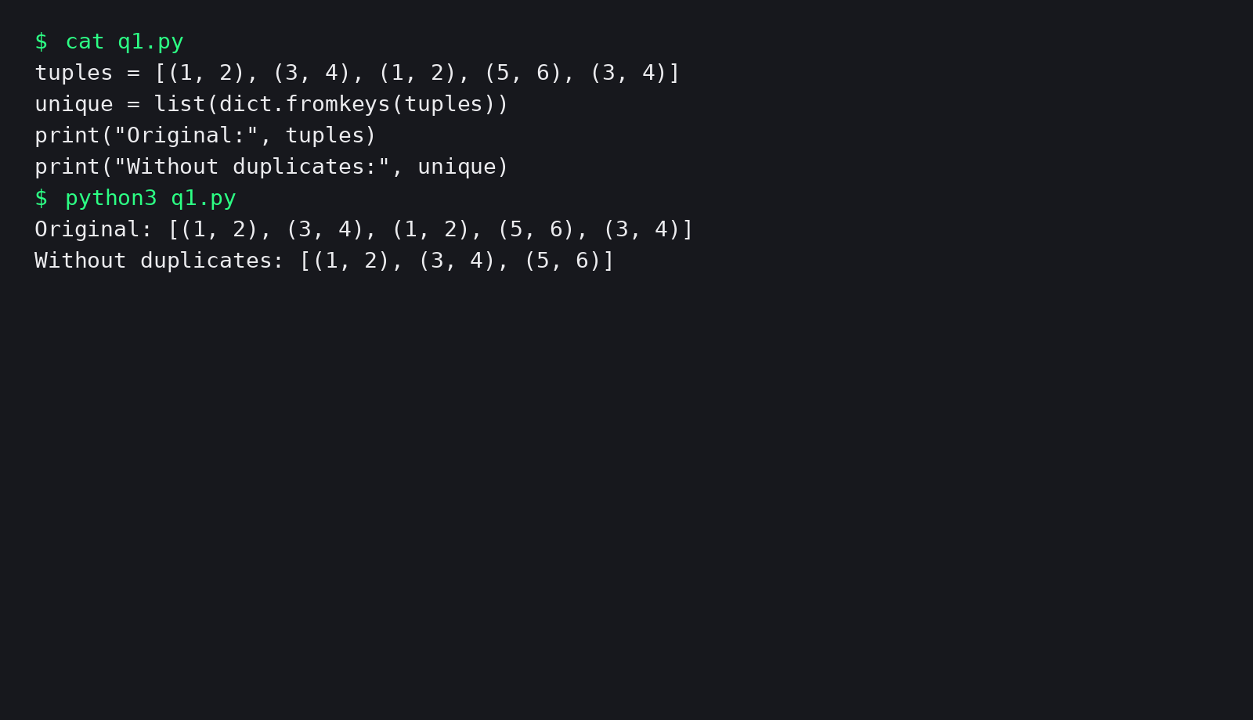
2) Swap tuple elements in list of tuples
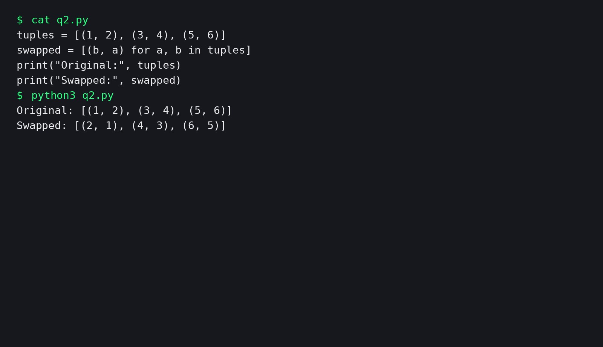
3) Reverse each tuple in a list of tuples
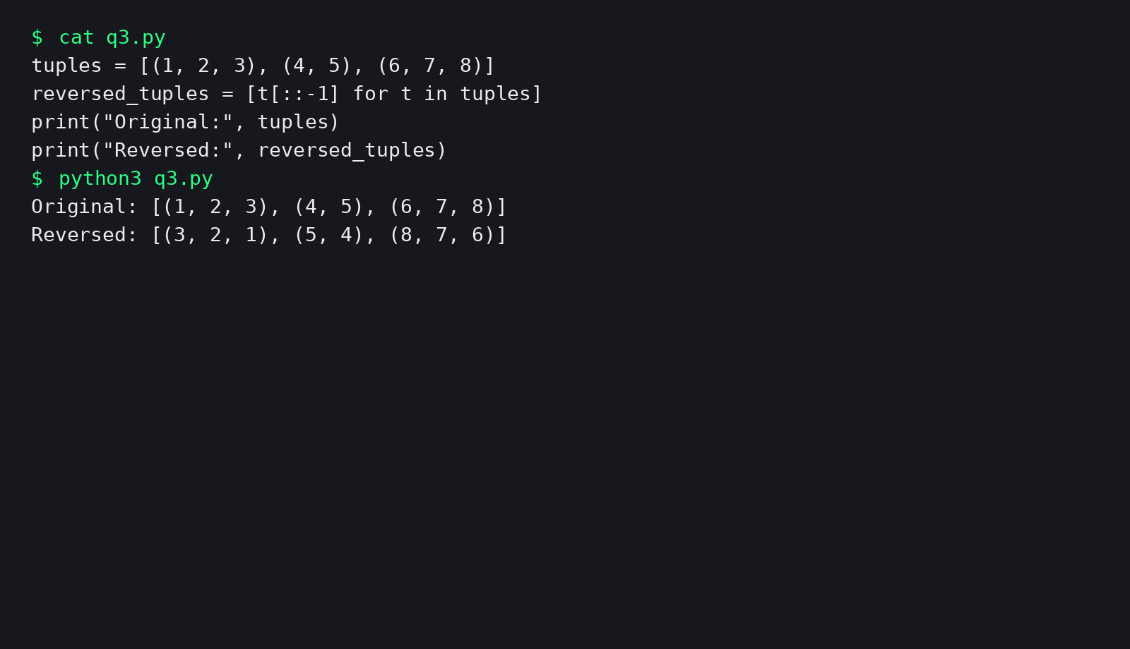
4) Sort list of tuples by specific ordering
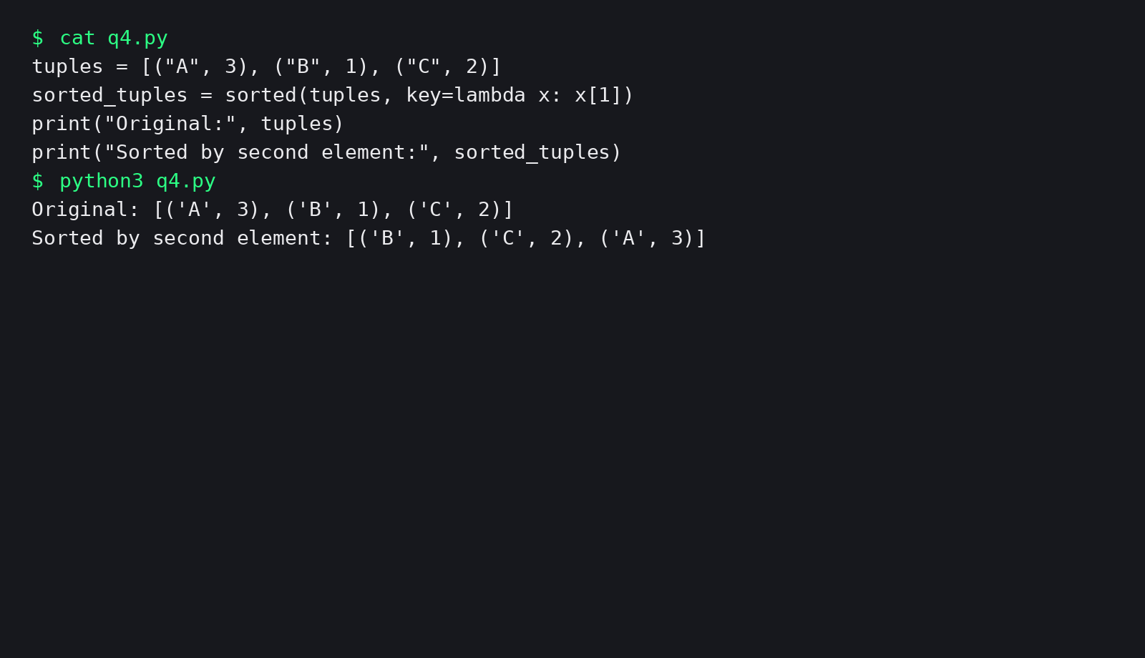
5) Write a program to read email IDs of n number of students and store them in a tuple. Create two new tuples, one to store only the usernames from the email IDs and second to store domain names from the email IDs. Print all three tuples at the end of the program.
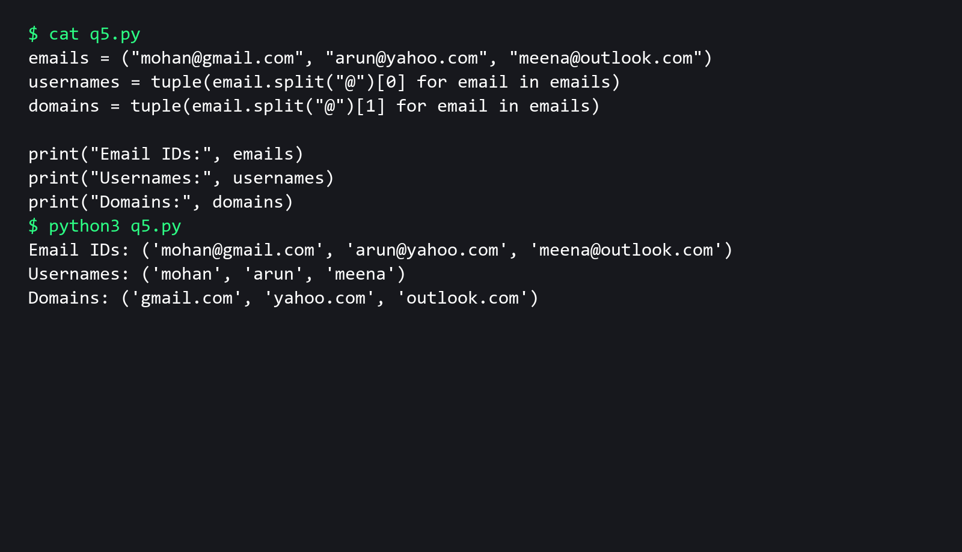
6) Write a program to input names of n students and store them in a tuple. Also, input a name from the user and find if this student is present in the tuple or not.
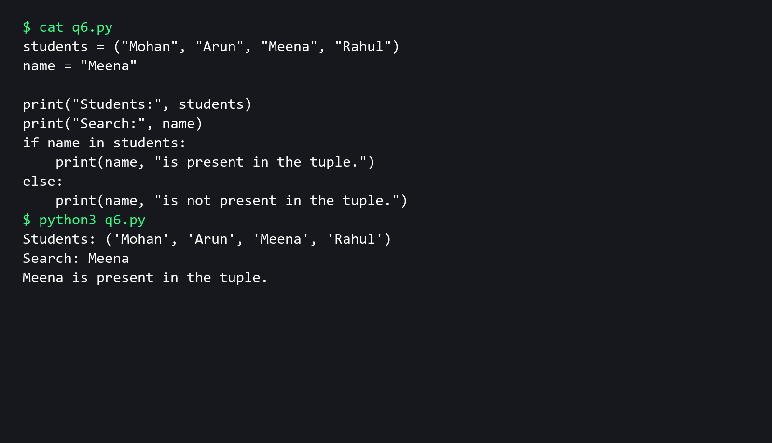
7) Write a program to input n numbers from the user. Store these numbers in a tuple. Print the maximum and minimum number from this tuple.
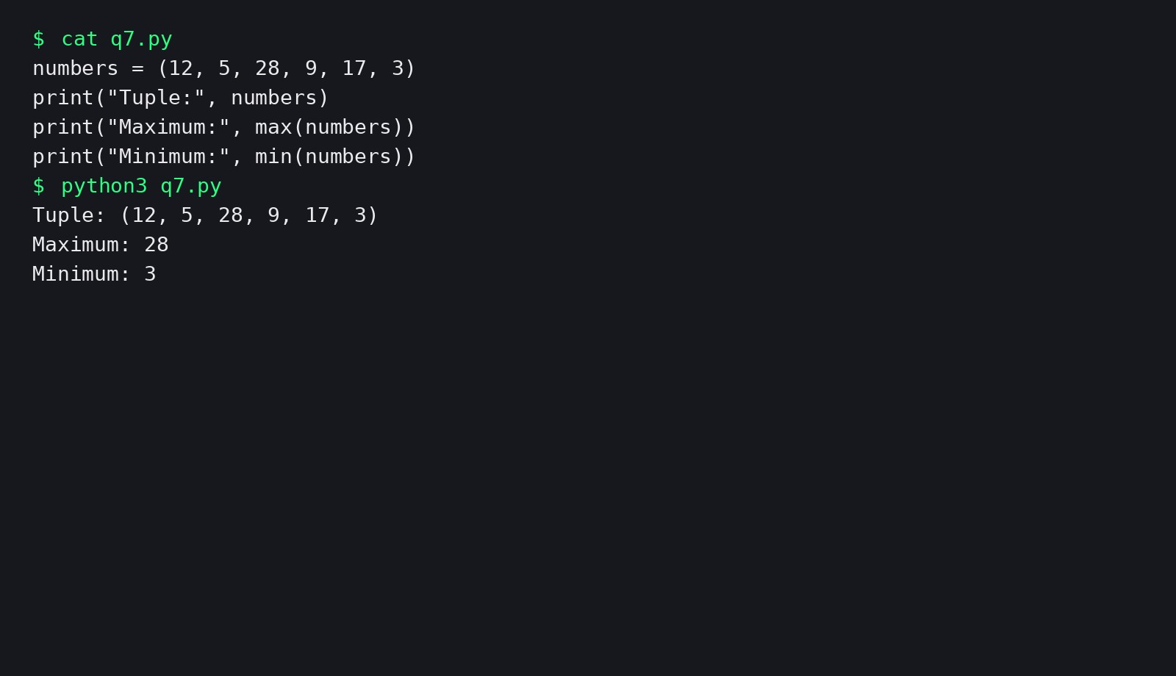
8) Write a Python program to find the highest 2 values in a dictionary.
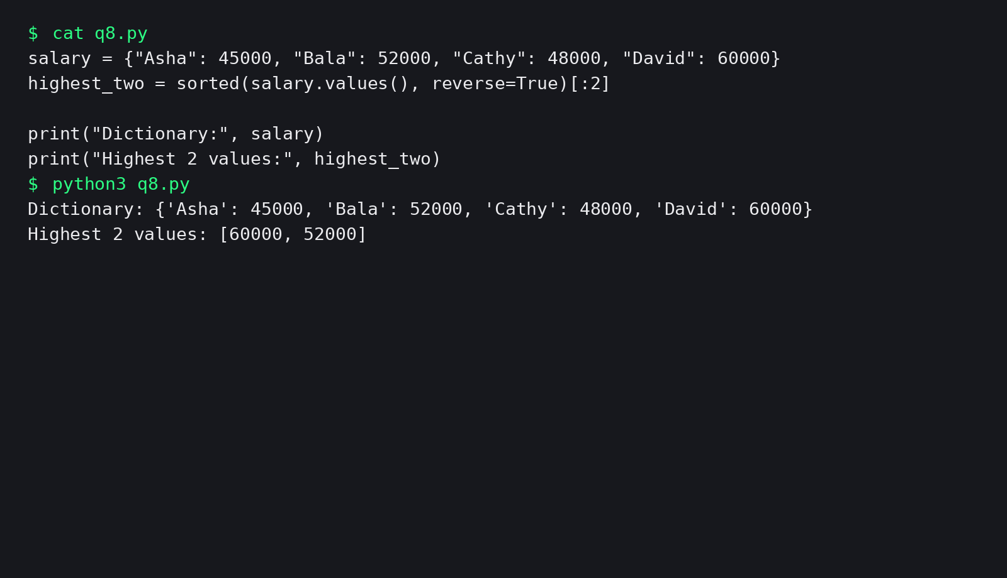
9) Write a program to create a dictionary which stores names of employees and their salary.
