CO4_AT1_INDUSTRY BASED QUESTION
Q1:Hospital Appointnment Management System

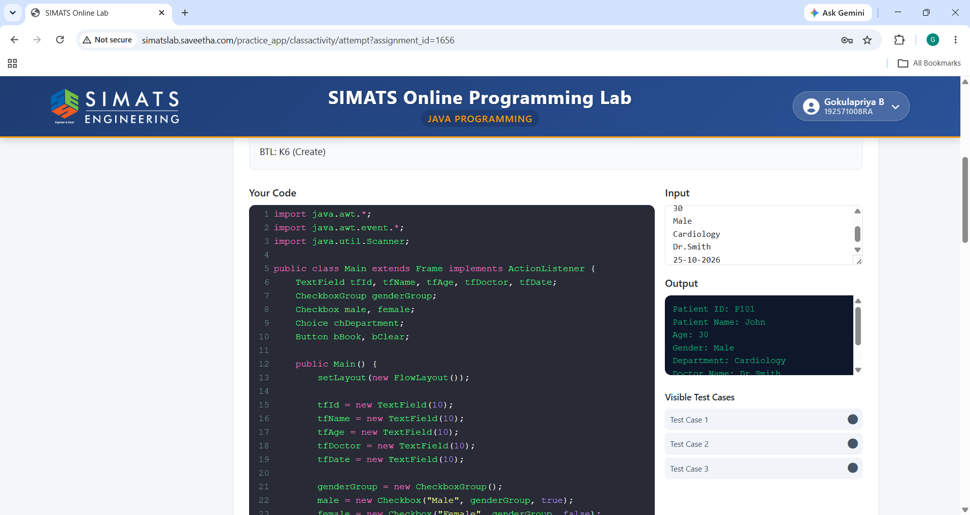

Q2:Online Banking Fund Transfer
