C03_AT3_ASSIGNMENT

Q1:Student and Graduate Student
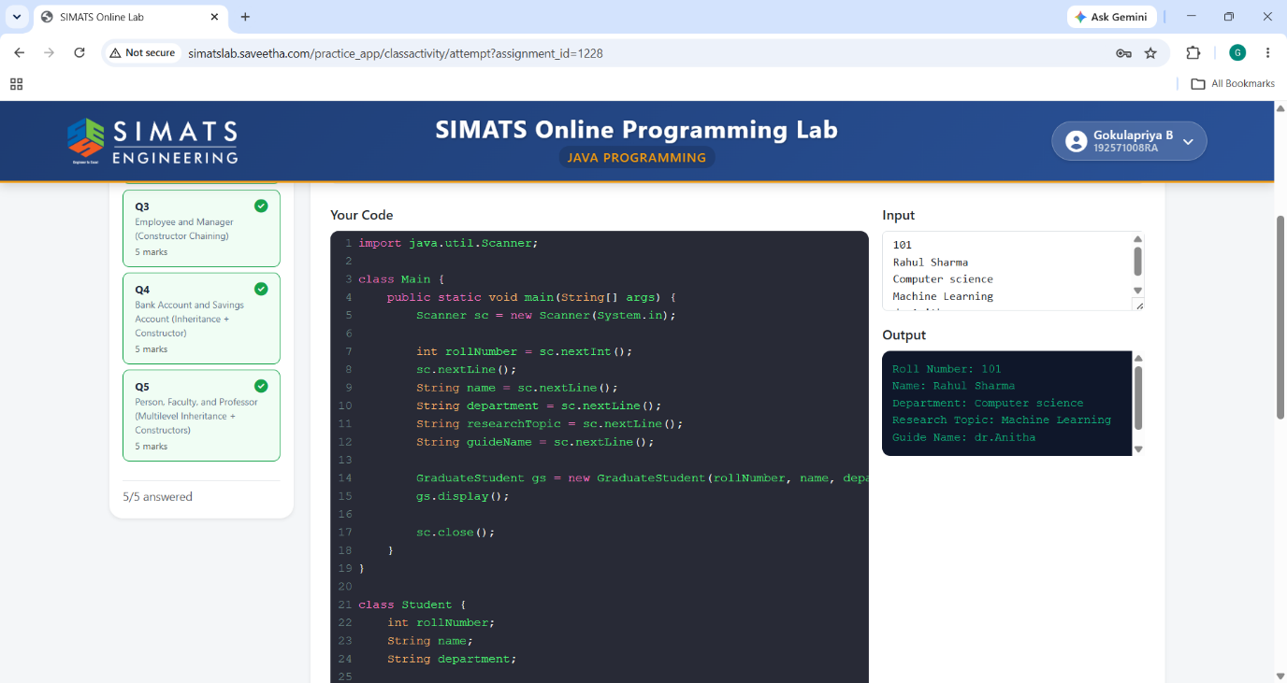

Q2:Vehicle and Eletric Vehicle
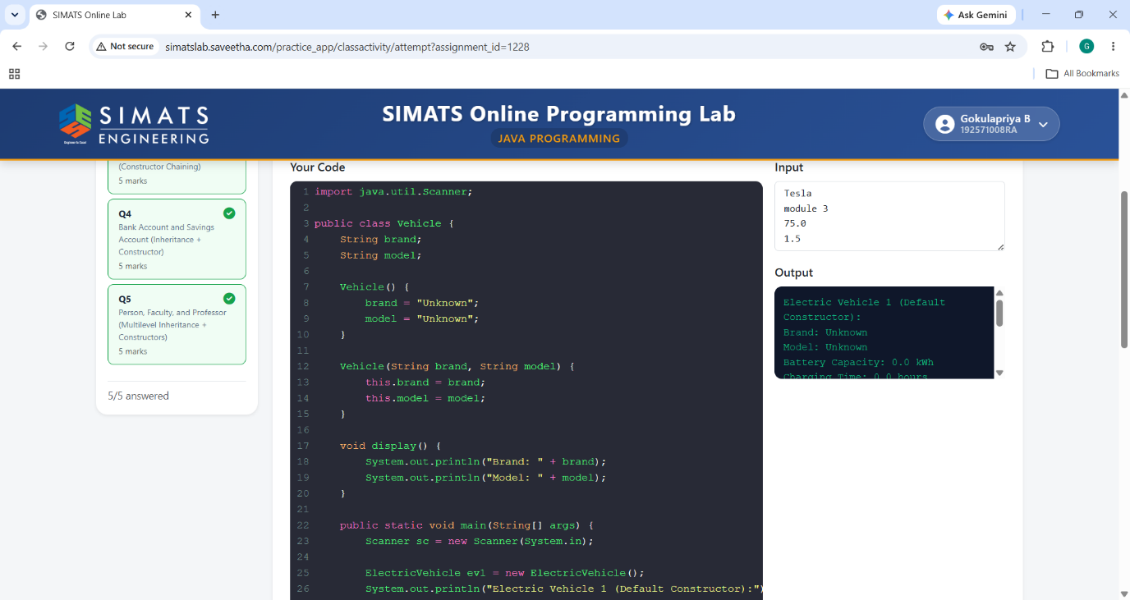

Q3:Employee and Manager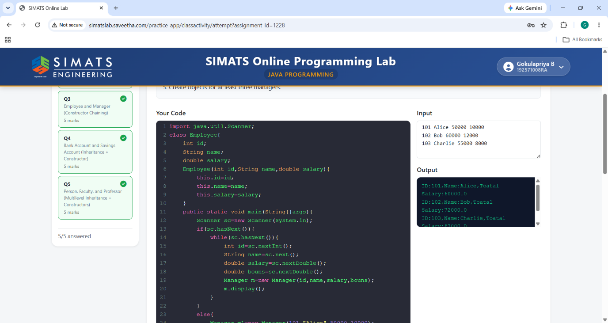

Q4:Bank Account and Savings Account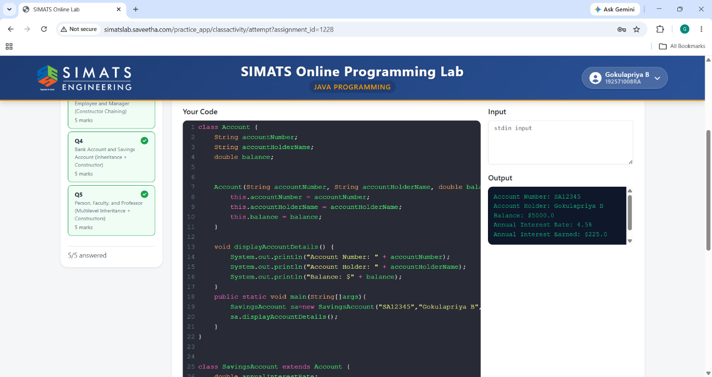

Q5:Person,Faculty,Professor