CO4_AT2 LABORATORY PERFORMANCE
Q1:Simple Applet Development
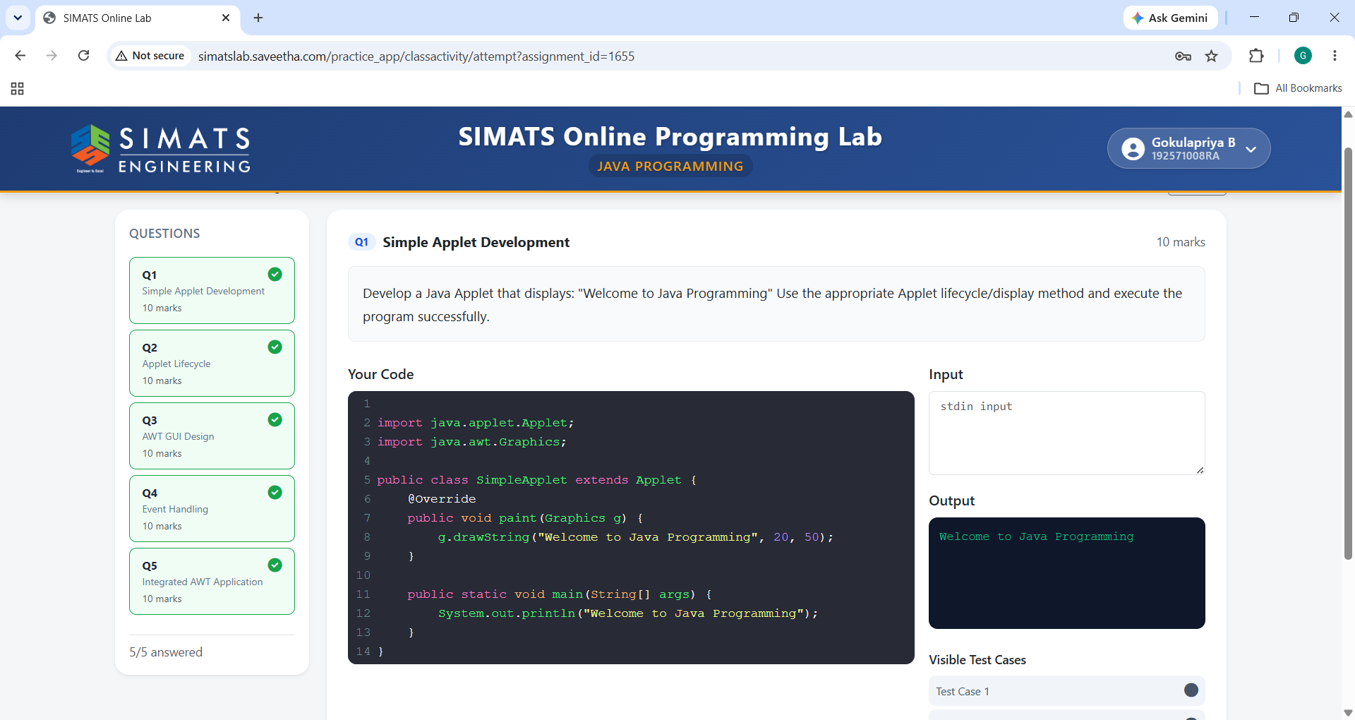

Q2:Applet Lifecycle
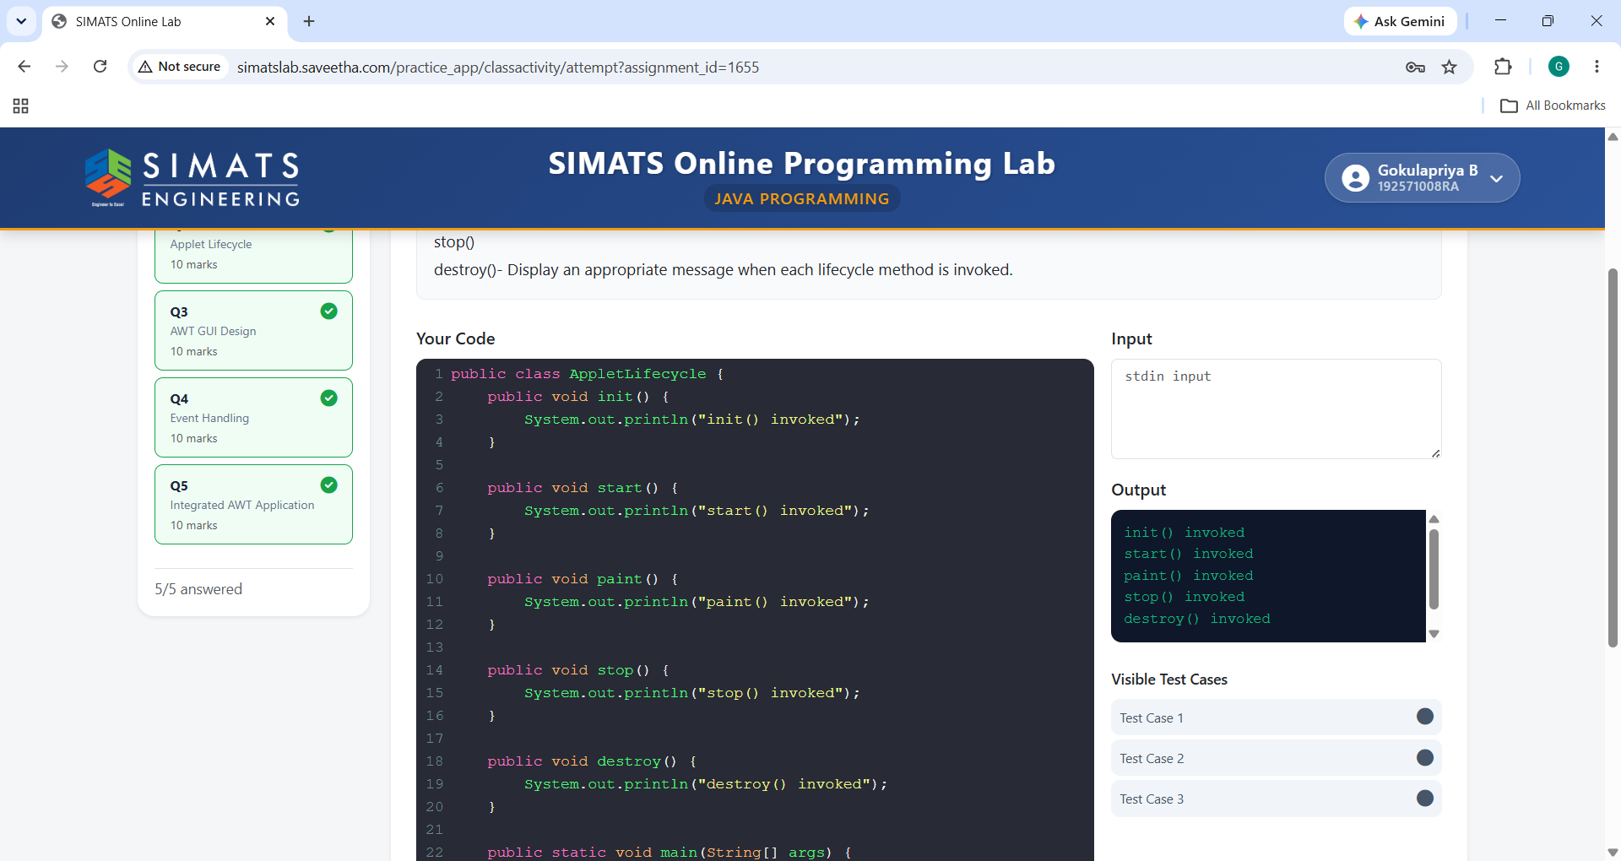

Q3:AWT GUL Design
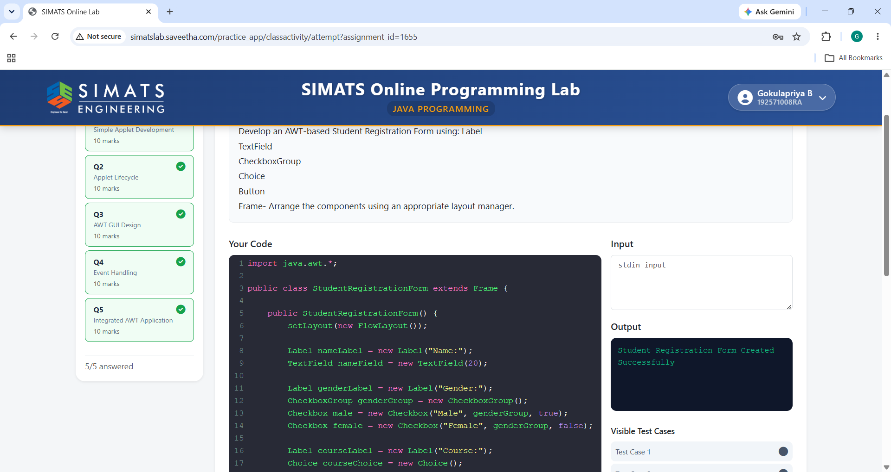

Q4:Event Handling
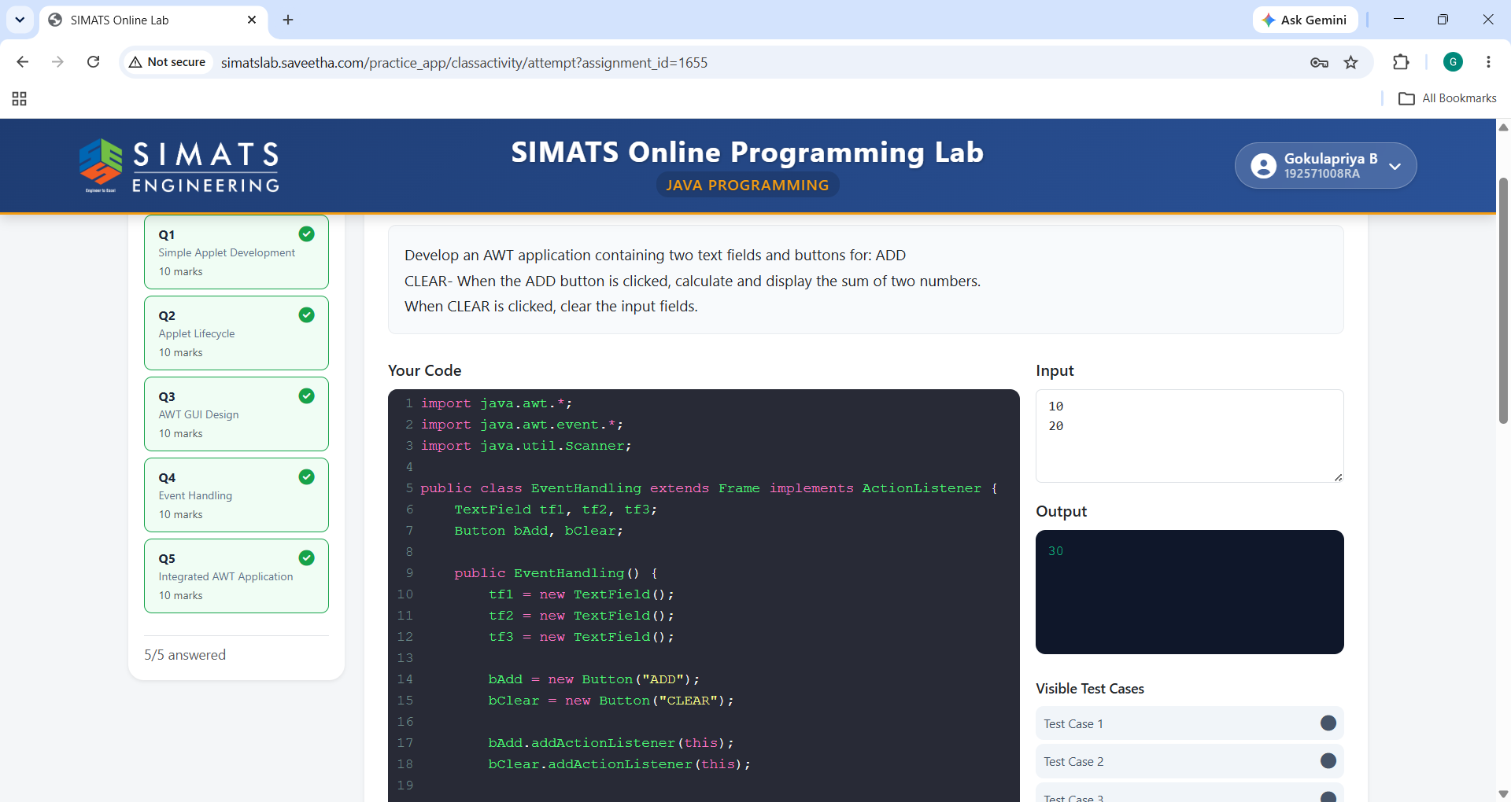

Q5:Integrated AWT Application
