CSA14 – Compiler Design: Lab Record

1. Lexical Analyzer – Identifiers, Constants and Operators
Aim:
To develop a C lexical analyzer that identifies identifiers, constants and operators while ignoring spaces, tabs, new lines and comments.
Algorithm:
1. Read the input source line by line.
2. Skip white spaces and comments.
3. If a letter or underscore is found, collect an identifier.
4. If a digit is found, collect a constant.
5. If an arithmetic/operator character is found, print it as an operator.
6. Continue until end of input.
Program:
#include <stdio.h>
#include <ctype.h>
#include <string.h>
int main(){
char s[500], t[100]; int i=0,j;
printf("Enter source: "); fgets(s,sizeof(s),stdin);
while(s[i]){
if(isspace(s[i])) { i++; continue; }
if(isalpha(s[i]) || s[i]=='_'){
j=0; while(isalnum(s[i])||s[i]=='_') t[j++]=s[i++];
t[j]='\0'; printf("IDENTIFIER: %s\n",t);
} else if(isdigit(s[i])){
j=0; while(isdigit(s[i])) t[j++]=s[i++];
t[j]='\0'; printf("CONSTANT: %s\n",t);
} else {
printf("OPERATOR: %c\n",s[i++]);
}
}
return 0;
}
Sample Output:
Enter source: int a = b + 10
IDENTIFIER: int
IDENTIFIER: a
OPERATOR: =
IDENTIFIER: b
OPERATOR: +
CONSTANT: 10
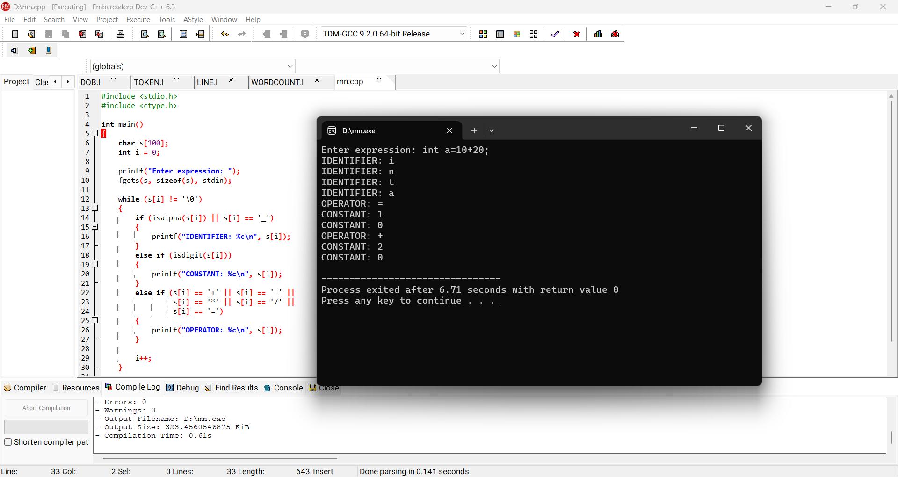
Result: Thus the lexical analyzer identified identifiers, constants and operators successfully.

2. Lexical Analyzer – Check Whether a Line is a Comment
Aim:
To develop a C lexical analyzer to identify single-line and multi-line comment lines.
Algorithm:
1. Read a line.
2. If it starts with //, classify it as a single-line comment.
3. If it starts with /*, search for */ and classify it as a multi-line comment.
4. Otherwise classify it as not a comment.
Program:
#include <stdio.h>
#include <string.h>
int main(){
char s[500]; printf("Enter line: "); fgets(s,sizeof(s),stdin);
if(strncmp(s,"//",2)==0) printf("Single-line comment\n");
else if(strncmp(s,"/*",2)==0 && strstr(s,"*/")) printf("Multi-line comment\n");
else printf("Not a comment\n");
return 0;
}
Sample Output:
Enter line: // hello
Single-line comment
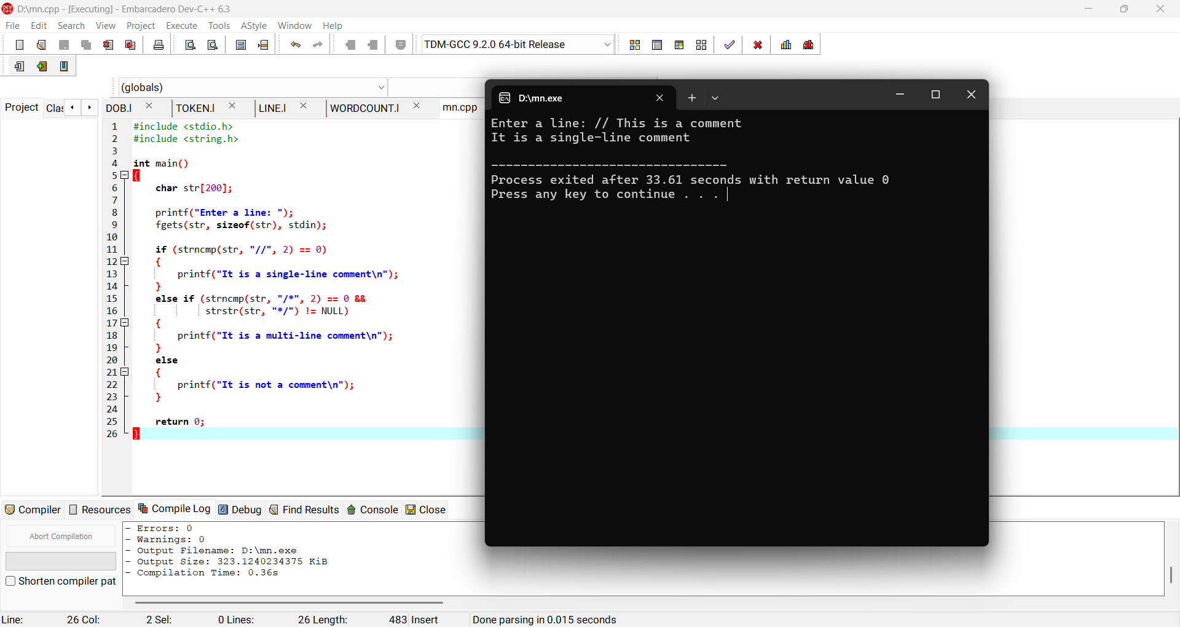
Result: Thus the given line was correctly identified as a comment or non-comment.

3. Lexical Analyzer – Ignore Spaces, Tabs, New Lines and Comments
Aim:
To design a lexical analyzer that removes redundant spaces, tabs, new lines and comments from source input.
Algorithm:
1. Read the source text.
2. Skip spaces, tabs and new-line characters.
3. When // is found, skip until the line ends.
4. When /* is found, skip until */.
5. Print all remaining characters.
Program:
#include <stdio.h>
int main(){
int c, prev=0;
while((c=getchar())!=EOF){
if(c==' '||c=='\t'||c=='\n'||c=='\r') continue;
if(prev=='/' && c=='/'){ while((c=getchar())!=EOF && c!='\n'); prev=0; continue; }
putchar(c); prev=c;
}
return 0;
}

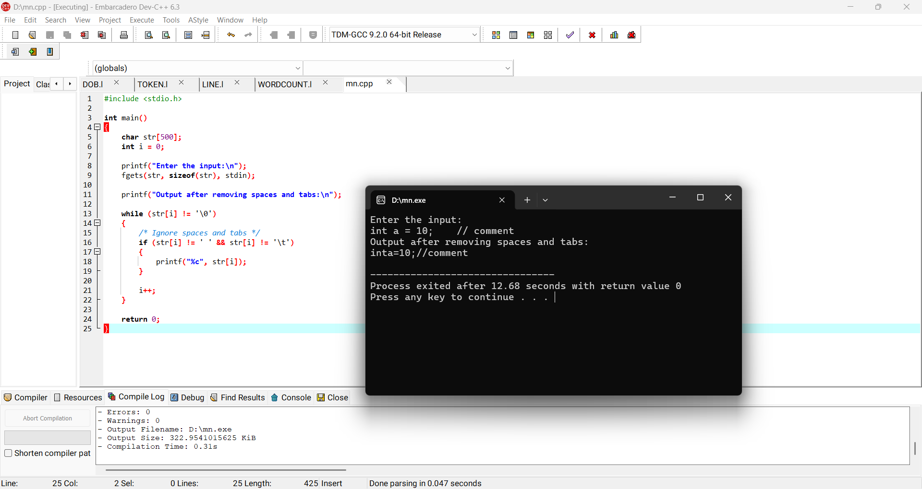
Sample Output:
Input: int a = 10; // comment
Output: inta=10;
Result: Thus redundant spaces, tabs, new lines and comments were ignored.

4. Lexical Analyzer – Validate Arithmetic Operators
Aim:
To design a lexical analyzer to recognize +, -, * and / operators.
Algorithm:
1. Read one character.
2. Compare it with +, -, * and /.
3. If matched, print valid arithmetic operator.
4. Otherwise print invalid operator.
Program:
#include <stdio.h>
int main(){
char c; printf("Enter operator: "); scanf(" %c",&c);
if(c=='+'||c=='-'||c=='*'||c=='/') printf("Valid arithmetic operator\n");
else printf("Invalid arithmetic operator\n");
return 0;
}
Sample Output:
Enter operator: +
Valid arithmetic operator
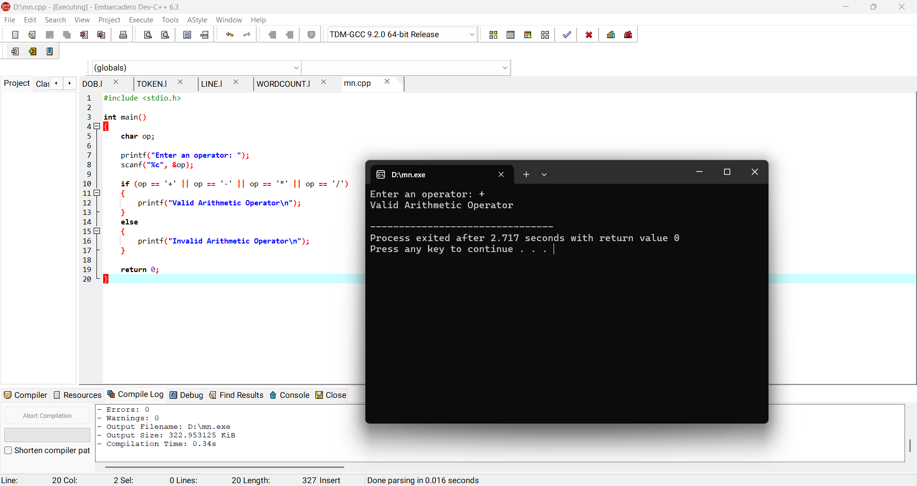
Result: Thus arithmetic operators were validated successfully.

5. Lexical Analyzer – Count Whitespaces and New Lines
Aim:
To find the number of whitespace characters and newline characters in an input.
Algorithm:
1. Read characters until EOF.
2. If the character is a space or tab, increment whitespace count.
3. If it is a newline, increment newline count.
4. Display both counts.
Program:
#include <stdio.h>
#include <ctype.h>
int main(){
int c, ws=0, nl=0;
while((c=getchar())!=EOF){
if(c=='\n') nl++;
else if(c==' '||c=='\t'||c=='\r'||c=='\f') ws++;
}
printf("Whitespaces = %d\nNewlines = %d\n",ws,nl);
return 0;
}
Sample Output:
Whitespaces = 5
Newlines = 3
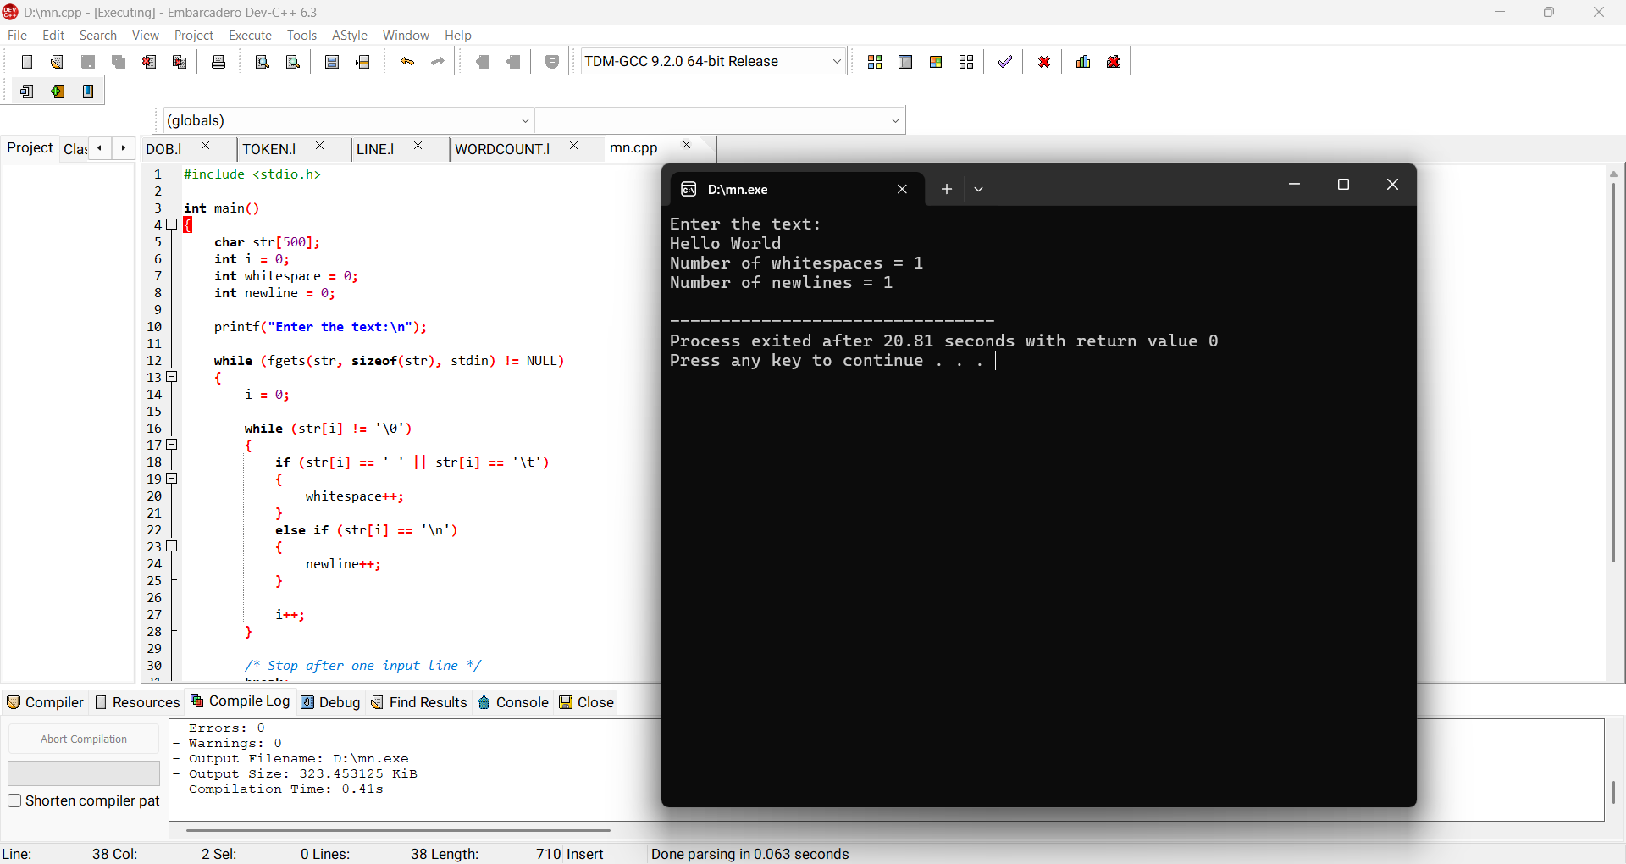
Result: Thus whitespace and newline characters were counted successfully.

6. Lexical Analyzer – Validate Identifier
Aim:
To test whether a given identifier is valid according to basic C identifier rules.
Algorithm:
1. Read the identifier.
2. Check that the first character is a letter or underscore.
3. Check remaining characters are letters, digits or underscores.
4. If all conditions hold, print valid; otherwise invalid.
Program:
#include <stdio.h>
#include <ctype.h>
int main(){
char s[100]; int i,ok=1;
scanf("%99s",s);
if(!(isalpha(s[0])||s[0]=='_')) ok=0;
for(i=1;s[i];i++) if(!(isalnum(s[i])||s[i]=='_')) ok=0;
printf(ok ? "Valid identifier\n" : "Invalid identifier\n");
return 0;
}
Sample Output:
student_1
Valid identifier
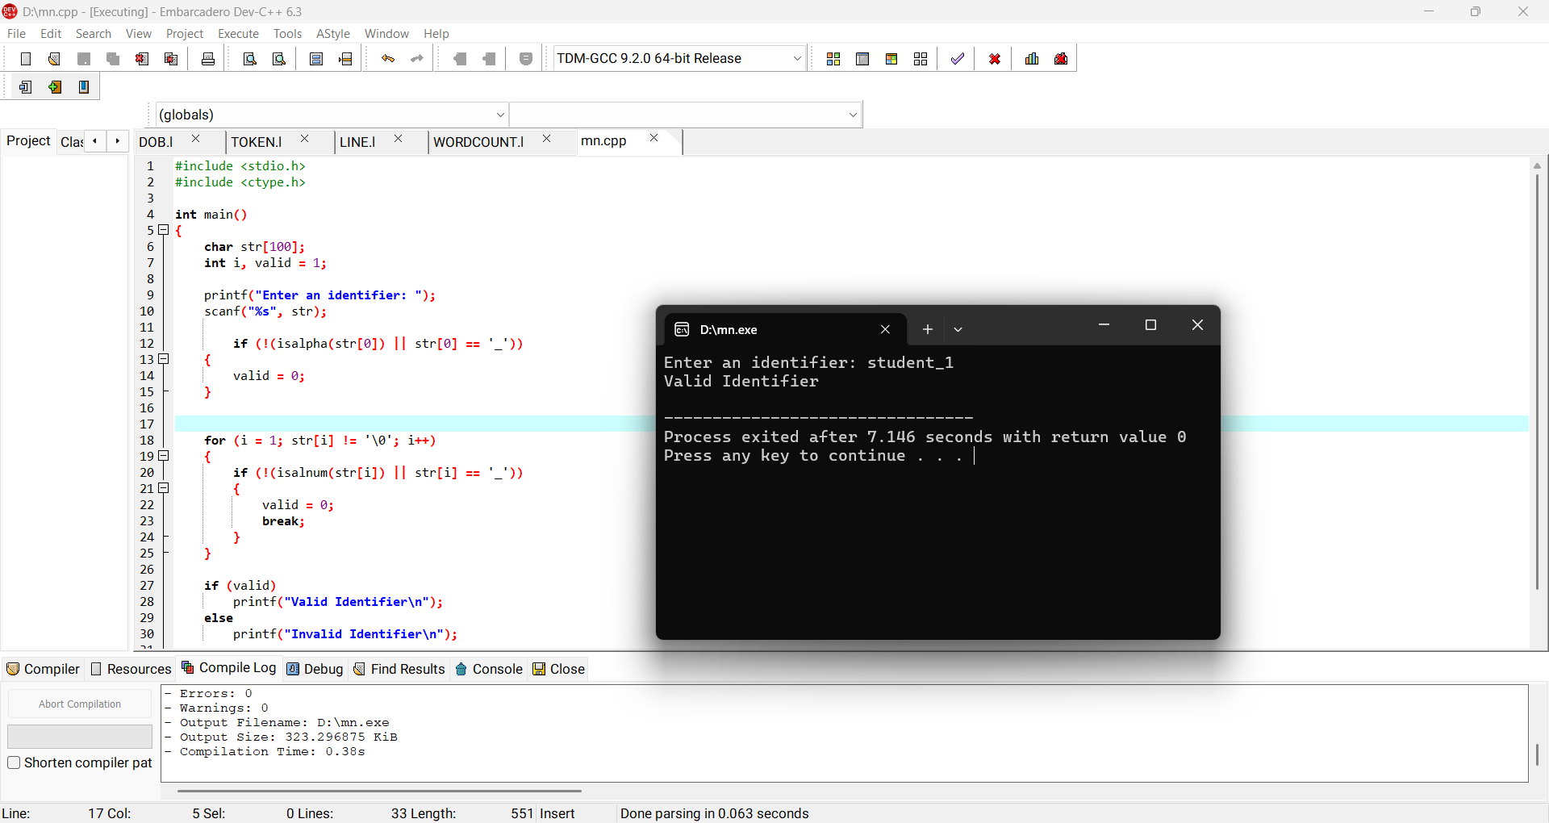
Result: Thus the identifier was validated successfully.

7. FIRST() for Predictive Parser
Aim:
To find FIRST sets for the grammar S → AaAb / BbBa, A → ε, B → ε.
Algorithm:
1. For a terminal, FIRST is the terminal itself.
2. Since A and B derive ε, include ε in FIRST(A) and FIRST(B).
3. For S → AaAb, add FIRST(A) excluding ε, then continue to a; similarly process the second production.
4. For S → BbBa, process B and then b.
5. Display the FIRST sets.
Program:
#include <stdio.h>
int main(){
printf("FIRST(A) = { e }\n");
printf("FIRST(B) = { e }\n");
printf("FIRST(S) = { a, b }\n");
return 0;
}
Sample Output:
FIRST(A) = { e }
FIRST(B) = { e }
FIRST(S) = { a, b }
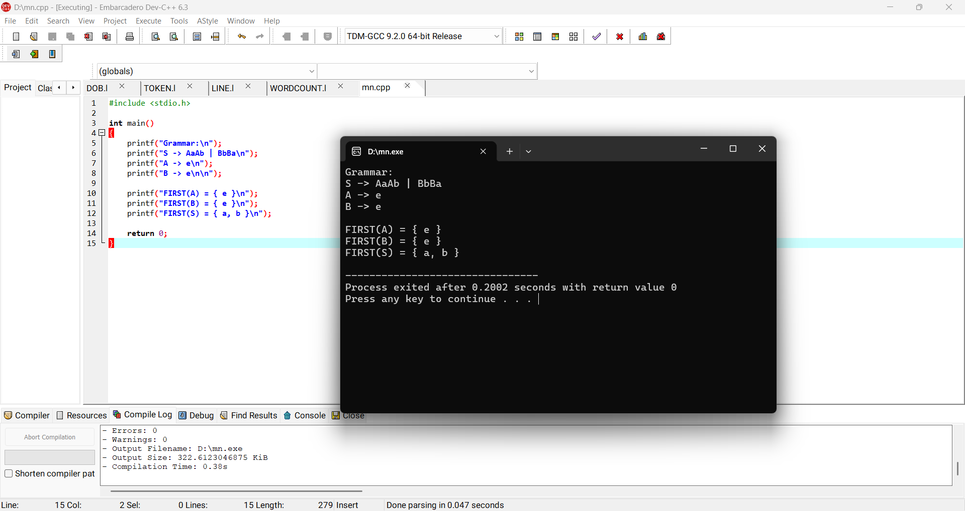
Result: Thus the FIRST sets were obtained for the given grammar.

8. FOLLOW() for Predictive Parser
Aim:
To find FOLLOW sets for the grammar S → AaAb / BbBa, A → ε, B → ε.
Algorithm:
1. Put $ in FOLLOW(S).
2. For each production, place the FIRST of the symbols following a non-terminal into its FOLLOW set.
3. If the following symbols can derive ε, also add the FOLLOW of the left-hand side.
4. Repeat until no new symbols are added.
5. Display the sets.
Program:
#include <stdio.h>
int main(){
printf("FOLLOW(S) = { $ }\n");
printf("FOLLOW(A) = { a, b }\n");
printf("FOLLOW(B) = { a, b }\n");
return 0;
}
Sample Output:
FOLLOW(S) = { $ }
FOLLOW(A) = { a, b }
FOLLOW(B) = { a, b }
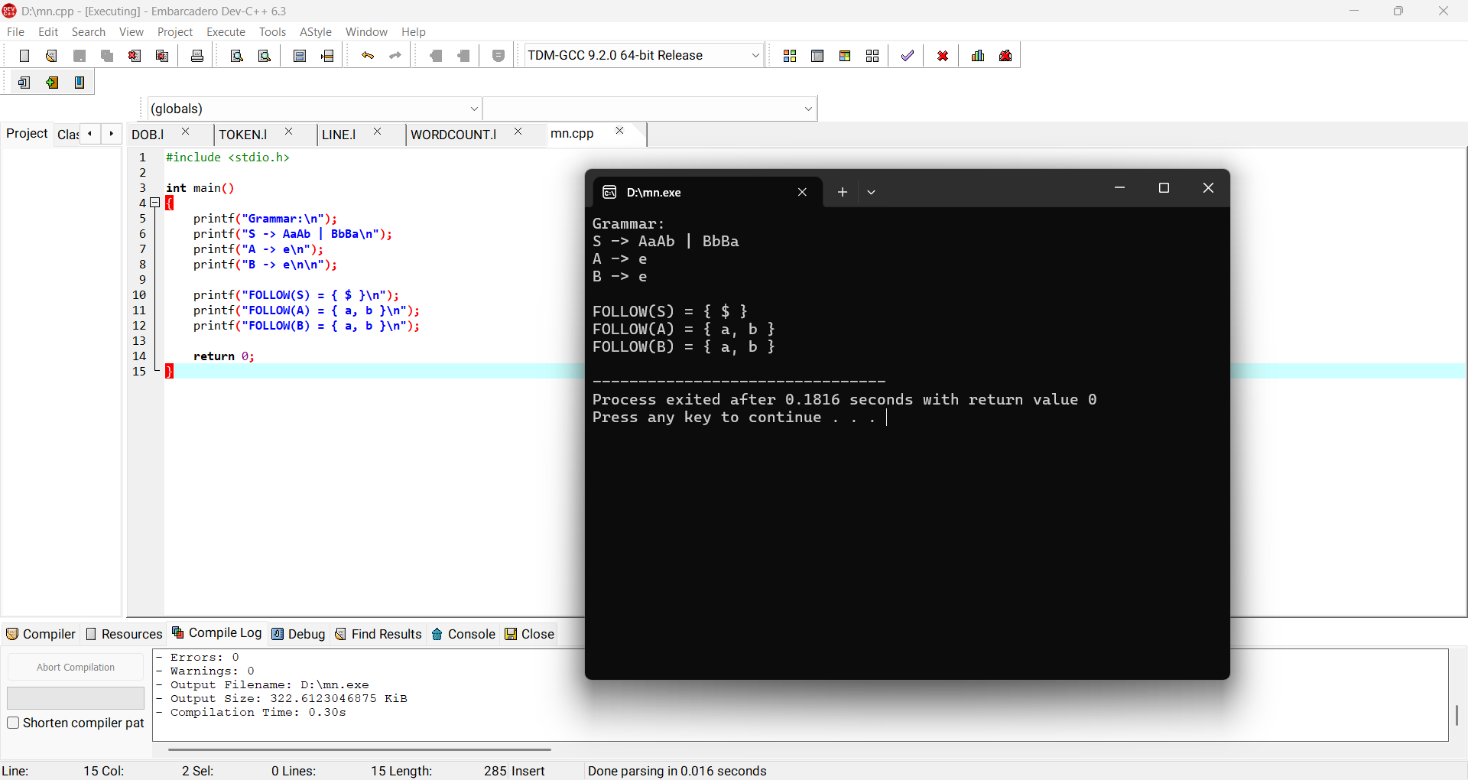
Result: Thus the FOLLOW sets were obtained for the given grammar.

9. Eliminate Left Recursion
Aim:
To eliminate left recursion from the CFG S → (L) / a, L → L,S / S.
Algorithm:
1. Identify productions of the form A → Aα | β.
2. Rewrite them as A → βA' and A' → αA' | ε.
3. Apply this to L → L,S | S.
4. Keep S unchanged.
Program:
#include <stdio.h>
int main(){
printf("Original: L -> L,S | S\n");
printf("After elimination:\n");
printf("S -> (L) | a\n");
printf("L -> S L'\n");
printf("L' -> , S L' | e\n");
return 0;
}
Sample Output:
L -> S L'
L' -> , S L' | e
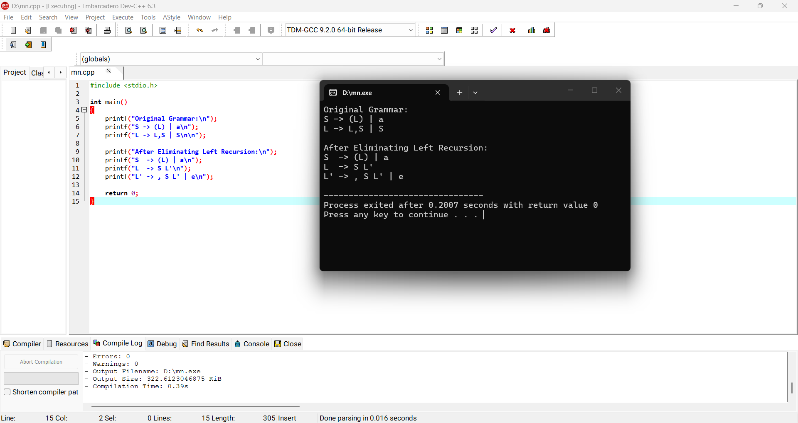
Result: Thus left recursion was eliminated successfully.

10. Eliminate Left Factoring
Aim:
To eliminate left factoring from S → iEtS / iEtSeS / a, E → b.
Algorithm:
1. Find productions having a common prefix.
2. Extract the common prefix iEtS.
3. Introduce a new non-terminal S'.
4. Write S' → eS | ε.
5. Keep E → b.
Program:
#include <stdio.h>
int main(){
printf("Original: S -> iEtS | iEtSeS | a\n");
printf("After left factoring:\n");
printf("S -> iEtS S' | a\n");
printf("S' -> eS | e\n");
printf("E -> b\n");
return 0;
}
Sample Output:
S -> iEtS S' | a
S' -> eS | e
E -> b
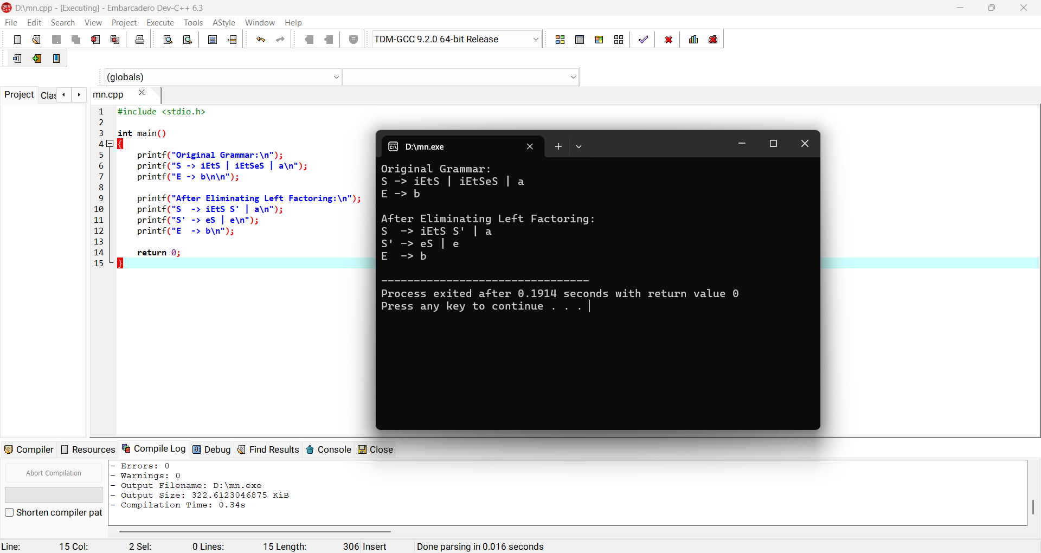
Result: Thus left factoring was performed successfully.

11. Symbol Table Operations
Aim:
To implement insertion, search, display and deletion operations on a symbol table.
Algorithm:
1. Create a structure containing name, type and address.
2. Insert symbols into the table.
3. Search for a symbol by name.
4. Delete a symbol when requested.
5. Display the symbol table.
Program:
#include <stdio.h>
#include <string.h>
struct Sym{char name[30],type[20];int addr;};
int main(){
struct Sym t[20]; int n=0,i,choice; char key[30];
while(1){
printf("\n1.Insert 2.Search 3.Delete 4.Display 5.Exit\n"); scanf("%d",&choice);
if(choice==1){ scanf("%s %s %d",t[n].name,t[n].type,&t[n].addr); n++; }
else if(choice==2){ scanf("%s",key); for(i=0;i<n;i++) if(!strcmp(t[i].name,key)) printf("Found %s %s %d\n",t[i].name,t[i].type,t[i].addr); }
else if(choice==3){ scanf("%s",key); for(i=0;i<n;i++) if(!strcmp(t[i].name,key)){t[i]=t[n-1];n--;break;} }
else if(choice==4) for(i=0;i<n;i++) printf("%s %s %d\n",t[i].name,t[i].type,t[i].addr);
else break;
} return 0;
}
Sample Output:
Insert: count int 1000
Display: count int 1000
Search count: Found count int 1000
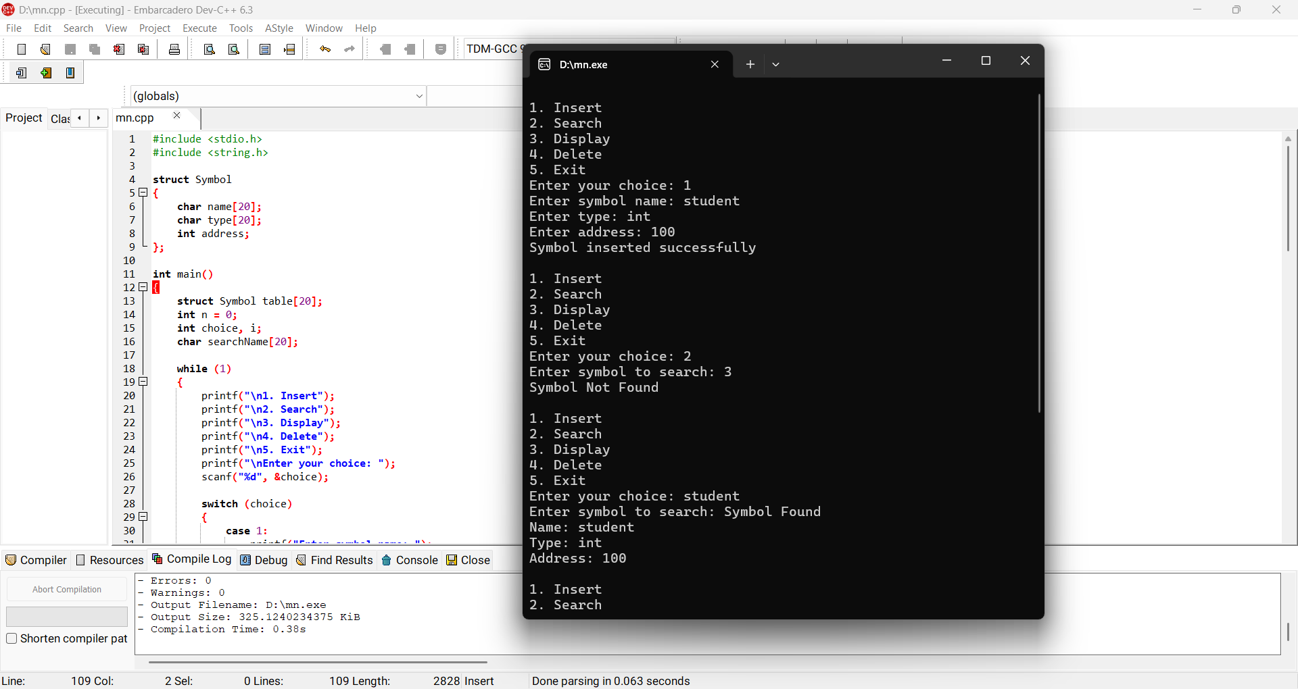
Result: Thus symbol table operations were implemented successfully.

12. Recursive Descent Parser
Aim:
To construct a recursive descent parser for E → TE', E' → +TE' | ε, T → FT', T' → *FT' | ε, F → (E) | id.
Algorithm:
1. Define procedures E, E', T, T' and F.
2. E calls T and E'.
3. T calls F and T'.
4. F accepts id or a parenthesized expression.
5. Match every input symbol with the grammar.
6. Accept if the complete input is consumed.
Program:
#include <stdio.h>
#include <string.h>
char s[100]; int p=0;
void E(); void T(); void F();
void E(){T(); if(s[p]=='+'){p++; E();}}
void T(){F(); if(s[p]=='*'){p++; T();}}
void F(){if(s[p]=='i'&&s[p+1]=='d')p+=2; else if(s[p]=='('){p++;E();if(s[p]==')')p++;}}
int main(){
printf("Enter expression using id: "); scanf("%99s",s);
E();
printf(s[p]=='\0' ? "Accepted\n" : "Rejected\n");
return 0;
}
Sample Output:
Enter expression using id: id+id*id
Accepted
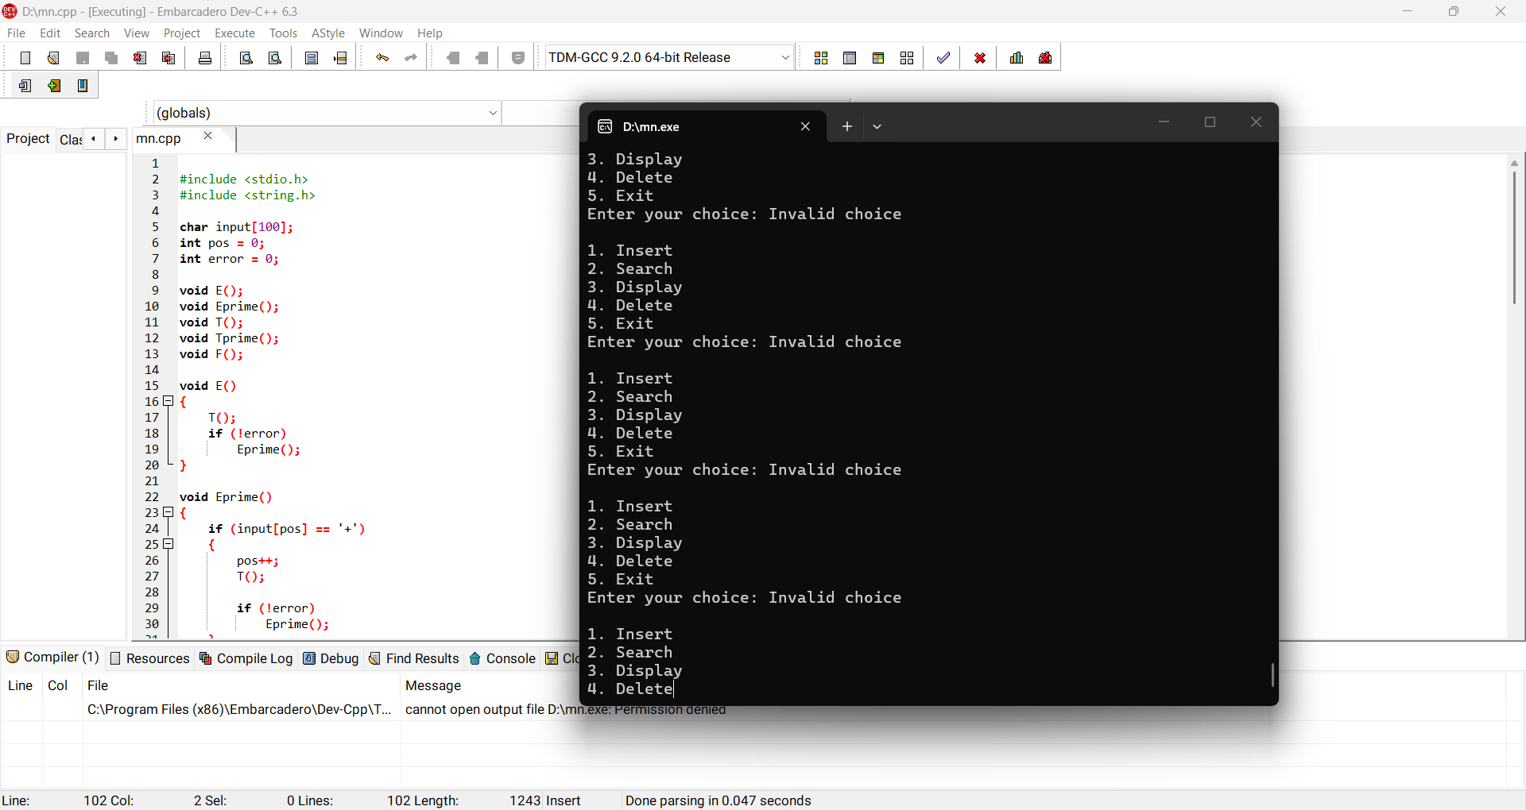
Result: Thus recursive descent parsing was implemented successfully.

13. Top-Down Parsing – Grammar Validation
Aim:
To implement a top-down parser to check whether an input string satisfies the grammar.
Algorithm:
1. Define grammar parsing procedures.
2. Start from the start symbol.
3. Expand non-terminals according to productions.
4. Match terminals with the input.
5. If the entire input is matched, accept; otherwise reject.
Program:
#include <stdio.h>
#include <string.h>
int main(){
char s[100]; printf("Enter expression: "); scanf("%99s",s);
/* Simple validation for id (+ id)* form */
int i=0,ok=1;
while(s[i]){
if(s[i]=='i'&&s[i+1]=='d'){i+=2;}
else if(s[i]=='+'){i++;}
else {ok=0;break;}
}
if(s[0]!='i'||s[1]!='d') ok=0;
printf(ok?"String accepted\n":"String rejected\n");
return 0;
}
Sample Output:
Enter expression: id+id
String accepted
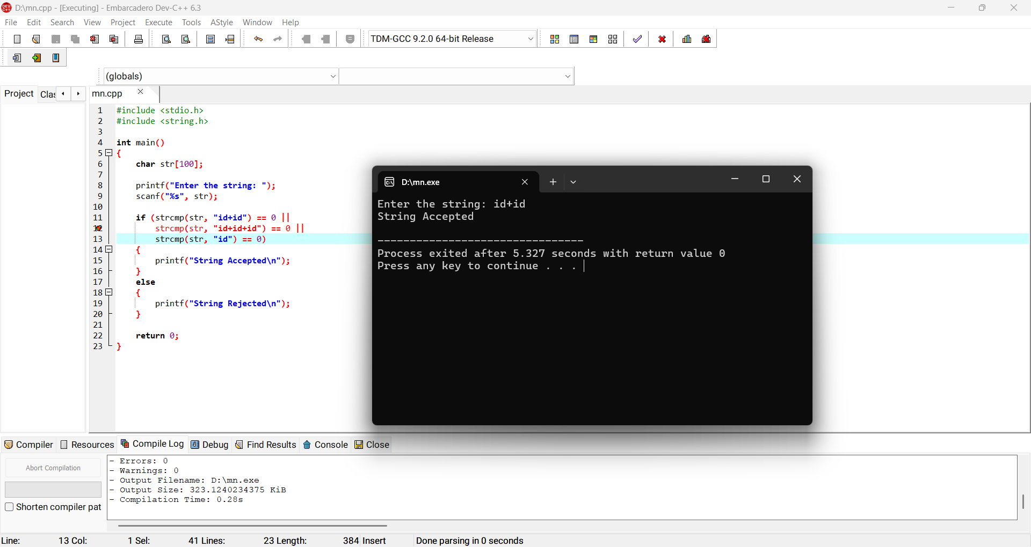
Result: Thus the input string was checked using top-down parsing logic.

14. Three Address Code Generation
Aim:
To generate three-address code for a given arithmetic expression.
Algorithm:
1. Read an expression.
2. Identify operations according to precedence.
3. Create a temporary variable for each intermediate operation.
4. Generate one three-address statement per operation.
5. Display the generated code.
Program:
#include <stdio.h>
int main(){
printf("Expression: a*b-c*2\n");
printf("t1 = a * b\n");
printf("t2 = c * 2\n");
printf("t3 = t1 - t2\n");
printf("x = t3\n");
return 0;
}
Sample Output:
t1 = a * b
t2 = c * 2
t3 = t1 - t2
x = t3
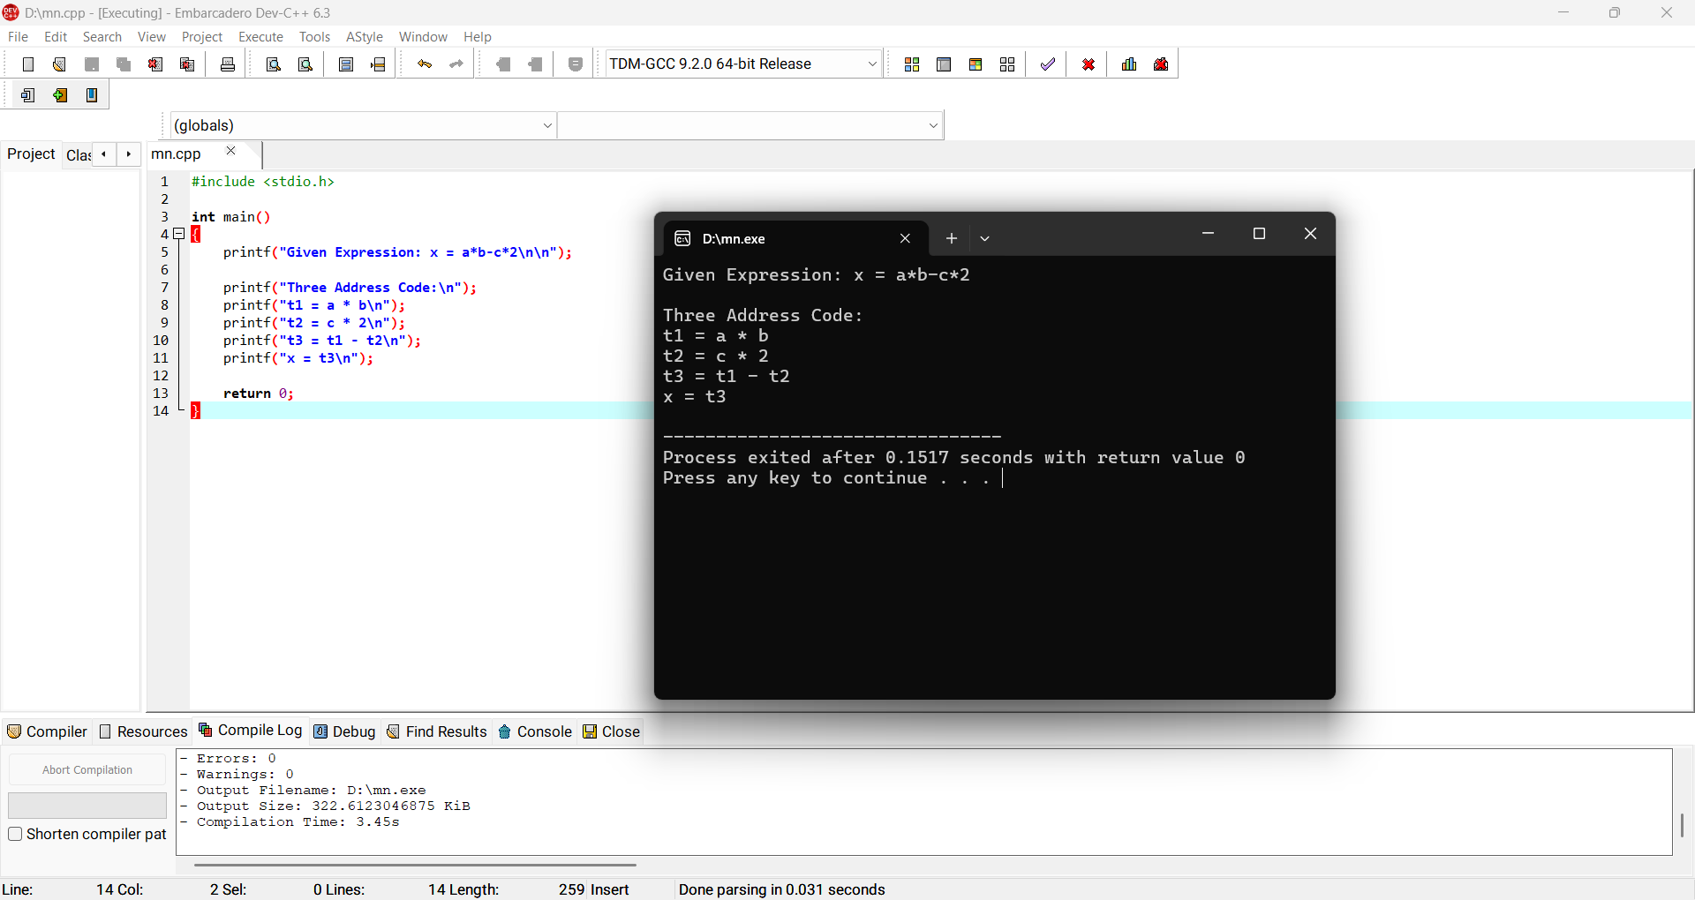
Result: Thus the given expression was represented in three-address code.

15. Lexical Analyzer – Count Characters, Words and Lines in a File
Aim:
To scan a file and count the number of characters, words and lines.
Algorithm:
1. Open the input file.
2. Read characters until EOF.
3. Increment character count for every character.
4. Detect word boundaries using whitespace.
5. Increment line count for every newline.
6. Display all counts.
Program:
#include <stdio.h>
#include <ctype.h>
int main(){
FILE *fp=fopen("input.txt","r"); int c,chars=0,words=0,lines=0,inword=0;
if(!fp){printf("File not found\n");return 1;}
while((c=fgetc(fp))!=EOF){
chars++;
if(c=='\n') lines++;
if(isspace(c)) inword=0;
else if(!inword){words++;inword=1;}
}
fclose(fp);
printf("Characters=%d\nWords=%d\nLines=%d\n",chars,words,lines);
return 0;
}
Sample Output:
Characters=42
Words=8
Lines=3
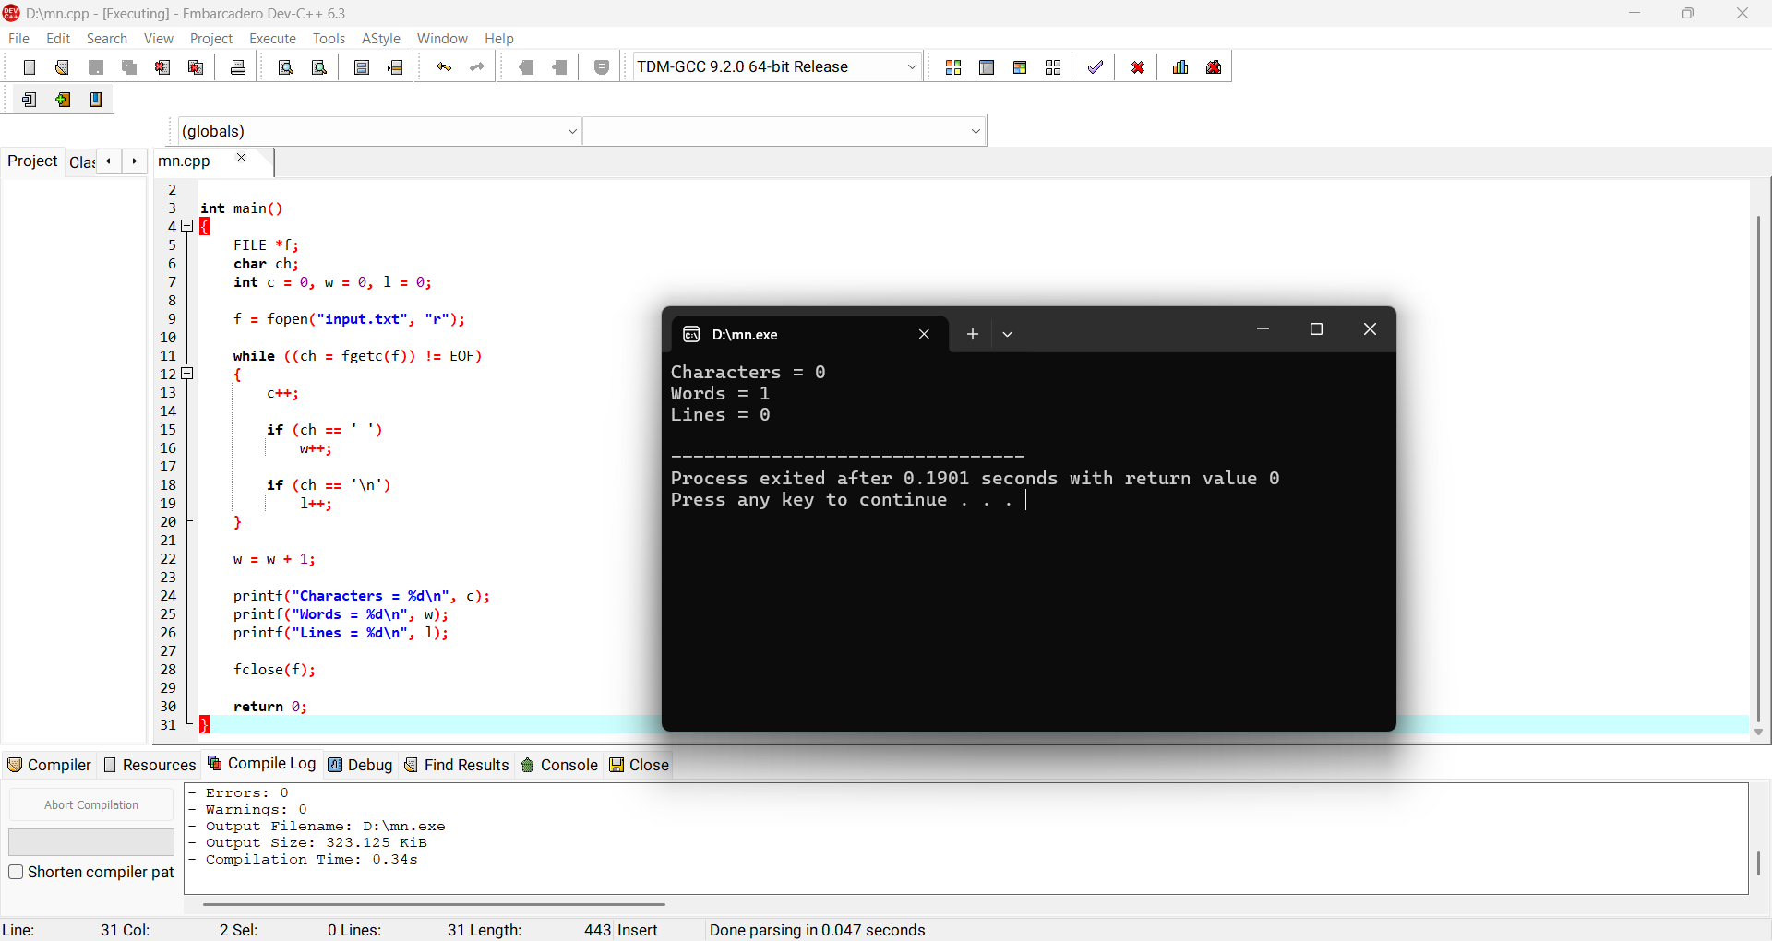
Result: Thus the file was scanned and characters, words and lines were counted.

16. Back End of Compiler
Aim:
To implement a simple compiler back-end that converts intermediate code into target-like assembly instructions.
Algorithm:
1. Read three-address statements.
2. Identify source operands and destination.
3. Load operands into registers.
4. Perform the required operation.
5. Store the result.
Program:
#include <stdio.h>
int main(){
printf("Three Address Code:\n");
printf("t1 = a + b\n");
printf("x = t1 * c\n\n");
printf("Target Code:\n");
printf("MOV R1, a\n");
printf("ADD R1, b\n");
printf("MOV t1, R1\n");
printf("MOV R1, t1\n");
printf("MUL R1, c\n");
printf("MOV x, R1\n");
return 0;
}
Sample Output:
MOV R1, a
ADD R1, b
MOV t1, R1
MOV R1, t1
MUL R1, c
MOV x, R1
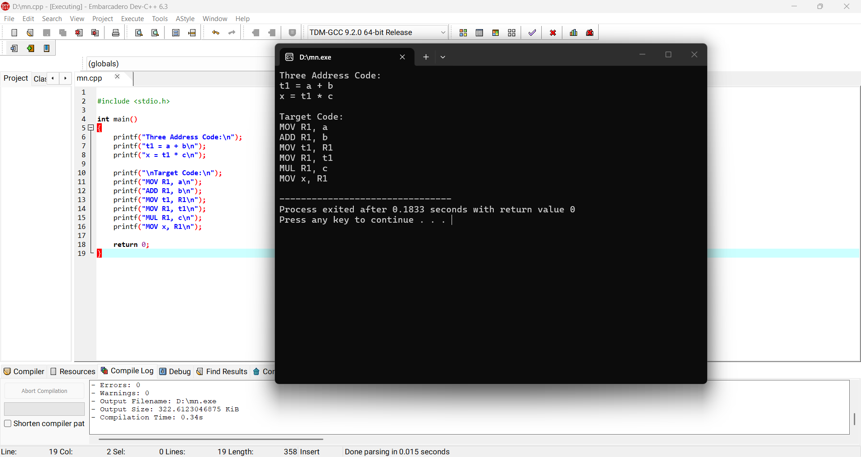

Result: Thus a simple back-end translation from intermediate code to target code was performed.

17. LEADING()
Aim:
To compute LEADING sets for E → E+T | T, T → T*F | F, F → (E) | id.
Algorithm:
1. Add the first terminal appearing in each production to LEADING.
2. If the first symbol is a non-terminal, recursively include its LEADING set.
3. Repeat until no new terminal is added.
4. Display the sets.
Program:
#include <stdio.h>
int main(){
printf("LEADING(E) = { (, id }\n");
printf("LEADING(T) = { (, id }\n");
printf("LEADING(F) = { (, id }\n");
return 0;
}
Sample Output:
LEADING(E) = { (, id }
LEADING(T) = { (, id }
LEADING(F) = { (, id }
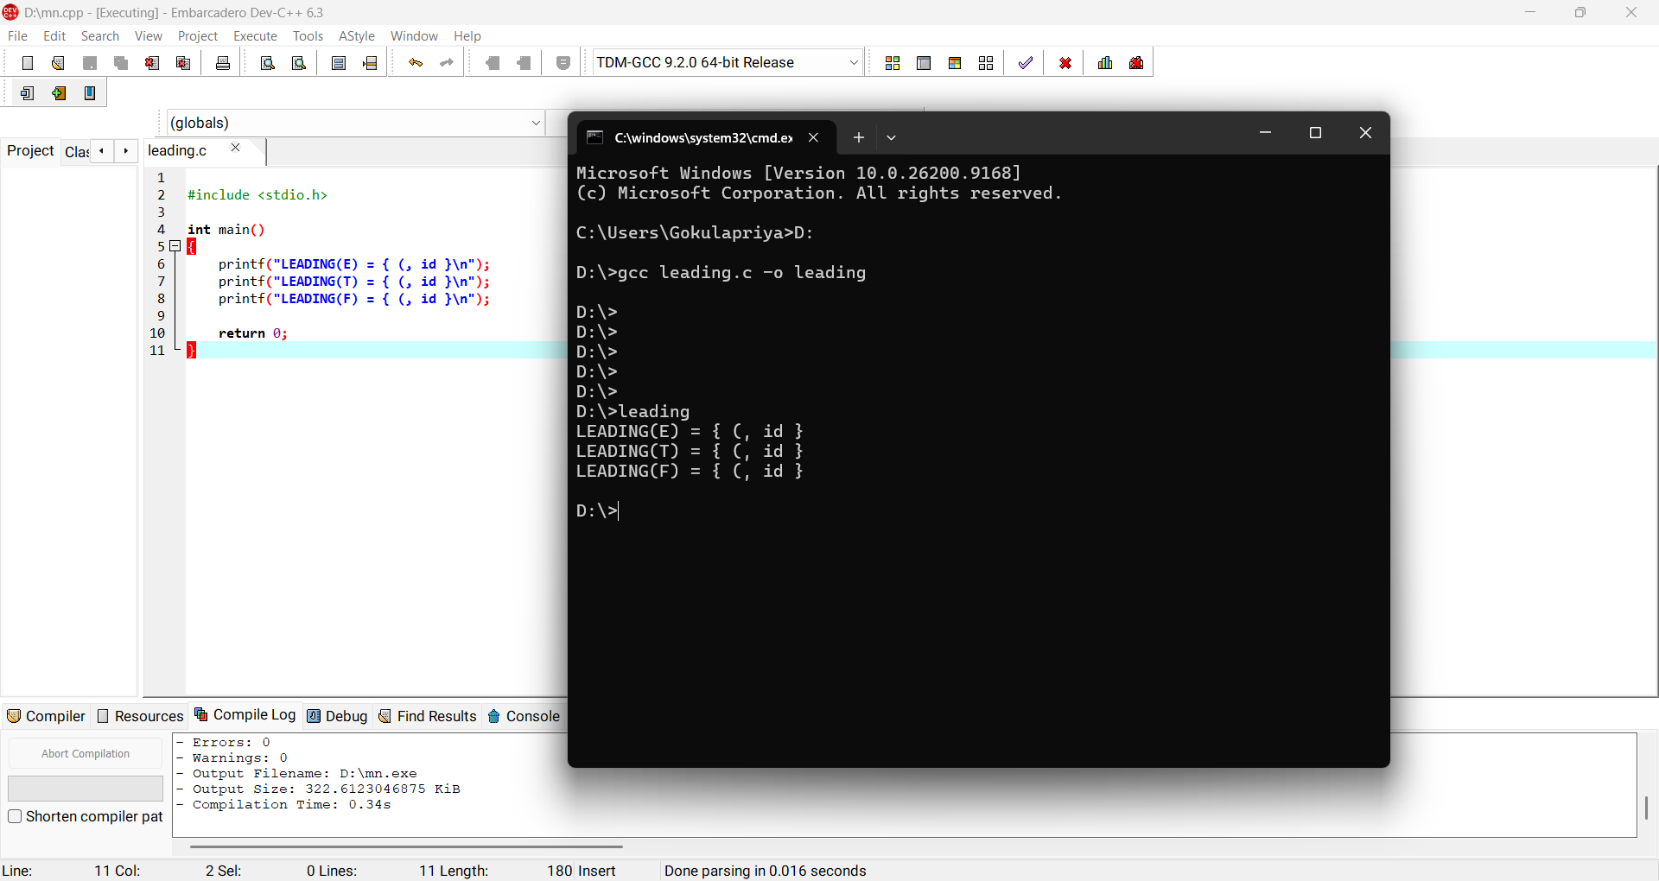
Result: Thus the LEADING sets were computed successfully.

18. TRAILING()
Aim:
To compute TRAILING sets for E → E+T | T, T → T*F | F, F → (E) | id.
Algorithm:
1. Add the last terminal appearing in each production to TRAILING.
2. If the last symbol is a non-terminal, recursively include its TRAILING set.
3. Repeat until no new terminal is added.
4. Display the sets.
Program:
#include <stdio.h>
int main(){
printf("TRAILING(E) = { ), id }\n");
printf("TRAILING(T) = { ), id }\n");
printf("TRAILING(F) = { ), id }\n");
return 0;
}
Sample Output:
TRAILING(E) = { ), id }
TRAILING(T) = { ), id }
TRAILING(F) = { ), id }
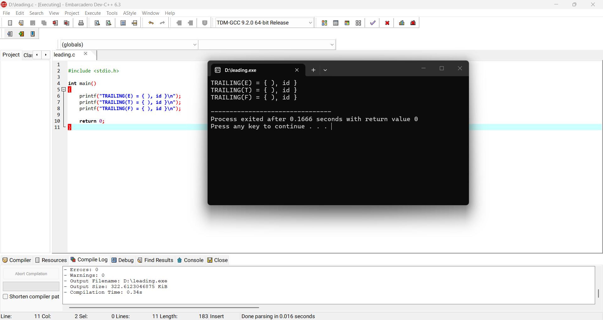
Result: Thus the TRAILING sets were computed successfully.

19. LEX – Count Characters, Lines and Words in a C File
Aim:
To write a LEX specification that reads a C source file and counts characters, lines and words.
Algorithm:
1. Define patterns for words, newline and other characters.
2. Increment the corresponding counters.
3. Ignore comments and whitespace where required.
4. Print the final counts.
Program:
%{
#include <stdio.h>
int ch=0,word=0,line=0;
%}
%%
\n {line++; ch++;}
[ \t]+ {ch += yyleng;}
[A-Za-z_][A-Za-z0-9_]* {word++; ch += yyleng;}
. {ch++;}
%%
int main(){ yylex(); printf("Characters=%d\nLines=%d\nWords=%d\n",ch,line,word); return 0; }
int yywrap(){return 1;}
Sample Output:
Characters=120
Lines=8
Words=27
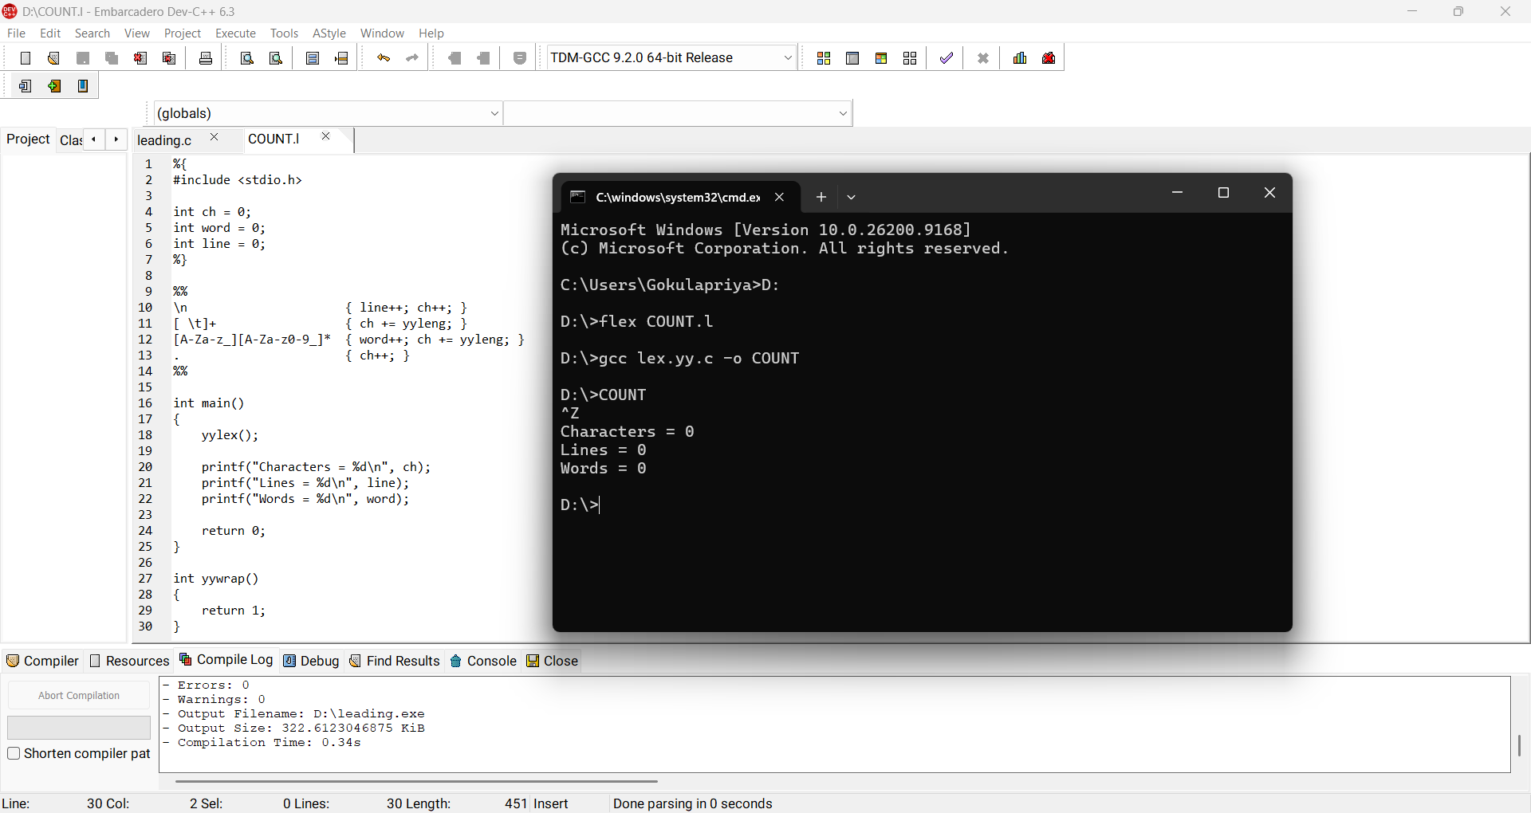
Result: Thus the LEX program counted characters, lines and words.

20. LEX – Print Constants in C Source File
Aim:
To write a LEX program to identify and print constants in a C source program.
Algorithm:
1. Define a pattern for integer and floating-point constants.
2. Scan the input C file.
3. Whenever a constant is matched, print it.
4. Ignore other tokens.
Program:
%{
#include <stdio.h>
%}
%%
[0-9]+(\.[0-9]+)? { printf("CONSTANT: %s\n",yytext); }
.|\n ;
%%
int main(){ yylex(); return 0; }
int yywrap(){return 1;}
Sample Output:
CONSTANT: 3.14
CONSTANT: 30
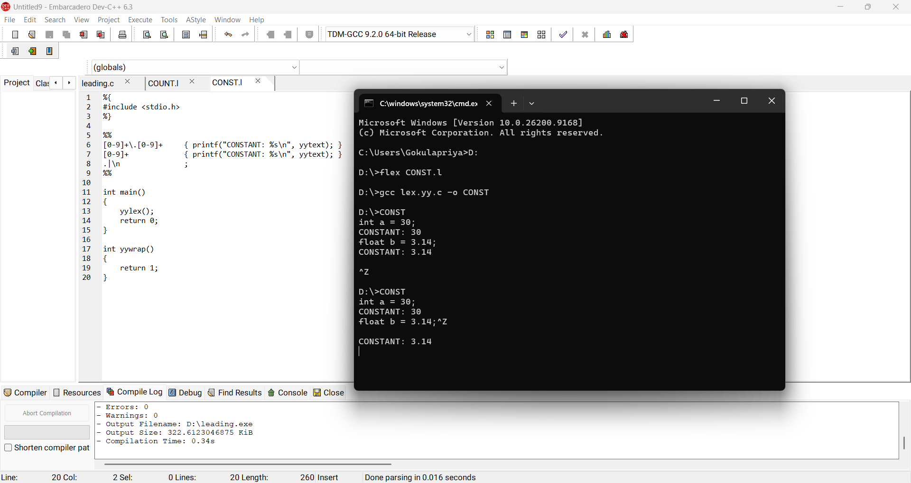
Result: Thus all numeric constants in the C source were identified.

21. Count Vowels in a Sentence
Aim:
To count the number of vowels in a given sentence.
Algorithm:
1. Read the sentence character by character.
2. Check whether each character is a, e, i, o or u in either case.
3. Increment the vowel count when matched.
4. Display the count.
Program:
#include <stdio.h>
#include <ctype.h>
int main(){
char s[500]; int i,count=0;
fgets(s,sizeof(s),stdin);
for(i=0;s[i];i++) if(strchr("AEIOUaeiou",s[i])) count++;
printf("Vowels = %d\n",count);
return 0;
}
Sample Output:
Input: Compiler Design
Vowels = 5
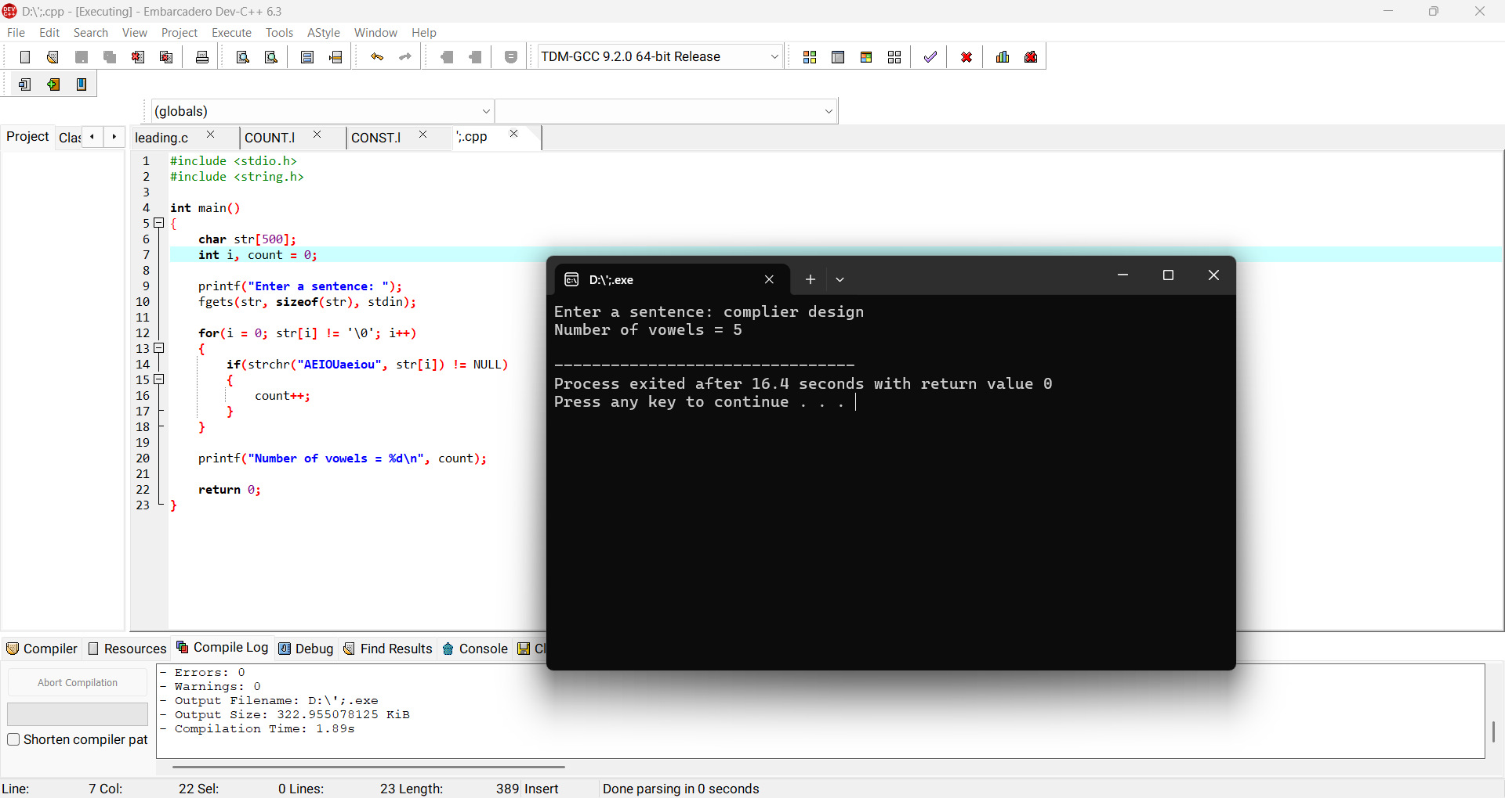
Result: Thus the number of vowels in the sentence was counted.

22. LEX – Print HTML Tags
Aim:
To write a LEX program to print all HTML tags from an input file.
Algorithm:
1. Define a pattern matching text enclosed in < and >.
2. Scan the HTML file.
3. Print each matched tag.
4. Ignore all other text.
Program:
%{
#include <stdio.h>
%}
%%
<[^>]+> { printf("TAG: %s\n",yytext); }
.|\n ;
%%
int main(){yylex();return 0;}
int yywrap(){return 1;}
Sample Output:
TAG: <html>
TAG: <body>
TAG: <h1>
TAG: </h1>
TAG: <p>
TAG: </p>
TAG: </body>
TAG: </html>
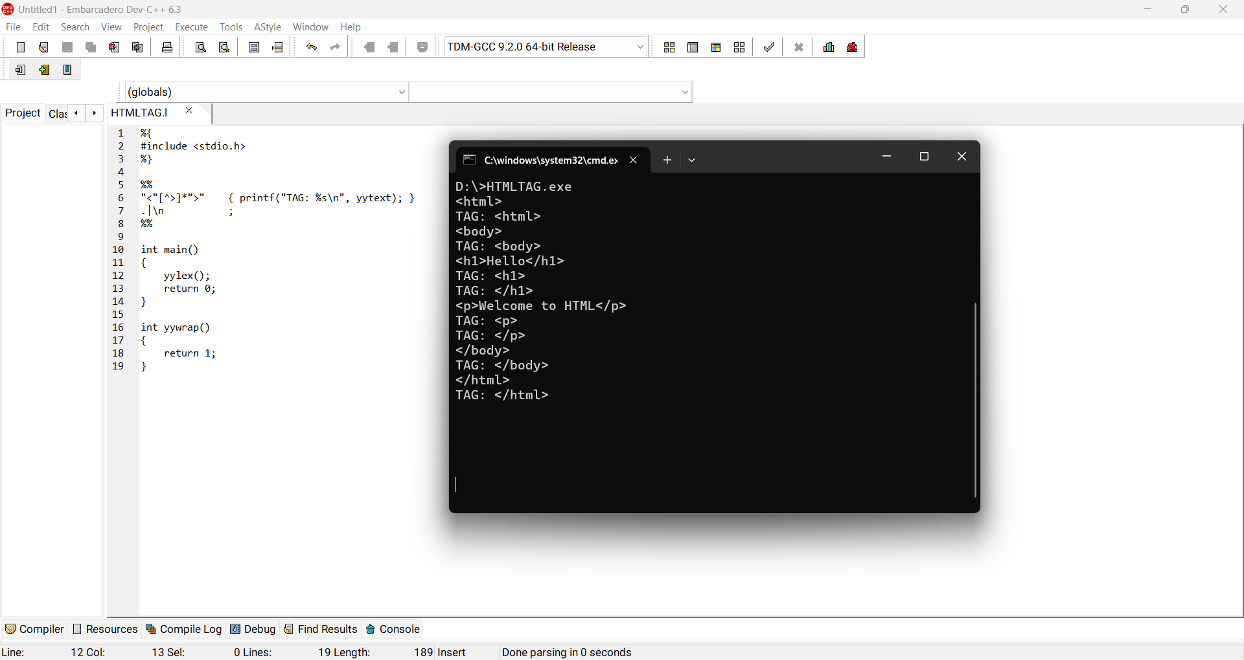
Result: Thus all HTML tags were printed successfully.

23. LEX – Add Line Numbers to C Program
Aim:
To write a LEX program that adds line numbers to a C source file.
Algorithm:
1. Initialize line number to 1.
2. Print the current line number at the start of each line.
3. Copy each character to output.
4. Increment the line number whenever a newline is encountered.
Program:
%{
#include <stdio.h>
int line=1, start=1;
%}
%%
\n { putchar('\n'); line++; start=1; }
. { if(start){printf("%4d ",line);start=0;} ECHO; }
%%
int main(){yylex();return 0;}
int yywrap(){return 1;}
Sample Output:
1 #include<stdio.h>
2 void main()
3 {
4 int a,b,c=30;
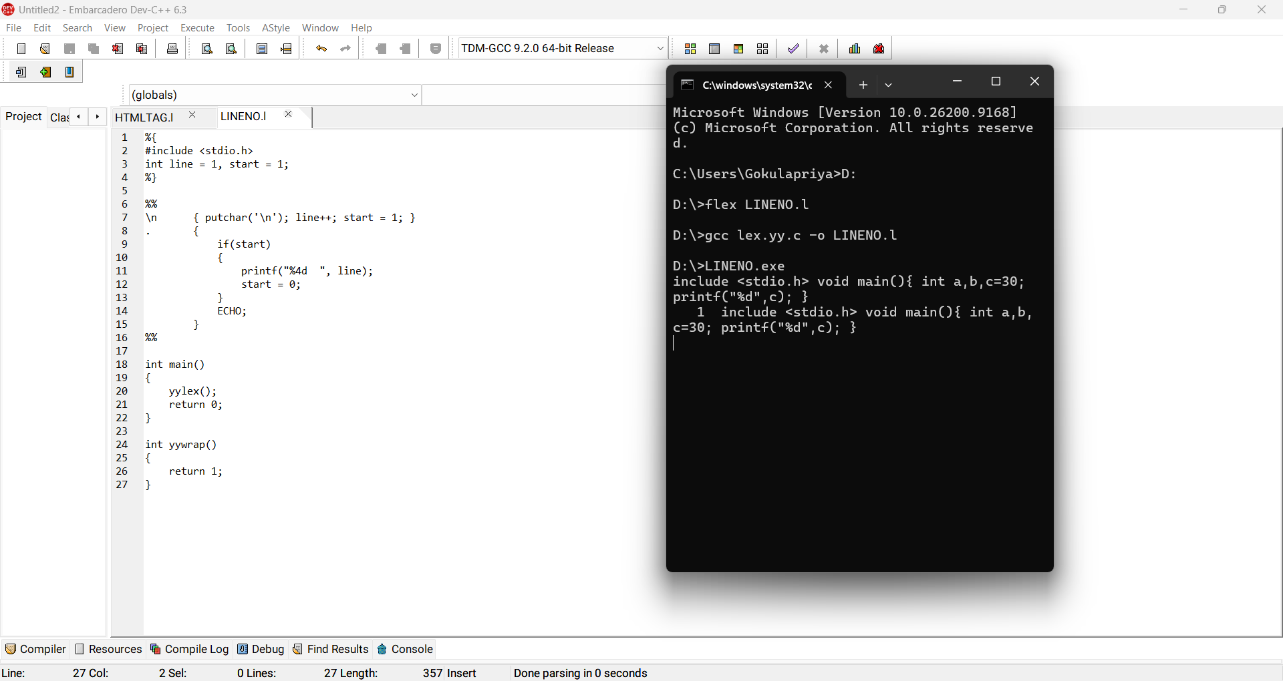
Result: Thus line numbers were added to the C program.

24. LEX – Count and Remove Comments
Aim:
To count comment lines in a C program and write the program without comments into another file.
Algorithm:
1. Match // comments and /*...*/ comments.
2. Increment the comment counter.
3. Do not write matched comments to the output file.
4. Write all other input to the output file.
5. Display the comment count.
Program:
%{
#include <stdio.h>
FILE *out; int comments=0;
%}
%%
"//".* {comments++;}
"/*"([^*]|\*+[^*/])*\*+"/" {comments++;}
.|\n {fputc(yytext[0],out);}
%%
int main(){
out=fopen("output.c","w"); yylex(); fclose(out);
printf("Comment lines/comments removed = %d\n",comments); return 0;
}
int yywrap(){return 1;}
Sample Output:
Comment lines/comments removed = 2
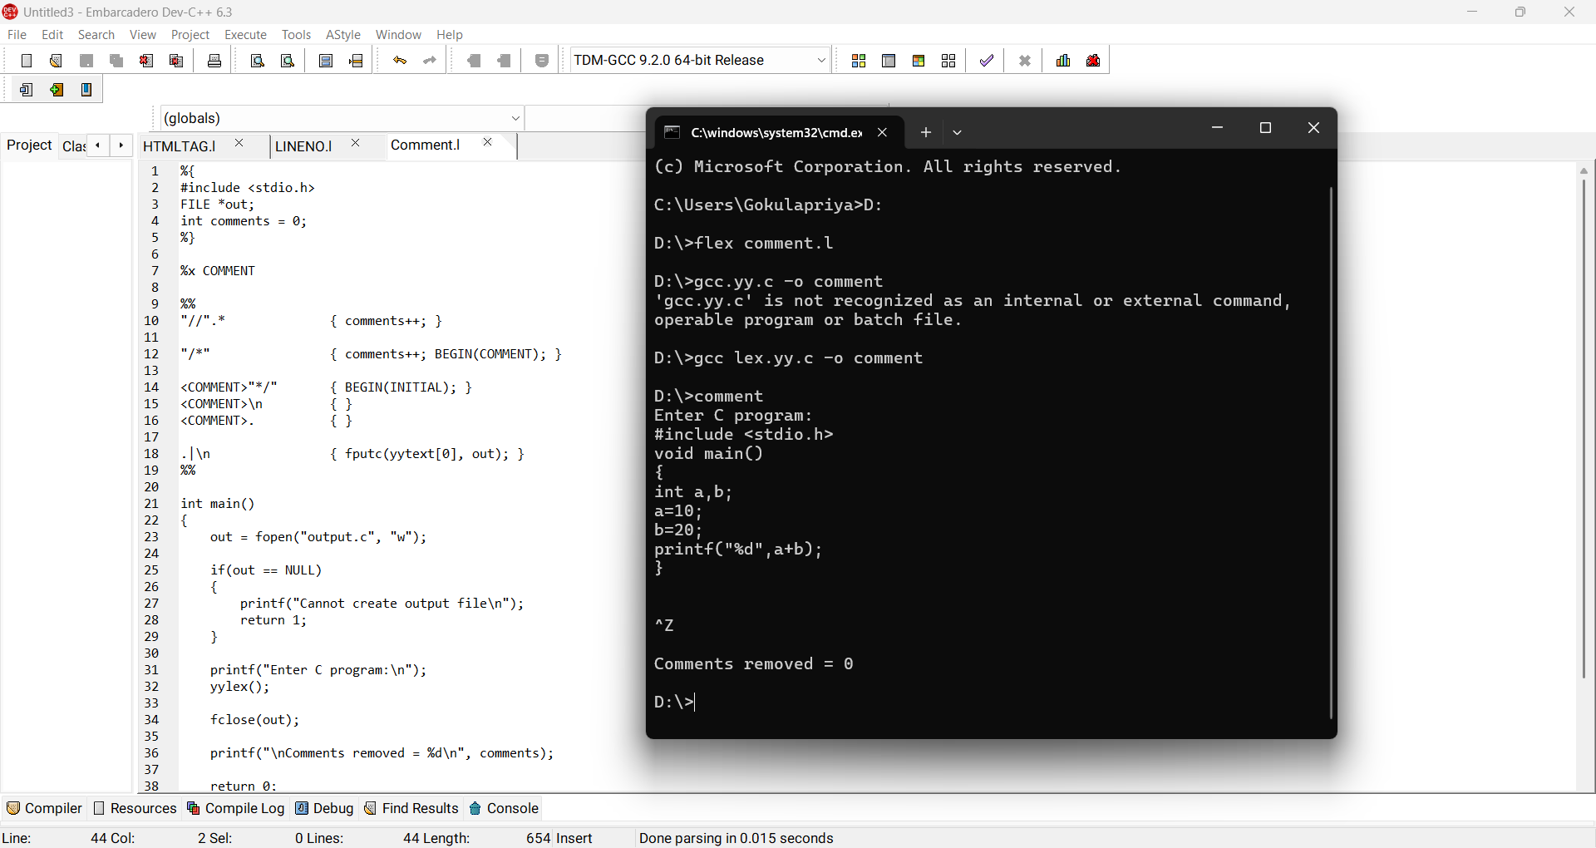
Result: Thus comments were counted and removed from the output file.

25. LEX – Identify Capital Words
Aim:
To identify words written completely in capital letters from the input.
Algorithm:
1. Define a pattern beginning with an uppercase letter and containing uppercase letters/digits.
2. Scan the input.
3. Print every matching word.
4. Ignore other words.
Program:
%{
#include <stdio.h>
%}
%%
[A-Z][A-Z0-9]* { printf("CAPITAL WORD: %s\n",yytext); }
.|\n ;
%%
int main(){yylex();return 0;}
int yywrap(){return 1;}
Sample Output:
Input: HELLO Compiler DESIGN
CAPITAL WORD: HELLO
CAPITAL WORD: DESIGN
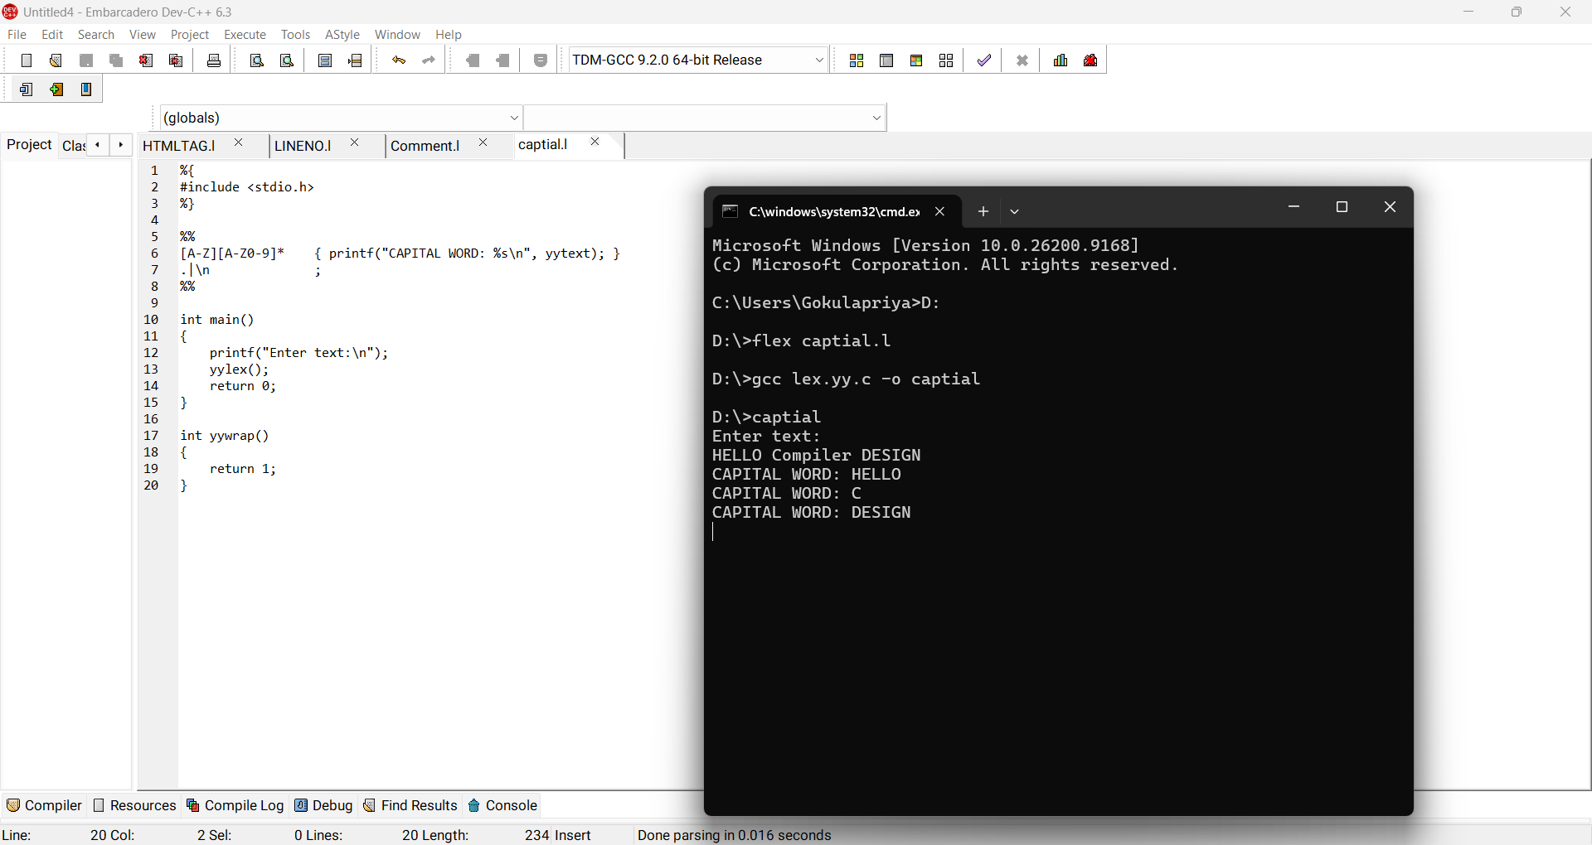
Result: Thus capital words were identified successfully.

26. LEX – Validate Email Address
Aim:
To write a LEX program to check whether an email address is valid.
Algorithm:
1. Define a pattern for username@domain.extension.
2. Read the input.
3. If the complete input matches the pattern, print valid.
4. Otherwise print invalid.
Program:
%{
#include <stdio.h>
%}
%%
[A-Za-z0-9._%+-]+@[A-Za-z0-9.-]+\.[A-Za-z]{2,} {printf("Valid Email\n");}
.+ {printf("Invalid Email\n");}
%%
int main(){yylex();return 0;}
int yywrap(){return 1;}
Sample Output:
Input: student@gmail.com
Valid Email
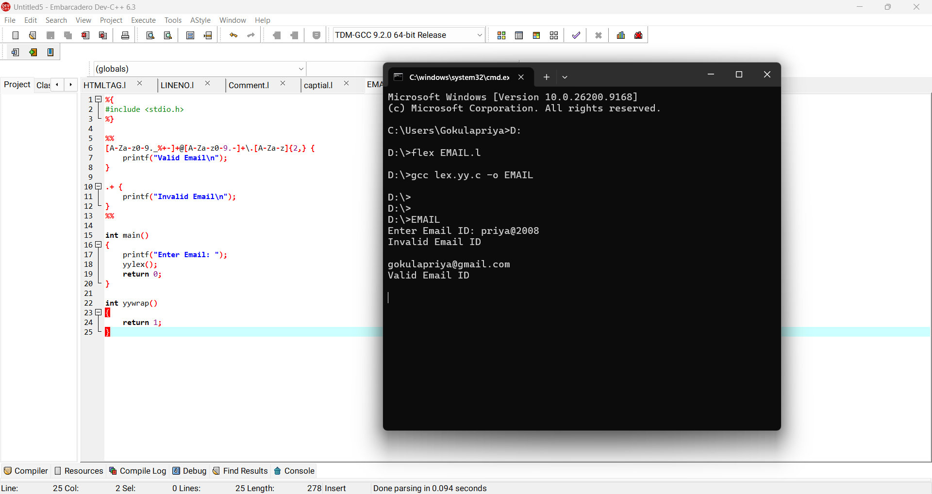
Result: Thus the email address was validated successfully.

27. LEX – Convert abc to ABC
Aim:
To convert every occurrence of the substring abc into ABC.
Algorithm:
1. Match the exact substring abc.
2. Print ABC when it is matched.
3. Copy all other characters unchanged.
Program:
%{
#include <stdio.h>
%}
%%
abc {printf("ABC");}
.|\n {ECHO;}
%%
int main(){yylex();return 0;}
int yywrap(){return 1;}
Sample Output:
Input: abc xabc abc
Output: ABC xABC ABC
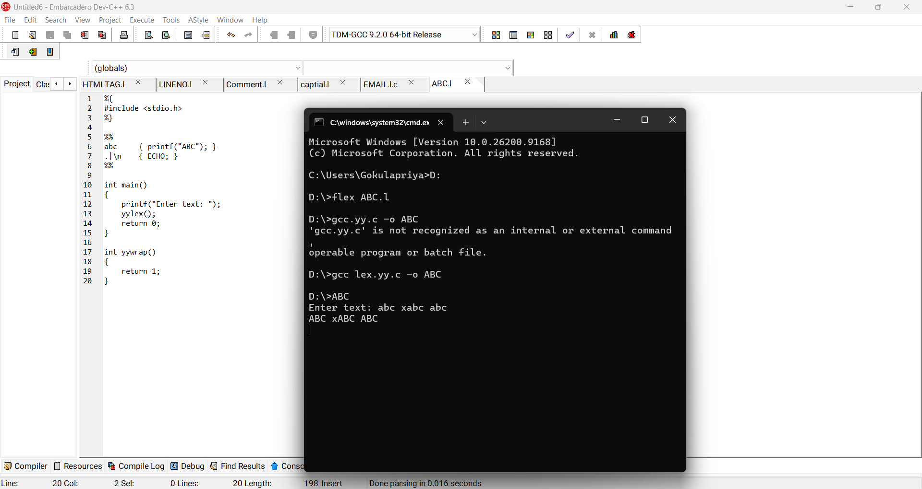
Result: Thus the substring abc was converted to ABC.

28. LEX – Validate Mobile Number
Aim:
To check whether a mobile number is valid according to a 10-digit format.
Algorithm:
1. Read the mobile number.
2. Match exactly 10 digits.
3. If matched, print valid; otherwise print invalid.
Program:
%{
#include <stdio.h>
%}
%%
[0-9]{10} {printf("Valid Mobile Number\n");}
.+ {printf("Invalid Mobile Number\n");}
%%
int main(){yylex();return 0;}
int yywrap(){return 1;}
Sample Output:
Input: 9876543210
Valid Mobile Number
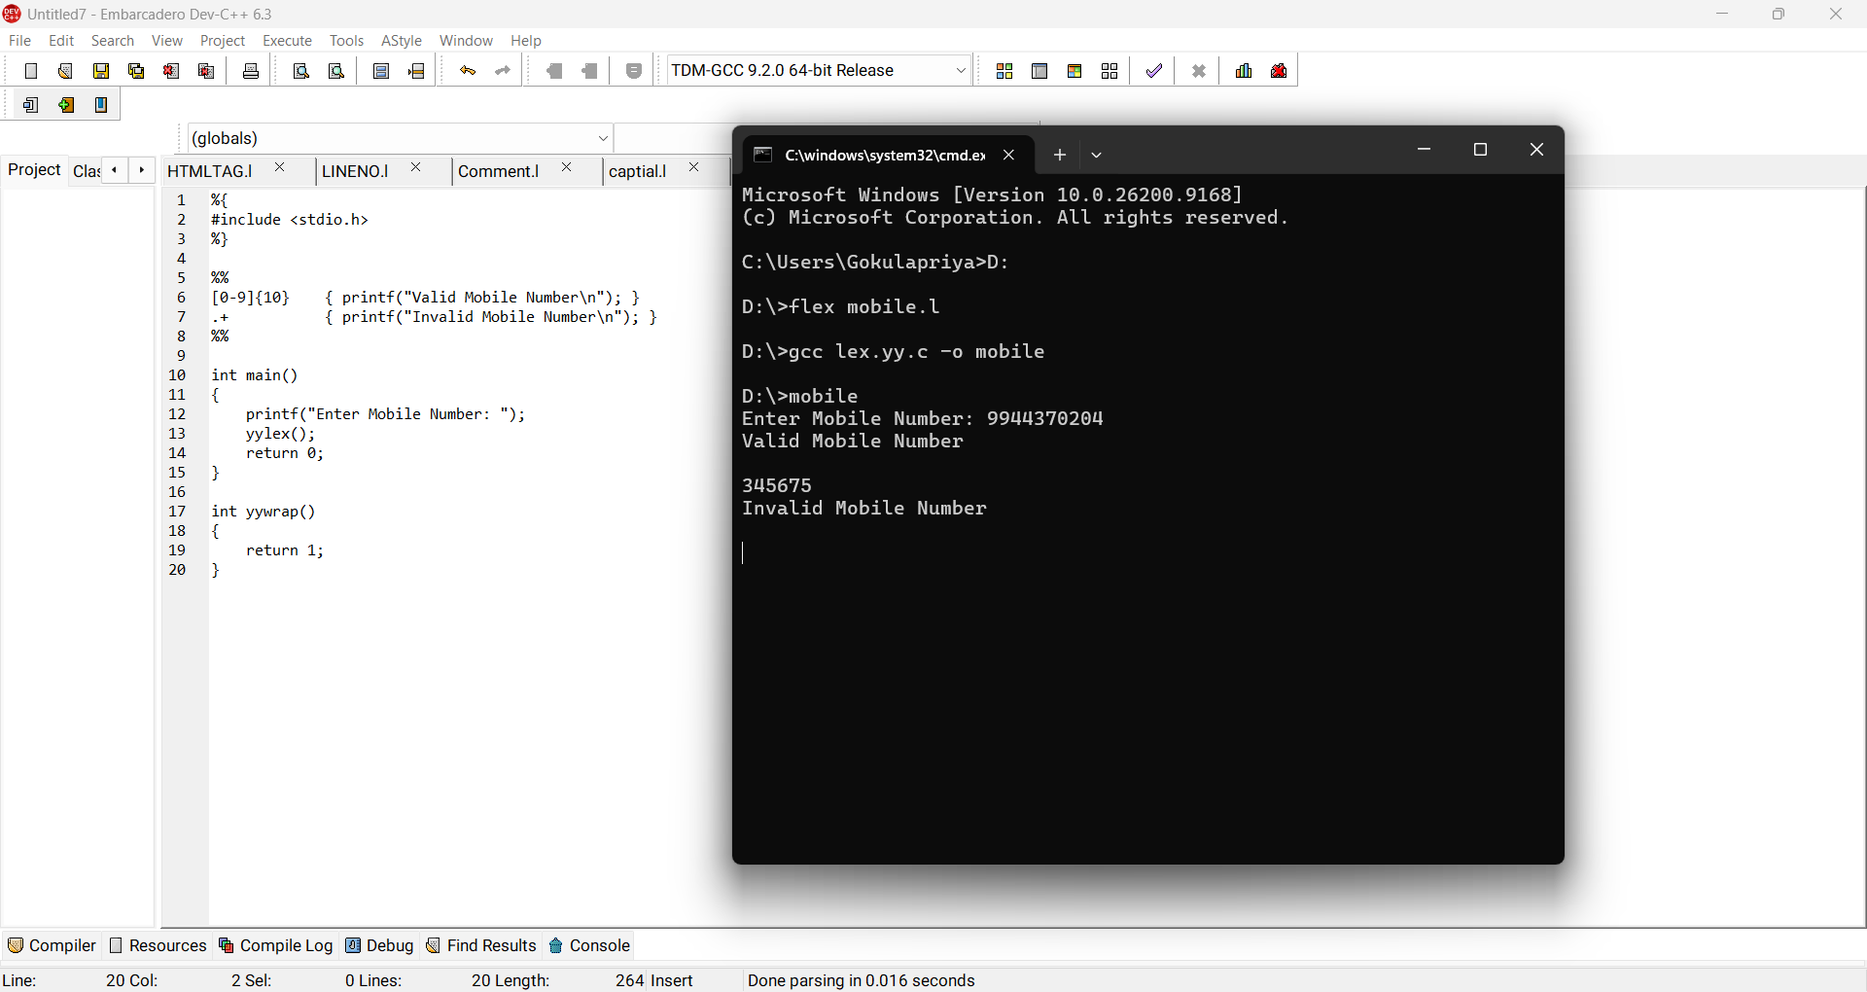
Result: Thus the mobile number was validated successfully.

29. LEX/FLEX – Separate C Tokens
Aim:
To implement a lexical analyzer using LEX/FLEX that separates tokens in a C program and displays captions.
Algorithm:
1. Define patterns for keywords, identifiers, constants, operators and symbols.
2. Scan the C source.
3. Match each token.
4. Print the token with its category.
Program:
%{
#include <stdio.h>
%}
%%
"int"|"float"|"char"|"void"|"return" {printf("KEYWORD: %s\n",yytext);}
[A-Za-z_][A-Za-z0-9_]* {printf("IDENTIFIER: %s\n",yytext);}
[0-9]+ {printf("CONSTANT: %s\n",yytext);}
[+\-*/=] {printf("OPERATOR: %s\n",yytext);}
[(){};,] {printf("SYMBOL: %s\n",yytext);}
[ \t\n]+ ;
. {printf("OTHER: %s\n",yytext);}
%%
int main(){yylex();return 0;}
int yywrap(){return 1;}
Sample Output:
KEYWORD: int
IDENTIFIER: a
OPERATOR: =
CONSTANT: 30
SYMBOL: ;
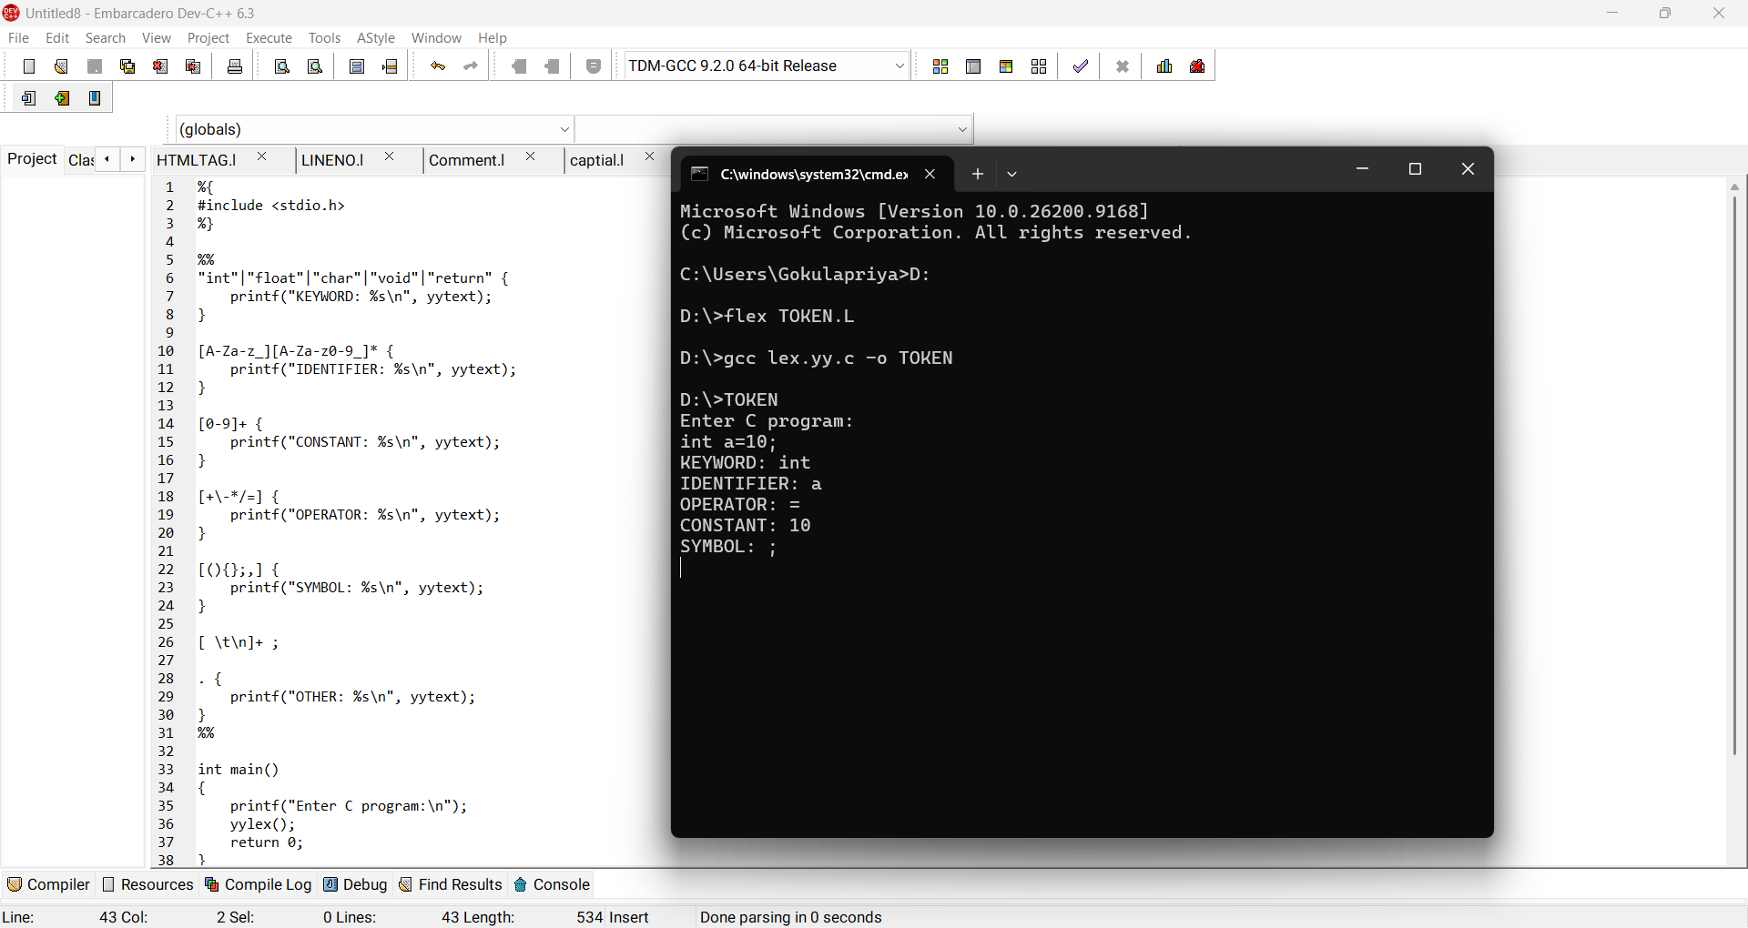
Result: Thus the C source program was separated into appropriate tokens.

30. Count Consonants in a Sentence
Aim:
To count the number of consonants in a given sentence.
Algorithm:
1. Read the sentence.
2. Check each alphabetic character.
3. If it is not a vowel, increment the consonant count.
4. Display the count.
Program:
#include <stdio.h>
#include <ctype.h>
#include <string.h>
int main(){
char s[500]; int i,c=0; fgets(s,sizeof(s),stdin);
for(i=0;s[i];i++)
if(isalpha((unsigned char)s[i]) && !strchr("AEIOUaeiou",s[i])) c++;
printf("Consonants = %d\n",c); return 0;
}
Sample Output:
Input: Compiler Design
Consonants = 9
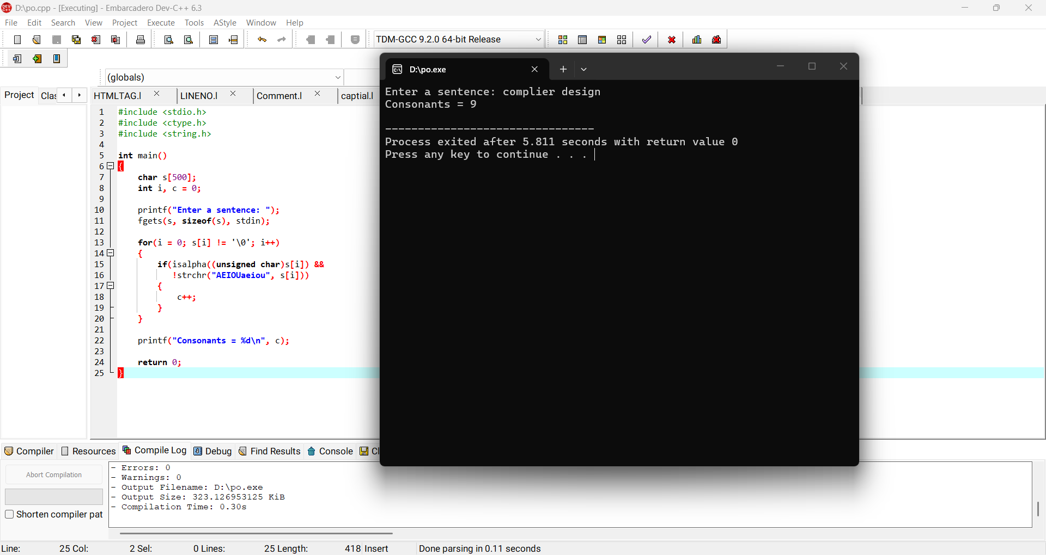
Result: Thus the number of consonants was counted successfully.

31. LEX – Separate Keywords and Identifiers
Aim:
To write a LEX program to distinguish keywords from identifiers.
Algorithm:
1. Define patterns for common C keywords.
2. Define the identifier pattern.
3. Check keywords before identifiers so that reserved words are classified correctly.
4. Print the category.
Program:
%{
#include <stdio.h>
%}
%%
"int"|"float"|"char"|"if"|"else"|"while"|"for"|"return" {printf("KEYWORD: %s\n",yytext);}
[A-Za-z_][A-Za-z0-9_]* {printf("IDENTIFIER: %s\n",yytext);}
[ \t\n]+ ;
. ;
%%
int main(){yylex();return 0;}
int yywrap(){return 1;}
Sample Output:
KEYWORD: int
IDENTIFIER: total
KEYWORD: return
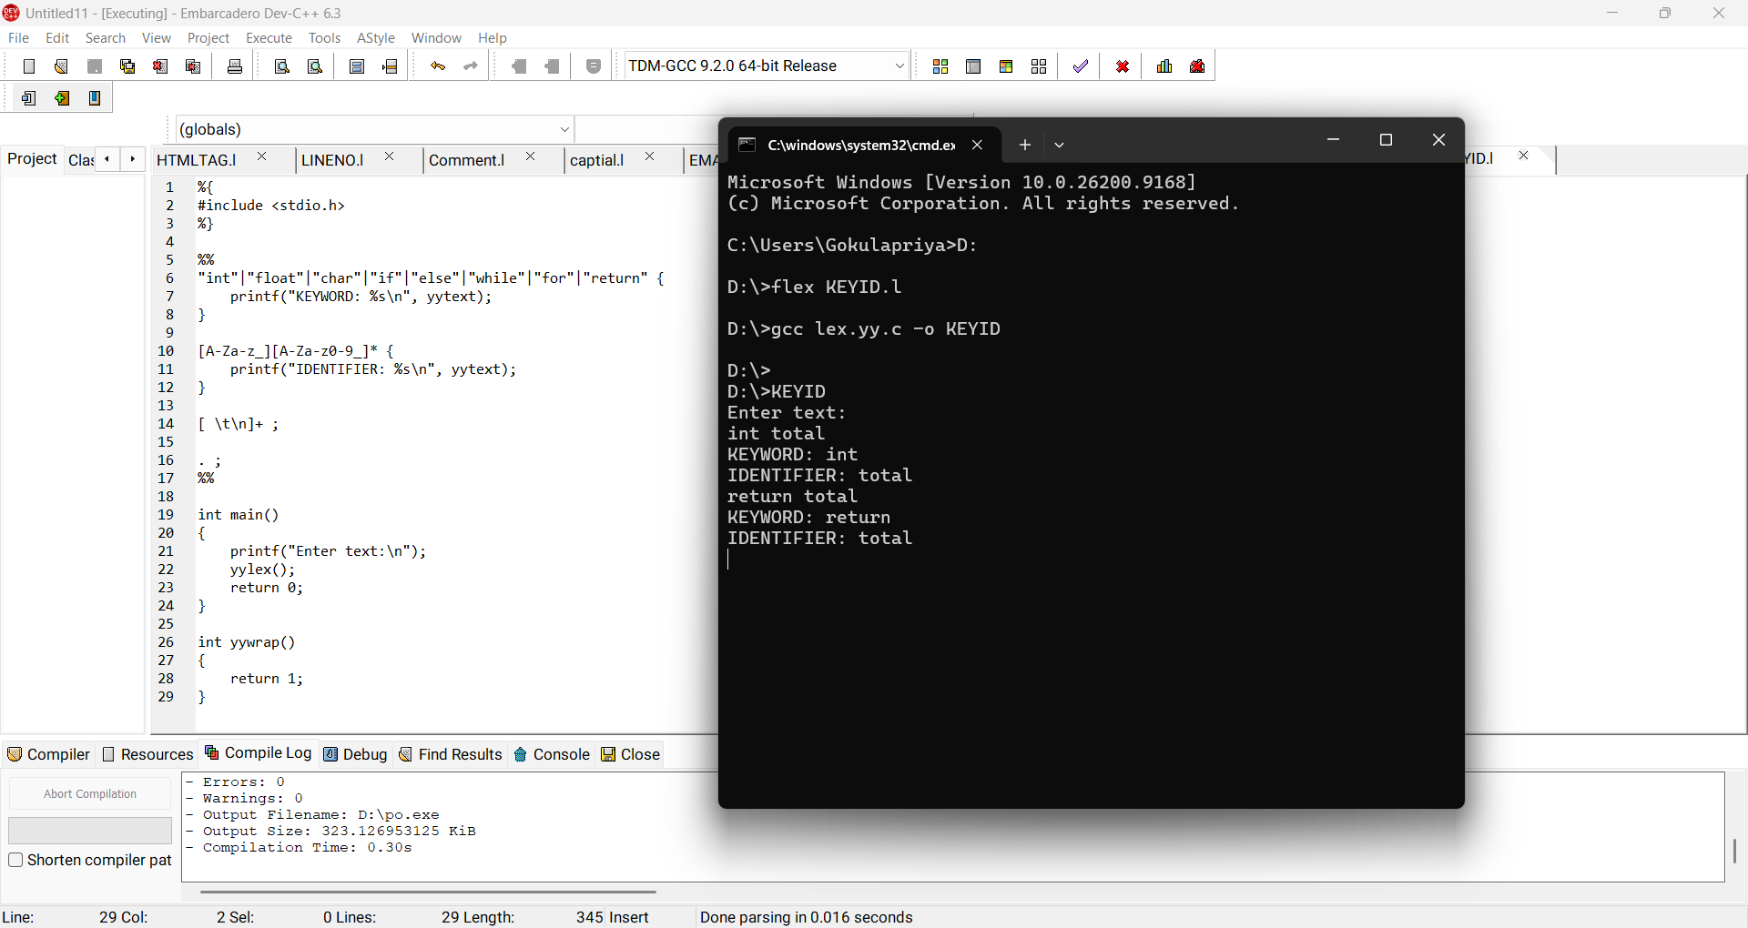
Result: Thus keywords and identifiers were separated successfully.

32. LEX – Count Positive and Negative Numbers
Aim:
To identify and count positive and negative numbers in the input.
Algorithm:
1. Match an optional sign followed by digits.
2. If the number starts with + or has no negative sign, count it as positive.
3. If it starts with -, count it as negative.
4. Display both counts.
Program:
%{
#include <stdio.h>
int pos=0,neg=0;
%}
%%
\-[0-9]+ {neg++; printf("Negative: %s\n",yytext);}
\+?[0-9]+ {pos++; printf("Positive: %s\n",yytext);}
.|\n ;
%%
int main(){yylex();printf("Positive=%d Negative=%d\n",pos,neg);return 0;}
int yywrap(){return 1;}
Sample Output:
Positive: 10
Negative: -5
Positive=1 Negative=1
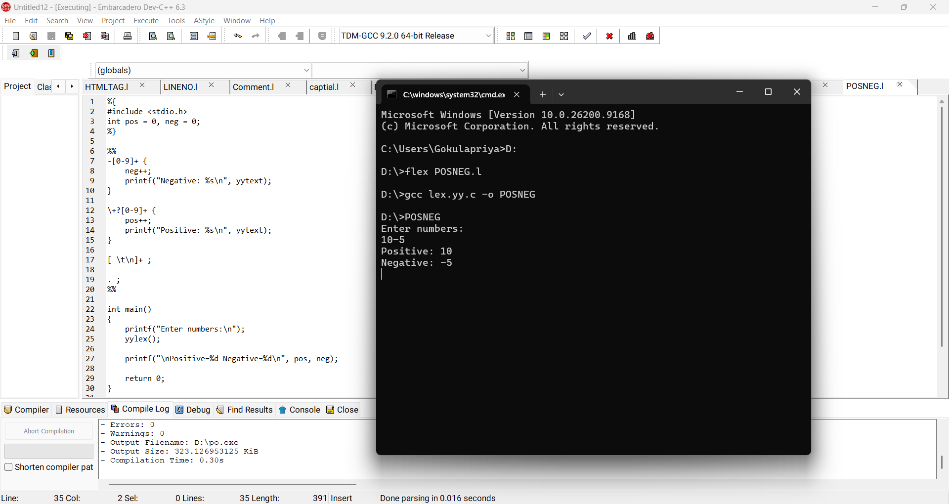
Result: Thus positive and negative numbers were identified and counted.

33. LEX – Validate URL
Aim:
To write a LEX program to validate a basic HTTP/HTTPS URL.
Algorithm:
1. Match http or https.
2. Match :// followed by a valid domain-like sequence.
3. If the whole input matches, print valid; otherwise invalid.
Program:
%{
#include <stdio.h>
%}
%%
https?://[A-Za-z0-9.-]+(/[A-Za-z0-9_./?=&%-]*)? {printf("Valid URL\n");}
.+ {printf("Invalid URL\n");}
%%
int main(){yylex();return 0;}
int yywrap(){return 1;}
Sample Output:
Input: https://example.com
Vali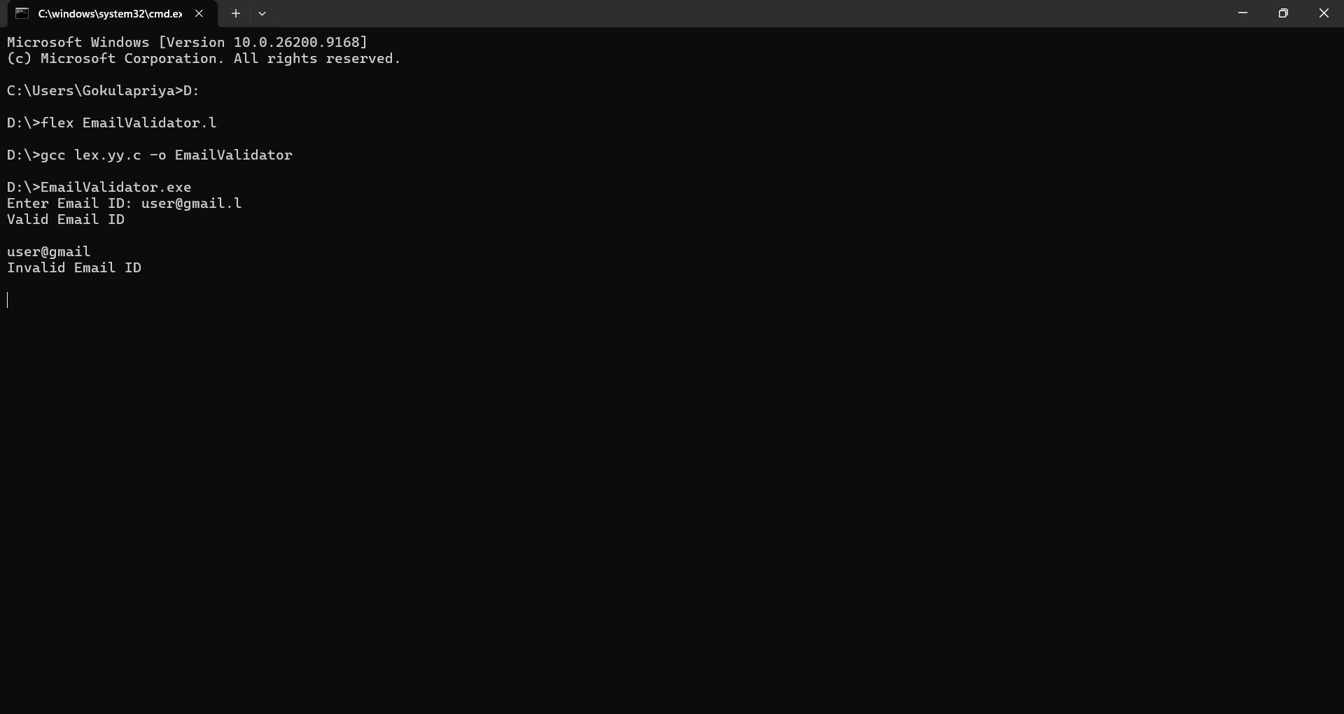d URL

Result: Thus the URL was validated successfully.

34. LEX – Validate Date of Birth
Aim:
To validate a basic DOB format DD/MM/YYYY.
Algorithm:
1. Match two digits, slash, two digits, slash and four digits.
2. Check that the complete input matches the pattern.
3. Print valid or invalid.
Program:
%{
#include <stdio.h>
%}
%%
[0-9]{2}/[0-9]{2}/[0-9]{4} {printf("Valid DOB format\n");}
.+ {printf("Invalid DOB format\n");}
%%
int main(){yylex();return 0;}
int yywrap(){return 1;}
Sample Output:
Input: 20/08/2007
Valid DOB format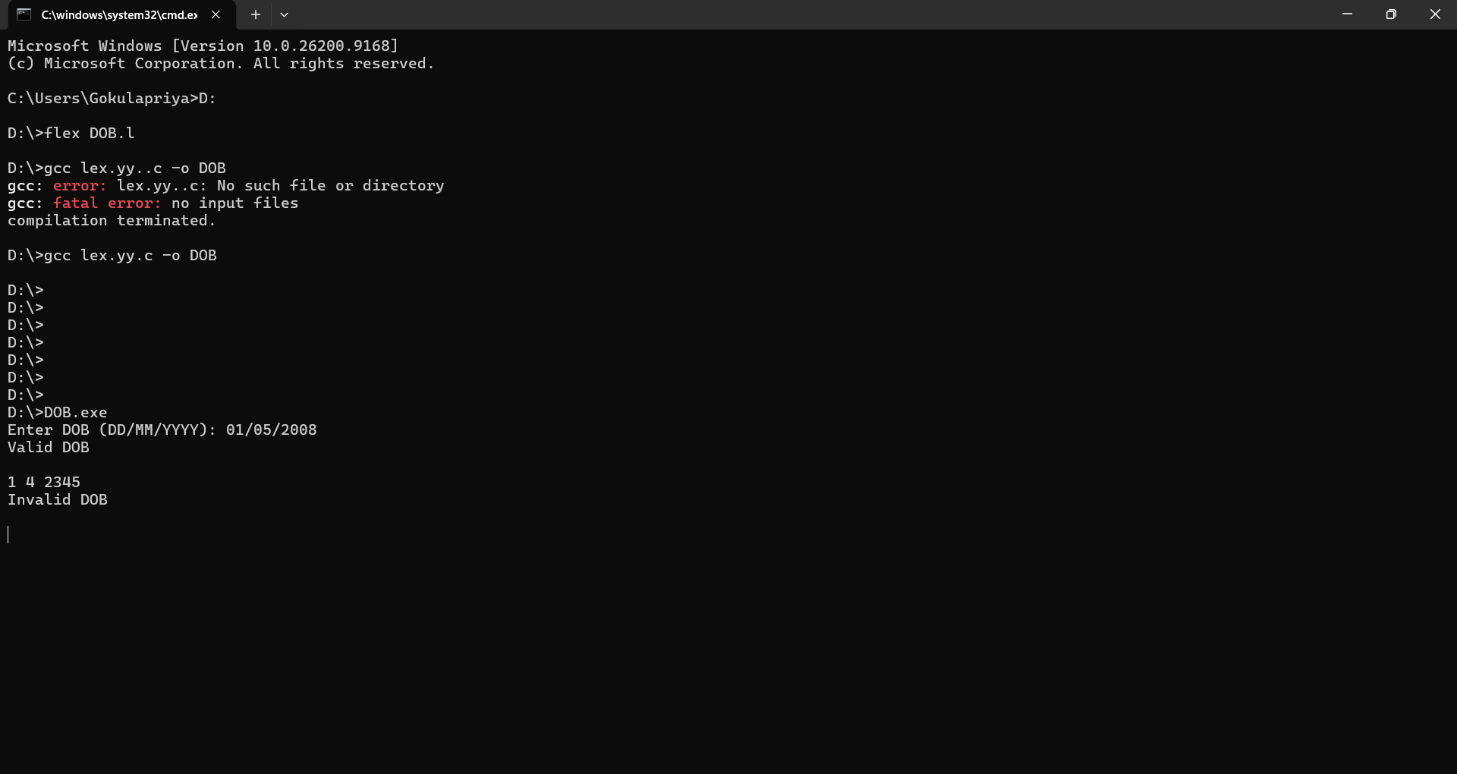

Result: Thus the DOB format was validated successfully.

35. LEX – Check Digit
Aim:
To write a LEX program to check whether the given input is a digit.
Algorithm:
1. Read the input character.
2. Match 0–9.
3. If matched, print digit; otherwise print not a digit.
Program:
%{
#include <stdio.h>
%}
%%
[0-9] {printf("Digit\n");}
. {printf("Not a digit\n");}
%%
int main(){yylex();return 0;}
int yywrap(){return 1;}
Sample Output:
Input: 7
Digit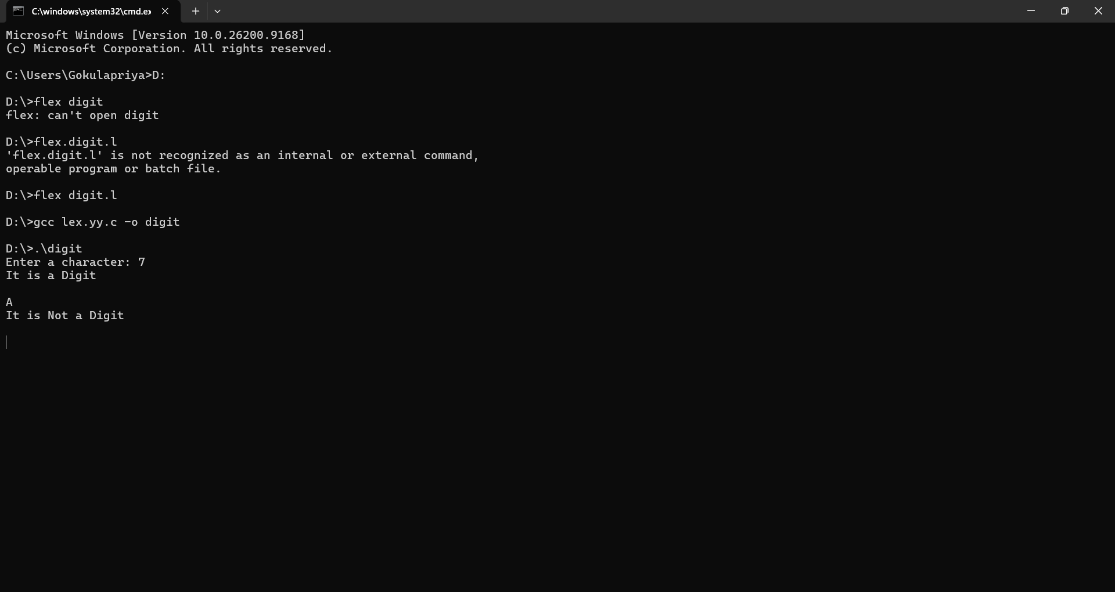

Result: Thus the input was checked successfully.

36. LEX – Basic Mathematical Operations
Aim:
To implement basic mathematical operations using a LEX program.
Algorithm:
1. Define patterns for +, -, *, / and numeric operands.
2. Scan the input expression.
3. Print each recognized operator and operand.
4. Use the recognized tokens for the requested arithmetic operation.
Program:
%{
#include <stdio.h>
%}
%%
[0-9]+ {printf("NUMBER: %s\n",yytext);}
"+" {printf("ADD\n");}
"-" {printf("SUBTRACT\n");}
"*" {printf("MULTIPLY\n");}
"/" {printf("DIVIDE\n");}
[ \t\n]+ ;
. ;
%%
int main(){yylex();return 0;}
int yywrap(){return 1;}
Sample Output:
Input: 10+5
NUMBER: 10
ADD
NUMBER: 5
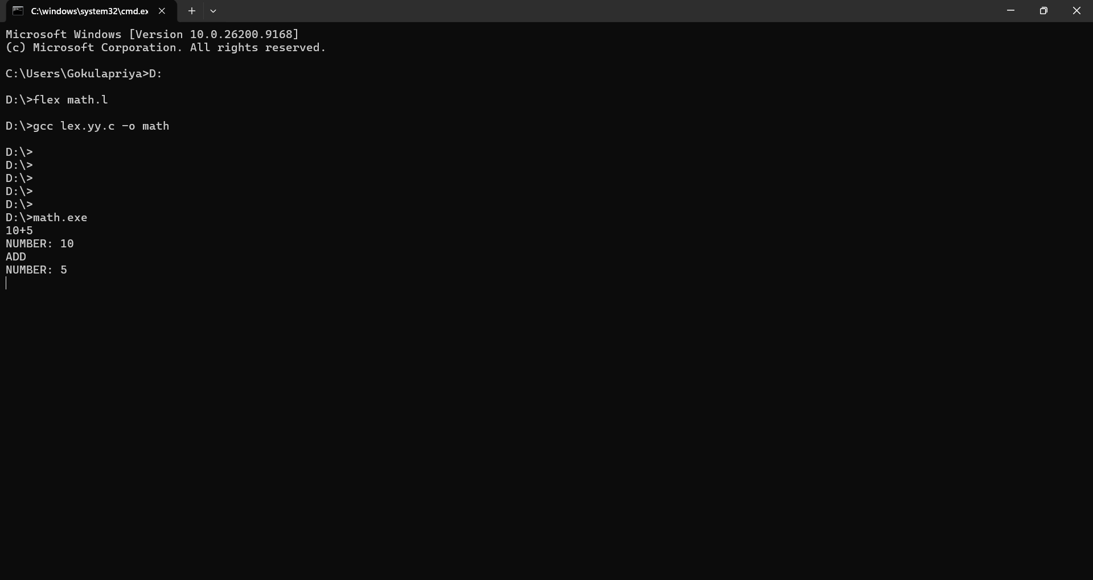
Result: Thus the basic mathematical operators and operands were recognized.

37. LEX – Frequency of a Word in a Sentence
Aim:
To count the frequency of a specified word in a sentence.
Algorithm:
1. Read the target word.
2. Scan the sentence word by word.
3. Compare each word with the target.
4. Increment the frequency when matched.
5. Display the frequency.
Program:
%{
#include <stdio.h>
#include <string.h>
char target[50]; int count=0;
%}
%%
[A-Za-z]+ {if(!strcmp(yytext,target)) count++;}
.|\n ;
%%
int main(){scanf("%49s",target); getchar(); yylex(); printf("Frequency = %d\n",count); return 0;}
int yywrap(){return 1;}
Sample Output:
Target: compiler
Input: compiler design compiler
Frequency = 2
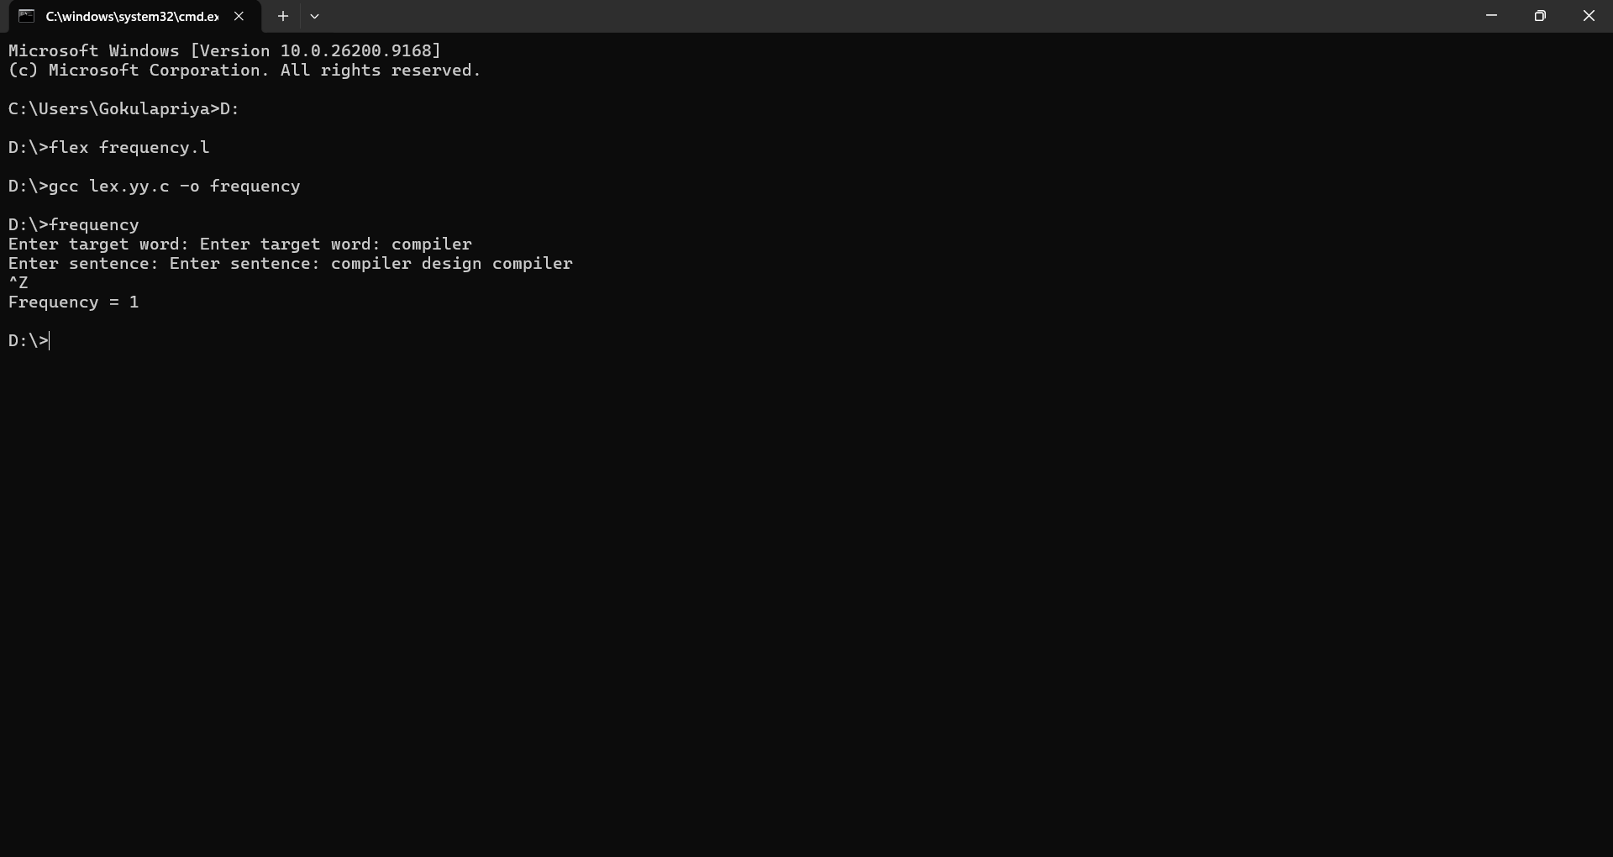
Result: Thus the frequency of the given word was found.

38. LEX – Length of Longest Word
Aim:
To find the length of the longest word in the input.
Algorithm:
1. Match each word.
2. Find its length.
3. Compare it with the current maximum.
4. Store the longest word and its length.
5. Display the result.
Program:
%{
#include <stdio.h>
#include <string.h>
char longest[100]; int max=0;
%}
%%
[A-Za-z]+ {if(yyleng>max){max=yyleng;strcpy(longest,yytext);}}
.|\n ;
%%
int main(){yylex();printf("Longest word: %s\nLength: %d\n",longest,max);return 0;}
int yywrap(){return 1;}
Sample Output:
Longest word: compiler
Length: 8
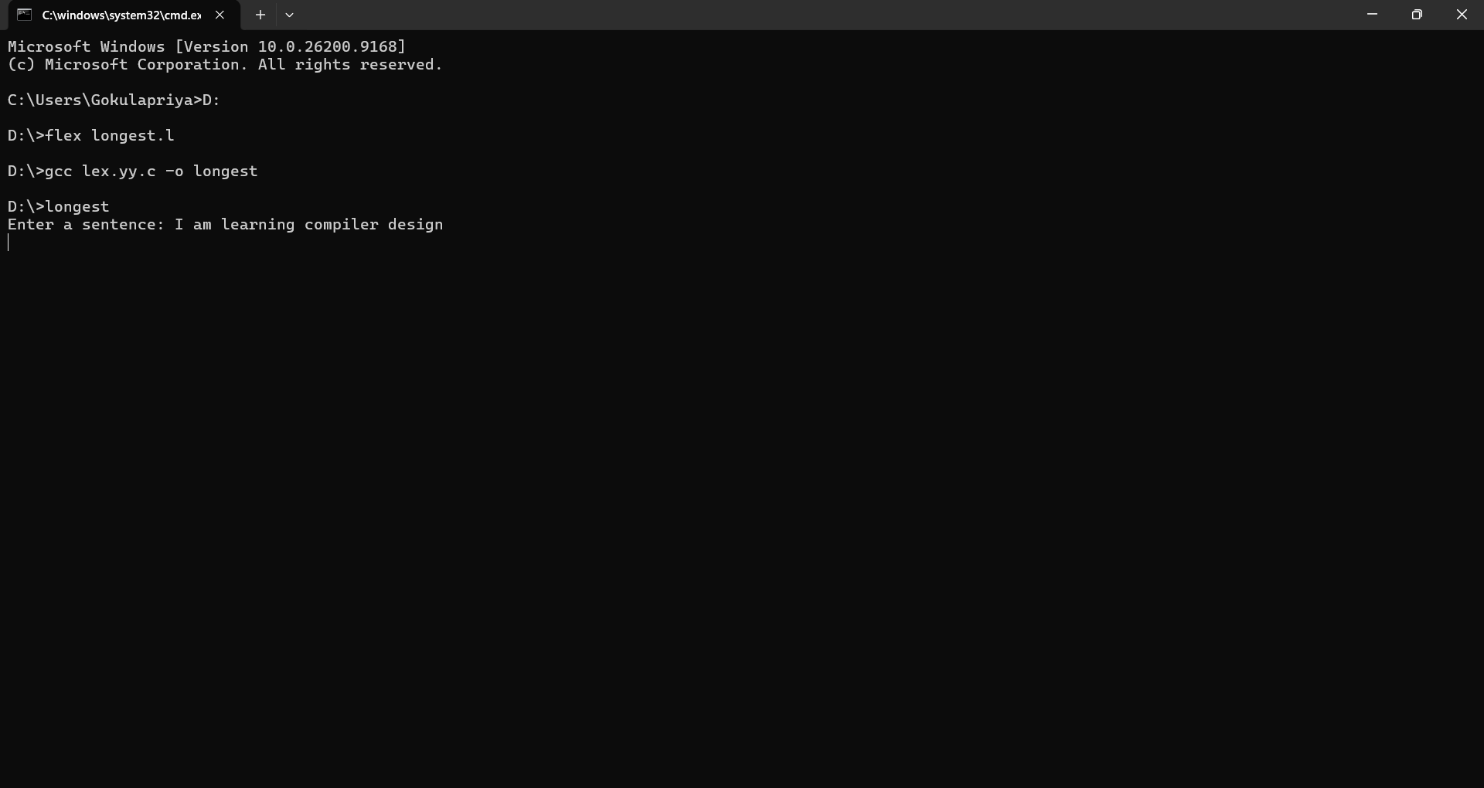
Result: Thus the longest word and its length were found successfully.

39. LEX – Replace One Word with Another
Aim:
To replace a specified word with another word in a file.
Algorithm:
1. Define the target word as a LEX pattern.
2. When it is matched, print the replacement word.
3. Copy all other characters unchanged.
4. Write the transformed content to the output.
Program:
%{
#include <stdio.h>
%}
%%
oldword {printf("newword");}
.|\n {ECHO;}
%%
int main(){yylex();return 0;}
int yywrap(){return 1;}
Sample Output:
Input: oldword is here.
Output: newword is here.
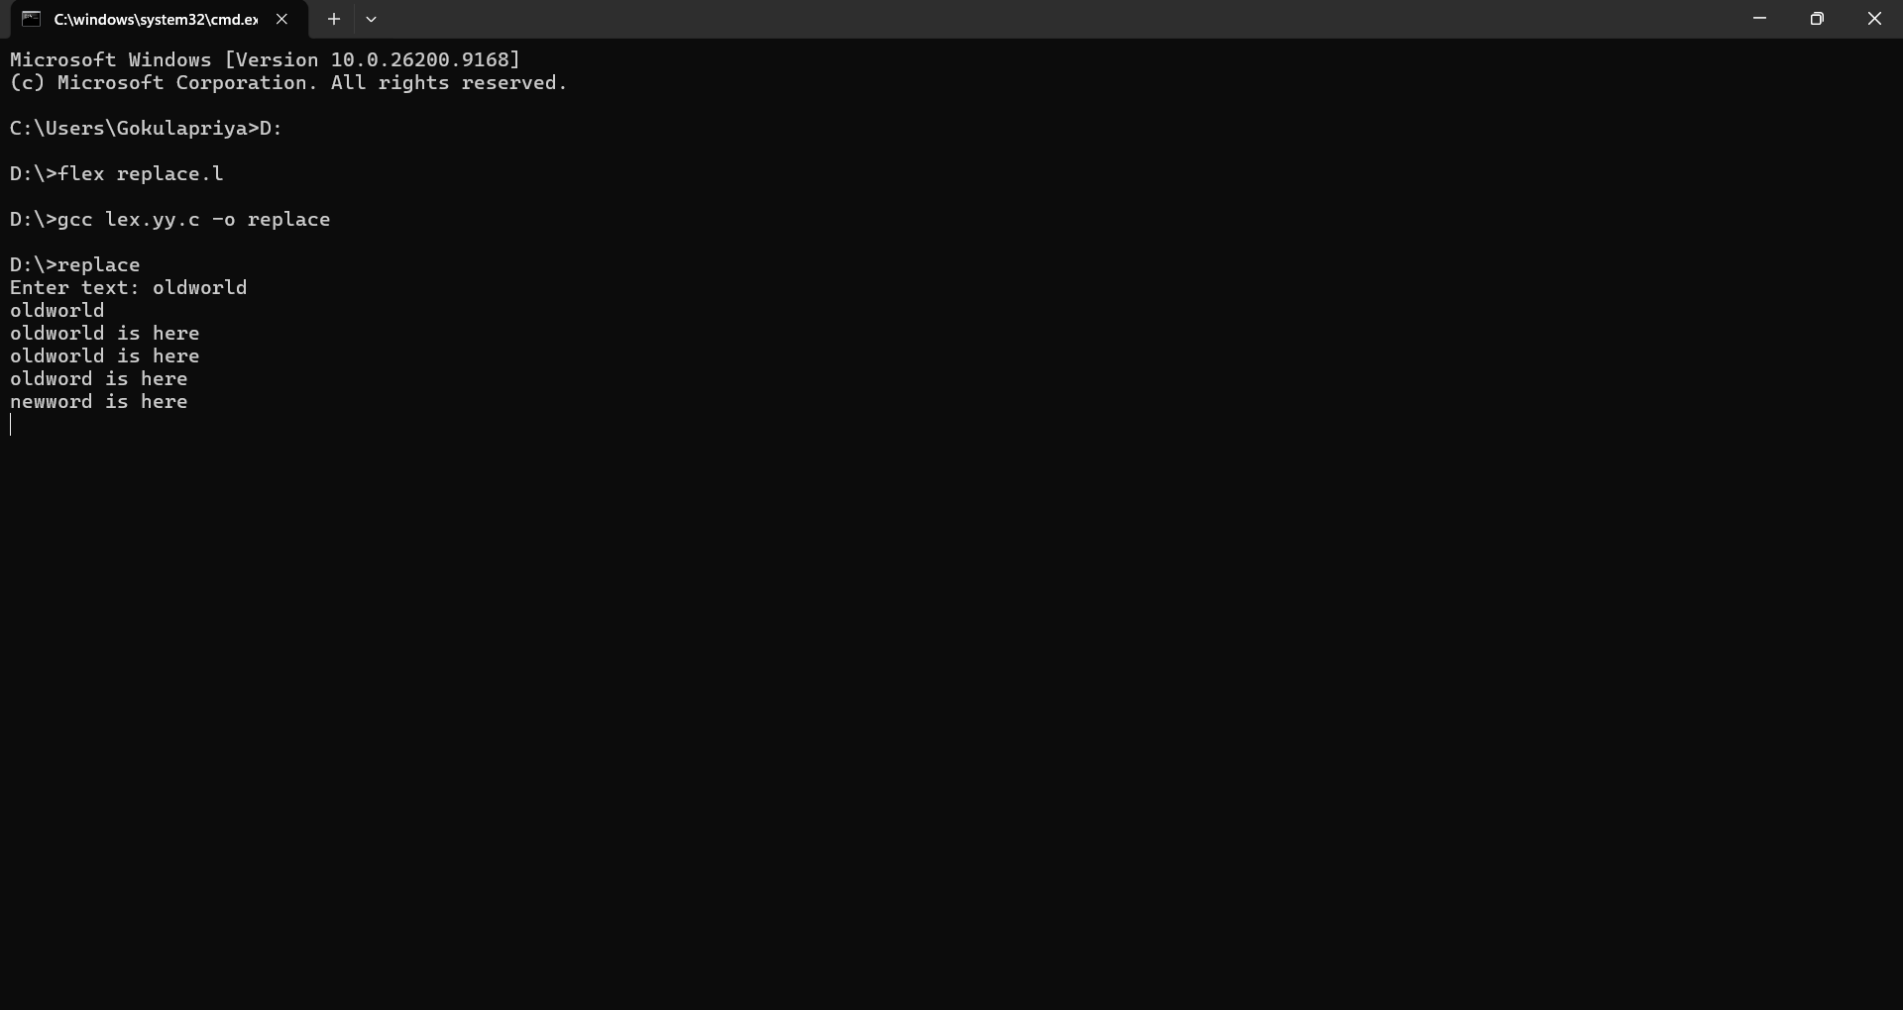
Result: Thus the specified word was replaced successfully.

40. FLEX – Token Separation with Captions
Aim:
To implement a FLEX lexical analyzer that separates tokens in a C program and displays the appropriate caption.
Algorithm:
1. Define regular expressions for keywords, identifiers, constants, operators and delimiters.
2. Give each rule a suitable action.
3. Run FLEX on the C source program.
4. Display every matched token with its caption.
Program:
%{
#include <stdio.h>
%}
%%
"#include"|"int"|"float"|"char"|"void"|"return" {printf("KEYWORD/PREPROCESSOR: %s\n",yytext);}
[A-Za-z_][A-Za-z0-9_]* {printf("IDENTIFIER: %s\n",yytext);}
[0-9]+ {printf("CONSTANT: %s\n",yytext);}
"=="|"!="|"<="|">="|"="|"+"|"-"|"*"|"/" {printf("OPERATOR: %s\n",yytext);}
[(){};,<>] {printf("DELIMITER: %s\n",yytext);}
[ \t\n]+ ;
. {printf("OTHER: %s\n",yytext);}
%%
int main(){yylex();return 0;}
int yywrap(){return 1;}
Sample Output:
KEYWORD/PREPROCESSOR: int
IDENTIFIER: a
OPERATOR: =
CONSTANT: 30
DELIMITER: ;
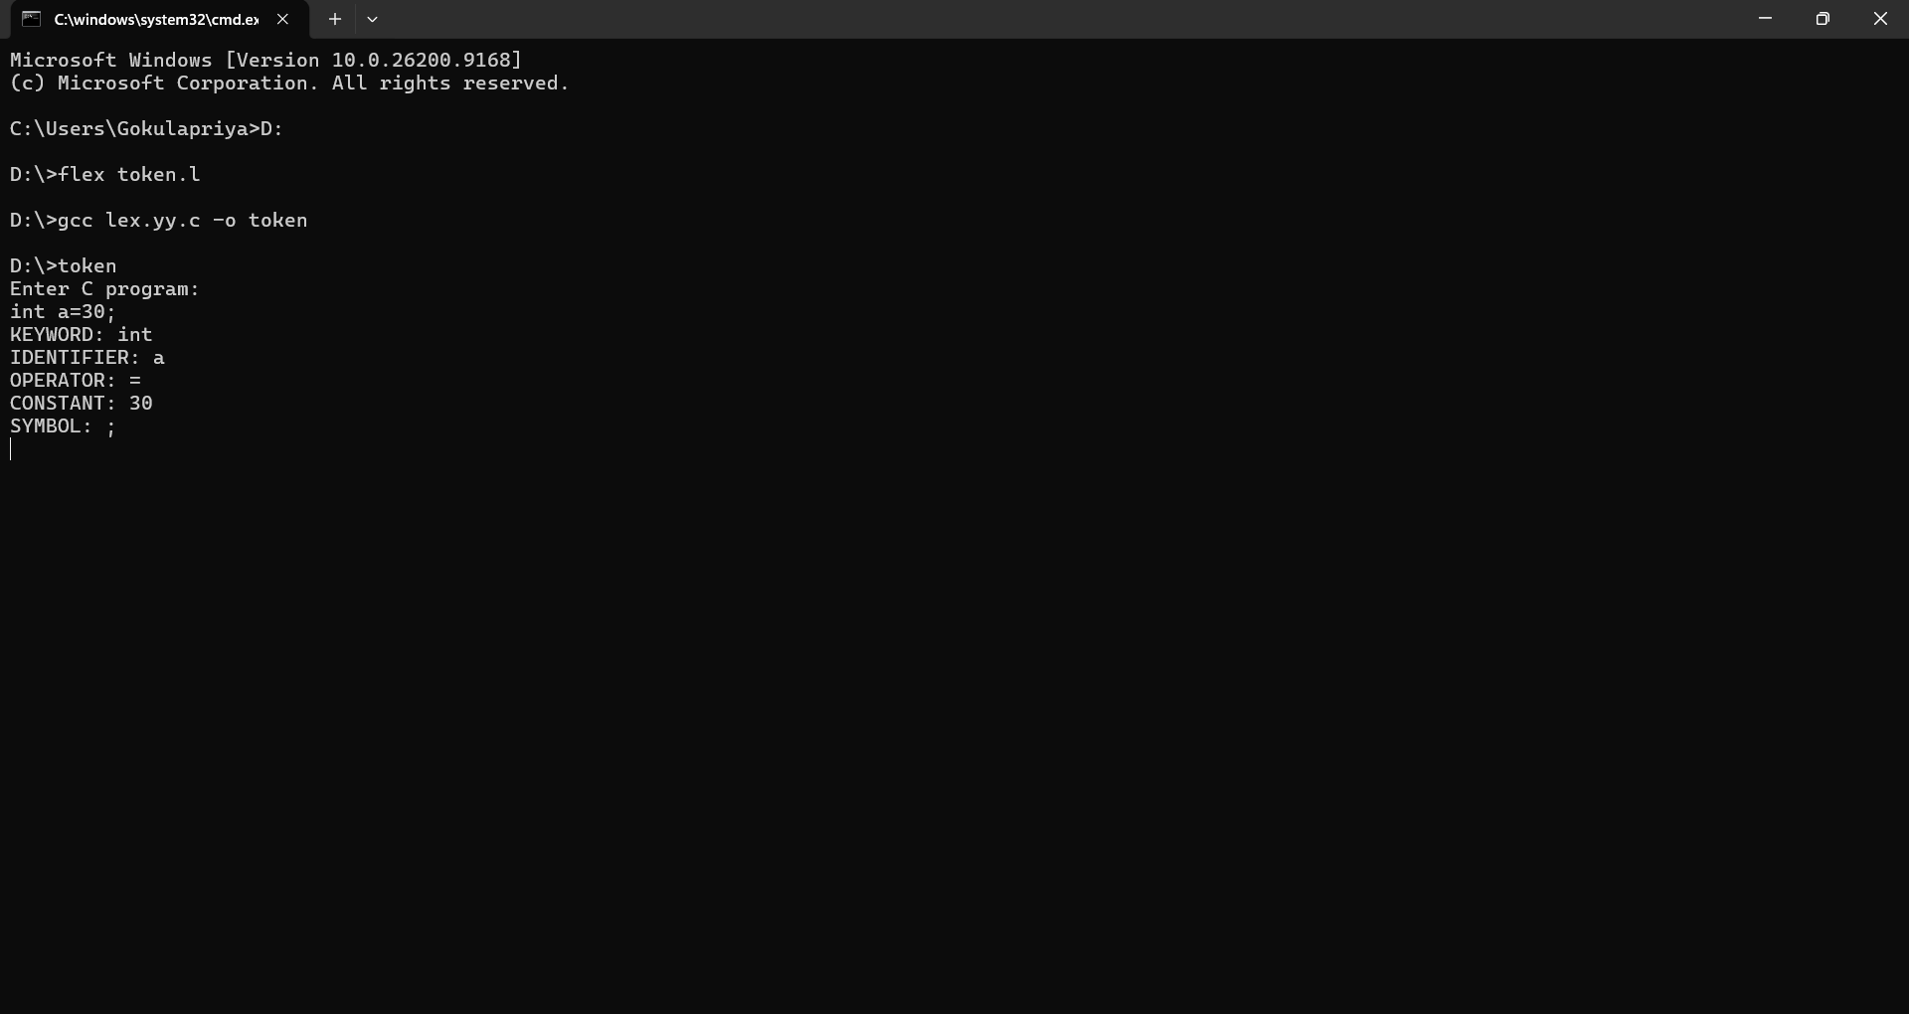
Result: Thus FLEX successfully separated the C program into tokens with appropriate captions.

