GOKULARASAN  Electrical & Electronics Engineering Student  gokularasan.28eee@gmail.com | LinkedIn | GitHub  Coimbatore, Tamil Nadu | 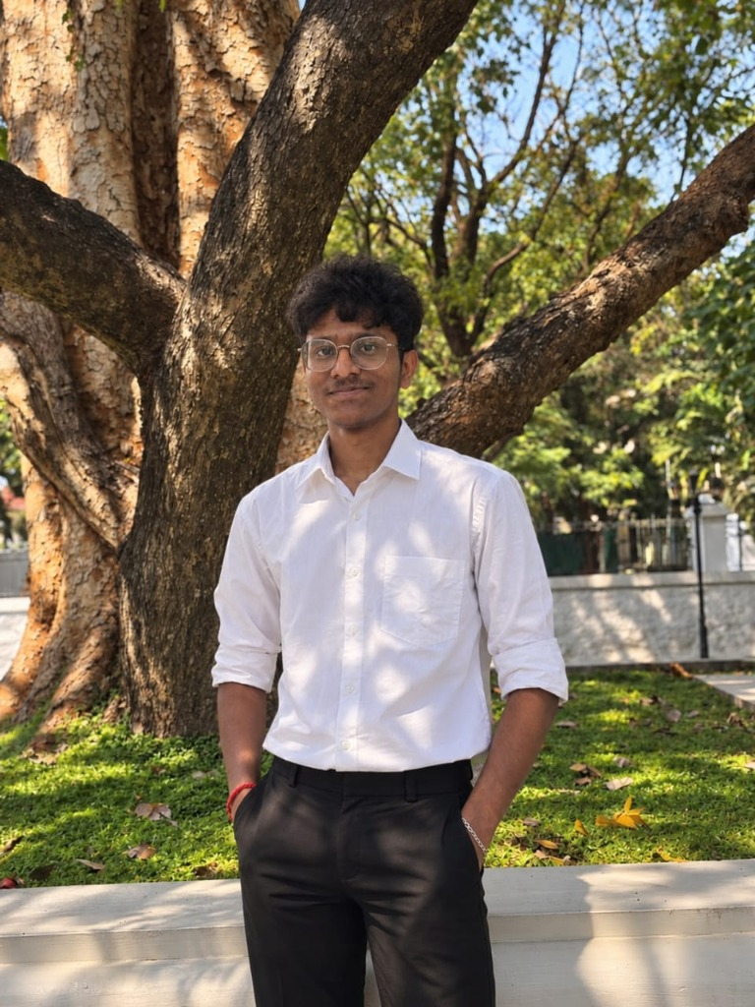
EDUCATION
Kumaraguru College of Technology | Coimbatore, Tamil Nadu
B.E., Electrical and Electronics Engineering
Sree Gokulam Matric Higher Secondary School | Grade 9 – 12 | 12th: 93.83% | 11th: 90.60%
Shalom Convent Matriculation Higher Secondary School | LKG – Grade 8 | 10th: 96.40%
INTERNSHIPS
Mara Signex Solar Experts — Solar Energy & EPC Operations | June 2026 | 150 hrs
- Gained hands-on exposure to On-Grid, Off-Grid, and Hybrid solar systems and their real-world applications.
- Researched and compared solar inverters from Sungrow, Growatt, Deye, and ABB (FIMER).
- Studied VFDs, harmonics, energy losses, and harmonic-reduction techniques; visited live solar plants.
- Prepared technical presentations and research material on solar technologies and EPC operations.
Electromotive Power Drives Pvt. Ltd. — Electrical Motor Manufacturing | May 2025 | 7 days, 45 hrs
- Gained firsthand exposure to electrical motor manufacturing, ISO standards, 5S, and TQM practices.
- Observed practical coil-winding techniques and studied key components of electrical motors.
- Connected theoretical electrical-machine concepts with real manufacturing processes and quality control.
PROJECTS
Real-Time Classroom Energy Monitoring System | ESP32, Current Sensor, IoT, Embedded Systems
- Built an IoT-based dashboard to track real-time current, power, energy usage, and estimated electricity cost.
- Enabled historical data analysis to identify peak consumption periods and reduce unnecessary energy usage.
- Added over-current/abnormal-consumption alerts, with scope for scaling across multiple classrooms.
Smart Cooking Oil Impurity Detection System | ESP32, pH/Moisture/Temp Sensors, IoT, Data Logging
- Designed a low-cost sensor system combining moisture, pH, and temperature sensing to flag oil contamination.
- Logged and compared fresh vs. used oil data with a threshold-based warning system on an IoT dashboard.
- Explored advanced parameters (turbidity, optical color analysis, conductivity) and ML-based classification.
HACKATHONS & EVENTS
- Kumaraguru Livestock Hackathon 2026 — Management Team: coordinated logistics, teams, and on-ground operations for a 3-day innovation event (Jan 2026).
- U & Me Hackathon, CIT — Participant: co-built an IoT-based Water Quality Monitoring System using sensors and embedded systems (Aug 2025).
- IGBC Poster & Model Making Competition — Student Coordinator: managed event promotion, registrations, and on-day coordination (Oct 2025).
- Student Conclave for Climate Action (SCCA'25) — Organizer: supported planning and execution of a student-led sustainability conclave (2025).
INDUSTRIAL EXPOSURE
- INTEC 2026 (Intl. Machine Tools & Industrial Trade Fair, Coimbatore) — Engaged with engineers and industry professionals on industrial machines and manufacturing systems (June 2026).
- Ambertex Universal Spinning Division — Studied the raw-cotton-to-yarn spinning process, automation, quality control, and a ~1,500-panel rooftop solar installation (June 2026).
SKILLS
- Technical: ESP32/Embedded Systems, IoT Dashboards, Sensor Integration, Electrical Machines, Solar (On/Off-Grid, Hybrid), VFDs & Harmonics
- Tools & Concepts: ISO Standards, 5S, TQM, Data Logging & Analysis, Technical Research & Presentation
- Soft Skills: Event Management, Team Coordination, Leadership, Technical Communication, Problem-Solving

