- The problem with temporal logitudinal type of data, the difficulty comes in maintaining relationship not just between columns which are reflected in the correlations between variables but also between rows which represent the temporal consistency
- Our finding, we identified that most studies that utilized synthetic data “as is”, assuming inherent privacy benefits without empirical evidence.
- The utility is measured with ML classification performance and descriptive statistical comparison.
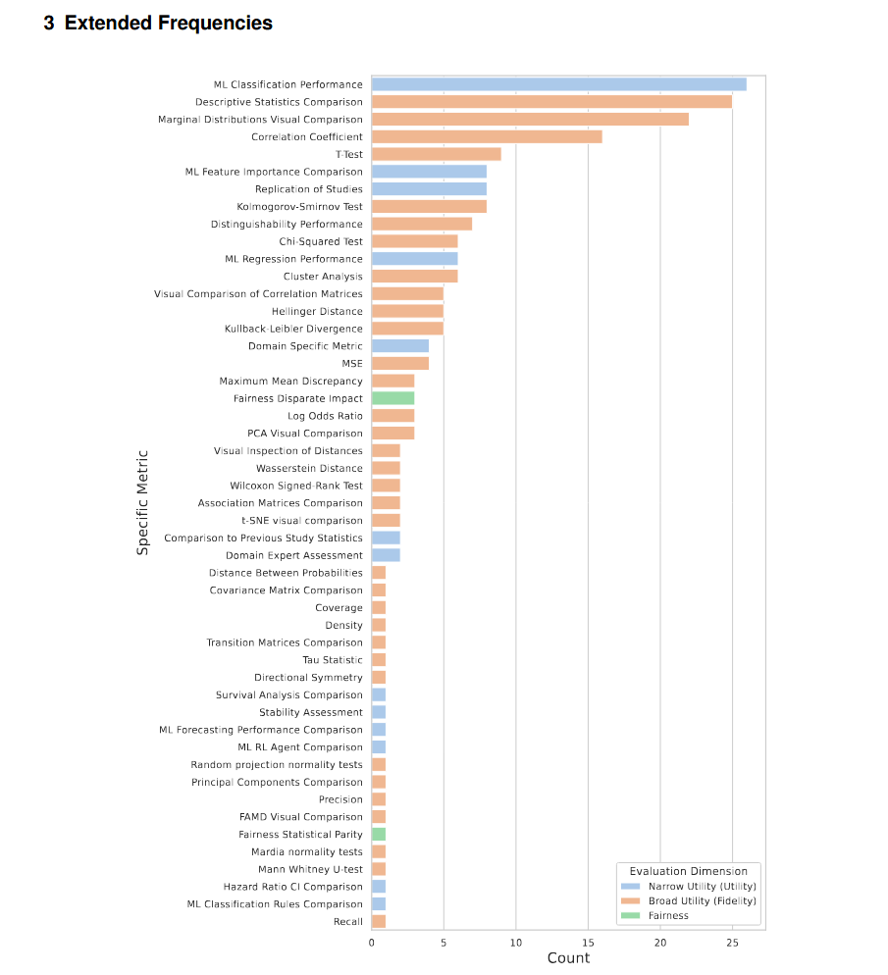

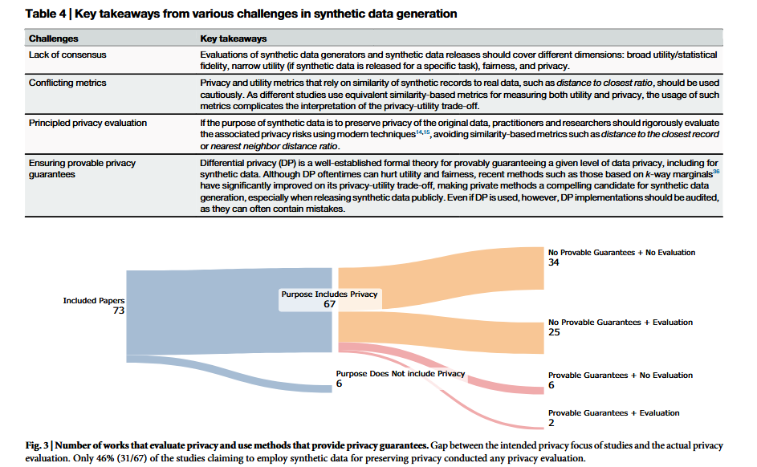

- We found that the privacy aspect of synthetic data for the purpose of preserving privacy do not evaluate the residual privacy risk.
- Practitioners may inadvertently assume that synthetic data they are generating is privacy preserving by default.
- We found that most works that use synthetic data for the purpose of preserving privacy do not evaluate the residual privacy risks.
- The dependence of similarity-based metrics for privacy evaluation is inadequate for two reasons
(1) Such metrics do not reflect that privacy guarantees faithfully, e.g. There can exist successful inference attacks even if synthetic data is dissimilar from the original dataset.
(2) The publication of similarity based metrics on its own can lead to novel privacy risks such as reconstruction attacks that leverage the reported metrics.
Taxonomy: Performance Related measures:
1. Broad Utility : (These methods are designed to capture specific aspects of data utility, ranging from straightforward one-dimensional comparisons to more complex analyses involving multiple variables and temporal patterns)
a. Univariate similarity
b. Bivariate similarity
c. Multivariate similarity
d. Longitudinal similarity
2. Narrow Utility (Focuses on the performance of synthetic data in specific tasks or contexts, it evaluates how well the data serves particular purposes, such as improving model accuracy for a specific prediction task or supporting a specific type of statistical analysis)
3. Fairness (The fairness dimension examines how well synthetic data provides equitable treatment across different groups)

