A Proposal for a Master’s Thesis

To be Entitled

HIV PrEP-DART (Data Analysis and Reporting Tool):
A Privacy-Preserving Data Pipeline Incorporating Synthetic data for Public Health Analytics Using the Health Data Lab Framework
by

[Gokul Thothathri]

To Be Submitted in Fulfillment for the Degree of MASTER OF SCIENCE BIOINFORMATICS

21 - 02 - 2025

Approved: _______________________  (Thesis Advisor/Examiner 1) |  |  |  | Date: ______________
Approved: _______________________  (Supervisor/Examiner 2) |  |  |  | Date: ______________

Title
HIV PrEP-DART (Data Analysis and Reporting Tool): A Privacy-Preserving Data Pipeline Incorporating Synthetic Data for Public Health Analytics Using the Health Data Lab Framework

Abstract
HIV pre-exposure prophylaxis (PrEP) programs are essential in preventing the transmission of HIV, requiring efficient monitoring and reporting frameworks to assess their reach and impact. This master thesis aims to develop a robust and scalable data analysis pipeline with emphasis on Synthetic Data Generation (SDG) techniques for reporting HIV-PrEP indicators, leveraging the indicator framework defined by the European Centre for Disease Prevention and Control (ECDC) [1]. Using dataset structure provided by the Health Data Lab, the methodology will automate data cleaning, integration, and transformation processes to compute and report key metrics. It will integrate relational data across multiple tables, as defined by the dataset's entity-relationship model (ER Diagrams), and maps indicators to relevant fields, such as patient demographics, prEP prescriptions, adherence records, and laboratory results, for computational calculation [2]. Traditional approaches of synthetic data generation (SDG) are widely used as a privacy-preserving technique which defends against linking attacks by suppression and generalization. The methodology outputs metrics called “PrEP indicators”, offering insights into program performance while remaining adaptable to future extensions or real-world data followed by benchmarking the expected results with different Synthetic Data Generation Algorithms (SDG) algorithms. By reducing the time and effort required for reporting, the proposed pipeline not only supports efficient monitoring of HIV-PrEP programs but also serves for better understandability of the underlying data structure and correlations between the medical data variables [3]. The research in this master thesis is guided by the following key questions:
RQ1: “How does the HIV-PrEP DART pipeline enhance the automation, scalability, and accuracy of PrEP indicator reporting in HIV surveillance systems?
RQ2: “How do different Synthetic Data Generation (SDG) techniques impact the accuracy and reliability of PrEP indicators in HIV-PrEP surveillance systems?”

Introduction

3.1 Health Data: Resources and Tools from FDZ Gesundheit (DaTrav Structure)

The Health Data Lab (FDZ Gesundheit) is a research infrastructure that provides access to anonymized health-related datasets collected from healthcare providers, insurance claims, and public health institutions in Germany. These datasets are curated to support research in public health, epidemiology and health informatics while ensuring strict compliance with data protection regulations. The Health Data Lab (FDZ Gesundheit) provides descriptions of resources and documentation to support researchers in accessing and analyzing health-related datasets. FDZ Gesundheit offers a detailed description of the available datasets, outlining their structure, variables, and interrelationships. A dedicated platform includes comprehensive information about the datasets, such as variable definitions, coding systems, and data formats. To assist researchers in understanding the data architecture, the site provides Entity-Relationship (ER) diagrams, which visually map the relationships between tables, facilitating efficient data integration and analysis. Additionally, the main FDZ Gesundheit website explains the broader context and purpose of the data lab, emphasizing its role in offering secure access to health data for research. The site highlights the measures taken to ensure data anonymization, including techniques such as k-anonymity, pseudonym replacement, and selective sampling, which preserve privacy while maintaining data utility in a broader context. This ensures that sensitive health data can be analyzed ethically and responsibly. Furthermore, FDZ Gesundheit focuses on enabling data-driven public health research by providing secure and well-documented data pipelines for analysis. These combined resources empower researchers to work confidently with complex health datasets, allowing for robust analyses and informed decision-making. Together, the documentation and tools provided by FDZ Gesundheit serve as a foundational database for advancing public health research in compliance with privacy and ethical standards.

3.2 PrEP Indicators: Measuring the Impact of HIV Prevention Strategies
The project “Surveillance of HIV pre-exposure prophylaxis” provision within the SHI system in Germany (PrEP Surv), initiated by Robert Koch-Institute and financed by the German Federal Ministry of Health (BMG), represents a pivotal effort in the surveillance and evaluation of HIV pre-exposure prophylaxis (PrEP) among HIV-negative population in Germany. Building on the outcomes of the prior project, "Evaluation of the Introduction of HIV Pre-Exposure Prophylaxis as a Benefit of Statutory Health Insurance (EvE-PrEP)", PrEP Surv was designed to monitor the efficacy and reach of PrEP within the framework of statutory health insurance (SHI). The initiative encompasses key components of PrEP care, including the administration of [tenofovir disoproxil + emtricitabine, TDF/FTC] [4], patient counseling, medication supply, and associated medical precautions such as diagnostic follow-ups. The launch of PrEP Surv marked the translation of evaluation findings into a structured surveillance program, aligned with EU-PrEP monitoring guidelines. Project PrEP Surv operated across three interconnected modules: (1) secondary data collection from pharmacies, health insurers, and FDZ, (2) enhancement of data collection from German HIV specialty care centers within the dägna network to strengthen PrEP service reporting, and (3) collaboration with communities with a potential need for PrEP to identify barriers to PrEP access and address unmet needs in HIV prevention. By leveraging these comprehensive data streams, PrEP Surv aimed to advance the penetration of PrEP services and establish an evidence-based foundation for future HIV monitoring strategies in Germany.
The framework includes indicators that are categorized into three domains: pre-uptake, uptake and coverage, and continued and effective use [6]. Pre-uptake indicators evaluate factors influencing PrEP adoption, such as service availability, awareness among potential users, and willingness to use prEP Uptake and coverage indicators measure the actual utilization and reach of PrEP, focusing on metrics like the number of current and new PrEP users, overall PrEP coverage, and the PrEP-to-Need Ratio (PnR), which serves as a proxy for assessing coverage. Continued and effective use indicators examine the sustainability and effectiveness of PrEP over time, tracking metrics like recent PrEP use among individuals newly diagnosed with HIV and the continuation rates of users after 12 months. These indicators are further classified into core, supplementary, and optional categories, based on their importance and feasibility for regular monitoring. Core indicators are essential and feasible for routine use, supplementary indicators provide valuable insights but may require additional resources, and optional indicators offer deeper understanding but are less practical for standard reporting. By implementing this structured indicator metrics, PrEP program performance can be systematically assessed, gaps identified, and strategies optimized to enhance HIV prevention efforts across diverse populations. Monitoring will be vital to understand whether programs succeed in engaging people into using PrEP appropriately, and in reducing the HIV epidemic. [5]

Objectives
1. Design and implement a scalable, automated, and privacy-preserving data pipeline for HIV-PrEP indicator reporting using the Health Data Lab (FDZ Gesundheit) framework.
2. Compare and evaluate different Synthetic Data Generation (SDG) techniques across three classes
- Class 1: Fundamental/Basic Anonymization (FDZ standard techniques).
- Class 2: Statistical and Perturbation-Based Techniques.
- Class 3: Privacy-Preserving Computational-Based Techniques.
3. Validate the accuracy, reliability, and effectiveness of PrEP indicators (e.g., PrEP coverage, adherence, retention rates, and PrEP-to-Need Ratio) derived from the synthetic datasets.

Literature Review
- A Review of Anonymization for Healthcare Data [7]
- Monitoring HIV pre-exposure prophylaxis programs in the EU/EEA (ECDC, 2024)
- Algorithms to anonymize structured medical and healthcare data: A systematic review [8]
- A richly interactive exploratory data analysis and visualization tool using electronic medical records [9]
- Effective Environmental Public Health Surveillance Programs: A Framework for identifying and evaluating data resources and indicators [10]
- Interactive Visualization Applications in Population Health and Health Services Research: Systematic Scoping Review [11]

Methodology

Data Collection using Synthetic Data Generation: Public Use Files (PUF)

The master thesis project utilizes synthetically generated datasets to simulate real-world data while preserving privacy and confidentiality requirements. The synthetic data is created using the framework provided by the Health Data Lab (FDZ Gesundheit) [12]. The Public Use File (PUF) repository enables researchers to develop and test analysis pipelines with datasets that mimic the structure and schema of FDZ’s actual datasets, including entity-relationship (ER) models and variable specifications. The PUF data is modeled to replicate the relationships between various entities in the FDZ datasets. These include patient demographics, prescription data, healthcare service utilization and regional health statistics. The synthetic nature of PUF data ensures privacy by destroying correlations, effectively preventing the extraction of sensitive insights or interferences that could compromise confidentiality. While the dataset will be structured like real-world data, it does not maintain the underlying relationship or patterns that exists in the actual data. However, this generalized SDG techniques (combination of K-anonymization, Pseudonymization, Random Shuffling, Data shuffling, Generalization, Suppression, Secondary Pseudonym pools, Column Segmentation) given by FDZ (ForschungsDatenZentrum) ignores individual differences and may lead to information loss if not optimized for narrow utility goal of HIV PrEP-DART. The PrEP indicator value depends on the how these synthetic data layouts are generated, which in turn may skew the results if PUF generation methods are different. Evaluation of synthetic data generators and synthetic data releases should cover different dimensions: broad utility/statistical fidelity, narrow utility (if synthetic data is released for a specific task), fairness and privacy [13]. This master thesis project aims to investigate whether better synthetic data generation methods ensures better results and usability. There exists a false sense of security bias that the practitioners may inadvertently assume that synthetic data the algorithms are generating is privacy preserving by default [13].

Pipeline Architecture: HIV PrEP-DART (HIV PrEP- Data Analysis and Reporting Tool)

The HIV PrEP DART architecture involves multiple stages, each designed to ensure the pipeline is scalable, efficient, and compliant with privacy standards. The pipeline begins with dataset model provided by the Health Data Lab (FDZ Gesundheit), which serves as the foundation for the PUF generated data. Further, the project will assess its impact through key metrics aligned with indicators and overall the PUF structure maintains the same structure as the DaTrav structure with core components of Entity-Relationship (ER) models, tables and variables, Data models and structural components such as Primary Keys (PK), relationships, Hierarchical Variables, Anonymized data and standardization. The pipeline outputs tabular summaries and visualizations, created using Python libraries such as Matplotlib, Seaborn, and Plotly. These outputs are not designed for real-world public health monitoring but rather serve as benchmarks for demonstrating the pipeline's functionality and readiness for future integration with real world datasets. This architecture illustrates how the PrEP-DART pipeline processes PUF datasets, maps them to standardized PrEP indicators, and converts anonymized data into meaningful insights for further evaluation and reporting. 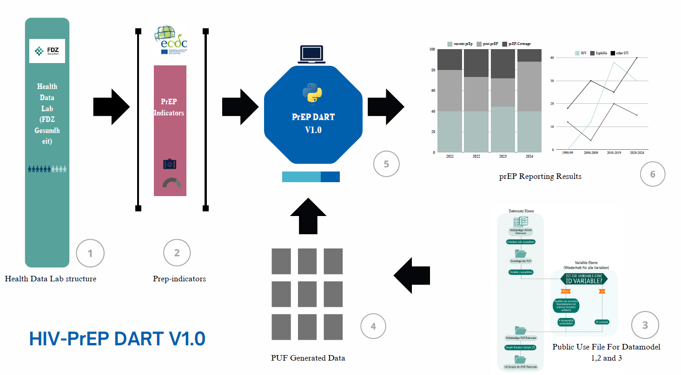
Figure 1: HIV-PrEP DART Anonymization Framework: Classification of Anonymization Techniques

Data Analysis: Data Processing, Integration, and Analytical Framework for HIV-PrEP Indicator Evaluation
The data pre-processing steps include handling missing or inconsistent values, standardizing formats across datasets (e.g., date formats, variable names), and removing duplicates or irrelevant records to ensure data quality. These computations will be performed for specific timeframes (e.g., annually and quarterly) to facilitate trend monitoring. The data analysis framework will include:
(1) Descriptive Analysis, to provide an overview of the dataset and key metrics.
(2) PrEP-Trend analysis, to monitor changes in PrEP indicators over time.
(3) Comparative Analysis, to identify disparities in prEP adoption across demographics or regions using group-wise comparisons (e.g., by age, gender, geography).
(4) Predictive Insights, to forecast future trends in prEP adoption and its impact on historical data.
(5) Indicator-Specific Insights – Identifies service gaps in PrEP coverage, assesses program effectiveness in reducing new infections (PnR), and evaluates adherence and retention trends among PrEP users
The resulting insights empower beneficiaries to make data-driven decisions, optimize resource allocation, and enhance the overall impact of HIV prevention programs.

6.4 Classification of Synthetic Data Generation (SDG) Techniques for Privacy-Preserving Health Data Processing
This study classifies Synthetic Data Generation (SDG) techniques into three categories to systematically evaluate their impact on pipeline results; Class 1: Fundamental/Basic Anonymization (given by FDZ): These include k-anonymization, pseudonymization, random shuffling, generalization, suppression, secondary pseudonym pools, and column segmentation, forming the baseline anonymization methods used in FDZ’s synthetic data framework. Class 2: Statistical and Perturbation-Based Techniques: This class includes top-bottom coding, micro-aggregation, bucketing (binning), masking and reduction, noise addition (data perturbation), and data swapping. These techniques introduce statistical variations to balance privacy and data utility, making them suitable for structured health data transformation. These methods are particularly effective in scenarios where data needs to be shared for research or analysis without exposing individual identities. However, they require careful calibration to ensure that the introduced modifications do not significantly distort the data's utility [14]. Class 3: Privacy-Preserving Computational-Based Techniques – This includes differential privacy and homomorphic encryption, which offer a higher degree of mathematical privacy protection, ensuring that synthetic data generation does not leak information about real individuals while maintaining analytical validity. Implementing such methods ensures that data can be utilized for valuable insights without compromising individual privacy. [15]

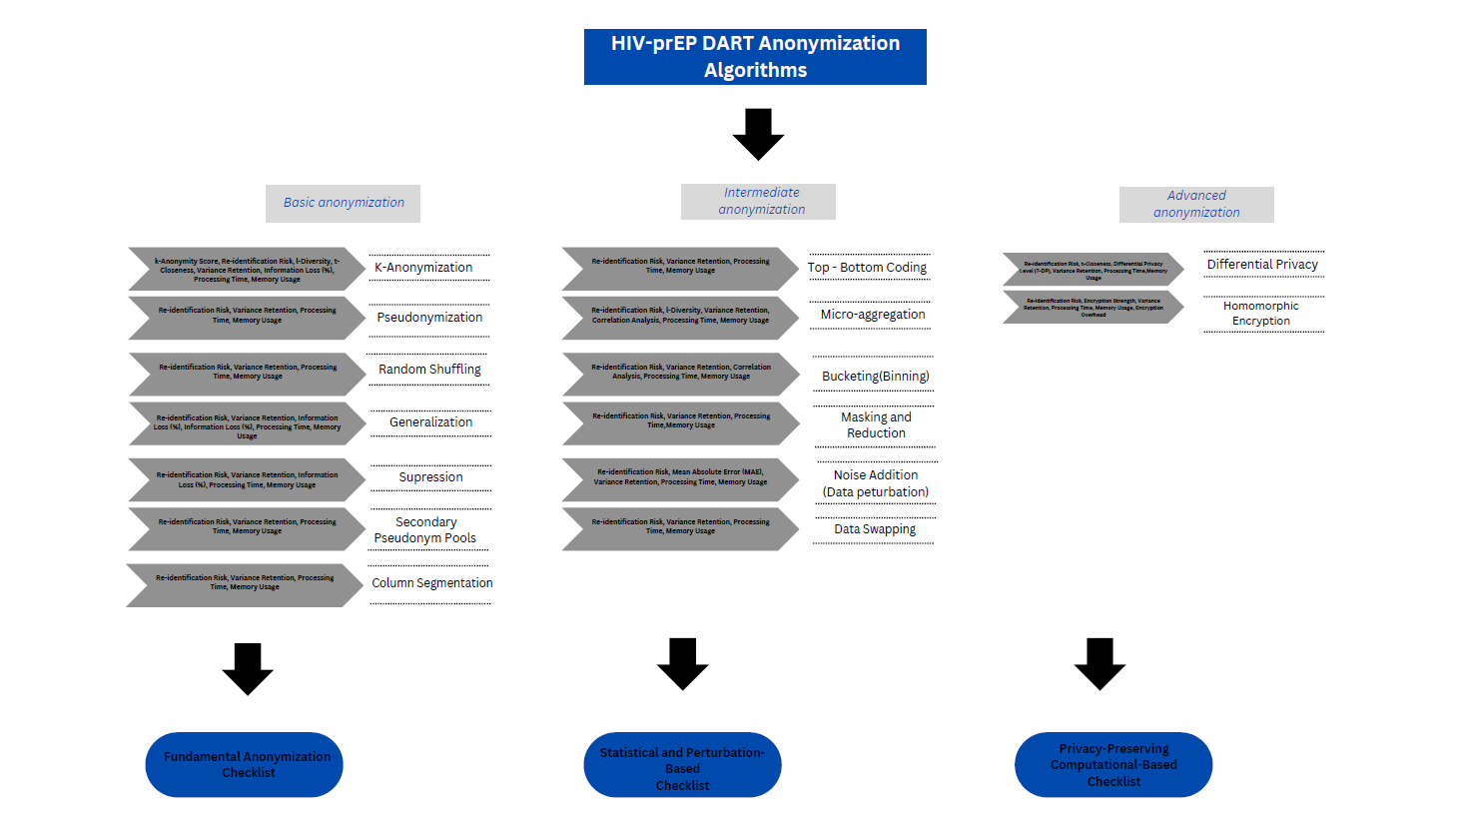

Figure 1: HIV-PrEP DART Anonymization Framework: Classification of Anonymization Techniques

The anonymization evaluation for each class after the synthetic data generation step serves as a structured framework to assess the effectiveness of synthetic data generation techniques and to ensuring privacy while maintaining analytical utility. Evaluation is based on metrics such as re-identification risk, variance retention, and information loss; Statistical and Perturbation-Based Techniques, such as top-bottom coding, micro-aggregation, data swapping, and noise addition, which focus on correlation analysis, mean absolute error (MAE), and variance reduction to balance privacy and statistical accuracy; and Privacy-Preserving Computational-Based Techniques, including differential privacy[16,17] and homomorphic encryption, which emphasize computational security, privacy guarantees, and data fidelity. However, a common security bias—the representativeness heuristic—leads to the mistaken assumption that synthetic data is inherently private simply because it differs from real data. This misconception can result in overlooked privacy vulnerabilities. By systematically applying this evaluation, the generated synthetic datasets undergo rigorous validation to ensure that privacy protection mechanisms do not excessively distort data utility, making them optimized for HIV-PrEP DART indicator analysis.

Timeline

Phase | Duration | Deliverables
Literature Review | 3 weeks | Annotated bibliography, draft background on PrEP indicators, privacy techniques
Data Collection | 2 weeks | Validation of FDZ Dataset Integration and PUF Generation
Framework Development | 2 months | A functional prototype of the data pipeline capable of processing synthetic PUF datasets and computing key PrEP indicators.
Indicator Mapping | 3 weeks | Mapping of ECDC-defined indicators to the PUF datasets
Data Analysis | 1 month | Statistical models, calculations of PrEP indicators, and initial visualizations
Automated Reporting | 2 weeks | Reports with tables and visualizations, final testing
Validation and Testing | 2 weeks | Validation with different mock datasets, and classes of Synthetic Data Generation methods followed by accuracy testing
Thesis Writing | continuous | Final thesis including methodology, results, and discussions

References

- European Centre for Disease Prevention and Control. (n.d.). Monitoring HIV pre-exposure prophylaxis programmes in the EU/EEA: HIV-PrEP indicators. Retrieved January 6, 2025, from
https://www.ecdc.europa.eu/assets/hiv-monitoring-preexposure/prep-indicators.html
- Forschungsdatenzentrum Gesundheit. (n.d.). Gesundheitsdaten am FDZ Gesundheit. Retrieved January 6, 2025, from https://www.forschungsdatenzentrum-gesundheit.de/gesundheitsdaten-amfdz-gesundheit
- Yasnoff, W. A., Overhage, J. M., Humphreys, B. L., LaVenture, M., Goodman, K. W., Gatewood,
L., Ross, D. A., Reid, J., Hammond, W. E., Dwyer, D., Huff, S. M., Gotham, I., Kukafka, R., Loonsk, J. W., & Wagner, M. M. (2001). A national agenda for public health informatics. Journal of public health management and practice: JPHMP, 7(6), 1–21. https://doi.org/10.1097/00124784-20010706000002
- Gelbe Liste. (n.d.). Tenofovirdisoproxil und Emtricitabin (ATC-Code: J05AR03). Retrieved January
6, 2025, from https://www.gelbe-liste.de/atc/Tenofovirdisoproxil-und-Emtricitabin_J05AR03
- Wijstma, Elinea; Vanhamel, Jefa; Deblonde, Jessikab; Nöstlinger, Christianaa; Noori, Teymurc; Vuylsteke, Beaa; Laga, Mariea. An overview of programmatic indicators to monitor the roll-out of
HIV preexposure prophylaxis. AIDS 37(1): p 1-17, January 1, 2023. | DOI: 10.1097/QAD.0000000000003399
- European Centre for Disease Prevention and Control. (n.d.). HIV pre-exposure prophylaxis (PrEP) monitoring: Indicators. Retrieved January 7, 2025, from https://www.ecdc.europa.eu/assets/hivmonitoring-preexposure/prep-indicators.html
- Olatunji, I. E., Rauch, J., Katzensteiner, M., & Khosla, M. (2024). A Review of Anonymization for Healthcare Data. Big data, 12(6), 538–555. https://doi.org/10.1089/big.2021.0169
- Sepas, A., Bangash, A. H., Alraoui, O., El Emam, K., & El-Hussuna, A. (2022). Algorithms to anonymize structured medical and healthcare data: a systematic review. Frontiers in Bioinformatics, 2, 984807.
- Huang, C. W., Lu, R., Iqbal, U., Lin, S. H., Nguyen, P. A., Yang, H. C., ... & Jian, W. S. (2015). A richly interactive exploratory data analysis and visualization tool using electronic medical records. BMC medical informatics and decision making, 15, 1-14.
- Malecki, K. C., Resnick, B., & Burke, T. A. (2008). Effective environmental public health surveillance programs: a framework for identifying and evaluating data resources and indicators. Journal of Public Health Management and Practice, 14(6), 543-551.
- Chishtie, J., Bielska, I. A., Barrera, A., Marchand, J. S., Imran, M., Tirmizi, S. F. A., ... & Jaglal, S. (2022). Interactive visualization applications in population health and health services research:
systematic scoping review. Journal of medical Internet research, 24(2), e27534.
- Qian, J., Jiang, H., Yu, Y., Wang, H., & Miao, D. (2024). Multi-level personalized k-anonymity privacy-preserving model based on sequential three-way decisions. Expert Systems with Applications, 239, 122343. https://doi.org/10.1016/j.eswa.2023.122343
- Kaabachi, Bayrem, et al. "A scoping review of privacy and utility metrics in medical synthetic data." NPJ digital medicine 8.1 (2025): 60.
- Sepas, Ali et al. “Algorithms to anonymize structured medical and healthcare data: A systematic review.” Frontiers in bioinformatics vol. 2 984807. 22 Dec. 2022, doi:10.3389/fbinf.2022.984807
- Huang, Yan, and Jacob Imola. "Differential Privacy: A Comprehensive Survey." arXiv, preprint, 18 Oct. 2022, arxiv.org/abs/2210.09963.
- Goncalves, Andre, et al. "Generation and evaluation of synthetic patient data." BMC medical research methodology 20 (2020): 1-40.
- Osorio-Marulanda, Pablo A., et al. "Privacy mechanisms and evaluation metrics for Synthetic Data Generation: A systematic review." IEEE Access (2024).

