A Proposal for a Master’s Thesis

To be Entitled

HIV PrEP-DART (Data Analysis and Reporting Tool):
A Privacy-Preserving Data Pipeline Incorporating Synthetic data for Public Health Analytics Using the Health Data Lab Framework
by

[Gokul Thothathri]

To Be Submitted in Fulfillment for the Degree of MASTER OF SCIENCE BIOINFORMATICS

29 - 01 - 2025

Approved: _______________________  (Thesis Advisor/Examiner 1) |  |  |  | Date: ______________
Approved: _______________________  (Supervisor/Examiner 2) |  |  |  | Date: ______________

Title
HIV PrEP-DART (Data Analysis and Reporting Tool): A Privacy-Preserving Data Pipeline Incorporating Synthetic Data for Public Health Analytics Using the Health Data Lab Framework

Abstract
HIV pre-exposure prophylaxis (PrEP) programs are essential in preventing the transmission of HIV, requiring efficient monitoring and reporting frameworks to assess their reach and impact. This master thesis aims to develop a robust and scalable data analysis pipeline with emphasis synthetic data generation techniques for reporting HIV-PrEP indicators, leveraging the indicator framework defined by the European Centre for Disease Prevention and Control (ECDC) [1]. Using dataset structure provided by the Health Data Lab, the methodology will automate data cleaning, integration, and transformation processes to compute and report key metrics. It will integrate relational data across multiple tables, as defined by the dataset's entity-relationship model (ER Diagrams), and maps indicators to relevant fields, such as patient demographics, prEP prescriptions, adherence records, and laboratory results, for computational calculation [2]. Traditional approaches of synthetic data generation (SDG) are widely used as a privacy-preserving technique which defends against linking attacks by suppression and generalization. However, this generalized SDG techniques (combination of K-anonymization, Pseudonymization, Random Shuffling, Data shuffling, Generalization, Suppression, Secondary Pseudonym pools, Column Segmentation) given by FDZ (Forschungsdatenzentrum) ignores individual differences and may lead to information loss if not optimized for narrow utility goal of HIV PrEP-DART. The methodology outputs metrics called “PrEP indicators”, offering insights into program performance while remaining adaptable to future extensions or real-world data. This master thesis project aims to address the critical challenges in public health informatics, such as the automation of complex reporting tasks, by focusing on the development of scalable data analysis pipeline by benchmarking the expected results with better SDG algorithms. By reducing the time and effort required for reporting, the proposed pipeline not only supports efficient monitoring of HIV-PrEP programs but also serves for better understandability of the underlying data structure and correlations between the medical data variables [3]. The results are expected to contribute to public health decision-making and improve resource allocation for HIV prevention strategies with emphasis on Synthetic Data Generation techniques.

Introduction

Health Data: Resources and Tools from FDZ Gesundheit (DaTrav Structure)

The Health Data Lab (FDZ Gesundheit) is a research infrastructure that provides access to anonymized health-related datasets collected from healthcare providers, insurance claims, and public health institutions in Germany. These datasets are curated to support research in public health, epidemiology and health informatics while ensuring strict compliance with data protection regulations. The Health Data Lab (FDZ Gesundheit) provides descriptions of resources and documentation to support researchers in accessing and analyzing health-related datasets. FDZ Gesundheit offers a detailed description of the available datasets, outlining their structure, variables, and interrelationships. A dedicated platform includes comprehensive information about the datasets, such as variable definitions, coding systems, and data formats. To assist researchers in understanding the data architecture, the site provides Entity-Relationship (ER) diagrams, which visually map the relationships between tables, facilitating efficient data integration and analysis. Additionally, the main FDZ Gesundheit website explains the broader context and purpose of the data lab, emphasizing its role in offering secure access to health data for research. The site highlights the measures taken to ensure data anonymization, including techniques such as k-anonymity, pseudonym replacement, and selective sampling, which preserve privacy while maintaining data utility in a broader context. This ensures that sensitive health data can be analyzed ethically and responsibly. Furthermore, FDZ Gesundheit focuses on enabling data-driven public health research by providing secure and well-documented data pipelines for analysis. These combined resources empower researchers to work confidently with complex health datasets, allowing for robust analyses and informed decision-making. Together, the documentation and tools provided by FDZ Gesundheit serve as a foundational database for advancing public health research in compliance with privacy and ethical standards.

3.1 PrEP Indicators: Measuring the Impact of HIV Prevention Strategies
The project “Surveillance of HIV pre-exposure prophylaxis” provision within the SHI system in Germany (PrEP Surv), initiated by Robert Koch-Institute and financed by the German Federal Ministry of Health (BMG), represents a pivotal effort in the surveillance and evaluation of HIV pre-exposure prophylaxis (PrEP) among HIV-negative population in Germany. Building on the outcomes of the prior project, "Evaluation of the Introduction of HIV Pre-Exposure Prophylaxis as a Benefit of Statutory Health Insurance (EvE-PrEP)", PrEP Surv was designed to monitor the efficacy and reach of PrEP within the framework of statutory health insurance (SHI). The initiative encompasses key components of PrEP care, including the administration of [tenofovir disoproxil + emtricitabine, TDF/FTC] [4], patient counseling, medication supply, and associated medical precautions such as diagnostic follow-ups. The launch of PrEP Surv marked the translation of evaluation findings into a structured surveillance program, aligned with EU-PrEP monitoring guidelines. Project PrEP Surv operated across three interconnected modules: (1) secondary data collection from pharmacies, health insurers, and FDZ, (2) enhancement of data collection from German HIV specialty care centers within the dägna network to strengthen PrEP service reporting, and (3) collaboration with communities with a potential need for PrEP to identify barriers to PrEP access and address unmet needs in HIV prevention. By leveraging these comprehensive data streams, PrEP Surv aimed to advance the penetration of PrEP services and establish an evidence-based foundation for future HIV monitoring strategies in Germany.
The European Centre for Disease Prevention and Control (ECDC) has established a comprehensive framework for monitoring HIV pre-exposure prophylaxis (PrEP) programs across the EU/EEA [6]. This framework includes indicators that are categorized into three domains: pre-uptake, uptake and coverage, and continued and effective use. Pre-uptake indicators evaluate factors influencing PrEP adoption, such as service availability, awareness among potential users, and willingness to use prEP Uptake and coverage indicators measure the actual utilization and reach of PrEP, focusing on metrics like the number of current and new PrEP users, overall PrEP coverage, and the PrEP-to-Need Ratio (PnR), which serves as a proxy for assessing coverage. Continued and effective use indicators examine the sustainability and effectiveness of PrEP over time, tracking metrics like recent PrEP use among individuals newly diagnosed with HIV and the continuation rates of users after 12 months. These indicators are further classified into core, supplementary, and optional categories, based on their importance and feasibility for regular monitoring. Core indicators are essential and feasible for routine use, supplementary indicators provide valuable insights but may require additional resources, and optional indicators offer deeper understanding but are less practical for standard reporting. By implementing this structured indicator metrics, PrEP program performance can be systematically assessed, gaps identified, and strategies optimized to enhance HIV prevention efforts across diverse populations. This robust monitoring framework enables data-driven decision-making to advance public health objectives. Monitoring will be vital to understand whether programs succeed in engaging people into using PrEP appropriately, and in reducing the HIV epidemic. [5]

Objectives
- To generate PUF using FDZ proposed Synthetic Data Generation (SDG) method.
- To develop a robust data pipeline, named PrEP-DART (prEP- Data Analysis and Reporting Tool), for automating data processing and reporting.
- To map ECDC-defined PrEP indicators to the Health Data Lab datasets for computational calculation. (Core, supplementary and optional PrEP indicators, such as PrEP coverage, new PrEP Users, and PrEP-to-Need Ratio (PnR), in alignment with EU guidelines and ensuring the reporting system is adaptable for real-world data and future extensions.
- Validate the HIV PrEP DART pipeline’s performance by benchmarking Class 2 and Class 3 Synthetic Data Generation methods against Class 1 SDG, analyzing their impact on results.

Literature Review
- A Review of Anonymization for Healthcare Data [7]
- Monitoring HIV pre-exposure prophylaxis programs in the EU/EEA (ECDC, 2024)
- Algorithms to anonymize structured medical and healthcare data: A systematic review [8]
- A richly interactive exploratory data analysis and visualization tool using electronic medical records [9]
- Effective Environmental Public Health Surveillance Programs: A Framework for identifying and evaluating data resources and indicators [10]
- Interactive Visualization Applications in Population Health and Health Services Research: Systematic Scoping Review [11]

Methodology

Data Collection using Synthetic Data Generation: Public Use Files (PUF)

The master thesis project utilizes synthetically generated datasets to simulate real-world data while preserving privacy and confidentiality requirements. The synthetic data is created using the framework provided by the Health Data Lab (FDZ Gesundheit) [12]. The Public Use File (PUF) repository enables researchers to develop and test analysis pipelines with datasets that mimic the structure and schema of FDZ’s actual datasets, including entity-relationship (ER) models and variable specifications. The PUF data is modeled to replicate the relationships between various entities in the FDZ datasets. These include patient demographics, prescription data, healthcare service utilization and regional health statistics. The data structure is based on ER diagrams that define the relationship between the tables, making it suitable for developing and testing relational databases. The synthetic nature of PUF data ensures privacy by destroying correlations, effectively preventing the extraction of sensitive insights or interferences that could compromise confidentiality. While the dataset will be structured like real-world data, it does not maintain the underlying relationship or patterns that exists in the actual data. However, the architecture of PUF Generation provided by the framework may or may not be optimized for HIV PrEP-DART architecture since the purpose of the PUF generation falls under broad utility whereas HIV PrEP-DART is focused on narrow utility used-case. The PrEP indicator value depends on the how these synthetic data layouts are generated, which in turn may skew the results if PUF generation methods are different. Evaluation of synthetic data generators and synthetic data releases should cover different dimensions: broad utility/statistical fidelity, narrow utility (if synthetic data is released for a specific task), fairness and privacy [13]. This master thesis project aims to investigate whether better synthetic data generation methods ensures better results and usability. There exists a false sense of security bias that the practitioners may inadvertently assume that synthetic data the algorithms are generating is privacy preserving by default [13]. The master thesis incorporates three classes of Synthetic Data Generation (SDG) techniques (1) Fundamental/Basic Anonymization (given by FDZ): These include k-anonymization, pseudonymization, random shuffling, generalization, suppression, secondary pseudonym pools, and column segmentation, forming the baseline anonymization methods used in FDZ’s synthetic data framework. (2) Statistical and Perturbation-Based Techniques: This class includes top-bottom coding, micro-aggregation, bucketing (binning), masking and reduction, noise addition (data perturbation), and data swapping. These techniques introduce statistical variations to balance privacy and data utility, making them suitable for structured health data transformation. (3) Privacy-Preserving Computational-Based Techniques – This includes differential privacy and homomorphic encryption, which offer a higher degree of mathematical privacy protection, ensuring that synthetic data generation does not leak information about real individuals while maintaining analytical validity.

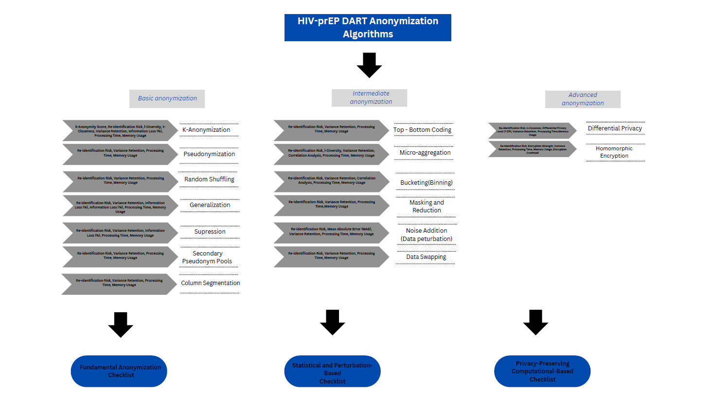

Figure 1: HIV-PrEP DART Anonymization Framework: Classification of Anonymization Techniques

The anonymization checklist for each class after the synthetic data generation step serves as a structured evaluation framework to assess the effectiveness of synthetic data generation techniques in ensuring privacy while maintaining analytical utility. Evaluation is based on metrics such as re-identification risk, variance retention, and information loss; Statistical and Perturbation-Based Techniques, such as top-bottom coding, micro-aggregation, data swapping, and noise addition, which focus on correlation analysis, mean absolute error (MAE), and variance reduction to balance privacy and statistical accuracy; and Privacy-Preserving Computational-Based Techniques, including differential privacy and homomorphic encryption, which emphasize computational security, privacy guarantees, and data fidelity. By systematically applying this checklist, the generated synthetic datasets undergo rigorous validation to ensure that privacy protection mechanisms do not excessively distort data utility, making them reliable for HIV-PrEP DART indicator analysis while preventing potential re-identification risks. The evaluation framework helps to understand whether and why the results vary for different Synthetic Data Generation (SDG) methods compared to the fundamental Synthetic Data Generation (SDG) method given by the FDZ. By running this evaluation framework, researchers can better understand the DaTrav Structure, which defines how health-related datasets are organized and accessed within the Health Data Lab (FDZ Gesundheit).

Pipeline Architecture: prEP-DART (prEP- Data Analysis and Reporting Tool)

The development of the prEP-DART (prEP- Data Analysis and Reporting Tool) pipeline involves creating a robust, automated system for processing and analyzing health datasets to compute key PrEP indicators. This process includes multiple stages, each designed to ensure the pipeline is scalable, efficient, and compliant with privacy standards. The pipeline begins with dataset model provided by the Health Data Lab (FDZ Gesundheit), which serves as the foundation for the PUF generated data. Further, mapping of relevant fields in the generated data to the ECDC-defined indicators for accurate calculations. The pipeline outputs tabular summaries and visualizations, created using Python libraries such as Matplotlib, Seaborn, and Plotly. These outputs are not designed for real-world public health monitoring but rather serve as benchmarks for demonstrating the pipeline's functionality and readiness for future integration with real world datasets. This architecture demonstrates how the prEP- Data Analysis and Reporting Tool pipeline integrates with PUF datasets, aligns them with standardized PrEP indicators, and transforms anonymized data into actionable insights. By leveraging privacy-preserving methods and automated workflows, the pipeline lays the foundation for efficient and ethical reporting and validation to support public health monitoring and improve resource allocation for HIV prevention strategies.
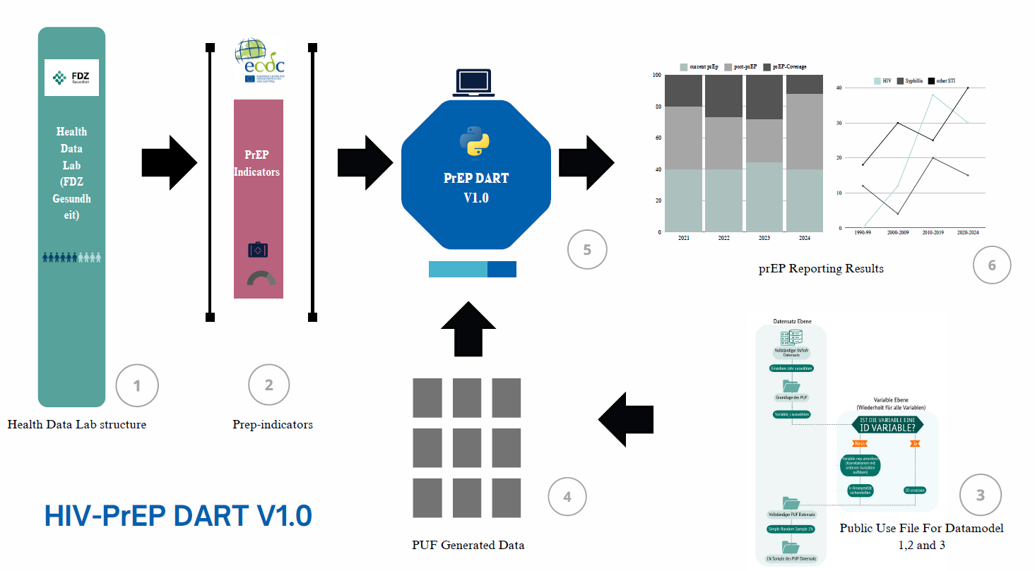
Figure 1: HIV-PrEP DART Anonymization Framework: Classification of Anonymization Techniques

Data Analysis
The project will assess its impact through key metrics aligned with the ECDC-defined indicators and overall the PUF structure maintains the same structure as the DaTrav structure with core components of Entity-Relationship (ER) models, tables and variables, Data models and structural components such as Primary Keys (PK), relationships, Hierarchical Variables, Anonymized data and standardization. The data pre-processing steps include handling missing or inconsistent values, standardizing formats across datasets (date formats, variable names) followed by removing duplicates and irrelevant records. Secondly, the algorithm uses ER diagrams to integrate relational datasets, ensuring consistency in linking tables such as patient records, prescriptions, and service data. Further the algorithm maps relevant data fields to the core, supplementary and optional indicators defined by the European Centre for Disease Prevention and Control (ECDC). These computations are performed for specific timeframes (eg., annually and quarterly) to monitor trends. The validations will be performed using running test cases on mock datasets to ensure accuracy and comparing calculated metrics against benchmark values and historical data. The data analysis will be distinguished as (1) Descriptive Analysis, to provide an overview of the dataset and key metrics (2) prEP-Trend analysis, to monitor changes in prEP indicators over time (3) Comparative Analysis, to identify disparities in prEP adoption across demographics or regions using group-wise comparisons (e.g., by age, gender, geography) (4) Predictive Insights, to forecast future trends in prEP adoption and its impact on historical data (5) Indicator-Specific Insights, to identify gaps in service provisions(prEP-coverage), to highlight the effectiveness of the program in reducing new infections (PnR) and to evaluate adherence and retention among prEP users (continuation rates). The resulting insights empower beneficiaries to make data-driven decisions, optimize resource allocation, and enhance the overall impact of HIV prevention programs. This pipeline serves as a benchmarking framework for understanding the DaTrav data structure while systematically evaluating the differences in results produced by the three classes of anonymization (synthetic data generation) techniques.

Timeline

Phase | Duration | Deliverables
Literature Review | 3 weeks | Annotated bibliography, draft background on PrEP indicators, privacy techniques
Data Collection | 2 weeks | Validation of FDZ Dataset Integration and PUF Generation
Framework Development | 2 months | A functional prototype of the data pipeline capable of processing synthetic PUF datasets and computing key PrEP indicators.
Indicator Mapping | 3 weeks | Mapping of ECDC-defined indicators to the PUF datasets
Data Analysis | 1 month | Statistical models, calculations of PrEP indicators, and initial visualizations
Automated Reporting | 2 weeks | Reports with tables and visualizations, final testing
Validation and Testing | 2 weeks | Validation with different mock datasets, and classes of Synthetic Data Generation methods followed by accuracy testing
Thesis Writing | 1 month | Final thesis including methodology, results, and discussions

References

- European Centre for Disease Prevention and Control. (n.d.). Monitoring HIV pre-exposure prophylaxis programmes in the EU/EEA: HIV-PrEP indicators. Retrieved January 6, 2025, from
https://www.ecdc.europa.eu/assets/hiv-monitoring-preexposure/prep-indicators.html
- Forschungsdatenzentrum Gesundheit. (n.d.). Gesundheitsdaten am FDZ Gesundheit. Retrieved January 6, 2025, from https://www.forschungsdatenzentrum-gesundheit.de/gesundheitsdaten-amfdz-gesundheit
- Yasnoff, W. A., Overhage, J. M., Humphreys, B. L., LaVenture, M., Goodman, K. W., Gatewood,
L., Ross, D. A., Reid, J., Hammond, W. E., Dwyer, D., Huff, S. M., Gotham, I., Kukafka, R., Loonsk, J. W., & Wagner, M. M. (2001). A national agenda for public health informatics. Journal of public health management and practice: JPHMP, 7(6), 1–21. https://doi.org/10.1097/00124784-20010706000002
- Gelbe Liste. (n.d.). Tenofovirdisoproxil und Emtricitabin (ATC-Code: J05AR03). Retrieved January
6, 2025, from https://www.gelbe-liste.de/atc/Tenofovirdisoproxil-und-Emtricitabin_J05AR03
- Wijstma, Elinea; Vanhamel, Jefa; Deblonde, Jessikab; Nöstlinger, Christianaa; Noori, Teymurc; Vuylsteke, Beaa; Laga, Mariea. An overview of programmatic indicators to monitor the roll-out of
HIV preexposure prophylaxis. AIDS 37(1): p 1-17, January 1, 2023. | DOI: 10.1097/QAD.0000000000003399
- European Centre for Disease Prevention and Control. (n.d.). HIV pre-exposure prophylaxis (PrEP) monitoring: Indicators. Retrieved January 7, 2025, from https://www.ecdc.europa.eu/assets/hivmonitoring-preexposure/prep-indicators.html
- Olatunji, I. E., Rauch, J., Katzensteiner, M., & Khosla, M. (2024). A Review of Anonymization for Healthcare Data. Big data, 12(6), 538–555. https://doi.org/10.1089/big.2021.0169
- Sepas, A., Bangash, A. H., Alraoui, O., El Emam, K., & El-Hussuna, A. (2022). Algorithms to anonymize structured medical and healthcare data: a systematic review. Frontiers in Bioinformatics, 2, 984807.
- Huang, C. W., Lu, R., Iqbal, U., Lin, S. H., Nguyen, P. A., Yang, H. C., ... & Jian, W. S. (2015). A richly interactive exploratory data analysis and visualization tool using electronic medical records. BMC medical informatics and decision making, 15, 1-14.
- Malecki, K. C., Resnick, B., & Burke, T. A. (2008). Effective environmental public health surveillance programs: a framework for identifying and evaluating data resources and indicators. Journal of Public Health Management and Practice, 14(6), 543-551.
- Chishtie, J., Bielska, I. A., Barrera, A., Marchand, J. S., Imran, M., Tirmizi, S. F. A., ... & Jaglal, S. (2022). Interactive visualization applications in population health and health services research:
systematic scoping review. Journal of medical Internet research, 24(2), e27534.
- Qian, J., Jiang, H., Yu, Y., Wang, H., & Miao, D. (2024). Multi-level personalized k-anonymity privacy-preserving model based on sequential three-way decisions. Expert Systems with Applications, 239, 122343. https://doi.org/10.1016/j.eswa.2023.122343
- Kaabachi, Bayrem, et al. "A scoping review of privacy and utility metrics in medical synthetic data." NPJ digital medicine 8.1 (2025): 60.

