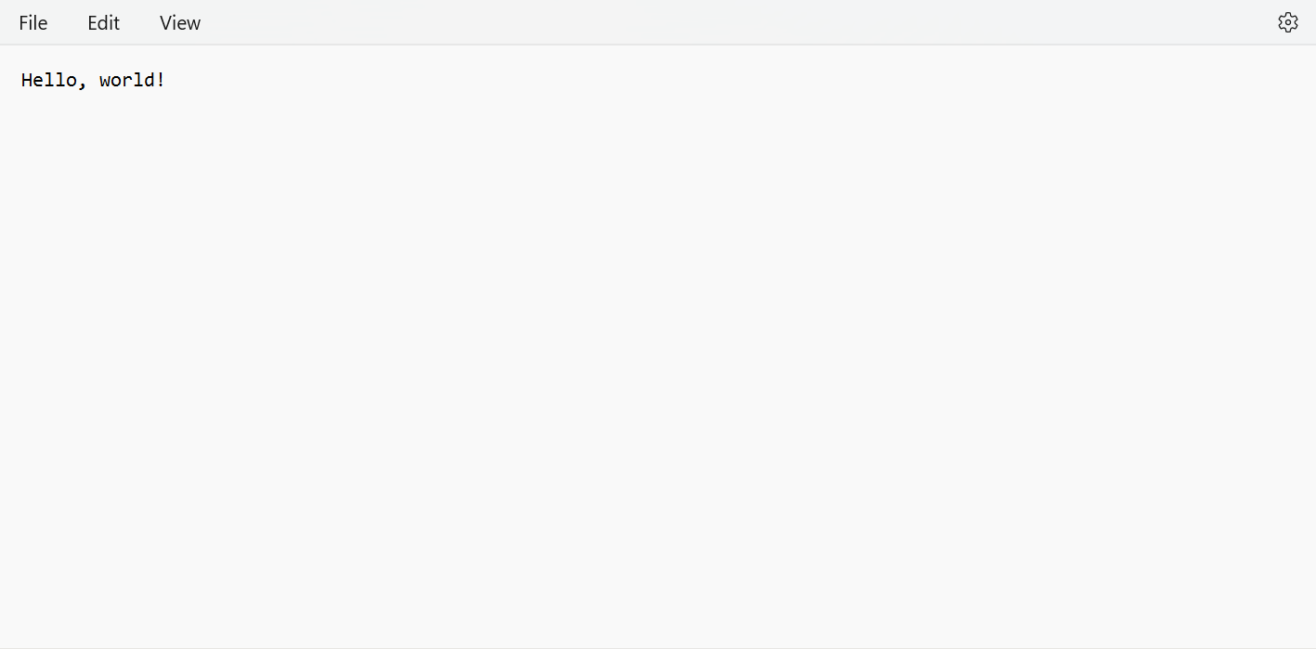

This is the secret message included with the code and it will automatically generate the output file as decoded file which is listed below

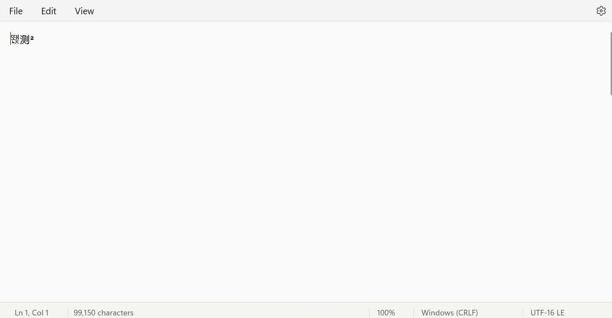

The above image is generated decoded file