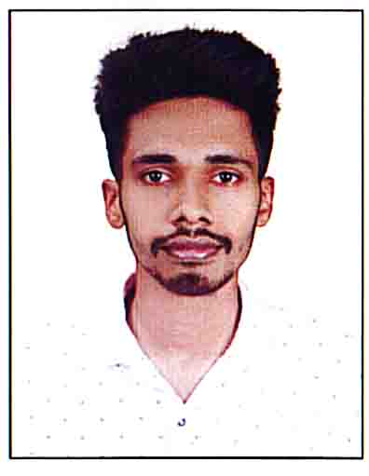**Gokuldas K T**

xxxxxx xxxxx p.o, xxxx, kozhikode Kerala, 6733xx

+91 9562863273

gokulgkldz@gmail.com

**Experience**

● Internship: infocampus 10 days internships on python programing

● Attended c programing workshop

● The digital marketing workshop by ieee pie kerala section

**Skills**

● C, C++ ,Python ,java ,Dbms , Mathematics

● Team Management and Problem Solving

**Projects**

● Hostel management (BTech Design Project, 5th Semester) Developed a online website for hostel management

**Education**

**PRESENT**

**2016**

**2014**

B.Tech in Computer Science, Mar Athanasius College of Engineering, Kothamangalam (7.03/10 CGPA)

12th (Senior Secondary Examination) 84.75% Kerala state board. Palora hss

10th (Secondary Examination) 84% Kerala state board.poyilkavu hs

**Interests**

● Chess ● programig ● Travel ● football