Project Title-Customer Churn Prediction

# Introduction:

Customer churn prediction is a vital component for customer relationship management and business analysis. It involves the usage of strategies like “Data Analysis” and “Machine Learning” to forecast when and why the customers may stop using a product or service.

The primary goal of customer churn prediction is to identify at risk customers early on and take proactive measures to retain them.By analyzing historical data of the customers and various business factors that may influence businesses can develop many predictive strategies which may help them in maintaining their customers and will probably help in increasing their customer services.

# Dataset:

The image you see below is the demo image of the dataset which will be used in this project.About the dataset this dataset can be found in kaggle which is a very famous online website for providing open sourced csv files which are used in Machine Learning as well as Data Analysis.

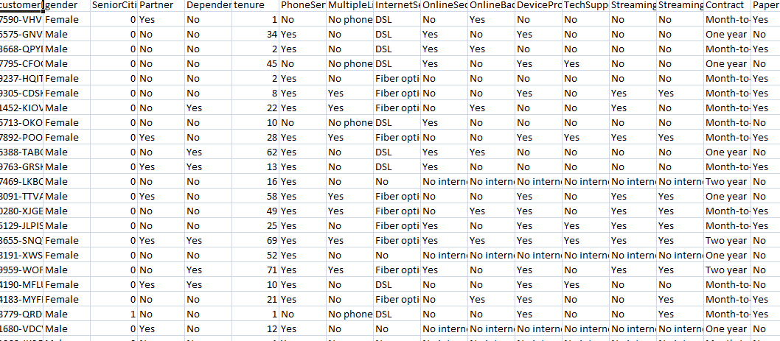

# Objectives of this project:

1)Early Detection:This allows the businesses to find out which customer will be churning faster when compared to the other customers.It will enable them to take proactive measures to save their customers.

2)Customer Retention Strategy:Here the developed retention strategies will be used on high risk customers to save them from leaving.

3)Cost Reduction:Churn prediction helps to reduce the customer acquisition cost.It introduces strategies to reduce the cost and retain customers at the same time making them profit.

# Flowchart:

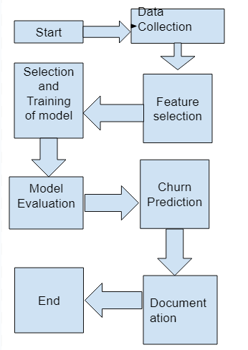

Data Collection:The data for this model is taken from kaggle webpage and the data is in the form of a csv file.

Feature Selection: It is the process of selecting the features which will be used by us for the model.

Selection and Model Training:This can be defined as the process of selecting the model and training the model which will be used for customer churn prediction.

Model Evaluation:This is the process of evaluating the model’s performance like the performance metrics such as accuracy,MSE ect...

Churn Prediction:This is the step in which the evaluated model is used for testing and finally predicting the customer churn using the model.

Documentation:This is the final step where the result from the model is submitted.

# ML models used in the model:

Linear Regression : To visualize the predicted features used in the model using linear regression.

Logistic Regression: To visualize the targeted features using logistic regression.

# Conclusion:

Thus this is all about the dataset which will be used in the project,objectives of the model,flowchart of the model and the ML models used in the project.