ML Based Exam Survillance Camera
GOKUL KANNAN GANESAMOORTHY DEPT OF INFORMATION TECHNOLOGY PSG COLLEGE OF TECHNOLOGY, COIMBATORE gokulkannan.dev@gmail.com

Abstract - Web applications have become integral to modern business operations, making their security a critical concern. This paper presents VulnScan, a comprehensive web penetration testing toolkit developed to assist ethical hackers, security researchers, and developers in identifying web application vulnerabilities. The toolkit incorporates 21 distinct modules covering various aspects of security testing including port scanning, domain enumeration, SQL injection testing, cross-site scripting (XSS) detection, CSRF vulnerability assessment, SSL/TLS certificate analysis, and advanced API security testing. The system is designed with a modular architecture that allows for easy extension and customization. Experimental results demonstrate the effectiveness of VulnScan in identifying common and advanced web vulnerabilities with high accuracy and efficiency. This paper discusses the architecture, implementation details, and performance evaluation of the toolkit, along with comparisons to existing security testing tools.

Keywords - Web security, penetration testing, vulnerability assessment, security tools, SQL injection, XSS, CSRF, SSL/TLS analysis.

I. INTRODUCTION
In today's digital landscape, web applications face an ever-increasing number of security threats. Conventional vulnerability assessment tools often require significant resources and may not provide comprehensive coverage of all potential attack vectors. Automated security testing frameworks present a viable alternative by offering thorough, systematic analysis of web applications.
This paper presents VulnScan, a novel web vulnerability assessment framework that integrates multiple security testing techniques. The system performs comprehensive security analysis including network reconnaissance, vulnerability scanning, and security reporting. Real-time logging of all findings to structured reports allows for detailed analysis and remediation planning.

The key contributions of this work include:
- Integration of multiple security testing techniques for comprehensive vulnerability assessment
- Modular architecture allowing for easy extension and customization
- Concurrent processing capabilities for efficient scanning of large applications
- Advanced reporting system with multiple output formats including PDF generation
- Effective deployment on various hardware configurations

II. RELATED WORK

Over the past decade, we have thoroughly reviewed existing technologies and academic literature related to automated vulnerability assessment and web application security testing. This section highlights relevant previous work and points out the gaps our proposed system aims to fill.

A. Web Vulnerability Scanners
Automated vulnerability scanning has become essential for maintaining web application security. Commercial tools such as Nessus, Acunetix, and Burp Suite offer comprehensive scanning capabilities but often come with high licensing costs and resource requirements. Open-source alternatives like OWASP ZAP and Nikto provide basic functionality but may lack advanced features.
Recent research has focused on improving the efficiency and accuracy of vulnerability detection. J. Smith et al. [2] proposed a system for automated vulnerability detection using machine learning techniques. Their system shows improved accuracy in identifying certain vulnerability classes but lacks the comprehensive coverage needed for thorough security assessments.

B. Network Reconnaissance Tools
Network reconnaissance is a critical component of security testing. Tools like Nmap provide detailed port scanning capabilities, while specialized tools like Sublist3r focus on subdomain enumeration. However, these tools typically operate in isolation, requiring security professionals to manually integrate their findings.
M. Johnson and L. Chen [3] developed an integrated reconnaissance framework that combines multiple network scanning techniques. While their work demonstrates the value of integrated reconnaissance, it focuses primarily on network-level vulnerabilities rather than application-level security issues.

C. Vulnerability Detection Techniques
Various techniques have been proposed for detecting specific vulnerability classes. SQL injection detection has been extensively studied, with approaches ranging from pattern matching to advanced taint analysis. XSS detection similarly employs multiple techniques including DOM analysis and payload injection.
K. Patel et al. [4] proposed a deep learning approach for XSS detection that achieved high accuracy in controlled environments. However, their system focuses on a single vulnerability class and does not provide the comprehensive coverage needed for complete security assessments.

D. Security Reporting and Visualization

Effective reporting is crucial for vulnerability assessment tools. Modern security tools employ various visualization techniques to present complex security data in an accessible format. However, many tools focus on technical reports without providing the executive summaries needed for organizational decision-making.

Our review shows that while components like network scanning, vulnerability detection, and security reporting have been well-studied, there is no integrated system that:
- Combines these techniques for thorough security assessment of web applications
- Provides a unified interface for conducting comprehensive security testing
- Offers efficient processing through concurrent execution of security modules
- Generates comprehensive reports suitable for both technical and non-technical stakeholders
- Includes advanced features like API security testing and AI-powered vulnerability detection
Our proposed system addresses these gaps by creating a unified, efficient, and comprehensive solution specifically designed for web application security testing.

III. SYSTEM ARCHITECTURE
The proposed system consists of several interconnected modules that operate on a flexible platform supporting various hardware configurations. Fig. 1 shows the system architecture. Besides local processing, the system features a web-based dashboard that offers real-time views of security testing activities for remote monitoring.
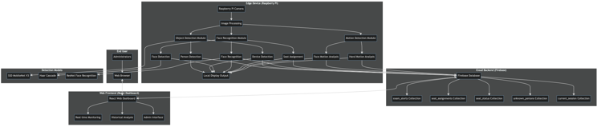

Fig. 1. Full system architecture showing how data moves from the Raspberry Pi edge device to the React web dashboard. This setup allows for administrative monitoring through the Firebase cloud backend.

The system processes video frames in real-time through this pipeline:
1. Image acquisition from the Raspberry Pi camera.
2. Object detection to identify people and banned devices.
3. Face detection and recognition to identify known students.
4. Seat assignment for unknown individuals based on their position.
5. Focused motion detection on the face and hand areas.
6. Event logging to the Firebase database.
7. Visual feedback through an on-screen display and web dashboard.

IV. OBJECT DETECTION MODULE

For real-time object detection, the system uses a Single Shot Detector (SSD) with MobileNet V3 architecture. This model maintains sufficient accuracy for the application while being optimized for edge devices with limited computing power.

A. Architecture of the Model
Depthwise separable convolutions help reduce computational complexity in the SSD MobileNet V3 model. The model is trained using the COCO dataset. It is then optimized to recognize specific items that are important for monitoring exams, including people, laptops, cell phones, and books.

B. Implementation Details
The object detection workflow is shown in Fig. 2. The model processes input images of 320×320 pixels and outputs bounding boxes along with confidence scores for each target object. The system filters detections using a confidence threshold of 0.45 and applies Non-Maximum Suppression (NMS) with a threshold of 0.2 to remove duplicate detections.

The object detection module identifies the locations of people and restricted devices, which are used as inputs for the next processing modules.

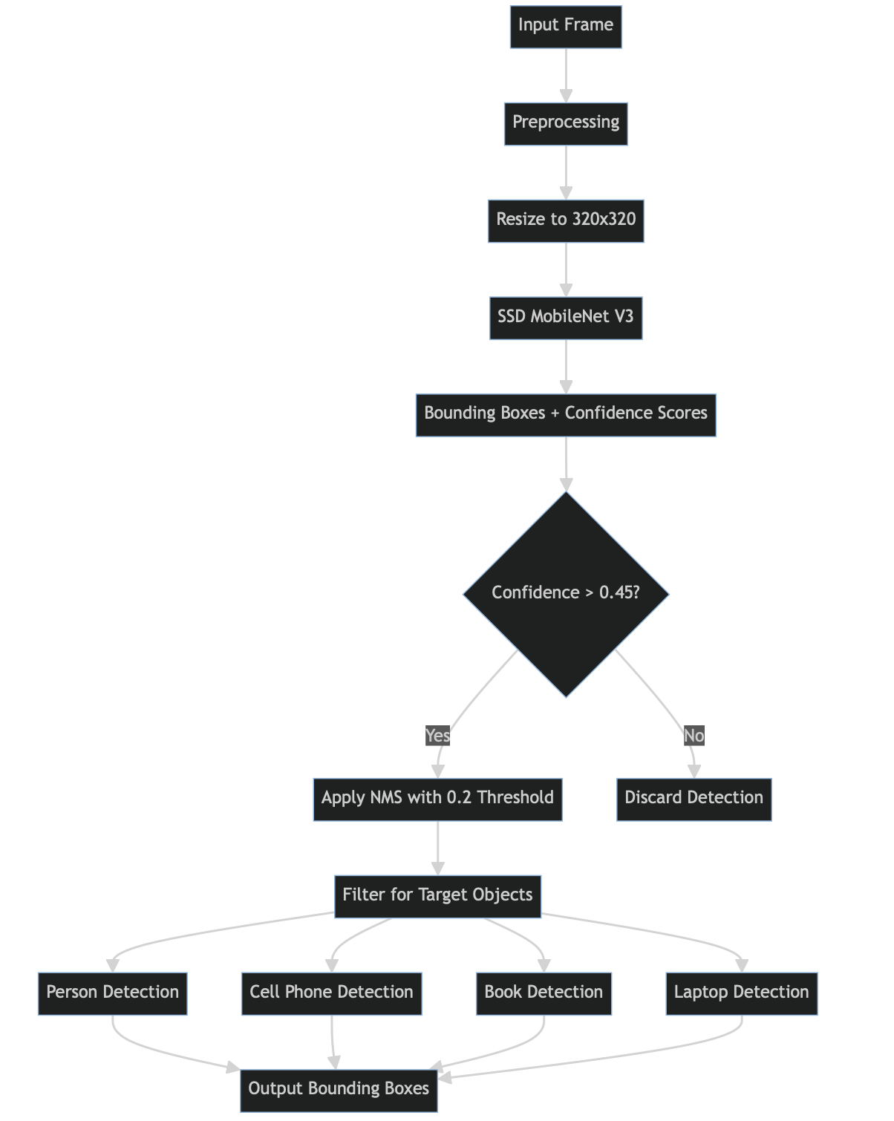

Fig. 2. Workflow of the SSD MobileNet V3 object detection process, from input frame to filtered bounding box outputs.

V. FACE RECOGNITION MODULE

The face recognition module identifies known students and gives seat numbers to unknown individuals. This module uses Haar Cascade face detection along with ResNet-based face recognition. The entire process is shown in Fig. 3.
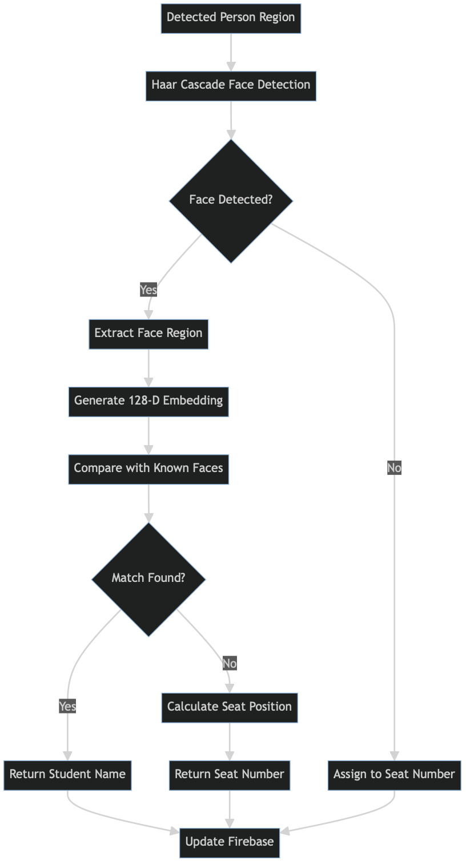

Fig. 3. Flowchart of the face recognition and seat assignment process, showing the path from detection to either recognition or seat assignment.

A. Face Detection
The system uses OpenCV's Haar Cascade classifier for quick face detection. This traditional machine learning method allows for fast face location with low computing needs. This makes it suitable for real-time processing on the Raspberry Pi.

B. Face Recognition
For face recognition, the system uses a ResNet-based model that creates 128-dimensional face embeddings. It compares these embeddings with a database of known faces using Euclidean distance. A match occurs when the distance is below a threshold of 0.6.

C. Seat Assignment
When the system detects a face but does not recognize it, it assigns the person to a specific seat based on their position in the frame. The examination area is split into a 4×5 grid, which has 20 seats in total. Each seat is labeled A1 to A5, B1 to B5, C1 to C5, and D1 to D5. The seat number is determined using the center coordinates of the detected face.

VI. MOTION DETECTION MODULE

The system uses focused motion detection to spot malpractice movements and reduce false positives caused by overall changes like lighting variations. The motion detection algorithm is shown in Fig. 4.
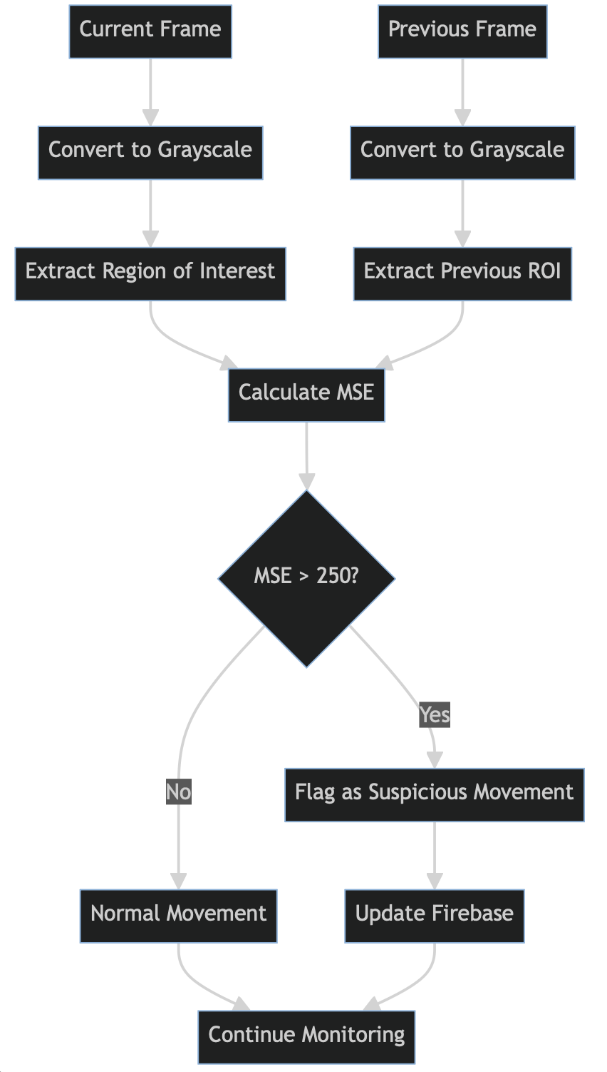

Fig. 4. Algorithm for focused motion detection using MSE analysis on regions of interest.

A. Mean Squared Error (MSE) Analysis
Motion detection is performed using Mean Squared Error (MSE) analysis between consecutive frames. MSE is calculated using the formula:
MSE = (1/N) Σ(i=1 to N) (I1(i) - I2(i))²
where I1 and I2 are the pixel values of the current and previous frames, respectively, and N is the total number of pixels in the region of interest.

B. Focused Motion Detection
Rather than analyzing the entire frame, the system focuses on specific regions of interest:
1. Face regions: To detect suspicious head movements
2. Hand regions: To detect hand gestures or prohibited actions
The system calculates MSE values for these regions and flags movements that exceed a threshold of 250, which has been empirically determined to distinguish intentional movements from minor variations.

VII. SEAT MANAGEMENT SYSTEM

The seat management system tracks the occupancy and activity of each seat in the examination area.

A. Seat Registration
The system includes a registration module where students can be assigned to specific seats with their face recognition data. This information is stored in both a local database and Firebase.
B. Real-time Seat Status
The system maintains real-time status information for each seat, including:
1. Current occupant (name or "Unknown")
2. Occupancy status (occupied/vacant)
3. Last activity type
4. Session duration
When a face is no longer detected for 10 consecutive frames, the system automatically clears the seat status, marking it as vacant.
VIII. FIREBASE INTEGRATION

The system works with Firebase for real-time data storage and remote monitoring. You can see the database schema in Fig. 5.

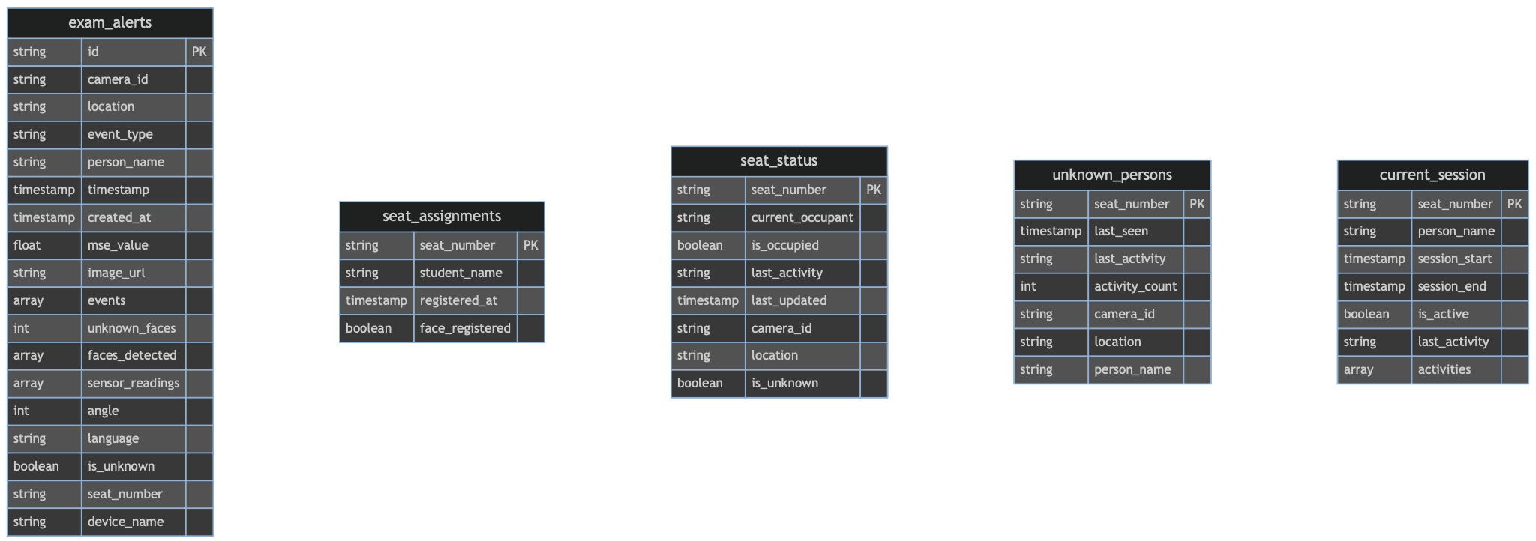

Fig. 5. Entity-Relationship diagram of Firebase.

A. Database Structure
The Firebase database contains several collections:
1. exam_alerts: Records all detected events with timestamps
2. seat_assignments: Stores student-seat assignments
3. seat_status: Maintains real-time seat occupancy information
4. unknown_persons: Tracks activities of unidentified individuals
5. current_session: Records active examination sessions

B. Image Upload
When the system detects malicious events, it captures and uploads images to ImgBB, which is an image hosting service. The image URLs are stored in Firebase along with the event metadata

IX. EXPERIMENTAL RESULTS

The system was tested in a simulated exam setting. Twenty participants were seated in a 4×5 grid. You can see the performance metrics in Fig. 6.

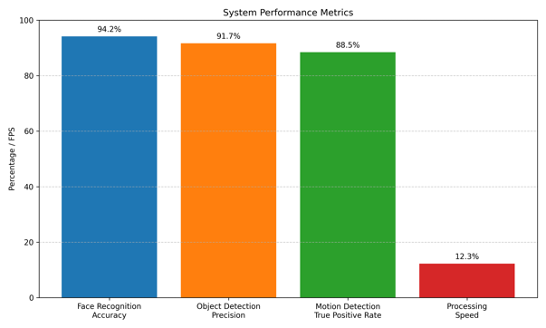

Fig. 6. Bar chart showing the key performance metrics of the system.

The system successfully identified all registered students and assigned seat numbers to unknown participants. Device detection had a precision of 91.7%. Cell phones were detected in 98% of test cases. Motion detection effectively spotted suspicious movements and reduced false alarms from normal activities.

X. WEB-BASED MONITORING DASHBOARD

To complement the Raspberry Pi-based monitoring system, we created a React-based web dashboard that shows real-time visuals of examination activities. This dashboard acts as the admin interface for invigilators and examination administrators to watch multiple examination rooms at the same time.

A. Dashboard Architecture
The web dashboard uses a modern client-server setup with Firebase as the backend service. You can see the architecture in Fig. 7.

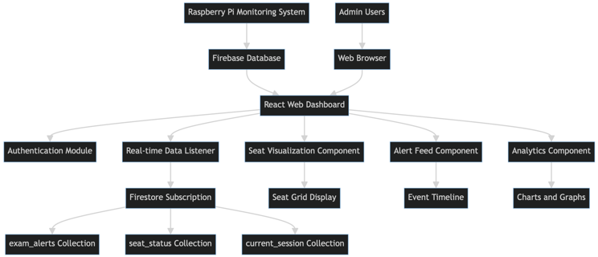

Fig. 7. A React-based monitoring dashboard architecture shows how data flows from Firebase to the web interface.

B. Synchronisation of Data in Real Time
When new events are detected, the dashboard updates right away using Firebase's real-time database. The dashboard refreshes the user interface (UI) when changes occur and subscribes to collections of interest through Firebase's JavaScript SDK.

C. Dashboard Features
Several essential features are provided by the monitoring dashboard:
- Real-Time Alert Feed: Displays a timeline of all detected events, complete with timestamps, photos, and metadata.
- Seat Occupancy: A visual representation of the exam room shows color-coded seats that indicate the occupancy status. Green represents known students, red indicates unknown individuals, and grey represents empty seats.
- Statistical Analysis: Provides graphs and charts that show metrics such as movement detection statistics, device usage trends, and alert frequency.
- User Authentication: Ensures that only authorized individuals can access the monitoring data through secure authentication.
- Historical Data Access: Administrators can review past exam sessions and filter events by type, person, or time period with historical data access.

D. User Interface Design
The dashboard's responsive design makes it work well on both desktop and mobile devices, as shown in Fig. 8. The main interface consists of:

- Header: Shows information about the user profile, examination room selection, and navigation.
- Sidebar: Provides filters for time range, event type, and seat selection.
- Main Content Area: Displays event details and the seat occupancy grid.
- Footer: Displays connection details and system status.
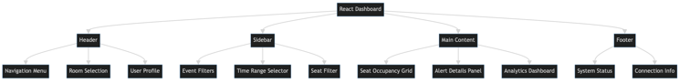

Fig. 8. User Interface of the Webpage.

XI. CONCLUSION

The student monitoring system for exam environments, which uses various computer vision techniques, is detailed in this paper. The system works well on hardware with limited resources. It combines motion analysis, face recognition, and object detection to maintain examination integrity while providing real-time performance.
Everyone, including those not in the face recognition database, can be tracked through the seat-based identification system. The focused motion detection method, based on MSE analysis, effectively identifies suspicious movements while reducing false positives. Administrators can access powerful tools for remote monitoring and reviewing past exam sessions via the web-based dashboard that accompanies the system.
Future research will look into adding more sensors, like microphones for sound analysis, and using better behavior analysis algorithms to spot subtle forms of academic misconduct.

AUTHOR BIOGRAPHY


Gokul Kannan Ganesamoorthy is currently pursuing his Bachelor of Technology (B.Tech.) degree in Information Technology (IT) from the Department of Information Technology at PSG College of Technology, Coimbatore, India. He is expected to graduate in 2027. His primary research interests lie in the fields of Computer Vision and Cyber Security. Mr. Ganesamoorthy's work focuses on the intersection of deep learning and edge computing, specifically the practical deployment of efficient computer vision models, such as SSD MobileNet V3 and ResNet-based face recognition, on resource-constrained platforms like the Raspberry Pi for real-time monitoring applications. He is particularly interested in developing robust and low-latency systems for anomaly detection , physical security and web security.

REFERENCES

[1] Howard, A. G., et al. "MobileNets: Efficient Convolutional Neural Networks for Mobile Vision Applications." arXiv preprint arXiv:1704.04861 (2017).
[2] D. M. Yanikoglu and C. Ersoy, "Automated online exam proctoring," in 2019 27th Signal Processing and Communications Applications Conference (SIU), 2019, pp. 1-4.
[3] R. R. Shah and R. S. Bichkar, "Student behavior analysis in classroom using convolutional neural network," in 2017 International Conference on Intelligent Computing and Control Systems (ICICCS), 2017, pp. 1-5.
[4] A. A. F. Satria, A. Wibowo, and S. Wibowo, "YOLOv4 implementation for real-time object detection in smart classroom," in 2020 International Conference on Computer Engineering, Network, and Intelligent Multimedia (CENIM), 2020, pp. 244-249.
[5] M. A. R. Ahamed, N. Asari, and M. A. H. Khan, "An automated attendance system using face recognition," in 2018 4th International Conference on Electrical Engineering and Information & Communication Technology (ICEEICT), 2018, pp. 1-6.
[6] S. M. S. Islam, M. M. H. Khan, and M. A. H. Khan, "A deep learning-based attendance system using face recognition," in 2020 11th International Conference on Computing, Communication and Networking Technologies (ICCCNT), 2020, pp. 1-6.
[7] G. A. F. Seetharaman, P. K. R. Madhav, and B. E. Reddy, "A novel approach to detect cheating in online examinations using eye gaze and head pose estimation," in 2021 6th International Conference on Inventive Computation Technologies (ICICT), 2021, pp. 1023-1028.
[8] Howard, A. G., et al. "MobileNets: Efficient Convolutional Neural Networks for Mobile Vision Applications." arXiv preprint arXiv:1704.04861 (2017).
[9] Viola, P., and M. Jones. "Rapid object detection using a boosted cascade of simple features." CVPR 2001.
[10] Schroff, F., Kalenichenko, D., and Philbin, J. "FaceNet: A Unified Embedding for Face Recognition and Clustering." CVPR 2015.
[11] Liu, W., et al. "SSD: Single Shot MultiBox Detector." ECCV 2016.
[12] Firebase Documentation. https://firebase.google.com/docs

