### AIM

To establish LAN

### REQUIREMENTS:

1. End device - They are the devices through which we can pass message from one device to another and they are interconnected.
2. Switch/Hub - Interface Between two devices.
3. Cable - Used to connect two devices.

### PROCEDURE:

1. The main objective is to set up a Local Area Network( LAN).
2. The concept involved in this network are IP Addressing and the address resolution Protocol (ARP).

3. The equipments required are 192.168.1.1, 192.168.1.2, 192.168.1.1, Host A, Host B, Host C, switch/Hub three PC’s equipped with at least one NIC, one HUB or Switch and the necessary cables.

1. When the physical LAN is set up the host need to be configured using the “ipconfig”

Command.

1. To verify communication among the machine the ping command is used.
2. Manipulate the routing tables at the host to understand how machines know where to send packets.
3. The ipconfig command places a default route into the routing tables, hence this route

must be deleted to ‘blindfold’ the machine.

1. The ping command is used again to show that communication is no longer available.
2. To re-establish communication the routes are put back into the routing table one host at a time.
3. Communication is once again verified using the ping command.

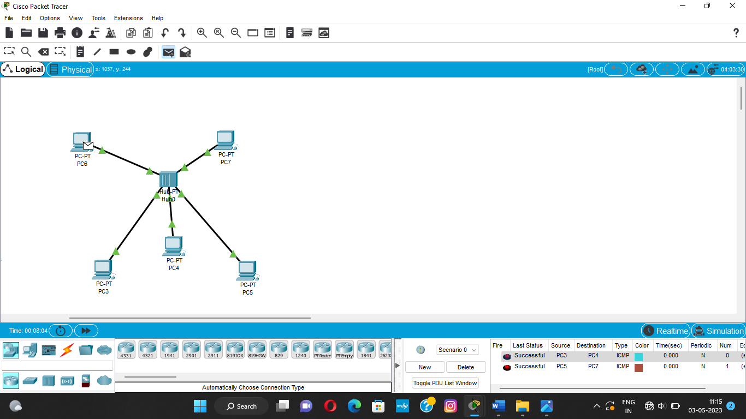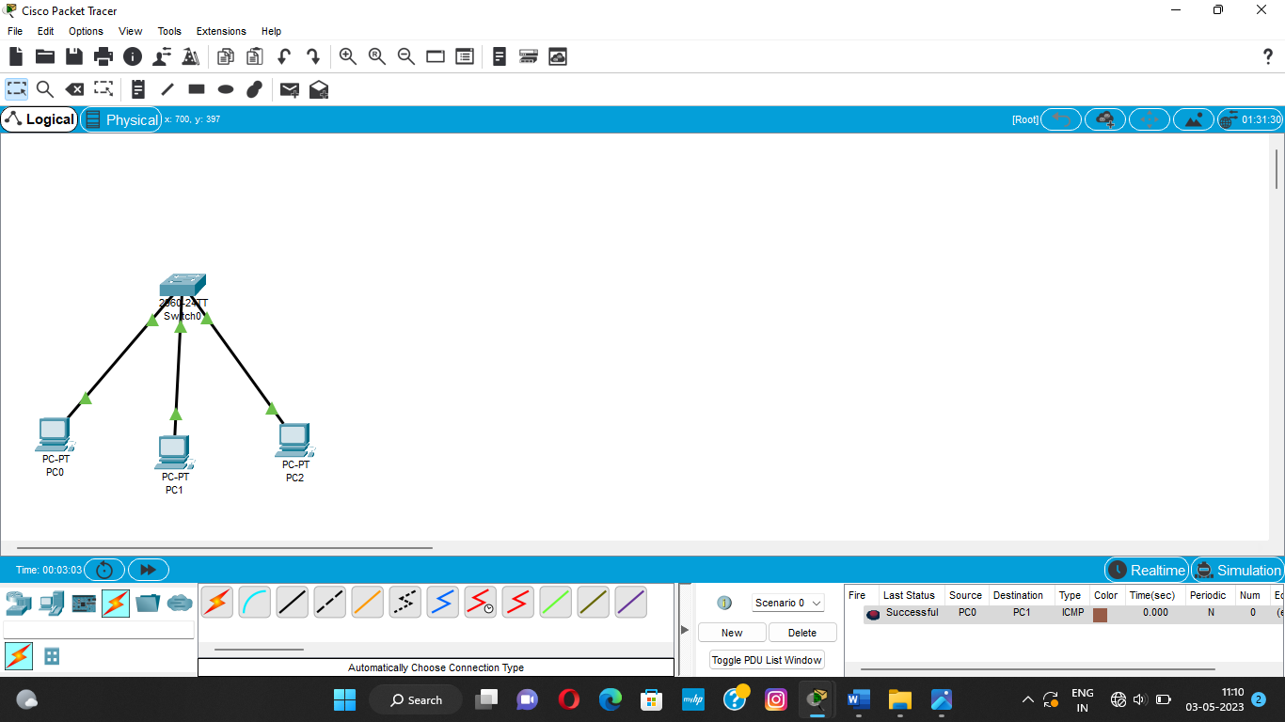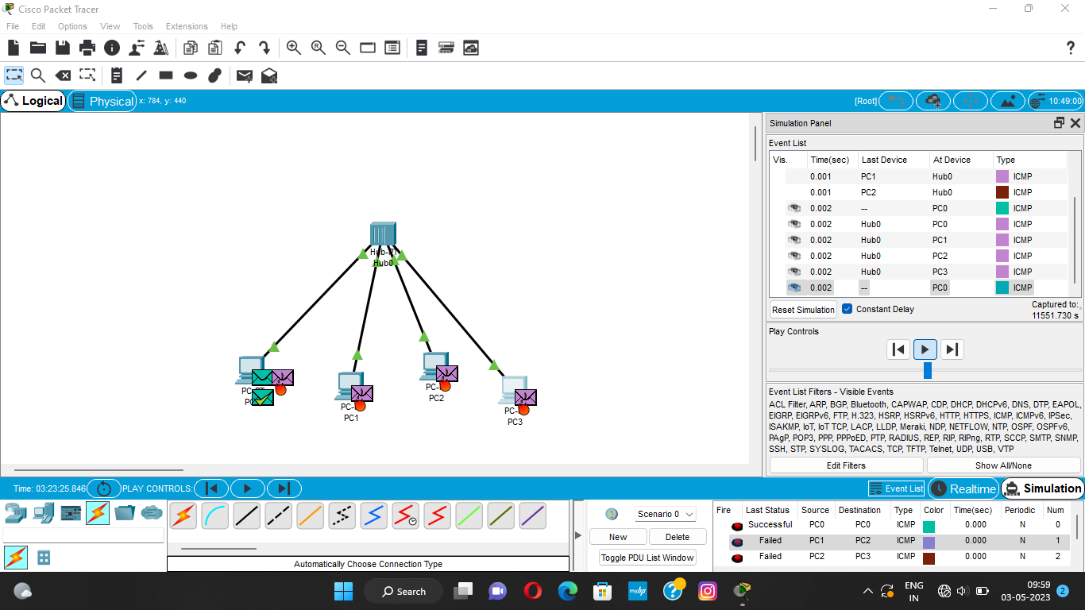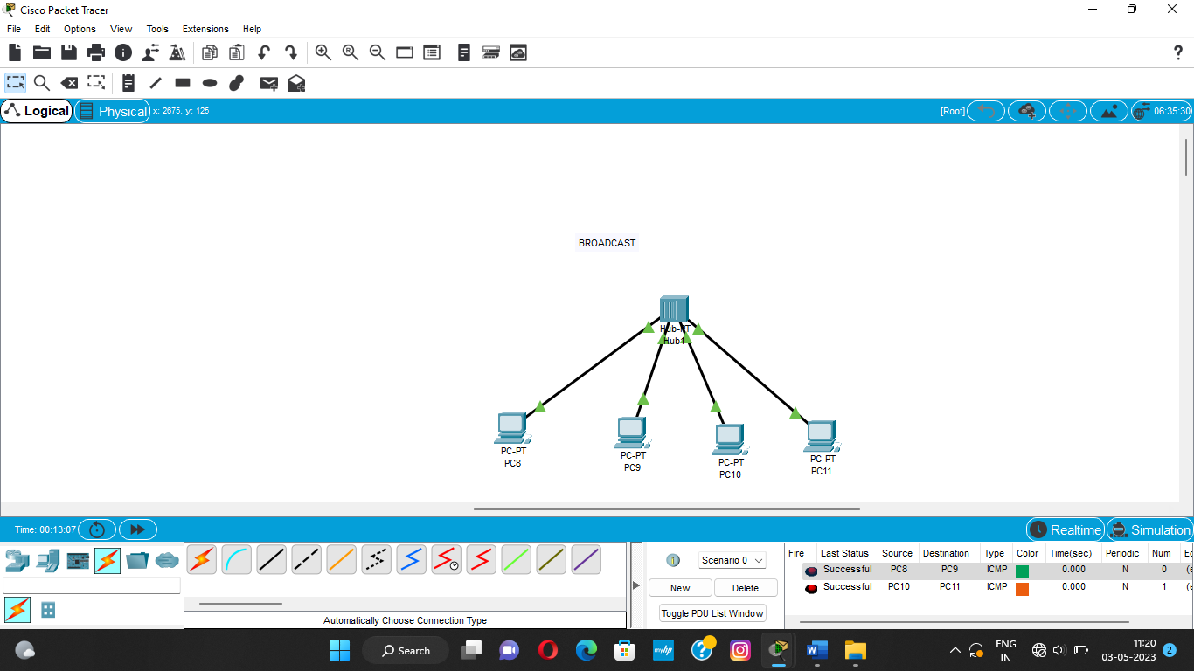

Result

Here we are able to get the verification by going through all the procedure by using LAN