MySQL

- sudo – u root -p
- Ctrl + L to clear screen

Creating a new user for a database
- CREATE USER ‘username’@‘localhost’ IDENTIFIED BY ‘password’;
- GRANT ALL PRIVILEGES ON dbName.tableName TO ‘username’@‘localhost’ IDENTIFIED BY ‘password’;

Database
- Collection of data stored and accessed electronically

Database Management System
- Collection of interrelated data and set of programs to access them. The goal of DBMS is to store and retrive data in a manner that is convenient and efficient.

Transactions

DDL, DML, DCL and TCL

- UPDATE tablename
SET colname1=‘theChange1’, colname2=‘theChange2’
WHERE <some-conditions>
(if where clause is not included, changes will be made to ALL rows of the table)
- DELETE FROM tablename
WHERE <some-conditions>
(DELETE removes rows, not columns)
- DROP vs. DELETE vs. TRUNCATE
  - https://youtu.be/_m1aJdD-oD8
  - DROP is a DDL command (i.e.), it deals with the schema structure
  - DROP table tablename deletes the existence of the entire table
  - Thus, only DBA will be authorized to use DROP

  - DELETE is a DML command
  - It is used to delete rows of a table conditionally

  - TRUNCATE is a DDL command
  - It is used to delete ALL rows of a table (no condition), but does not delete the table itself (i.e.), DESC tablename will output the schema structure (with 0 records)

  - DELETE from tablename vs. TRUNCATE tablename
  - Both delete all rows from the table, but do not delete the table itself
  - Differences
    - TRUNCATE is faster because it locks the table and deletes all the records in one go
    - DELETE is slower because it makes use of log to store each record before deleting it
    - Thus, rollback before commit is possible in DELETE, but not in TRUNCATE

- How to rollback a query
  - https://stackoverflow.com/questions/2356566/how-can-i-roll-back-my-last-delete-command-in-mysql

- Create user and grant permissions
  - https://www.digitalocean.com/community/tutorials/how-to-create-a-new-user-and-grant-permissions-in-mysql

Resources
- http://g2pc1.bu.edu/~qzpeng/manual/MySQL%20Commands.htm
- https://www.mysqltutorial.org/

Table manipulation and basic SQL
- CREATE
- INSERT
  - INSERT INTO table_name(col_1, col_2, ...) VALUES(val1, val2, ...)
- UPDATE
  - UPDATE table_name SET col1=val1, col2=val2, ... WHERE ...
- ADD CONSTRAINT
  - Primary key vs. unique constraint
- show columns from <table-name>
- Viewing meta-data (information_schema)
  - https://dev.mysql.com/doc/mysql-infoschema-excerpt/8.0/en/information-schema-table-reference.html
  - Eg:
select COLUMN_NAME
from information_schema.KEY_COLUMN_USAGE

- RENAME TO
  - ALTER TABLE table_name RENAME TO new_table_name

- WHERE clause ‘helpers’
  - OR, AND, NOT
  - IN
    - ... where col_name IN (value1, value2, ...)
  - BETWEEN
    - ... where col_name BETWEEN x and y
    - applicable to dates as well
  - Wildcard characters: % (placeholder for any number of characters); _ (placeholder for one character)

- GROUP BY
  - used when you have an aggregate function and a column to aggregate on (see below eg.), more specifically, when you have a HAVING clause or when you use an aggregate function on a column, use GROUP BY for that column
  - Use GROUP BY between WHERE and HAVING
  - Using non-aggregated columns in the SELECT statement of a GROUP BY query (Short answer: Use inner join between the GROUP BY result and the original table) – https://stackoverflow.com/questions/3168042/can-i-use-non-aggregate-columns-with-group-by

- HAVING
  - comes after GROUP BY (see below eg.)

- ORDER BY
- Aggregate functions (5)
  - AVG, COUNT, MIN, MAX, SUM
  - SELECT count(col_name) FROM table_name;
  - Count distinct (entries in a column)
SELECT count(*) FROM
(SELECT DISTINCT col_to_count FROM table_name) distinct_records;
COUNT(DISTINCT col_name) is also allowed
COUNT(ALL col_name) counts only non-null values
  - SELECT country, count(*) FROM table_name
GROUP BY country
HAVING count(*) > 1
ORDER BY count(*), country
- LIMIT x (at the end) returns x records
  - alternate: LIMIT offset, x (ONLY integer literals are allowed)
- LIKE “%something”; RLIKE “<regex>”
- DISTINCT
  - SELECT DISTINCT column_1, column_2, ... FROM table_name
- Relational Operators
  - UNION, MINUS, INTERSECTION
  - SELECT col_1, col_2, ..
FROM table_1
WHERE ...
MINUS
SELECT col_1, col_2, ..
FROM table_2
WHERE ... ;
- Pivot - https://youtu.be/WMllKTpn7WE
- Column Aliases can only be used in GROUP BY, ORDER BY or HAVING clauses (not WHERE
- IF - select if(condition, <value if condition is true>, <value if condition is falss>)

Storing results of queries for future use
- https://stackoverflow.com/questions/2233013/sql-how-do-i-refer-to-the-result-of-a-previous-query (as per MS SQL)
  - SQL variables
    - set @var_name = value;
  - Temp Table
    - CREATE TEMPORARY TABLE table_name
SELECT ....
    - CREATE TEMPORARY TABLE table_name(
<typical table creation syntax>
)
  - Sub-query

String functions
- https://www.mysqltutorial.org/mysql-string-functions/
- concat(s1, s2, ...)
- instr(str, substr)
  - returns position of first match
- lower(str)
- substring(str, start, length)
- <>

Math functions
- abs()
- ceil()
- floor()
- round()
- truncate()
- mod()

Date functions
- month(), monthname()
- day(), dayofweek(), dayname()
- year()
- date_add(start_date, interval expr unit)
  - date_add(‘2020-10-31’, interval 1 day)

Joins
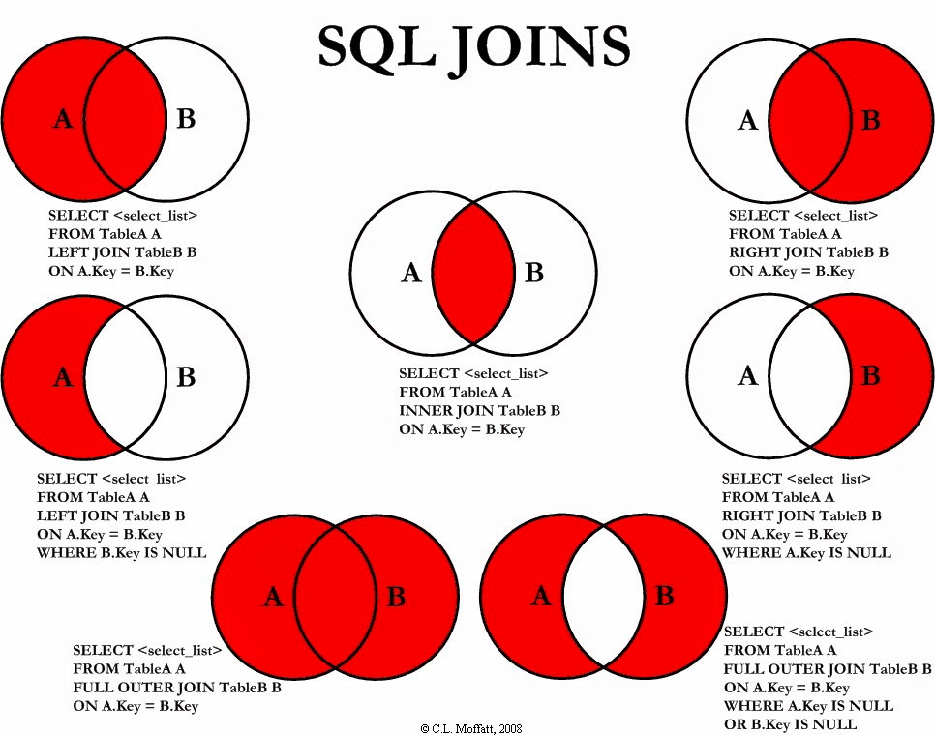
Examples that can be used:
- Customer and Order
- Martian-visitor
- User Invoice
- Generic

Views
- Virtual tables that make it easy to search (not in terms of speed!)
  - A view is primarily a means of masking or rearranging information so that it appears in a different format
  - Or in other words, it is a saved result of a (complicated) query
- Views provide security. By giving engineers only access to views, confidential data in the original table (if any) can be protected
- They also provide simplicity (UNION example)
- CREATE VIEW viewname AS
SELECT col1, col2, col3, ...
FROM tablename;
- Are views updateable? (Yes, under certain conditions) – https://stackoverflow.com/questions/3777918/is-a-view-in-the-database-updatable
  - Some of the conditions –
    - The view is based on 1 table
    - The view has the primary key of the table
    - The view has not been defined using aggregrates, ...

https://stackoverflow.com/questions/42241871/how-do-i-update-mysql-views-when-a-column-is-added-deleted-from-the-table
  - If the table is updated, the views that depend on the table will not be updated (view has to be ALTERed or DROPped-and-CREATEd again)

- Tables vs. Views
  - What happens when you add an index to a view?

Sequences

Built-in functions
- Arithmetic
- String manipulation

Indices
- Used to speed up the process of retrieving data (like index in a book)
- Good naming convention: tablename_colname_idx
- CREATE INDEX idxname
ON tablename(colnames);
- However building index takes time
- A database can have more than 1 index; an index can be made for more than one column (ORDER MATTERS!)
- Indexes require storage; they also need to be updated whenever new records are inserted/ deleted/ updated.
- Clustered vs. non-clustered index
  - clustered index : non-clustered index :: phone book sorted alphabetically by first name : index on last name at the back of the phone book (page# ~ pointer to row)

Questions to try again
- Query the two cities in STATION with the shortest and longest CITY names, as well as their respective lengths (i.e.: number of characters in the name). If there is more than one smallest or largest city, choose the one that comes first when ordered alphabetically.
- Median of a column
- Ollivander’s Wand –

select w__.id, w__.age, w__.coins_needed, w__.power
from (
select w.id, non_evil.age, w.coins_needed, w.power
from wands w
inner join (select code, age
from wands_property
where is_evil=0) non_evil
on w.code=non_evil.code
) w__
inner join (
select w_.age, min(w_.coins_needed) as mincoins, w_.power
from (
select w.id, non_evil.age, w.coins_needed, w.power
from wands w
inner join (select code, age
from wands_property
where is_evil=0) non_evil
on w.code=non_evil.code
) w_
group by w_.power, w_.age
) m
on m.age=w__.age and m.power=w__.power and m.mincoins=w__.coins_needed
order by power desc, age desc;

Procedural SQL
- Cursors
- Exceptions

ER Diagrams
- Entity, attributes, entity set
- Relationship, descriptive attributes, relationship set
- Attributes
- Relationship types

Keys
- Superkey
  - No of superkeys = 2^{# non-prime attributes}
- Candidate key
- Primary key

Constraints
- Primary key vs. Unique

Functional dependency
- Trivial functional dependencies are of the form 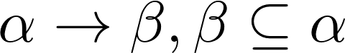

Closure of F

Normalization
- Normal forms
  - to avoid redundancy
  - to have easy access

- Prime attributes – any attribute that is part of a candidate key

- 1NF
  - Attribute domain should be atomic
    - No composite attribute
    - No multivalued attribute
- 2NF
  - No non-prime attribute should be partially dependent on any candidate key

- 3NF
  - Every non-prime attribute should
    - depend on every candidate key (candidate key defn. ?)
    - never depend on only a part of a candidate key
    - should not depend on other non-prime attributes

(2NF and 3NF specify table design with respect to non-prime attributes)

- BCNF
  - All functional dependencies satisfy either of the 2:
    - 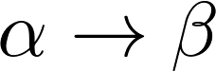 is a trivial dependency
    -  is a superkey of r(R) (r-> relation; R -> schema)
  - A relation with 2 attributes is always in BCNF
  - Decomposing a relation not in BCNF

- 4NF – The only multivalued dependencies allowed are those on the key (Makes sense only if there are more than 2 attributes ?)

- 5NF – It should not be possible to obtain the table from joining other tables

- Yet to study:
  - lossless decomposition
  - dependency preserving decomposition
  - Construct closure set of functional dependencies – https://www.nielit.gov.in/gorakhpur/sites/default/files/Gorakhpur/Alevel_1_DBMS_12May2020_AV.pdf
  - How to handle composite and multi-valued attributes
  - Representation of many-many relationships
  - multivalued-dependency
  - cursors

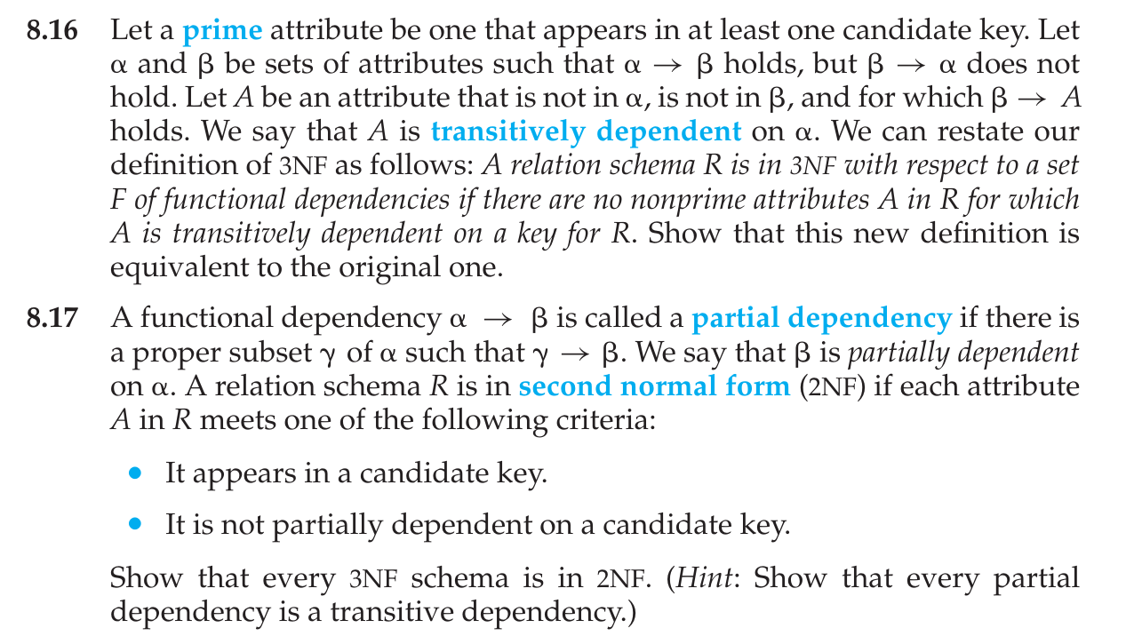

Database Design
- https://youtu.be/zHEEKq6GJq0
- https://youtu.be/zBZEz1vZdIQ
  - Not a good idea to enforce application logic in the database
  - Combining tables (eg: likes entity)

Transactions
- Collection of operations that perform a single logical function in the database

To go over:
- JOINS
  - Examples for join
  - Left join to inner join optimization
- Views vs. Tables
  - Where are views used?
  - Applications of views in monitoring
- Indexes
  - Where are clustered and non-clustered indices used respectively?
  - Finish watching video
- SQL
  - Extracting records that do not have a match in left join
  - Built-in functions (arithmetic, string, datetime)
  - Insert queries
  - constraints (primary key, foreign key, not null, unique, check)
- Procedures vs. Functions
- Normalization vs. denormalization
- ACID properties
- COMMIT, ROLLBACK, ABORT
- “keep table”
- varchar2

