Machine Learning

- Prototype in Octave first before migrating to other languages
- Definitions
  - 1:
  - 2:
- Supervised learning
  - “right answers” given
  - Regression – predict continuous valued output (eg: price)
  - Classification – discrete valued output (eg: malignant or benign)
  - How to handle infinite number of features? Support Vector Machine
- Unsupervised learning
  - Given dataset (no labels or no idea about effect of variables in the data), is it possible to find some structure in the data?
  - No feedback
  - Clustering
    - “Data lives in clusters”
    - Eg: Google news stories – looks at thousands of news stories across the web and groups them into related clusters
    - Other eg: Computer clustering (data centres), Social network analysis, maket segmentation, astronomical data
  - Cocktail party algorithm
    - Mixed audio -> Cocktail Party Algorithm -> (“Mixture of 2 audio sounds”, Output_1, Output_2 ... )
    - one line of code in Octave (using svd – singular value decomposition)

Linear Regression

- Notations
  - m: # of training examples
  - x: input variables (features)
  - y: output variables (target)
  - (x(i), y(i)): ith training example
  - hypothesis function (mapping from x to y): ( : parameters)

- Cost function
  - (find the parameters that minimize J) (squared error function)
( is chosen for mathematical convenience – see gradient descent)
  - vs.
    - For every pair , there exists a corresponding line (hypothesis ) in the x-y plane.
- Gradient descent
  - To solve a general minimization problem -

  - Algorithm
Repeat until convergence {
for i=0 and i=1 SIMULTANEOUSLY}
is the learning rate (“how big do you want your steps to be as you move down the hill (update the parameters) ” - see pdf)
  - Intuition of the derivative term
  - Effects of increasing or decreasing
  - With fixed, as approaches a local minimum, the gradient descent automatically reduces the step size (since the derivative term will automatically get smaller) .

- Cost function is always convex (bowl-shaped) for linear regression, (i.e.), there is only 1 minima
- Batch gradient descent – looks at all examples in the training set at every step

Linear Algebra
- Matrix
  - rectangular array of numbers
  - refers to the set of all mxn matrices whose elements belong to the set of real numbers
- Vector
  - nx1 matrix (row matrix)
  - Also called ‘n-dimensional vector’;

Linear Regression with Multiple variables
- n: # of features
- : features of ith training example ()
- : jth feature of ith training example

Let , where ;
Both vectors are 0-indexed and
Thus
- Gradient descent for multiple variables
- Feature scaling
  - Easier for gradient descent to find it s way to the global minimum if all features take on a common range of values
(“θ will descend quickly on small ranges and slowly on large ranges”)
  - Usually we the following range is preferred:
Note: Anything close to this is also accepted
  - Mean Normalization:
- Influence of learning rate
  - If is sufficiently small, always decreases after every iteration of gradient descent
  - If is large, then it may “overshoot and diverge, therby increasing after every iteration”.
  - Plot vs. #iterations to declare convergence as well as to find a suitable learning rate.

- Features and Polynomial Regression
  - It is not required to only use the features provided. New features could also be defined using the existing ones.
    - Eg: Assume x1 = frontage and x2 = depth; one could define a new feature, area (=frontage x depth), that would be better suited for predicting prices. (Insight into problem is helpful in this case)
  - Assume you want to fit a quadratic or cubic polynomial to your data. Higher order (order > 1) terms can each be treated as feature and so the same linear regression model can be used for this purpose also.
    - Note that feature scaling is very important when trying to fit higher order polynomials to data.

- Normal Equation method
  - Explicitly finding the minimum of (by setting the derivatives to 0)
  - No need of feature scaling
  - ,
where
  - Gradient descent vs. Normal equation
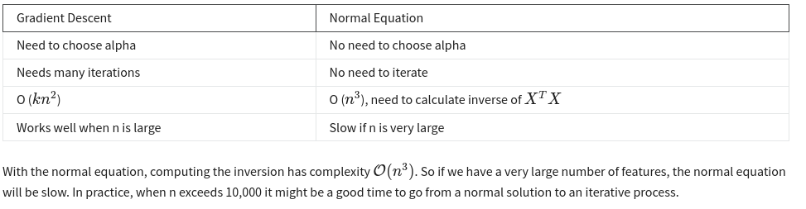
  - <>

Vectorization
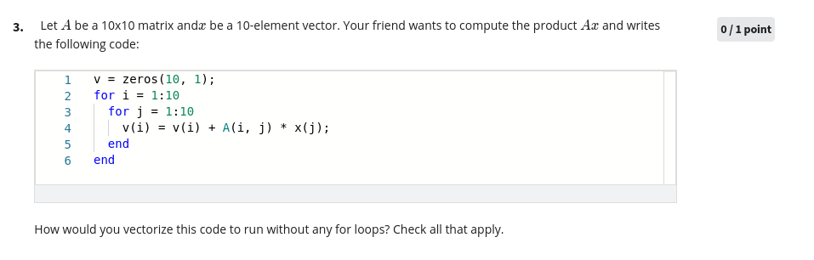

Logistic Regression
- Does feature scaling affect ?
- Linear regression is not suitable for classification problems
- 0 – negative class; 1 – positive class (for binary classification)
- For a given feature of a training example, , the corresponding is called the label of that training example.
- For logistic regression, we want .

- Hypthesis representation
  - For linear regression, we had,
  - For logistic regression, , where is called the sigmoid or logistic function
  - Here gives the probability that the output y=1 (positive class), given features and parameters . Thus,
  - Also, note that for binary classification:

- Decision Boundary
  - Let us assume that,

  - From , it can be seen that for , , (i.e.), (this is the decision boundary)
  - The region obtained from the previous inequality is the region where y=1, in a plane where (assuming we have 3 features, where x0 is always 1) x1 and x2 represent the x and y-axis respectively.
  - Note that the decision boundary is a property of the hypothesis and the parameters of the hypothesis, not the dataset.
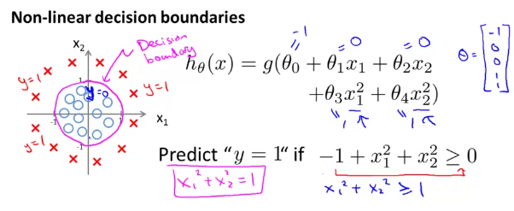
Neural Networks
- Motivation
  - To come up with a non-linear hypothesis with large number of features* is computationally intensive to do using logistic regression
  - *say the input is a 100x100 image (104 pixels); then, including quadratic terms in our hypothesis, we would have (104 x 104)/2 features (0.5 x 108 = 5 x 107 = 50 million)
- Neurons
  - Dendrites = input wires
  - Cell body = processing centre
  - Axon = output wire

- Model representation
  - Layer 1 – input layer (“dendrites”)
  - Final layer – output layer
  - Middle layers – hidden layers
  - Activation function – (sigmoid function)
  - Weights – parameters
  - The value of a node in a given layer is denoted as and is given by
, where
represents the parameters required to map layer to layer and denoted the number of nodes in layer .
  - It can be seen that the dimension of is (+1 is due to the bias)
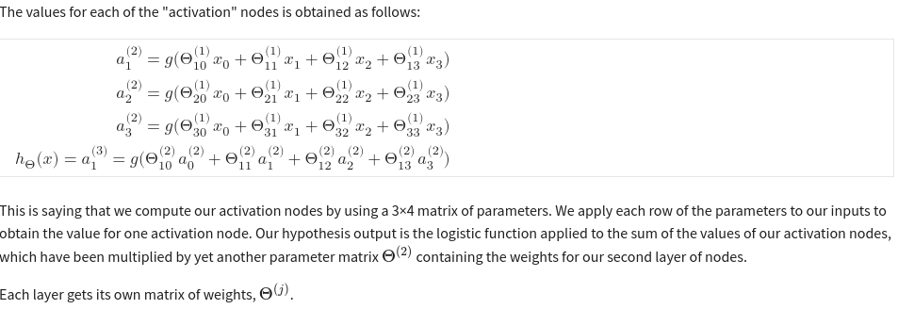

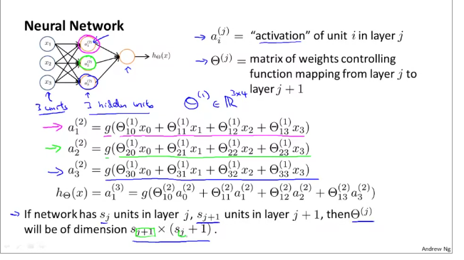
- Overfitting
  - Hypothesis has high variance – we don’t know much about the problem to restrict ourselves to some bias; so we have a large hypothesis space
  - This happens when the number of features is large (?)

VC Dimension
- https://datascience.stackexchange.com/questions/32557/what-is-the-exact-definition-of-vc-dimension

Bias-Variance Tradeoff
- Bias – The inability of a ML algorithm to capture the true underlying relationship between the features and the output (eg: using straight lines (linear regression) to fit a quadratic relationship)
- Variance – The difference in fits between datasets (low variability => consistent predictions across different datasets; predictions may be good, but not great, if the model has high bias)
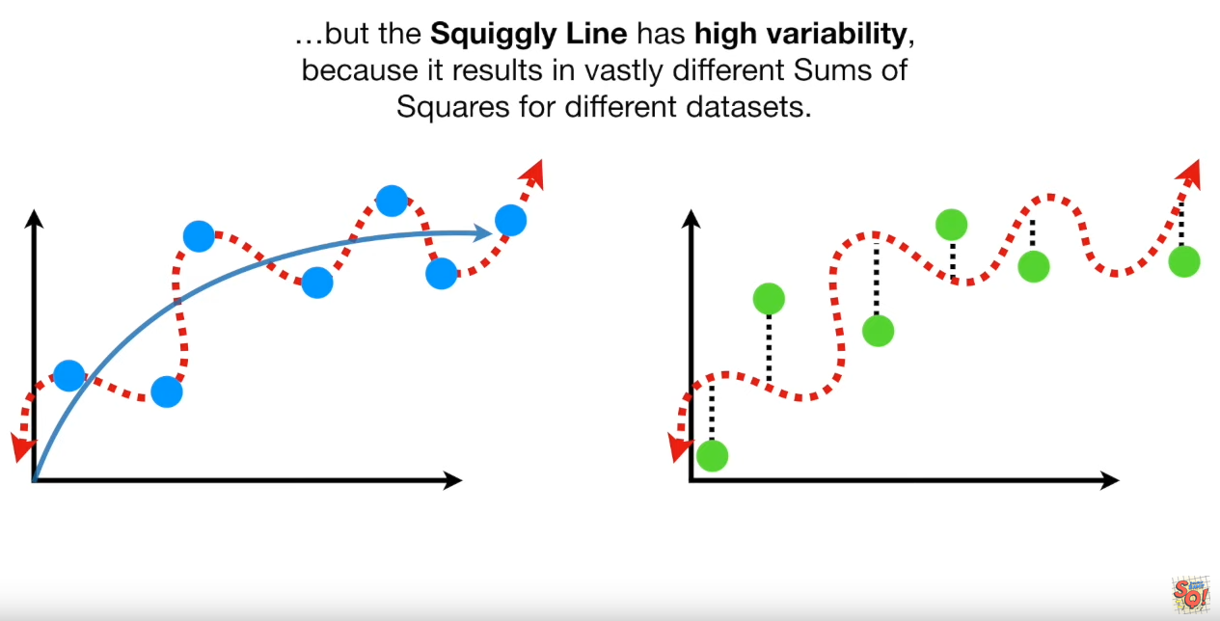

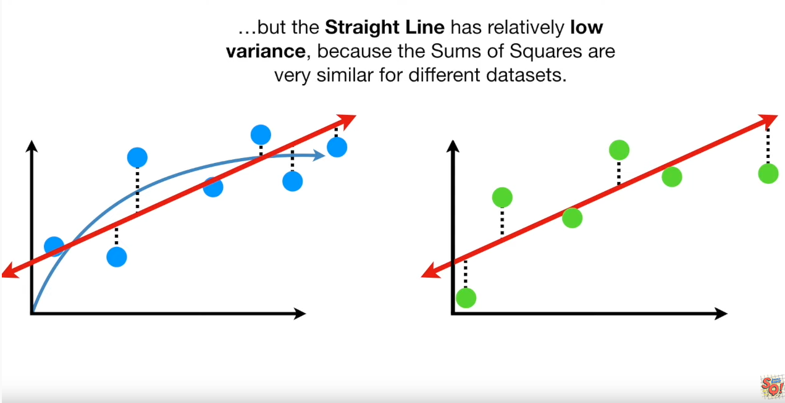

Decision Trees
- Gini Impurity – https://towardsdatascience.com/gini-impurity-measure-dbd3878ead33
- Entropy
  - https://stats.stackexchange.com/questions/95261/why-am-i-getting-information-entropy-greater-than-1
  - Information Gain vs. KL-Divergence
    - https://stats.stackexchange.com/questions/103175/information-gain-is-kl-divergence
    - https://stats.stackexchange.com/questions/13389/information-gain-mutual-information-and-related-measures
  - https://towardsdatascience.com/entropy-and-information-gain-in-decision-trees-c7db67a3a293

- Algorithm

Support Vector Machines

- Source: https://shuzhanfan.github.io/2018/05/understanding-mathematics-behind-support-vector-machines/

- Pre-requisites:
  - Equation of a plane
  - What do positive and negative values output by the LHS of the standard equation of a plane (for a given point) mean?
  - Shortest distance from a point to a plane – https://math.stackexchange.com/questions/1210545/distance-from-a-point-to-a-hyperplane

- It is a supervised learning algorithm that (for classification problems) aims to find the hyperplane (boundary) that has the widest “margin” of separation from the data points, (i.e.), all points above the margin are points from the positive class and those below are from the negative class

- Margin referes to the shortest “distance” between all the data points and the hyperplane. (distance refers to the perpendicular (or shortest) distance measure)

- In order to obtain such a hyperplane, the distance from all points to the plane must be >= the margin distance. (By definition of a margin, there cannot be any point that has lesser distance (than the margin distance) from the hyperplane)
- Thus, the following constraint should be satisfied by the required hyperplane –

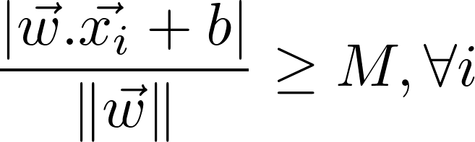, where M is the margin length

- The above constraint is only for those hyperplanes that give correct classification. But how do we know if a hyperplane classifies the data points correctly or not? We can incorporate this information into the above constraint as well. Before that, let’s define yi, (the label for the sample xi) to be 1 for the positive class and -1 for the negative class.
- Now our constraint becomes 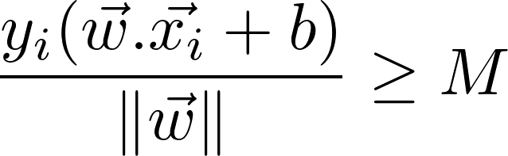
  - The LHS will be negative when the point is incorrectly classified by the hyperplane

- Since we are looking to maximize the margin, all those hyperplanes that gave an incorrect classification will be taken out of the picture since they output negative values in the LHS of the constraint.

- To simplify things, let’s take 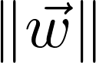 to the RHS and set 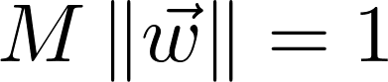. Thus we have our final constraint 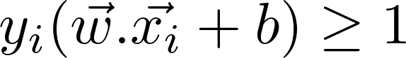

- Next, we determine the length of the margin (more specifically, we will find the length of the maximum width separating the 2 classes = 2 x margin_length) graphically and use the above constraint in the expression that we obtain.

Boosting
- https://towardsdatascience.com/boosting-algorithms-explained-d38f56ef3f30
- https://www.mygreatlearning.com/blog/adaboost-algorithm/

Backpropagation
- Matrix Calculus – https://math.stackexchange.com/questions/1621948/derivative-of-a-vector-with-respect-to-a-matrix

CNN
- https://towardsdatascience.com/a-comprehensive-guide-to-convolutional-neural-networks-the-eli5-way-3bd2b1164a53
- Application of Computer Vision
  - Image classification
  - Object detection (drawing a bounding box around the required object + finding out it’s position)
  - Neural style transfer (“re-paint” an image according to a given style)
- Why CNN and not normal neural networks?
  - Say, we need to detect features of a 1000 x 1000 color image, (i.e.), 106 x 3 pixels
  - If the 2nd layer in the NN has 1000 nodes, then the total number of weights required will be 1000 x [(106 x 3)+1] ~ 3 billion weights and thus it is not feasible to train it due to the heavy computational and memory requirements
- Edge detection
  - The filter matrix used for convolution with the image is usually 3x3 with fixed coefficients.
  - These weights can be learned using backpropagation (instead of being fixed), to get an image in which the edges are detected the best.
  - Convolution of an n x n image with an f x f filter (f is almost always odd) results in a matrix of dimension (n-f+1) x (n-f+1) (“valid convolution”)
- Padding
  - To prevent shrinking of image size at successive layers
  - To prevent loss of information in the “corner” pixels
  - If the amount of padding is p, then the size of the resultant matrix (after convolution) is (n+2p-f+1) x (n+2p-f+1)
  - If (n+2p-f+1) = n (i.e.), the size of the resultant matrix is the same as that of the image, then p = (f-1)/2 (“same convolution”)
- Strided convolutions
  - Stride = 2 => shift the filter matrix by 2 positions for every set of convolution
  - Dimension of resulting matrix using strides =
- Cross-correlation vs. convolution
  - Convolution involves flipping the filter matrix both horizontally and vertically and then computing the product-sum
    - take the horizontal mirror-image (), then the vertical mirror-image
()
  - If no filp is involved, the operation is technically called “cross-correlation”
  - Convolution follows the associative property: (A*B)*C = A*(B*C), but this is not of much importance in computer vision.
  - In CV, when we refer to “convolution”, it actually means cross-correlation
- Convolution over volume
  - The dimension of an RGB image is represented as: height x width x 3, where 3 refers to the number of channels (sometimes called depth)
  - To convolve over sunch an image, the filter should also have the same number of channels, (i.e.) f1 x f2 x 3 (f1 – height, f2 - width of filter matrix)
  - Each channel is convolved with its corresponding filter channel and the output for a given location (or pixel) is the sum of the outputs of all channels for that location.
  - The output is will be of dimension (n-f+1) x (n-f+1) x nc’, where nc’ is the number of filters being used, (i.e.), different filters can be applied to the image and their corresponding outputs will be stacked in the final output.
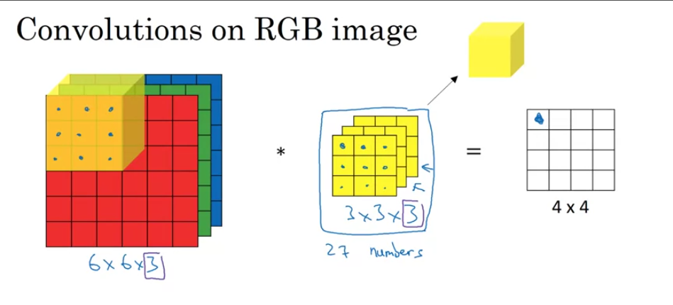
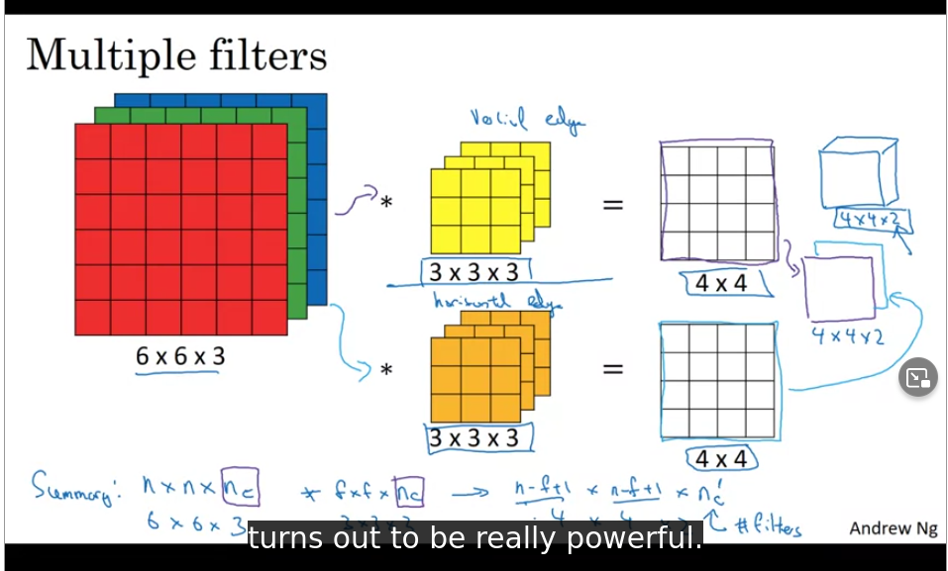

- One layer of a CNN
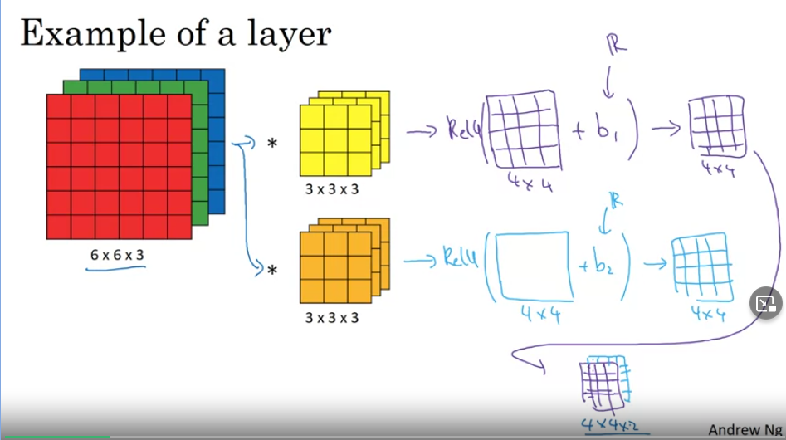
- Why convolution?
  - Parameter sharing
    - The same filter is used to detect a particular feature for all pixel positions
  - Sparcity of connections
    - The output of a particular pixel depends only on its neighbours and not on other pixels
  - Translation invariance
    - A “cat” image shifted by a few pixels would also be labelled correctly

- Note
  - Typically, as we move across the different layers (from left to right), the height and width decrease, while the number of channels increase.

- Popular CNNs
  - LeNet
    - ~60K parameters
    - used sigmoid/tanh activation (instead of ReLu)
    - non-linearity after pooling
    - involved computing convolution differently for a filter with nc channels to reduce computational cost

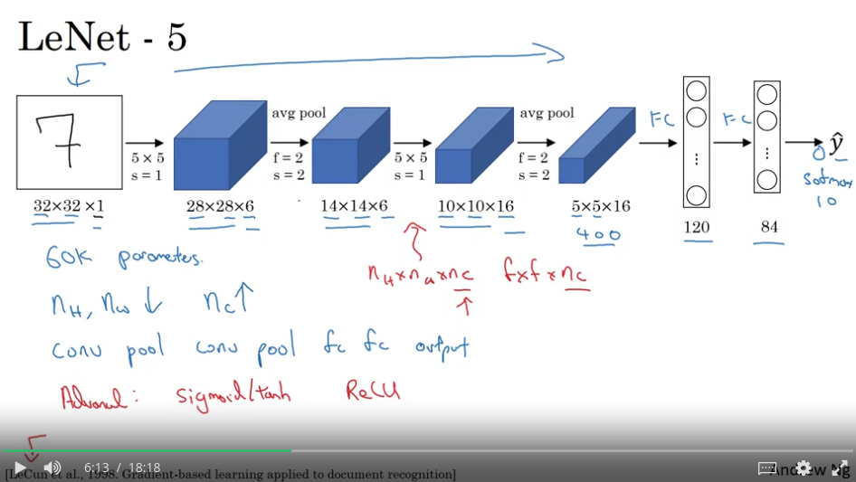

  - AlexNet
    - ~60M parameters
    - involves Local Response Normalization
    - parallel GPU execution

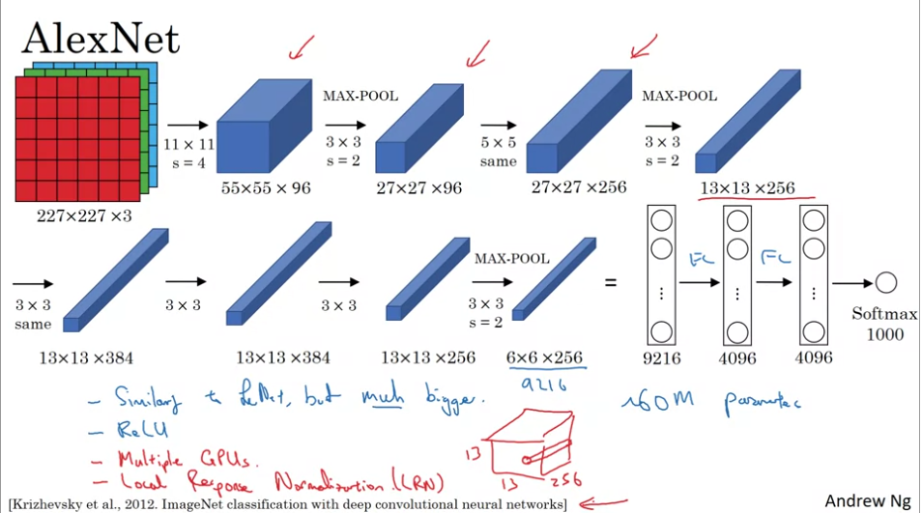

  - VGG-16 (VGG-19)
    - ~138M parameters
    - noted for simplicity
      - fixed convolution and pooling parameters
      - number of filters doubles for every set of convolution

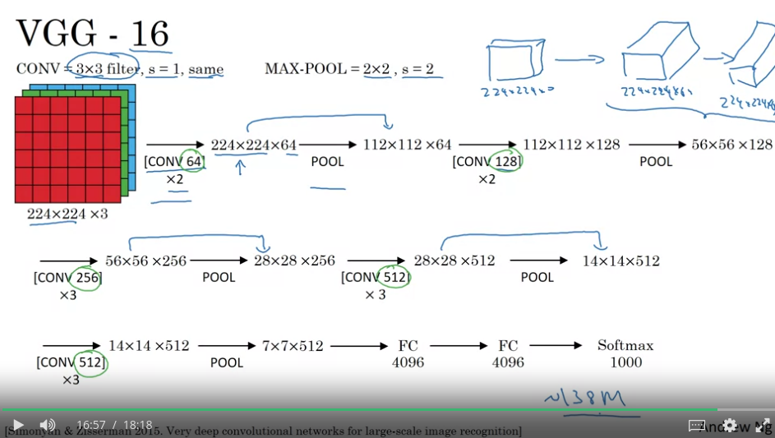

- ResNets
  - Difficult to train very deep NNs due to vanishing/exploding gradient problems

Feature Extraction ?

Support Vector Machines
- Cost function of Logistic Regression vs. SVM
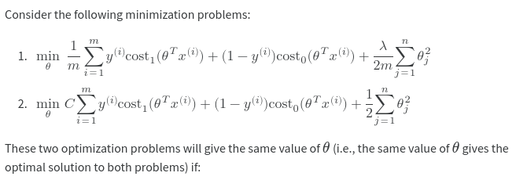

- <>

RNN
- Mitesh Khapra Deep Learning series (NPTEL) – https://youtube.com/playlist?list=PLyqSpQzTE6M9gCgajvQbc68Hk_JKGBAYT
- LSTM – http://colah.github.io/posts/2015-08-Understanding-LSTMs/
- GRU – https://towardsdatascience.com/understanding-gru-networks-2ef37df6c9be

Generative Modeling
- In discriminate modeling, we do classification, (i.e.), we finding P(C/X) directly by learning the mapping. Here X is the input feature, C is the class label
- In generative modeling, we want to do classification (or some other task) by finding out P(X/C) first. (How likely is it that X comes from class C as opposed to how likely is it that X belongs to class C)
  - If we want to do classification, we can apply Bayes Theorem and find out P(C/X)
- How to find P(X/C)?
  - Assume X as the white blood cell count and C as the class label for cancer (C=0 indicates no cancer)
  - We also assume that P(X/C) is normally distributed, (i.e.), we are performing Gaussian Generative modeling
  - Thus, we need to generate 2 distributions – P(X/C=0) and P(X/C=1)
  - For each distribution, we need 2 parameters – the mean and standard deviation
  - There is a way to estimated these parameters (MLE – Maximum Likelihood Estimation) for each distribution by using the training samples of the respective classes (refer slides for the derivation and formula) and we end up with the required distributions

Autoencoder

Techniques to prevent Overfitting in CNNs

Validation Set
- This is used after training and before testing
- It is used to check if the model has overfit the training data. (If training accuracy is high and validation accuracy is much lower, then overfitting has happened)
- In case of overfitting (see graph below), suitables changes are made to the training process and the model is run on the validation test set again.
- This process repeats until the model generalizes well, i.e, until validation accuracy is high and not much lesser than training accuracy.

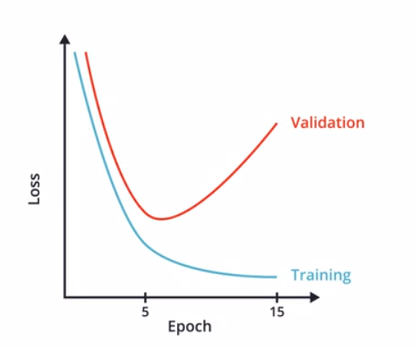

- Image Augmentation
  - Apply transformations such as rotation, zoom, flip, etc., to training images and add the transformed images to the training samples as well so that the model can generalize well on images it has not seen before.
- Dropout
  - Randomly “turn off” some neurons in the network during training
- Early stopping

Reading Materials – https://hackernoon.com/memorizing-is-not-learning-6-tricks-to-prevent-overfitting-in-machine-learning-820b091dc42

Expectation Maximization – https://www.kaggle.com/code/charel/learn-by-example-expectation-maximization/notebook

Overfitting-handling techniques
- Holdout dataset (cross-validation)
- Regularization
- Data Augmentation

Transfer Learning
- Side-track: Explanation-based neural network learning – multi-task learning – better performance
- Basic idea – Taking a pre-trained neural network and tweak it to fit the new scenario, (i.e.), a neural network that has been trained on a large dataset can apply its knowledge to a dataset it has never seen before
- Training
  - Only the weights pertaining to the output layer of the pre-trained model must be changed. Other variables of the pre-trained model should be frozen (non-trainable).
  - If we do not freeze the variables of the pre-trained model, the whole point of transfer learning is lost since our objective is to use the weights of the pre-trained model for our own training task.
  - As an additional benefit, the training time is reduced significantly.
- Tensorflow Hub – Repository of pre-trained models
- Sample Code

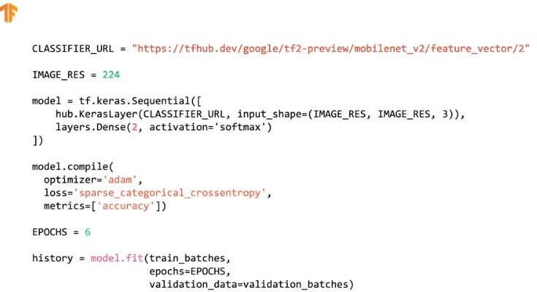

ML Implementation notes

- Markdown
  - https://www.markdownguide.org/cheat-sheet/
  - https://www.dataquest.io/blog/jupyter-notebook-tips-tricks-shortcuts/
  - ESC to enter command mode
    - dd to delete a cell
    - y to convert to python cell
    - m to convert to markdown cell
  - Enclose in $ <equation> $ to enter equations

- Matplotlib (import matplotlib.pyplot as plt)
  - plt.figure(num, figsize=(width_inches, height_inches))

  - plt.plot(x_values, y_values)
plt.plot(x_values2, y_values2)
# both of the above will appear in the same window => use legends to identify the plots
plt.xlabel(<>)
plt.ylabel(<>)
plt.title(<>)
plt.show()

  - Adding legends
plt.legend([<labels in the order in which they were plotted>]) (OR)
plt.legend() # if label arguments are provided in plt.plot()

  - Other arguments for plt.plot()
    - Use color, linestyle, marker arguments in plt.plot() (OR) Format string: ‘[marker][line][color]’ (hex values can also be used for color)
    - linewidth

  - plt.tight_layout() - to adjust padding
  - plt.grid(True) – to show grids on the plot

  - Style
    - print(plt.style.available) – to see the available (in-built) plot styles
    - plt.style.use(<style-name>)
    - plt.xkcd() # in reference to xkcd comics
  - plt.savefig(‘<>.png’) # to save a plot
  - %inline ?
  - color map ?

- Categorical encoding – https://towardsdatascience.com/categorical-encoding-using-label-encoding-and-one-hot-encoder-911ef77fb5bd
- Accessing drive files in Colab – https://stackoverflow.com/questions/48376580/google-colab-how-to-read-data-from-my-google-drive
  - from google.colab import drive
drive.mount(‘/content/drive’)
# use ‘/content/drive/My Drive/filename’

- Numpy and Pandas – https://www.hackerearth.com/practice/machine-learning/data-manipulation-visualisation-r-python/tutorial-data-manipulation-numpy-pandas-python/tutorial/

- Numpy
  - Numpy slicing – https://stackoverflow.com/questions/5347091/slicing-numpy-array-representing-nested-list
    - a = np.array([[1,2,3],[4,5,6],[7,8,9]])
    - a[:, :1] => [[1],[4],[7]]; a[:, 0] => array([1,4])
      - Slicing syntax: numpyArray[dim_1, dim_2, ... , dim_n], where dim_i can be of the form start_index : end_index : step
      - Note: Only numpy arrays (not lists) can be sliced using commas as above
  - np.random.uniform(low, high, size)
  - np.random.normal(mean, sd, size)
  - np.random.randint(low, high, size) – generates a random integer in the range [low, high)
  - np.append()
  - np.hstack()
  - np.array vs. np.ndarray()
  - np.ndarray.item()
  - np.sum()
  - np.matmul()
  - https://stackoverflow.com/questions/24439137/efficient-way-for-appending-numpy-array

- Pandas (DataFrame)

  - Creating a dataframe
    - data = [[item1a, item1b], [item2a, item2b], ...]
    - df = pd.DataFrame(data, columns = [‘col1’, ‘col2’])

  - To access column names: df.columns
  - Each row in a DataFrame is a Series
  - Count the different attributes of a column: a[“col_label”].value_counts()
  - Accessing particular row(s)/ columns(s)
    - https://stackoverflow.com/questions/31593201/how-are-iloc-and-loc-different
    - https://stackoverflow.com/questions/45983801/pandas-iloc-vs-direct-slicing
    - a.loc[index_label,:] (OR) a.iloc[:, col_name]
    - a.iloc[index, :] (OR) a.iloc[:, col_index] (use .iloc, .iloc to access values)
  - Changing index
    - https://stackoverflow.com/questions/19851005/rename-pandas-dataframe-index
  - Adding a row
  - Adding a column
  - Deleting a row
  - Deleting a column
    - a.drop([‘col_name1’, ‘col_name2’, ...])
  - Iterate over rows
    - for index, row in df.iterrows(): <>
    - https://stackoverflow.com/questions/16476924/how-to-iterate-over-rows-in-a-dataframe-in-pandas

  - Sorting
    - df.sort_values(by=[‘col1’, ‘col2’, …], ascending=True)

  - Grouping
    - Grouped = Df.groupby(by=‘col’)
    - Access a particular group
      - grouped.get_group(group_name)
        - Group names are available in grouped.groups
    - Iteration
For name, group in grouped.__iter__():
pass
    - <>
  - Index
    - Replace current index with default 0-based indexing
      - Df.reset_index(drop=True)
        - drop=False retains the old index as a column in the dataframe

  - List non-numeric columns
    - num_cols = df._get_numeric_data().columns
list(set(df.columns) – set(num_cols))

  - Handling datetime values
    - Time difference between 2 columns
      - pd.Timedelta(t1 – t2).total_seconds() / 3600, where t1 and t2 are Datetime objects
      - https://stackoverflow.com/questions/22923775/calculate-time-difference-between-two-pandas-columns-in-hours-and-minutes
    - Datetime index
      - https://towardsdatascience.com/tips-on-working-with-datetime-index-in-pandas-2bcedf956d70

  - Handling null values
    - NaN vs. NaT vs. None
      - https://dev.to/discdiver/the-weird-world-of-missing-values-in-pandas-3kph
    - Count all null values: df.isna().sum() (OR) df[‘col_name’].isna().sum()
    - Check for null values
      - pd.isnull(df.iloc[0][‘col_name’])
      - https://stackoverflow.com/questions/49435317/how-to-test-if-a-variable-is-pd-nat
    - Delete rows with null values: df.dropna(axis=0)

- Normal Distributions
  - scipy.stats.norm(mean, sd).pdf(data_point)

- Loading images from a folder – https://stackoverflow.com/questions/30230592/loading-all-images-using-imread-from-a-given-folder
- Matplotlib – https://youtube.com/playlist?list=PL-osiE80TeTvipOqomVEeZ1HRrcEvtZB_
- Automate data fetching (44)
- Using hash to split train and test data (50)
- Stratified sampling (51)
- Data cleaning (61) (start from 267)

- Sklearn
  - Splitting into training and testing
    - from sklean.model_selection import train_test_split
    - X_train, X_test, y_train, y_test = train_test_split(X, y, train_size=0.7, random_state=42)

  - Shuffling dataset
    - from sklearn.utils import shuffle
X, y = shuffle(X, y)
    - https://stackoverflow.com/questions/35076223/how-to-randomly-shuffle-data-and-target-in-python

  - Scikit Linear Regression
    - https://www.kdnuggets.com/2019/03/beginners-guide-linear-regression-python-scikit-learn.html
    - https://youtube.com/playlist?list=PL5-da3qGB5ID7YYAqireYEew2mWVvgmj6

  - Feature scaling
    - from sklearn.preprocessing import MinMaxScalar
    - scalar = MinMaxScalar()
    - X_scaled = scalar.fit_transform(X)
    - https://scikit-learn.org/stable/modules/generated/sklearn.preprocessing.MinMaxScaler.html

https://colab.research.google.com/github/tensorflow/docs/blob/master/site/en/tutorials/load_data/images.ipynb#scrollTo=oV9PtjdKKWyI

glob – to match files/folders that follow a specified pattern

- glob patterns are not the same as regex; regex are more powerful
- Source: https://youtu.be/Vc5kGYty18k
- Explore more on */ and **/

import glob
png_files = glob.glob(“path/*.png”) # return a list of filenames that match this pattern

# returns an iterator
# used in cases where you do not want to/ cannot store the file names in main memory
it = glob.iglob(“path/*.png”)

# recursive searching
# **/ is used to match zero or more subdirectories
glob.glob(“path/**/*.png”, recursive=True)

os

- Refer **/College/Machine_Learning/prerequisites_python/
- mkdir() vs. makedirs(); rmdir() vs. removedirs()
- os.listdir(“<dir_path>”) lists filenames in the directory
- os.path
  - .join
  - .basename
  - .dirname (get the parent-directory name)
  - .split (combines output of .basename and .dirname)
  - .exists
  - .isdir
  - .isfile
  - .splitext – to get filename without extension (...splitext[0])
- os.walk(directory)
  - for root, dirs, files in os.walk(directory):
- os.path.getsize(“<filename>”) – to get file size

# do something

pathlib

- Reference – https://youtu.be/iqZ2V8qTYq8
- Cheat sheet at **/College/Machine_Learning/prerequisites_python
- pathlib.Path(“...”).with_suffix(‘.txt’) – replaces existing suffix with the new suffix

datetime
generators and iterators

Pillow (import PIL)
- PIL.Image.open(“filepath/../sample.jpg”)

open-cv (import cv2)
- cv2.imread(“filepath/../sample.jpg”) # reads in BGR format
  - https://stackoverflow.com/questions/54959387/rgb-image-display-in-matplotlib-plt-imshow-returns-a-blue-image
    - Read grayscale images: cv2.imread(“file”, cv2.IMREAD_GRAYSCALE)
- cv2.resize(img, (width, height)) # returns image

subprocess
- run external script in Python
  - result = subprocess.run([‘program.sh’, ‘arg1’, ‘arg2’, ..,], capture_output=True, text=True)
print(result.stdout, result.stderr)
  - https://stackoverflow.com/questions/4760215/running-shell-command-and-capturing-the-output
  - os.system(‘command to run in cmd’)

Create a custom data generator
- https://github.com/anujshah1003/custom_data_generator
- Use case: When you have –
  - A csv file which maps the image filenames to their classes
  - An image directory containing all images
- Steps
  - create_samples(csv_file)
    - return a list of the form [[image_name1, label1], [image_name1, label1], ... [image_name_n, label_n]]
  - data_generator(samples, image_dir)
    - a generator function which takes samples (as described above) and ‘yields’ a generator

multiprocessing
- https://www.digitalocean.com/community/tutorials/python-multiprocessing-example
- https://colab.research.google.com/github/pnavaro/python-notebooks/blob/master/notebooks/10-Multiprocessing.ipynb

Misc
- use %timeit module to measure the time
- https://towardsdatascience.com/latest-winning-techniques-for-kaggle-image-classification-with-limited-data-5259e7736327
- https://www.kaggle.com/code/vbookshelf/python-generators-to-reduce-ram-usage-part-2/notebook
- wandb API key: 6126efc3a7a9a191e68b2067a05f874ac618d6a1
- https://www.kaggle.com/code/akarshu121/document-image-classification-with-docformer/notebook
Tensorflow

ML algorithm – a function that can tune variables in order to correctly map the inputs to their corresponding outputs

- Fashion MNIST training using vanilla neural network – https://colab.research.google.com/github/tensorflow/examples/blob/master/courses/udacity_intro_to_tensorflow_for_deep_learning/l03c01_classifying_images_of_clothing.ipynb#scrollTo=-KtnHECKZni_

- Fashion MNIST training using CNN – https://colab.research.google.com/github/tensorflow/examples/blob/master/courses/udacity_intro_to_tensorflow_for_deep_learning/l04c01_image_classification_with_cnns.ipynb

- model.summary()

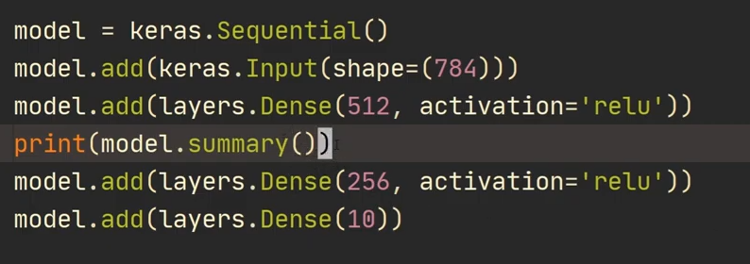

- Loading images – https://www.tensorflow.org/tutorials/load_data/images
- tensorflow.data.Dataset.load()
  - https://www.tensorflow.org/datasets/api_docs/python/tfds/load
  - https://stackoverflow.com/questions/58683675/how-to-manipulate-tfds-load-datasets-correctly-in-tensorflow-2-x
- When choose functional API over sequential API? (multiple inputs and outputs?)
- Reading image dataset – https://stackoverflow.com/questions/62654715/how-to-read-images-dataset-in-google-colab-for-deep-learning

Image classification from scratch – https://keras.io/examples/vision/image_classification_from_scratch/

Losses (tf.keras.losses)
- SparseCategoricalCrossEntropy()
  - https://datascience.stackexchange.com/questions/73093/what-does-from-logits-true-do-in-sparsecategoricalcrossentropy-loss-function
- Linear activation
- Softmax
- Understanding losses – https://gombru.github.io/2018/05/23/cross_entropy_loss/
- https://levelup.gitconnected.com/killer-combo-softmax-and-cross-entropy-5907442f60ba

Loading images

- https://www.tensorflow.org/tutorials/load_data/images
- tf.keras.utils.get_file(

)
- <>

tf.data.Dataset
- skip and take – https://stackoverflow.com/questions/48213766/split-a-dataset-created-by-tensorflow-dataset-api-in-to-train-and-test
- https://www.tensorflow.org/api_docs/python/tf/data/Dataset

tf.keras.layers.Rescaling

Looping under model.fit()
- https://stackoverflow.com/questions/50448743/is-it-logical-to-loop-on-model-fit-in-keras
- https://github.com/keras-team/keras/issues/2708

Grayscale to RGB
- https://stackoverflow.com/questions/70876871/transfer-learning-mobilenet-with-dataset-that-contains-grayscale-images

Data Augmentation
- https://www.tensorflow.org/tutorials/images/data_augmentation
- https://www.tensorflow.org/api_docs/python/tf/keras/layers/RandomZoom

Creating dataset from Google Images/ Bing
- https://pyimagesearch.com/2017/12/04/how-to-create-a-deep-learning-dataset-using-google-images/
- https://medium.com/analytics-vidhya/a-simple-way-to-collect-your-deep-learning-image-dataset-4ead47b6826c
- <>

- https://developers.google.com/machine-learning/crash-course/representation/feature-engineering

Probability distributions
- https://stats.stackexchange.com/questions/214275/intuitive-difference-between-joint-probability-and-conditional-probability-in-th
- https://math.stackexchange.com/questions/1566215/difference-between-joint-probability-distribution-and-conditional-probability-di

Bias variance – http://scott.fortmann-roe.com/docs/BiasVariance.html

RNN
- https://stackoverflow.com/questions/43408463/how-does-tensorflows-multirnncell-work
  - For advanced learning, see the blog post mentioned in the accepted answer
- https://machinelearningmastery.com/understanding-simple-recurrent-neural-networks-in-keras/
- SimpleRNN vs. SimpleRNNCell – https://stackoverflow.com/questions/50608080/what-is-a-cell-class-in-keras/50608296
- get_weights() for LSTM – https://stackoverflow.com/questions/68845790/gate-weights-order-for-lstm-layers-in-tensorflow
- Migrating from v1 to v2 – https://github.com/tensorflow/tensorflow/issues/28216
- xi

Autoencoders
- Terms – Latent variable model, variational inference, Evidence Lower Bound (ELBO)
- https://youtu.be/c27SHdQr4lw
- https://bjlkeng.github.io/posts/variational-autoencoders/
- https://ermongroup.github.io/cs228-notes/learning/latent/
- https://datascience.stackexchange.com/questions/63977/how-does-joint-probability-generate-new-data-in-generative-model

Initializing weights – https://stats.stackexchange.com/questions/27112/danger-of-setting-all-initial-weights-to-zero-in-backpropagation

Kaggle
- Use double dollar ($$) for Math Equations
- Hamming Loss – https://www.kaggle.com/competitions/mlp3/data (see sampleSubmission.csv)

