Angular JS

- MVC JS framework
  - Model View Controller architecture (separation of concerns)
  - Model – data (database, JSON, etc.)
  - View – HTML template to display content ; use expressions to insert data
  - Controller – controls functionality of views; performs interation between models and views (reacting to actions)
  - Nowadays, MVW (W - Whatever)
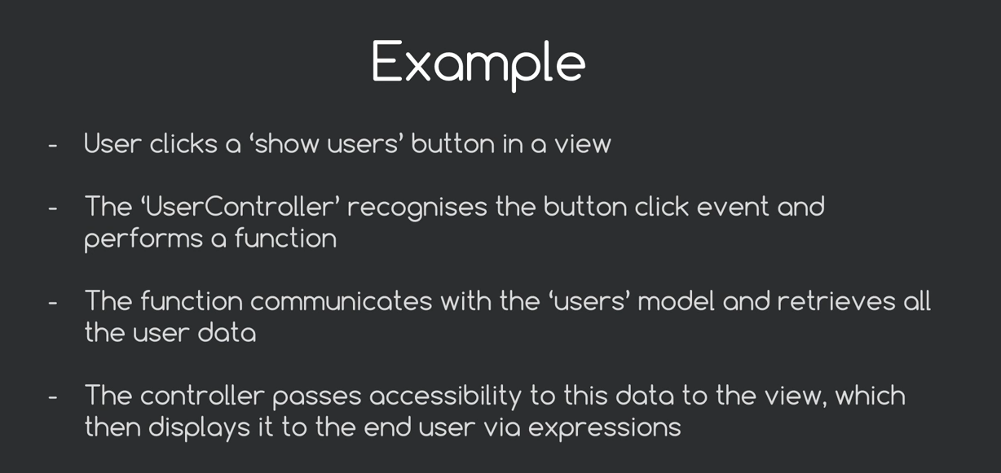

- single-page data driven applications
  - additional content brought into webpage without refreshing the page (using views and routing)
- Features
  - 2-way data binding (update model <-> update view)
  - Directives
      - “directing” Angular to do something for us
      - added as attributes to html tag
      - Custom directives could be made (eg: <ninja></ninja> - programming some behavour into this tag/directive)
      - ng-app directive – an attribute to decide the scope of the Angular application for your website
      - ng-model=“variable_name” – to store data
      - ng-init=“numbers=[1,2,3,4]” - used for initializing variables
      - ng-repeat
      - ng-include
        - to dump HTML content from another file into our view
        - can be used as attribute and tag
        - <ng-include src=“ ‘path/filename.html’ ”></ng-include>
        - <header ng-include=“ ‘path/filename.html’ ”></header>
      - ng-show – eg: <li ng-show = “ninja.available” ... > ... </li> (element is displayed if ng-show returns true; for ng-hide, element is hidden if ng-hide returns true)
      - ng-click (new variables can also be set; eg: <button ngclick=“newvar = ‘value’ ”>...</button>)
      - ng-submit – used for invoking functions after submitting forms (read more on how to store form data in an object using ng-model and controller)
      - ng-src
        - used instead of src=“{{ path }}” to ensure browser waits for Angular to load the source path dynamically instead of it (the browser) seaching the path, “{{ path }}” and throwing an error

  - Expressions
    - Snippets of JS code normally placed within curly braces, {{ }}
    - {{ user.name }} - user model, name property
    - Can also be used this way: <p class=“{{ className }}”>Some Text</p>
  - DOM
- Angular Modules and Controllers – to divide code into manageable chunks
  - Modules – container for various components (like controllers, ...)
    - define module(s) in a .js file
    - var myApp = angular.module(‘moduleName’, [/dependencies/]) (namespacing application so that scripts and variables outside Angular don’t intefere with the application code)
    - ng-app=“moduleName” – to make the HTML to be controlled by the module
  - Controller
    - controls application data
    - different controllers control different parts of the app
    - scope object – binding part between the HTML view and the JS controller
    - To protect variable name during minification, enclose dependencies (and function) in an array –
myApp.controller(‘controllerName’, [$scope, function($scope){} ])

- Filters
  - changing how we display the data (eg: prefixing, reordering)
  - orderBy, filter (for searching), currency
  - <li ng-repeat=“ninja in ninjas | orderBy: ‘name’ ”> {{ ninja.cost | currency: ‘$’}} </li>

Views and Routes
- <main ng-view></main> - place similar code in the place where you need your view to appear
- According to the routing specified, the corresponding view will be displayed in that place.
- If the route is /home, then the URL will be #/home (include # in href of <a>)

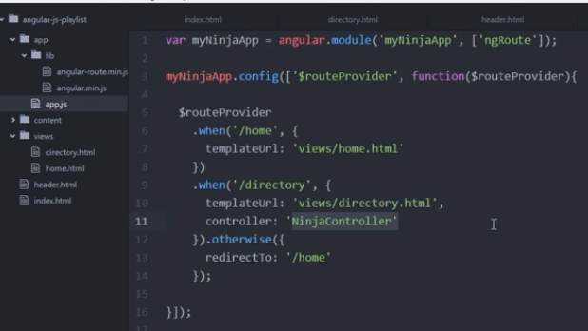

Service
- Piece of code that handles common tasks within application. Eg: http service is used for communication between the application and an external data source (http server)
- Pass $http as a dependency in the controller to use the service
- $http.get(/JSON_file_path/).success(function(data) {
<do something with data>
})

JSON
- Verify JSON – https://www.jsonlint.com/
- Online REST APIs - https://gorest.co.in/
- $http.get().then() - https://stackoverflow.com/questions/41169385/http-get-success-is-not-a-function
- Parsing JSON with spaces in key-name: https://stackoverflow.com/questions/22039760/parsing-json-with-spaces-in-key-name-with-angularjs

Component
- https://ultimatecourses.com/blog/exploring-the-angular-1-5-component-method

Custom Directives
- The custom directive will have its own isolated scope. Data in the view scope can be passed into this scope using the scope property defined in the custom directive
- Eg: creating a custom directive to output an image of a random ninja. The custom directive is called <random-ninja>
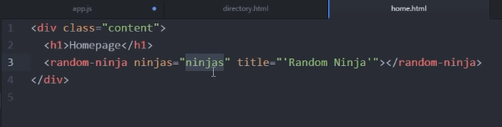

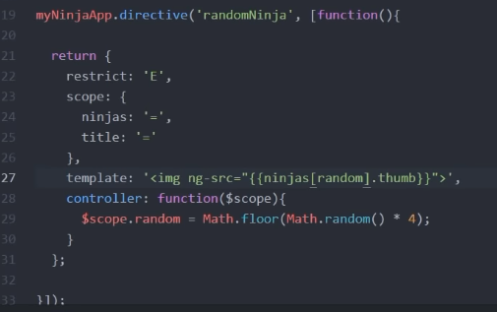
- when the ninjas property(?) is seen in scope, it searches for the same attribute in the place where the custom directive is used; because the ‘=’ value is specified, the 2 “things” bind together
- templateUrl can also be used in place of template to perform more complex operations
  - Anything within <random-ninja> will be replaced with the view specified in templateUrl
  - Specify transclude: true (in the scope) and ng-transclude as an attribut to a HTML tag in the template – nested html tags (inside custom directive) will also be displayed
  - replace: true replaces the custom directive tag with the outermost tag specified in the template

Animations
- https://docs.angularjs.org/api/ngAnimate
- Download library; include script; include as dependency (‘ngAnimate’) in the Angular module
- The library includes classes for elements entering/leaving the application, etc.
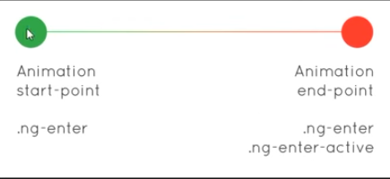

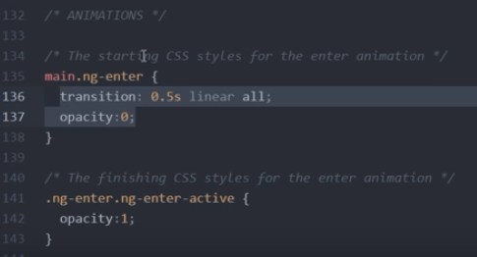

- transform: translateY(30px) can also be used for animaton
- ng-enter vs. ng-leave
- Stagger effect
  - When animating several items at once
  - “stagger” => wait for some time before the next animation
  - Eg: Deleting all contents – without stagger all content would appear to be swiped off at the same time (assuming there exits an animation for swapping in place)
  - 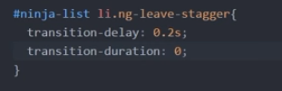
  - This gives a look where each element is being swiped off one after the other
  - transition-duration: 0 ensures that no other animations are inherited
- https://css-tricks.com/animations-the-angular-way/

Angular JS events
- https://stackoverflow.com/questions/17470790/how-to-use-a-keypress-event-in-angularjs

Provider vs. Factory vs. Service
- https://stackoverflow.com/questions/23074875/angularjs-factory-and-service
- https://docs.angularjs.org/guide/providers
- Factory
  - https://stackoverflow.com/questions/21919962/share-data-between-angularjs-controllers ($watch ?)
  - https://www.sitepoint.com/mastering-watch-angularjs/
  - https://stackoverflow.com/questions/16596569/angularjs-what-is-a-factory

Components
- Template + controller
- https://docs.angularjs.org/tutorial/step_03
- Reasons for usage
  - Reusability of functionality
  - Isolated scope
- Component vs. directives – directives are more powerful

Server side interaction
- https://stackoverflow.com/questions/34733010/php-get-params-from-angularjs-http-get-request
- https://stackoverflow.com/questions/11758079/how-to-get-the-url-parameters-using-angularjs (understand ‘url parameters’)
- https://stackoverflow.com/questions/48423009/how-to-get-data-with-php-from-angularjs-form
- https://stackoverflow.com/questions/15485354/angularjs-http-post-to-php-and-undefined (serialization)
- https://stackoverflow.com/questions/15155911/how-to-pass-querystring-in-angular-routes
- Displaying data from PHP to HTML
  - https://makitweb.com/how-to-get-data-from-mysql-with-angularjs-php/
  - https://stackoverflow.com/questions/46644703/angularjs-with-php-and-i-want-the-response-in-json

Misc
- “If you use ng-model, you have to have a dot in there” – https://stackoverflow.com/questions/12618342/ng-model-does-not-update-controller-value/22768720#22768720
- Linking an external JS file to a controller – https://stackoverflow.com/questions/28775810/can-i-link-an-external-javascript-file-to-an-angularjs-controller
- Single controller with 2 views – https://stackoverflow.com/questions/39068971/angularjs-using-single-controller-with-two-views
- this vs. $scope – https://stackoverflow.com/questions/11605917/this-vs-scope-in-angularjs-controllers
- Custom directives
  - https://stackoverflow.com/questions/20878830/angularjs-isolated-scope-for-directives-without-own-template
  - https://stackoverflow.com/questions/38432716/using-service-inside-directive
  - https://stackoverflow.com/questions/30480128/how-to-pass-parameter-and-get-values-from-custom-directive-in-angular-js
  - https://stackoverflow.com/questions/24651250/directive-scope-attributes-without-an-isolated-scope-in-angularjs
- Passing data from one controller to another – https://stackoverflow.com/questions/18856153/how-can-i-pass-some-data-from-one-controller-to-another-peer-controller

Terminologies
- module – container for controllers, directive, services, etc. which get applied to the application during the Bootstrap process

- directive – marker on HTML DOM that tells AngularJS’s HTML compiler, $compile, to attach a specified behaviour to that DOM element

- controller – business logic for application (technically, contructor function or class)

- component – special kind of directive suitable for component-based application structure

- filter – formats expression

- service - substitutable objects wired together using DI (below)
- Dependency Injection – software design pattern that deals with how components get hold of their dependencies
- Bootstrapping
  - Automatic Initialization
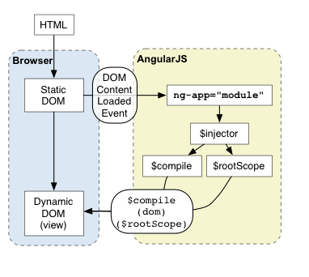

  - Manual – angular.bootstrap(document, [“myApp”])

- 2-way binding (ng-bind vs. ng-model)
- $scope
- ng-template
- ng-transclude

