HTML, CSS, JS

HTML

- HTML vs CSS (to change how HTML is going to look like)
- index.html – front page of website
- Tag
- Attribute – Information about the tag
- Element
  - Regular
  - Empty – no empty tags
- <head> tag contains the non-visible contents of the websites
  - <title> tag
  - <meta> tag contains information about the website (eg. Charset)
  - <link>
- 2 ways to display text
  - <p>
    - <br> tag
  - <hi>
    - upto <h6>, with h1 being the most important
    - only 1 <h1> tag allowed
    - use h1 to tell what the website is about; h2 for section-titles
  - search engines search based on content in the <hi> and <p> tags
  - <section> - to group similar content
  - <article> - content inside it are related to each other?
- Containers (“boxes”)
  - <div> - box (to group content) that has no specific purpose and which can be moved around
- Comments:
  - <!-- comment -->
- <div> vs. <span>
  - https://blog.hubspot.com/website/span-vs-div (EXCELLENT MATERIAL!)
  - algin attribute can be used only in div?
- <class> vs. <id>
  - class – multiple class names allowed for a single attribute; can be reused
  - ID – only single id for an element; cannot be reused; involved in Javascript functionalities
  - IDs can be used for navigating to a particular block in a webpage (bookmarks)
  - Why assign multiple classes to a single html element?
  - Can a class and an ID have the same name?
- <a>
  - target= “_blank” – to open in a new tab
  - <a href= “#”> Not sure where this link will lead </a>
  - a:hover (CSS)
- <form class=“” action=“” method=“”>
  - https://www.w3schools.com/html/html_forms.asp
  - action = “<filename>”
  - methods – get (data appears in URL, 3000 characters limit), post (for sensitive data)
  - <input type=“” placeholder=“”>
    - Values for the ‘type’ attribute
      - submit
      - button
      - email
      - password
  - <textarea>yyy</textarea> <textarea value=“yyy”></textarea>
  - <button></button>
  - Other (common) attributes: name, value, checked (no value)
  - Frames
  - href vs. src vs. target

Input fields
- Radio button
<p>Caption</p>
{
<input type=“radio” name=“xyz” id=“aaa”>
<label for=“aaa”>AAA</label>
} repeat this unit, ensuring same values for name, but different values for id
- Check box – similar to radio buttons, but different values for both name and id (for every option)
- Drop-down
<label for=“aaa”>SomeList</label>
<select id=“aaa” name=“aaa”>
<option value=“x”>Option1</option>
<option value=“y”>Option2</option>
</select>
- Hotspots
<img src=“...” usemap=“#somemap”>
<map name=“somemap”>
<area shape=“rect” coord=“x_topLeft, y_topLeft, x_bottomRight, y_bottomRight” href=“#”>
</map>
- <label for=“someID”>labelName</label> - used in radio buttons to ensure that click the label for an option is equivalent to clicking the corresponding radio button
- <fieldset> and <legend> are used as group boxes
- For radio-buttons, selection-lists (selected) and check-boxes (checked), the value attribute is sent to the server side on submitting the form
- For radio-button, name attributes should all be the same

Ways to add styles (CSS)
- Using stylesheets
- Using style tag
  - <style>
body {font-family: "Times New Roman";}
</style>
  - Note the semi-colon
- Using style attribute
  - <div style="margin: auto; width: 50%; border: 3px solid green">
  - Note the semi-colon

Ways to represent color
- name
- hex-code: #ab13f2 (OR) #fff
- rgb(255, 1, 255)
- rgba(255, 1, 255, ɑ) ɑ ranges from 0 to 1 to indicate transparency

CSS
- Reset stylesheet - http://html5doctor.com/html-5-reset-stylesheet/
  - resets all default stylings of different browsers
  - ensures html is rendered the same way in all browsers
- Order (for padding, margin, ...) : top right bottom left; top&botton left&right
- RGB order?
- CSS Units?
- Line height?
- Margin?
- Padding?
- Inline vs Block?
- Grid vs. Flexbox?
- Float
- Display
- max-width
- Color websites -
  - https://coolors.co
  - https://color.adobe.com/create/color-wheel
  - https://www.webfx.com/web-design/hex-to-rgb/
- Comments:
  - /* comment */
- Override critera – those that follow below override the styles on top (if applicable)
- Classes: .class-name{} ; ID: #id-name{}
- Inheritence
- To centre-align a div, use the following styling
.example-div-class {

width: 50% /* margin: auto does not work without width*/
margin: auto
border: 3px solid green /*note that there are 3 values*/

}
- To center an element (eg: button) inside a div, use text-align: center;
- Block element modifier (CSS naming convention)
- Adding background image – background-image: url(‘...’);
- To remove default input box styling, give outline: none;
- Box Shadow: box-shadow: h-offset v-offset blur spread color
- overflow: hidden ?
- Combining classes with dots in CSS selector – https://stackoverflow.com/questions/18584015/multiple-dots-periods-in-css
- CSS Combinator Selectors
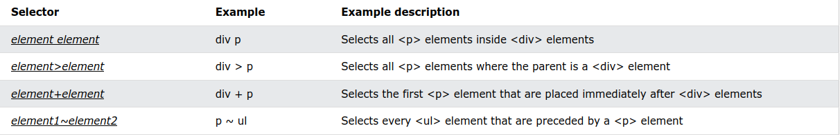

Text Styling
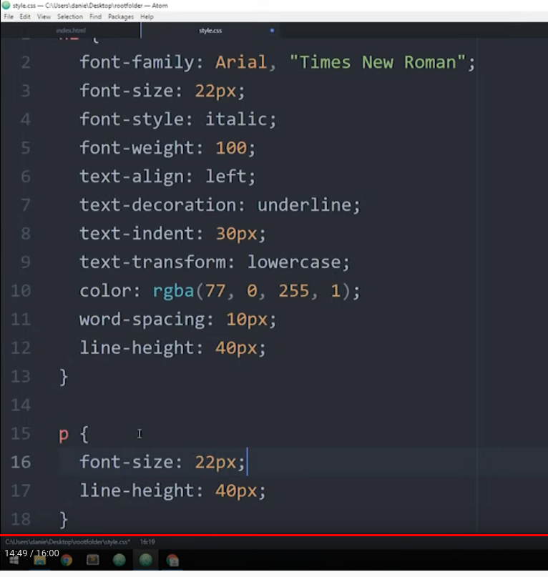

- Aligning text inside a div
  - Horizontal – use text-align
  - Vertical – use padding
Importing New Fonts
- Add as link (go to https://fonts.google.com/ )
  - Add to <head> as <link rel=“stylesheet” href=“<link>”;
In the CSS file, specify font-family
  - Use the @import method in the CSS file
- Download (https://www.dafont.com/ )
    - Use the @font-face rule
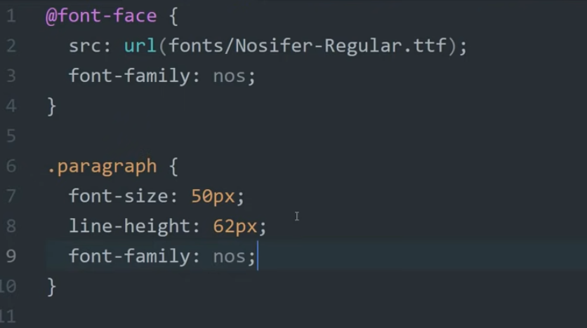

Creating Nav Bar
- <nav> tag

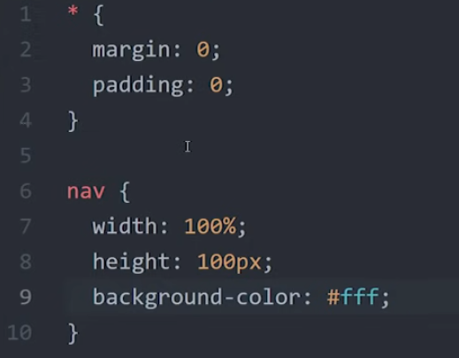
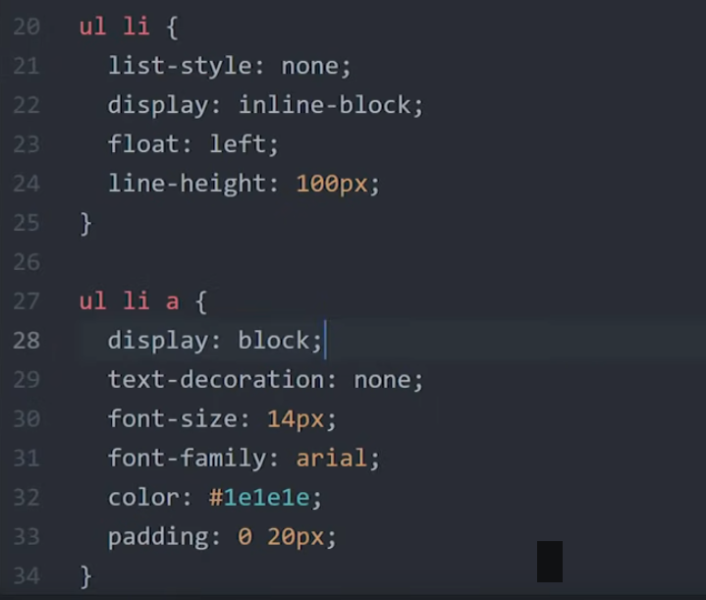
To remove spacing between list elements
For centre alignment (vertical)
To make the padding regions clickable as well

Why “display: block;” for ul li a ?

Image styling
- https://blog.hubspot.com/website/insert-image-in-html

Wrapper
- https://stackoverflow.com/questions/4535983/for-div-to-extend-full-height

Image Insertion
- <alt> tag – used by search engines
- If one length (width or height) is specified, the other will be set automatically according to scale
- contain vs cover: https://stackoverflow.com/questions/27939971/difference-between-background-sizecover-and-background-sizecontain
- https://www.digitalocean.com/community/tutorials/how-to-change-a-css-background-images-opacity
Block vs. Inline
- https://web.stanford.edu/class/archive/cs/cs193x/cs193x.1176/lectures/05/block-inline

Float
- Box model applies to only block-level elements
- Floats were originally intended to wrap text around images
  - When an element is “floated”, it is taken out of the normal document flow (no height with respect to the parent)
  - float: left|right;
  - clear: left|right|both – to restart normal document flow
    - but top-margin property does not have any effect; so do this after floated elements: <div style=“clear: both;”></div> (OR) use ‘after’ pseudo-class
  - If a <div> has a floated child, float the <div> as well to include the floated child inside it.

Flexbox
- Some browsers do not support flexbox => use Modernizr (adds a class to the CSS to style for that specific browser that does not support flexbox)
- Apply flexbox to parent container (display: flex) => all (direct) children become ‘flex-items’
- Styling to be applied to parent container are given a red font color.

- display: flex /* to re-arrange elements in the container using flexbox */
  - Default behaviour of flex-items – being stacked left-right in a row

- flex-grow: 1
  - to expand elements into available space and the rate of expansion is relative to the other flex-items
- flex-shrink: 1
  - determines the rate at which elements shrink as the browser window gets smaller (relative to sibling items)

- flex-wrap: wrap (reverse-wrap/ no-wrap)
  - to prevent content from going off the page when the browser window is made smaller

- flex-basis:
  - like min-width, but when window size is decreased, they shrink as normal flex-items would do (if wrapping is not possible)

- flex: <grow> <shrink> <basis>

- flex-direction: row /*default*/ (OR)
flex-flow: row wrap

- justify-content: center /* space-around vs. space-evenly ? */
  - other options: flex-start (default); flex-end; space-between

- align-items: stretch /* to extend div to the full “cell” */
- align-content:
Note: align-items is used for rearranging items in a row; align-content is used rearrage the layout of all rows (?)

Animations
- https://www.joshwcomeau.com/animation/css-transitions/

Creating a close button
- https://stackoverflow.com/questions/18611195/x-close-button-only-using-css

Miscellaneous
- Changing font style of option (drop-down) – https://stackoverflow.com/questions/10696004/how-to-change-font-family-of-drop-downs-list-item
- Modal dialog – https://stackoverflow.com/questions/8973951/put-select-element-in-a-javascript-prompt/8973996#8973996
- Fit background image to div
- different input types
- CSS to forms (and styling buttons)
- CSS color styles
- Anchor tag styling
- https://www.geeksforgeeks.org/how-to-set-div-width-to-fit-content-using-css/
- display properties
- Name vs. id vs. class
- Theory doubts
  - XML
  - DTD declarations
  - HTML 4 vs HTML 5
- CSS Positions (z-index)
- section, aside, nav
- CSS units
- negative margin (for collapsing) – https://stackoverflow.com/questions/17915865/how-to-make-borders-collapse-on-a-div

