PHP

- Setting up local server
  - XAMPP – Run apache and mysql
- HTML and JS, Jquery codes can also be written inside a PHP folder
- index.php (OR) index.html – both are recognized as starting pages

- End statements with ;
- Displaying
  - echo
  - print (echo is faster)
  - arithmetic can also be done
  - use dot as separator (leave space before and after the ‘.’)
- Variables
  - $variable_name = “value”
  - Use case eg: Echo different outputs based on user’s input
    - $name = $_GET[‘person’] (assume you have an input field ‘named’ person in an HTML form)
    - Note: GET method => you get something in the URL
- Comments
  - Single line: //
  - Multiple lines: /* ... */
- Pre-determined (internal) functions
  - strlen(string)
  - str_word_count(string)
  - strrev(string)
  - strpos(string, word_to_find)
  - str_replace(to_replace, replacement, string)
- Datatypes
  - String
  - Integer
  - Float
  - Boolean
  - Array
    - $names = array(“name1”, “name2”, “name3”);
    - echo $names[‘0’]; // outputs “name1”
- Operators
  - Arithmetic: +, -, *, /, %, **
  - Assignment
  - Comparison: === (checks if both value and data-type are equal); !== (opposite of ===)
    - if ($x === $y) {
<do something>
}
elseif ($x == $y) {
<do something>
}
else {
<do something>
}
    - switch case (same as C-syntax)
  - Logical operators: or (||), and (&&), xor
- include vs. require
  - include(‘<path>’) vs. require(‘<path>’)
  - include carries on with the rest of the code if there is an error; require throws a fatal error and does not carry on with the rest of the code

Object Oriented PHP

- Benefits of OOP PHP
  - Re-usability of code
  - Easier to work with in groups (separate files to do separate things)

- 3 things that PHP does
  - Query database (model)
  - Getting data from user (controller)
  - Displaying data to user from the database (view)

- Classes serve as blueprints or templates for a particular entity; classes containe properties and methods.

- Model-View-Controller Model
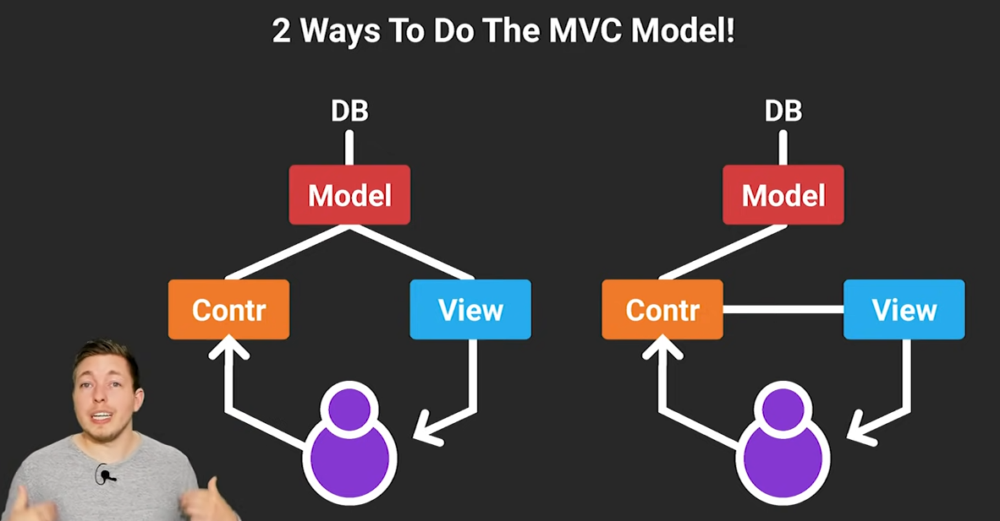

- Including a class from another file – https://stackoverflow.com/questions/14350803/how-to-use-a-php-class-from-another-file

- Inheritance
class ChildClass extends ParentClass {
// code
}

- Use $this->something to access the property ‘something’ inside that class

- -> vs. :: - https://stackoverflow.com/questions/3037526/where-do-we-use-the-object-operator-in-php

- Constructor
public function __construct() {
}

- Destructor
public __destruct() {
}

- web server

