GNU Octave

- a^b (carat) OR a**b (exponentiation)
- A’ (transpose of A)
- linspace(start, end, n) – returns a row vector with n elements (from start to end) spaced uniformly
- plot(x, y, property)
- hold on – to plot another graph on top of the existing ones

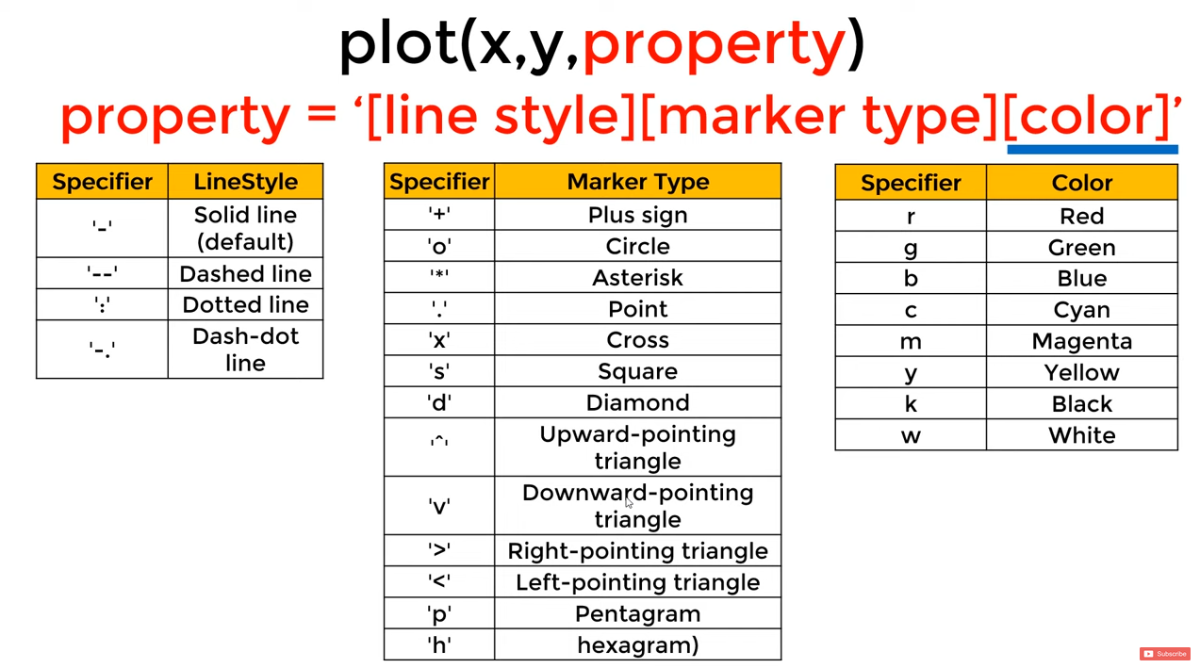

- axis([x_{min} x_{max} y_{min} y_{max]}) – to control range of x and y axes in the plot
- set(gca, ‘FontSize’, 24) (gca – current axes object (figure?))
  - Xtick, XTickLabel: set(gca, 'XTick', -2*pi:pi:2*pi, 'XTickLabel', {'-2\pi', '-\pi', '0', '\pi', '2\pi'})
- legend(‘str1’,‘str2’)
- print -dpng ‘plot_image.png’
- imagesc(A) – to visualize a matrix
  - imagesc(A), colorbar, colormap grey; (comma chaining)
- not equal: ~=
- PS1(‘<< ’)
- disp(sprintf(‘’))
- format short; format long
- x=[1 2; 3 4; 5 6]
- rand(m,n) – generates mxn matrix with numbers drawn from the uniform distribution between 0 and 1 randomly
- randn(m,n) – same as above, but uses Gaussian distribution
- hist(w, nbins)
(mean, variance ?)
- eye(m) – mxm identity matrix
- length vs. size
  - size(A) returns a 1x2 matrix: [#rows #columns]
  - length(A) returns the length of the longest dimension (usually applied only to vectors)
- load <filename> (OR) load(‘<filename>’)
- who – to show variables in the current scope (use ‘whos’ to get a detailed view)
- clc – clears command window
- clear var_name – removes variable from scope
- save filename var_name – to save a variable to a file
- A(:,2) – everything in the 2nd column of A
- A([1 3],:) - 1st and 3rd row with all columns
- A(:) - put all elements of A into a single column vector
- C = [A B] – concatenating 2 matrices side by side ([A;B] to concatenate top-bottom)
  - Note: [A B] is the same as [A, B]
- A*B – matrix multiplication; A.*B – multiply corresponding elements (inner product)
  - A.^2 gives element-wise squaring
  - 1 ./ A gives element-wise reciprocal
  - -A is the same as -1*A
  - A+1 increments every element in A by 1
- max
  - [value, index] = max([1 2 -1 4]) – to get both value and index of the maximum element
  - max(A) or max(A,[],1) gives the colum-wise maximum of the matrix A
  - max(A,[],2) gives the row-wise maximum
- A < n returns a binary matrix of the same size where a_{ij}=1 if a_{ij} < n
- find(A < n) returns a vector with indices of elements which satisfy
- sum(A,1) returns the column-wise sum; sum(A,2) returns the row-wise sum
- flipud(A) – flips each column (vertical flip)
- pinv(A) – to take the (pseudo) inverse of A

- for i=1:10 % for i=some_array
disp(i)
end;

- if <condition>,
<do something>
elseif <condition>,
<do_something>
end;

- function return_value = func_name(parameters)
- addpath(‘...’) % add octave searchpath

