Stuff learned in CP

- Area of triangle
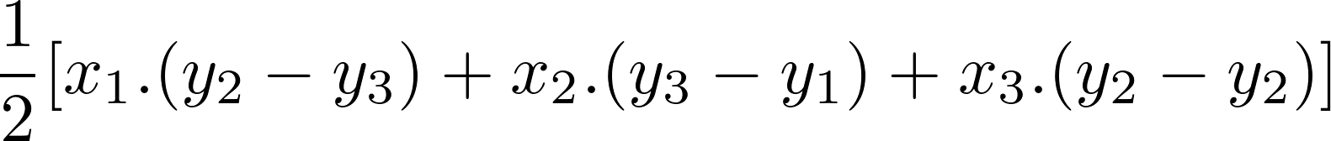

- GCD-LCM: LCM(a,b) =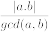
  - Python: math.gcd(x,y) (import math)
  - C++: __gcd(x,y) (#include<algorithm>)
  - Euclidean method:
// x<y
gcd (x,y) {
if (x==y) {
return x;
}
else if (x==0) {
return y;
}
else if (y==0) {
return x;
}
else if (x>y) {
return gcd(y,x);
}
else {
return gcd(x,y%x);
}
}

- Counting the number of digits in a number:

- Bit shifts
  - https://stackoverflow.com/questions/141525/what-are-bitwise-shift-bit-shift-operators-and-how-do-they-work
  - Left shift <<
    - equivalent to multiplication by powers of 2
    - Eg:
    - meets needs of both logical and arithmetic left shift (how?)
  - Logical right shift >>>
    - for unsigned numbers
    - equivalent to division by powers of 2
    - Eg: 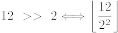
  - Arithmetic right shift >>
    - same as >>>, but for signed numbers (sign-preserving)

- mod of negative numbers
  - https://math.stackexchange.com/questions/2179579/how-can-i-find-a-mod-with-negative-number
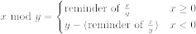

- Inclusion-exclusion to find multiples
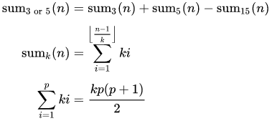
- Pythagorean triplet (a + b + c = 1000) - https://stackoverflow.com/questions/2817848/find-pythagorean-triplet-for-which-a-b-c-1000

- Even Fibonacci numbers

- Non-decreasing sub array

- Kadane’s algorithm (maximum contiguous sum)
  - sum = 0
  - ans = INT_MIN
  - for num in num_list:
    - sum += num
    - ans = max(ans, sum)
    - if sum < 0:
      - sum = 0

- Prefix sum
  - prefix_sum = [num_list[0]]
  - for i in range(len(num_list)):
    - prefix_sum.append(prefix_sum[i-1] + num_list[i])
(OR)
  - prefix_sum(n+1,0)
for i: 0 to len(num_list)-1:
    - prefix_sum[i+1]=prefix_sum[i]+num_list[i]
  - To find the sum between the indexes start and end: prefix_sum[end+1]-prefix_sum[start]
  - If the n+1 format is used, prefix_sum[i], represents the sum upto the (i-1)^{th} element.

  - Marker array – assume you given q queries and each query asks you to increment the elements from l to r by k. (l, r and k differ for each query) You need to print out the final array (num_list) -
  - marker = [0,0, ... (n times)] (n is the array length)
  - for each query:
    - marker[l] += k
    - marker[r+1] -= k, provided r < n -1
  - marker = find_prefix_sum(marker)
    - // now every element in marker indicates, by how much every element in the array needs to be incremented
  - for i in range(n):
    - num_list[i] += marker[i]

  - Given 2 lists of intervals (every element in each list is of the form (l,r) which denotes that numbers from l to r, are contained in that interval), say X and Y. For every interval in the list Y, you are required to find the count of numbers in X from Y_{i}.l to Y_{i}.r, whose frequencies are greater than some integer k.
  - Create an array, marker (initialized with 0) of size = # of numbers that X encompasses
  - For every interval in X:
    - marker[index representing X_{i}.l] += 1 (check!)
    - marker[index representing X_{i}.r + 1] += -1
  - Find_prefix_sum(marker_array)
    - // now you know how many times each number in marker repeats
  - Next, make a slight modification to the prefix_sum array, so that prefix_sum[i] represents the number of elements whose frequencies are greater than k, starting from the element representing index 0 to the element representing index i (or i-1 if the n+1 format is used.)
  - To find the count of numbers from a and b whose frequencies are greater than k, use the new prefix_sum array and compute (# of elements upto b that have a frequency>k) - (# of elements upto a-1 that have a frequency>k) = prefix[index representing b]-prefix[index representing a-1]

- Difference Array – https://codeforces.com/blog/entry/78762

- Floyd’s algorithm (repetition in N+1 numbers)
  - Important: If elements that make up a list are from 1 to n (and the array size is n+1), then you can visit every element in this list (starting from index 0) by using each element as an index.
  - slow = fast = num_list[0]
  - do {
    - slow = num_list[slow]
    - fast = num_list[num_list[fast]]
} while slow != fast
  - fast = num_list[0]
  - while slow != fast:
    - fast = num_list[fast]
    - slow = num_list[slow]

- Dutch National Flag algorithm
  - low = mid = 0
  - high = n-1
  - while mid <= high:
    - if mid == 0:
      - swap(num_list[low], num_list[mid])
      - mid++, low++
    - else if mid == 1:
      - mid++
    - else: # mid = 2
      - swap(num_list[high], num_list[mid])
      - mid ++, high--

- 2-sum problem
  - index_map<int,int> = {} // mapping from num_list[i] to i
  - for i in range(n):
    - if (target – num_list[i]) in index_map:
      - return [index_map[target – num_list[i]], i]
    - else:
      - index_map[num_list[i]] = i

- 4-sum problem
  - 3-pointers + binary search
  - 2-pointers + 2 pointers

- https://towardsdatascience.com/two-pointer-approach-python-code-f3986b602640

- Cycle Detection – undirected – BFS
  - visited = [-1 for i in range(V)]
  - for i:1 to V
// identifying components of the graph
    - If visited[i]== -1:
      - do cycle detection starting from i (Method 1 or 2)
Note: visited is passed by reference for both methods

  - Method 1:
    - bfs_queue = [<start, -1>] // <node, parent> form
    - while bfs_queue is not empty:
      - current = bfs_queue.popfront() // <node, parent> pair
      - visited[current.node] = 1
      - for u in adj_list[current.node]:
        - if visited[u] == -1:
          - bfs_queue.append(<u, current.node>)
        - else if (u != current.parent):
          - return True // cycle exists
    - return False

  - Method 2:
    - bfs_queue = [<start, -1>] // <node, parent> form
    - visited[start]=0 # -1 => unvisited; 0 => in-queue; 1 => visited
    - while bfs_queue is not empty:
      - current = bfs_queue.popfront() // <node, parent> pair
      - visited[current.node] = 1
      - for u in adj_list[current.node]:
        - if visited[u] == -1:
          - bfs_queue.append(<u, current.node>)
          - visited[u]=0
        - else if visited[u]==0:
          - return True // cycle exists
    - return False

- Cycle Detection – undirected – DFS
  - Similar to method 1 of undirected cycle detection using BFS

- Cycle Detection – directed – BFS
  - Using the idea of Khan’s algorithm

- Cycle Detection – directed – DFS
  - Similar to method 2 of undirected cycle detection using BFS

- Topological Sort – BFS (Khan’s algorithm)
  - https://practice.geeksforgeeks.org/problems/topological-sort/1
(log in through Google with SSN mail ID)

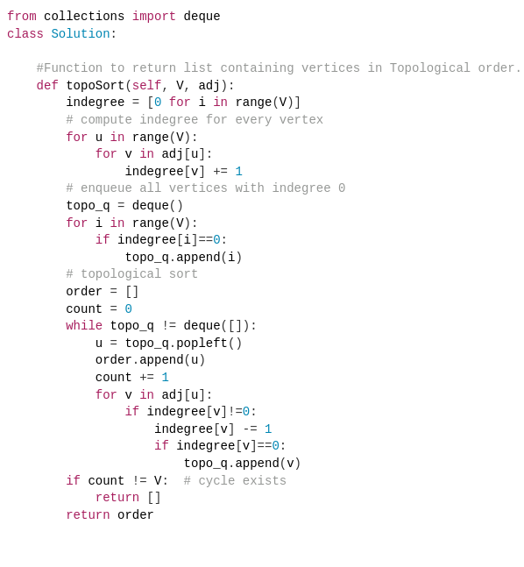

- Topological Sort – DFS
- Bipartite Matching (Kuhn’s algorithm)
  - https://cp-algorithms.com/graph/kuhn_maximum_bipartite_matching.html

- DFS Tree properties
  - https://codeforces.com/blog/entry/68138

- Rat in a maze using BFS
  - https://www.techiedelight.com/find-shortest-path-in-maze/

- Disjoint Sets
- Kruskal’s Algorithm
- Prim’s Algorithm
- Floyd-Warshal Algorithm
- Ford-Fulkerson Algorithm

- https://www.geeksforgeeks.org/minimum-time-required-so-that-all-oranges-become-rotten/
- https://stackoverflow.com/questions/29741691/maximum-flow-in-the-undirected-graph

- Fractional Knapsack Problem (Greedy)
  - Input: W (knapsack capacity), array with elements of type (w_{i}, v_{i}), where w_{i} and v_{i} denote the weight and value of the i^{th} element in the knapsack
  - Sort the items by decreasing order of their value to weight ratio
  - Add elements

- Job Sequencing (Greedy)
  - https://www.gatevidyalay.com/job-sequencing-with-deadlines/

- Bitmasking DP (suited for subset-type problems)

for x from 0 to 2^{n}:
// check which bits are set and do required processing
for k from 0 to size: // size refers to max of bit-string of x
if kth bit is set/unset in x:
// do required processing
Operations
  - To set the i^{th} bit in bit-string b: b | (1 << i)
  - To unset the i^{th} bit: b & !(1 << i)
  - To check if i^{th} bit is set: b & (1 << i) should be non-zero

- https://www.geeksforgeeks.org/bitmasking-and-dynamic-programming-set-1-count-ways-to-assign-unique-cap-to-every-person/

- Binary search
  - Smallest character greater than a given target character – https://leetcode.com/problems/find-smallest-letter-greater-than-target/submissions/
  - Matrix median
  - Aggressive cows

- Backtracking
  - https://www.techiedelight.com/find-shortest-path-in-maze/

- Others:
  - Understand “set matrix to zero”
  - arr[-1] (merging overlapping subintervals)
  - “repeat and missing number”
  - “n-meetings in a room” – Striver’s algo

---Python---

- File Handling-
  - with open(“filepath/filename.txt”, “r”) as fp
    - Exceptions – FileNotFoundError
  - csv
  - fp.readlines
  - fp.readline
  - fp.read(n) (n: number of characters to be read)
  - fp.seek(offset, from_what)
    - from_what = 0 (beginning), 1 (current position), 2 (end of file)
  - EOF: if whatever_read == “” - https://stackoverflow.com/questions/10140281/how-to-find-out-whether-a-file-is-at-its-eof
  - Reading/ writing objects to file (pickle) – https://stackoverflow.com/questions/4529815/saving-an-object-data-persistence

- Numpy-
  - inverse
  - det – np.linalg.det
  - solve – np.linalg.solve(mat1, mat2)
  - dot

- Deep and shallow copy
  - https://www.geeksforgeeks.org/copy-python-deep-copy-shallow-copy/
  - Assigning 2d lists: new_list = copy.deepcopy(old_list) # import copy

- Sorting 2d lists: sorted_list = sorted(old_list, key=lambda x: x[i]) (i = 0 or 1)
- Sorting files using iter() - https://stackoverflow.com/questions/37145734/python-sorting-a-file-with-names-and-scores

- Heaps (import heapq)
It is minheap by default. For maxheap, negate all elements and heapify.
  - heapq.heapify(iterable)
  - heapq.heappush(heap, ele)
  - heapq.heappop(heap)
  - heap.nlargest(n, iterable, key) [return the n largest elements in the iterable]
  - User defined heap invariants (example)
class myList(list):
def __lt__(self, other):
return self[1] < other[1] # for min-heap based on 2nd list elements
  - Heap updation
heap_dict = {key:[element_1, element_2, ...], ...}
# note that one of the elements would be the key itself
heap = [[element_1, element_2, ...], ...]
def heapupdate(to_update, new_value, heap, heap_dict):
old_entry = heap_dict.pop(to_update)
old_entry[-1] = 1
# note that old_entry would still be in the heap
# the last element in each entry needs to be an indicator if the entry is old/updated
new_entry = new_value
# both the heap and the dictionary should have the same reference
heapq.heappush(heap, new_entry)
heap_dict[to_update] = new_entry
  - see functools.total_ordering for more details on __lt__

- Sets (unordered collection of unique elements – see time complexity of every operation)
  - x = set(()) (OR) x = {1,2,3}
  - x.add(n)

- Dictionaries
  - dict_name.pop(key) – deletes and returns the value for dict_name[key]
  - if key_ in dict_name – to check if a key exists
  - dict_name.fromkeys(keys, value=None) - returns a dictionary with specified keys and the specified value (singular)

- float(“inf”) – for infinity

- Queue implementations
  - list
    - list_name = []
    - list_name.append(value) – to add at the end
    - list_name.pop(index)
  - deque (from collections import deque)
    - q = deque()
    - q.append(value)
    - q.appendleft(value)
    - q.pop()
    - q.popleft()
  - Queue (from queue import Queue)

- Removing duplicates (from collections import OrderedDict)
list(OrderedDict.fromkeys(list_name,val=None))

- How to pass by reference (IMPORTANT!)
https://stackoverflow.com/questions/986006/how-do-i-pass-a-variable-by-reference

- Default arguments
  - Do not pass mutable data types as default
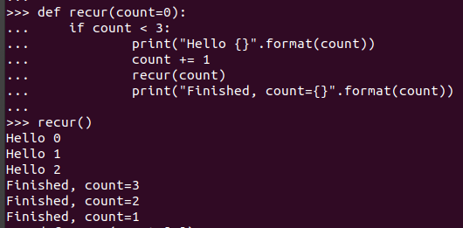
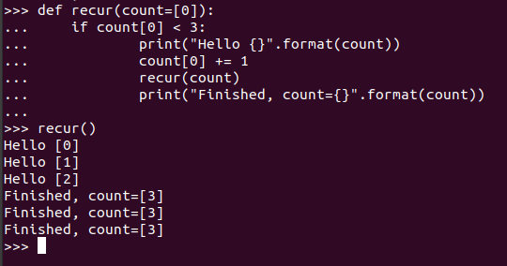

- Regex
import re
txt = ‘This is the input string’
re.search(“^.$”, txt)
# re.search returns a Match object
# other functions – re.findall, re.split, re.sub
https://developers.google.com/edu/python/regular-expressions

- repr vs. str
  - repr is used to be unambiguous (mainly intended for developers)
    - repr returns a string that can be executed in Python
  - str is used for readability

- JSON (import json) – https://www.programiz.com/python-programming/json
  - Loading JSON: person_dict = json.loads(personJSON)
  - Pretty printing JSON: json.dumps(person_dict, indent=4, sort_keys=True)

- Object Oriented Programming
  - Class – A blueprint for a real-world entity
  - Object – an instance of a class
  - Class = attributes (data) + methods (functions)
  - Abstraction vs. Encapsulation – https://stackoverflow.com/questions/15176356/difference-between-encapsulation-and-abstraction
https://stackoverflow.com/questions/742341/difference-between-abstraction-and-encapsulation
    - Encapsulation – Information hiding – internal representation of a class is hidden (division of class members into those that can be manipluated outside and those that cannot, (i.e.), insulation of a part of the class from the rest)
    - Abstraction – Implementation hiding – mechanics of how something works is hidden. Abstraction can be thought of as a generalization of a particular functionality. Eg: qsort is an abstration because one can use this function for any data type.
      - Why is this a thing in OOPs? Doesn’t it offer the same functionality as function calls?
    - Eg: Car brake pedal and internal circuitry, calculator button and internal circuitry
  - Inheritance

  - Polymorphism
    - Compile time
      - Function Overloading, Operator Overloading
    - Run time
      - How can parent class variable store child class object (Java) (OR) how can parent class pointer variable point to child class objects? (in terms of memory) (OR) why can a variable’s object type not be determined at compile time?
      - Eg: Function Overriding (same function signature, but should the function of the parent class be called or the overriden function in the current(child) object be called?)
      - Virtual functions

VARIABLES
  - Instance variables
    - Data that is unique to each instance
    - These are set using self.variableName
  - Class variables
    - Variables that are shared among all instances of a class
    - Can be accessed through instance as well as class name
    - When accessing a class variable through instance name –
      - the namespace of the instance (objectName.__dict__) is checked first and if it is unavailable, it moves on to check the class variable
      - However, when making an assignment, a new variable is created in the namespace of the object
    - Using self.classVariableName in methods –
      - This is better if you want to override the variable for a specific instance
      - It also allows sub-class to override

METHODS
  - Instance methods
    - When creating methods within class, they receive the first argument (self is used by convention when defining methods) as the class instance (which is passed automatically when the method is invoked).
    - __init__(self, args) method will be run automatically when a class is created
    - methods can also be run using the class name – Employee.fullname(emp1), where emp1 is an instance of class Employee
  - Class methods
    - Automatically take class name (conventially, cls) as the first argument
    - use @classmethod (this decorator is used to alter the functionality of the method to where we now receive the class as the first argument)
    - Rarely invoked using objects
    - Alternate constructors (eg: datetime module in python)
      - method name usually starts with ‘from_’
      - Eg: say we already have a constructor (__init__) that takes in 3 arguments, but the data that is given to us is in the form of a single string that can be parsed to extract the 3 arguments
      - @classmethod
def from_string(cls, given_string):
arg1, arg2, arg3 = function_to_parse()
return cls(arg1, arg2, arg3)
  - Static methods
    - Do not pass anything automatically
    - They behave like normal functions; they are included in the classs because they have some logical connection
    - Use @staticmethod decorator
    - If a function does not need access to the instance or the class, but it has some logical connection with that class, declare it as static
    - Invoke as cls.staticMethodName()
  - Virtual methods – https://stackoverflow.com/questions/4714136/how-to-implement-virtual-methods-in-python

INHERITANCE
  - class childClass(<classes_to_inherit>)
  - Python walks up the chain of inheritance until it finds out what it is looking for – AKA method resolution order (see help(childClass))
  - To execute a function from the parent class
    - super().funcToExecute(args) (OR)
    - parentClassName.funcToExecute(self, args)
  - issubclass(classToCheck, parentClass); isinstance(object, class)
  - Eg: Python exception class (HTTPException)

SPECIAL METHODS (Eg: datetime module)
  - __ (double underscores) is called dunder
  - dunder methods allow classes to perform language operator overloading
  - Eg: __repr__(self), __str__(self) (if not defined, falls back to __repr__(); overloads print), __add__(self, other), __len__(self, other)
  - 1+2 is the same as int.__add__(1, 2)
  - https://docs.python.org/3/reference/datamodel.html#special-method-names

PROPERTY DECORATOR
- Allows to define method that can be accessed like an attribute
- Say, we have an attribute that is currently in need of a change – to correct this, a method can be created which returns the required attribute value. But those who are currently using our class will need to change that attribute syntax to a method syntax
- To avoid this, a property decorator can be used
@property
def email(self): # this can be invoked as objName.email (delete the self.email attribute)
return <required_value>

- Let’s say we want to set other attributes using another “attribute”
- Say, we have the function fullname() -
@property
def fullname(self):
return <fullname>

@fullname.setter
def fullname(self, name): # objName.fullname = ‘hello world’
first, last = fullname.split()
self.first = first
self.last = last

- To delete an attribute – del obj.someAttribute (deleter for that attribute will be called)
@fullname.deleter # provided @property is defined for fullname
def fullname(self): # no more arguments
<some cleanup code>

- To delete an object, use del object (internally, className.__del__(object) will be called)
- Defining methods outside classes – https://stackoverflow.com/questions/9455111/define-a-method-outside-of-class-definition
- Importing classes – https://docs.python.org/3/tutorial/modules.html#packages (from package.module import className)
- Practice – https://pynative.com/python-object-oriented-programming-oop-exercise/
- Usage of if __name__ == “__main__” - acts as a guard code to prevent the python file from running when imported in another file

EXCEPTION HANDLING
- try:
<code that may raise an exception>
<custom exception can also be raised>
raise Exception (more on the Exception class!)
- except FileNotFoundError as e:
print(e)
- except Exception:
print(“Some custom error message”)
- else:
<gets executed if try block throws no exceptions>
- finally:
<gets executed irrespective of whether an exception is thrown or not>

---C---
- qsort
  - void qsort(void *base, size_t total_count, size_t element_size, int (*comparator) (const void *, const void*) );
  - int comparator (const void *p1, const void *p2)
{
UserDefined *x1 = (UserDefined *) p1;
UserDefined *x2 = (UserDefined *) p2;
return (x1.(...) - x2.(...));
// return value > 0 => arg_1 should come after arg_2
}
- sprintf - sprintf(str, "Value of Pi = %f", M_PI); [str is now = “Value of Pi = 3.14159...”]
- itoa - itoa(num, snum, 10); [convert int to string]
- strcat - char *strcat(char *s1, const char *s2);
- when using <math.h>, add -lm, (i.e.), gcc {filename.c} -lm
- https://stackoverflow.com/questions/3736210/how-to-execute-a-shell-script-from-c-in-linux
- Clearing input buffer - https://www.geeksforgeeks.org/clearing-the-input-buffer-in-cc/
- getline() – size_t getline (char **string, size_t *n, FILE *stream);
- THREADS
  - #include<pthread.h>

pthread_t thread_1;
// thread creation
pthread_create(&thread_1, NULL, void_ptr_returning_function, function_args_as_void_ptr); // 2nd argument is thread attributes

// to ensure that the calling thread does not terminate before its created thread completes
pthread_join(created_thread, NULL);

// mutex lock
pthread_mutex_t lock_thread_1 = PTHREAD_MUTEX_INITIALIZER
// alternate
pthread_mutex_t lock_thread_2;
pthread_mutex_init(&thread2, NULL);

// locking and unlocking
pthread_mutex_lock(&lock_thread1);
// code to protect
pthread_mutex_unlock(&lock_thread1);
  - Tutorial - https://youtu.be/GXXE42bkqQk
  - “Locking a resource using mutex” - https://stackoverflow.com/questions/40479316/what-does-it-mean-to-lock-a-resource-using-pthread-mutex-lock (GOOD!)
  - pthread_mutex_init vs. PTHREAD_MUTEX_INITIALIZER - https://stackoverflow.com/questions/14320041/pthread-mutex-initializer-vs-pthread-mutex-init-mutex-param
  - Why wait and signal need to be atomic?
    - https://stackoverflow.com/questions/67046250/why-do-the-wait-and-signal-semaphore-operations-need-to-be-atomic
    - https://www.quora.com/In-semaphores-are-wait-and-signal-operations-atomic-or-just-modification-of-S-semaphore-and-condition-S-0-atomic
  - local mutex locking - https://stackoverflow.com/questions/20617095/how-to-lock-thread-by-using-mutex-variable-locally?rq=1
  - function inside pthread_mutex_lock(&lock_thread) - https://stackoverflow.com/questions/60527669/can-i-insert-a-function-inside-a-pthread-mutex-lock-and-unlock-statements

---C++---
- https://stackoverflow.com/questions/589985/vectors-structs-and-stdfind
- https://stackoverflow.com/questions/31039900/bool-operator-in-c/46699996
- find_if - https://www.geeksforgeeks.org/stdfind_if-stdfind_if_not-in-c/
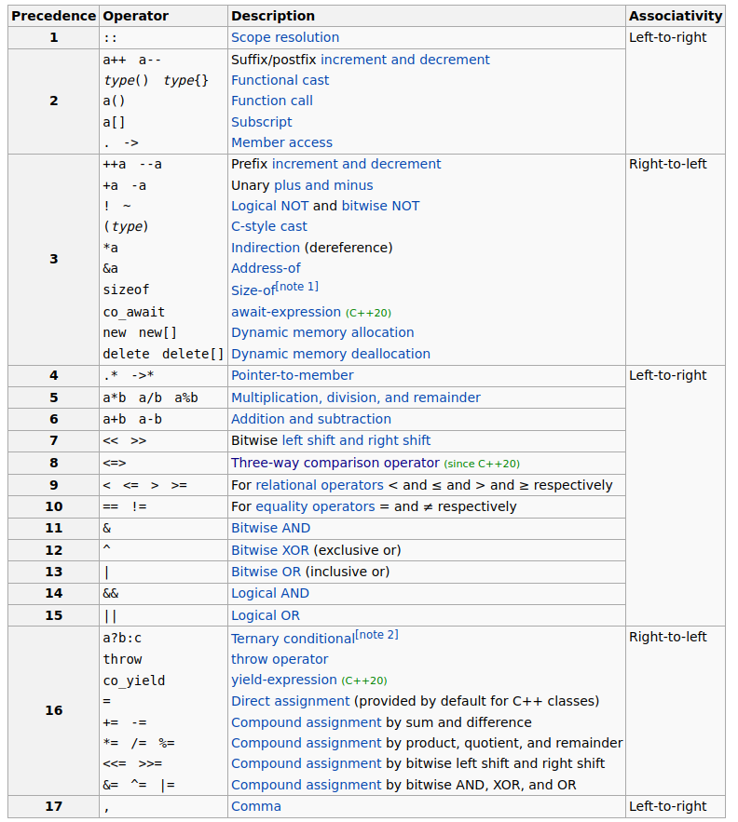
- Unordered vs. Ordered maps
- Priority Queue for user defined data types (refer ~/Documents/College/cpp/comparator.cpp)
- const int vs int const – https://stackoverflow.com/questions/162480/const-int-vs-int-const-as-function-parameters-in-c-and-c
- Compare (comparator)
  - https://en.cppreference.com/w/cpp/named_req/Compare
  - Operator overloading
    - Function call
    - < operator
  - Weak ordering
    - https://codeforces.com/blog/entry/72525
    - https://stackoverflow.com/questions/979759/operator-and-strict-weak-ordering
- STL containers - https://home.csulb.edu/~pnguyen/cecs282/lecnotes/stlcontainer.html
- Sorting 2-D lists
- Initializing arrays and objects - https://stackoverflow.com/questions/4118025/brace-enclosed-initializer-list-constructor
  - vector initialization
    - constructor
vector<int> vect1(n, -1); // initializing n elements with -1
vector<int> vect2(vect1.begin(), vect1.end());
vector<int> vect{1,2,3,4};
    - other
vector<int> vect1(n);
fill(vect1.begin(), vect1.end(), 5); // initializing with 5
  - pair
    - constructor
pair<int, int> p1(x,y);
pair<int, int> p2(p1);
    - other
make_pair(x, y) or {x,y}
- Strings
  - s1.substr(start_index, length_of_substr);
- Integer to string
  - to_string(n);
- char to int
  - char a = ‘4’;
int x = a – ‘0’;
- string to integer
stringstream test("1234 5678 9101");
while (test.good())
{
int x;
test >> x; // stringstream automatically stops reading at blank space
cout << "\nNumber: " << x;
}
- Counting the number of words
string word;
int count = 0;
while (test >> word)
{
count ++;
}
- Using boost::lexical_cast
#include<boost/lexical_cast.hpp>
...
int num = boost::lexical_cast<int>(s1); // string to integer
(sudo apt-get install libboost-dev)
- getline
  - https://www.javatpoint.com/cpp-getline (3 synataxes)
  - use cin.ignore() or cin.ignore(256, ‘\n’) if you have used cin before
  - while(getline(...)) to process until newline is encountered

- PBDS - https://codeforces.com/blog/entry/11080
- move_iterator, value_type
- cout formatting
  - http://faculty.cs.niu.edu/~hutchins/csci241/output.htm
  - Eg: cout << setw(n) << “Some expression”;
Ensures that “Some expression” takes up at least (a minimum of) n characters (right justified) (use << left for left justification)
- for loop (since C++11) for (int n: num_array) { }
- regex
  - #include<regex>
regex to_match("<reg_expr>");
return regex_match(string_to_match, to_match);
  - regex_search – to obtain information about matching(s)
https://www.cplusplus.com/reference/regex/match_results/position/
regex to_match("<some-re>")
smatch m;
regex_search(string_to_check, m, to_match)
for (int i=0; i<m.size(); ++i)
{
cout << m[i] << m.position(i);
}

- Binary search
  - bool binary_search(start_it, end_it, key) // array should be sorted

  - iterator<> lower_bound(start_it, end_it, key) // returns an iterator to key if it exists else returns an interator to the (immediate) next element greater than key

  - iterator<> upper_bound(start_it, end_it, key) // returns an interator to the (immediate) next element greater than key

  - Note: Subtracting the result of lower_bound or upper_bound with the start iterator will give the index of that element

- stringstream
- Template function
  - template<typename T> void print(vector<vector<T>> arr)
{
}

- Iterators
  - Reverse iterators – to iterate from the end of the array to the beginning
std::vector<int>::reverse_iterator it = vect_test.rbegin();
std::vector<int>::reverse_iterator it = vect_test.rend();
  - Get index of iterator
    - it – vec.begin()
    - std::distance(vec.begin(), it)
    - https://stackoverflow.com/questions/2152986/what-is-the-most-effective-way-to-get-the-index-of-an-iterator-of-an-stdvector

- Bit manipulation
  - Count the number of set bits: __builtin_popcount(x)
  - Get the parity: __builtin_parity(x)
    - 1 if the number of set bits is odd; else even
  - Count the number of leading zeros: __builtin_clz(x) // for 32-bit int
  - Count the number of trailing zeros: __builtin_ctz(x)
  - Index (1-based) of least significant set bit: __builtin_ffs(x) // Find First Set
  - Index of highest set bit: std::lg(x)
  - Note: The above are for integers. For long, add ‘l’; for long long, add ‘ll’ (eg: __builtin_parityl(x), __builtin_parityll(x))
  - https://codeforces.com/blog/entry/72437

- Friend functions/classes (/Documents/College/c-cpp-py)
  - Friend function
    - A non-member function that can access the private and protected members of a class
    - Should be declared in the class as: friend function_name(class_name &obj);
  - Friend class
    - A class which can access the private and protected members of another class
    - Should be declared in the class as: friend class class_name;
    - The friend class should be defined after the class for which it is a friend.

- Static data member/function (/Documents/College/c-cpp-py)
  - Both are class level members (as opposed to object level) => they are common to all instaces (objects) of a class. In other words, a single copy of the member is accessed by all instances.
  - They can be accessed (without instanting an object) using the scope resolution operator along with the class name
  - Static data member
    - Declared inside a class (under appropriate access-specifier) as: static int count
    - Should be also be declared (and may be explicitly initialized) outside the class (using the scope resolution operator) as: int class_name::count = 0; (default initialization is 0 for int, float, ...) .
  - Static member function
    - static function_name() { }
    - has access to only static variables, other static functions and functions declared outside the class.

- Copy constructors
- Priority Queue vs. Sets - https://stackoverflow.com/questions/10141841/difference-between-stdset-and-stdpriority-queue
  - Priority queue updation – https://stackoverflow.com/questions/649640/how-to-do-an-efficient-priority-update-in-stl-priority-queue
- Multisets and Multimaps
- File Handling
  - #include<fstream>
...
fstream fileObj;
fileObj.open(“filename.txt”);
char data[100];
fileObj >> data; // reading from file
...
fileObj << data; // writing to file
fileObj.seekg(pos, ios::cur); // to seek pos positions forward from the current position
fileObj.close();

  - Use fileObj.clear() to seek to new positions in the file after reaching the end (clearing the flags set) – https://stackoverflow.com/questions/5343173/returning-to-beginning-of-file-after-getline
  - Passing stream object as parameter - https://stackoverflow.com/questions/27501160/pass-a-reference-to-stdifstream-as-parameter
  - Read specific amount of characters from a file: fileObj.read(buffer, n)
  - Reading until EOF - https://stackoverflow.com/questions/21647/reading-from-text-file-until-eof-repeats-last-line
while(1)
{
...
if (fileObj.eof())
break;
...
}

Bitwise operators-
- Precedence: ~, <<, >>, & , ^, |
- 4 << 1 => 100 << (1 time) = 1000 = 8
- 4 >> 2 => 100 >> (1 time) = 010 = 2

Sorting
- Stable

Regular expressions
- Escape special characters (below) with \
  - . [ { ( ) \ ^ $ | ? * +
- Character matching
  - . matches any character except newline
  - word (\w) character => a-z, A-Z, 0-9, _
    - \W matches those which are NOT word characters (uppercase => negation of lowercase matching expr)
  - whitespace (\s) => space, tab, newline
- Anchors
  - \b matches word boundaries
  - ^ for beginning of string (string => ‘line’)
  - $ for end of string
- Character set [<characters to match>] - matches one character from this list
  - no need to escape characters like .
  - - when place at the ends means to match the literal .; else it is used to specify range. Eg: [1-7]
  - ^ is used to negate the set [^<some-expr>]
- Quantifiers
  - * is 0 or more
  - + is 1 or more
  - ? is 0 or 1
  - {3} denotes the exact number (3, in this case)
  - {min#, max#}
- Groups
- Exercises
  - match phone numbers
  - match names (M(r|s|rs)\.?\s[A-Z]\w* (can space be used instead of \s?)

Java
- Input
  - Scanner.nextInt, nextLine, ...
- Sorting
  - import java.util.Arrays
....
Arrays.sort(nums)
Arrays.sort(nums, start_index, end_index+1)

  - Multidimensional arrays
Arrays.sort(nums, (a,b)->Integer.compare(a[0],b[0]))
  - <>

- ArrayList
  - import java.util.ArrayList
ArrayList<Integer> sample = new ArrayList<Integer>();
ArrayList<ArrayList<Integer>> sample2 = new ArrayList<ArrayList<Integer>>();
sample2.add(new ArrayList<Integer>(Arrays.asList(1,2,3)));

  - To access an element: list.get(index)
  - To set the value of an element: list.set(index, value)

- HashMap
  - HashMap<Integer, Integer> sample = new HashMap<Integer, Integer>();
sample.put(key, value);
System.out.println(sample.get(key));
System.out.println(sample.containsKey(someKey));
System.out.println(sample);
  - Iterating through HashMap

- Finding maximum/ minimum
  - import java.util.Collections
ArrayList<Integer> sample = new ArrayList<Integer>(Arrays.asList(1,2,3,4,5));
System.out.print(Collections.max(sample));
  - Math.min(num1, num2)

- String
  - String object in Java is immutable (use StringBuffer class in java.lang.*)
    - StringBuffer mutable_s=new StringBuffer(original)
mutable.setCharAt(index, char)
  - s1.charAt(index)
  - s1.substring(start_index, end_index)

- Set
  - Set<Integer> test=new HashSet<>(Arrays.asList(1,2,4));
    - More on initialization – https://www.techiedelight.com/initialize-set-java/

- No default arguments in Java – use function overloading
- Scanner – https://stackoverflow.com/questions/13102045/scanner-is-skipping-nextline-after-using-next-or-nextfoo

Incomplete problems

- Palindrome partitioning (leetcode)
- Hamiltonian Circuit (HackerEarth – bitmask)
- Assignment Problem (HackerEarth – bitmask)

Project Euler-
- 172 – repeated digits (3 at most)
- 43 - Pandigital numbers (substring divisibility)
- 127 – abc-hits
- 18, 67 – maximum path I, II (https://www.geeksforgeeks.org/maximum-cost-path-in-an-undirected-graph-such-that-no-edge-is-visited-twice-in-a-row/)
- 65 – convergents of e
- 121 – disc game
- k-smallest pairs – https://www.geeksforgeeks.org/find-k-pairs-smallest-sums-two-arrays/
- least coins – https://www.geeksforgeeks.org/find-minimum-number-of-coins-that-make-a-change/
- maximal square (dp)

CodeChef
- DP – count subarrays

Swagger
- Swagger editor
  - https://swagger.io/docs/specification/basic-structure/
  - https://swagger.io/docs/specification/describing-parameters/
  - https://inspector.swagger.io/builder
  - https://swagger.io/docs/specification/data-models/data-types/
- Swagger Inspector

