Sheets

* Comparing entries in 2 Sheets
  + IF(‘Sheet abcd’!A1=‘Sheet 2 efgh’, “Same”, “Diff”)
    - If the Sheet name has more than 1 word, enclose it in SINGLE quotes
* Import data from another spreadsheet

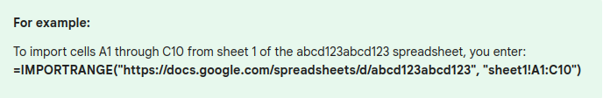

* CHAR function
  + Tick mark: CHAR(10003)
  + Cross: CHAR(128502)
* QUERY
  + QUERY(A1:C10, “SELECT * WHERE F = “&Sheet2!F1&” ”)
  + [Examples to the Use of Literals in Query in Google Sheets (infoinspired.com)](https://infoinspired.com/google-docs/spreadsheet/literals-in-query-in-google-sheets/)