Overview
This report includes a chart showing OpenAI's growth.
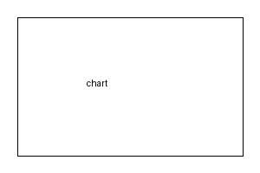
More text after the figure.

