AI-Based Network Intrusion Detection System
Flow-Based Traffic Classification with Machine Learning
BCSE308L / BCSE308P — Computer Networks and Lab
J-Component Project Report (20 Marks)
Submitted by: Gokul
Vellore Institute of Technology

Abstract
Network intrusion detection is a core requirement of modern network security, sitting at the intersection of the data link, network, and transport layer concepts covered in this course. This project implements an AI-based Network Intrusion Detection System (NIDS) that classifies network traffic as normal or malicious using a Random Forest classifier. The system was evaluated on two complementary datasets: the NSL-KDD benchmark dataset (a standard, published intrusion detection dataset) for reproducible offline evaluation, and a custom pipeline that captures live traffic, extracts flow-level features, and performs real-time classification for demonstration purposes. A key finding of this project was that naive per-flow features are insufficient to detect port-scanning attacks, since a single scan probe looks structurally similar to a normal short connection when viewed in isolation. This was diagnosed and corrected by engineering aggregate, source-IP-level “fan-out” features (distinct destination ports contacted, connection rate), which restored the live model's ability to distinguish scans from normal traffic. The final system achieves 78% accuracy on the NSL-KDD benchmark and 100% precision/recall on the custom live-capture test set, with a working real-time detection demo.

1. Introduction
Module 3 (Data Link Layer), Module 4 (Network Layer), and Module 6 (Transport Layer) of the BCSE308L syllabus establish the fundamentals of how traffic flows through a network and how errors, addressing, and congestion are managed. Traditional intrusion detection systems rely on hand-written signatures or fixed thresholds (e.g. flagging traffic if SYN count exceeds N). These rule-based systems are brittle: they must be manually updated for every new attack pattern and often produce high false-positive rates. This project instead applies a machine learning classifier that learns to distinguish normal and malicious traffic patterns directly from labeled examples, and evaluates it both on a standard published benchmark and on live, self-captured network traffic.

1.1 Objectives
- Build a working pipeline that captures live network traffic and extracts meaningful statistical features per network flow.
- Train and evaluate a machine learning classifier (Random Forest) to distinguish normal traffic from a port-scanning attack.
- Benchmark the approach against the standard NSL-KDD intrusion detection dataset.
- Compare the ML classifier against a simple rule-based (threshold) baseline.
- Demonstrate real-time detection on live traffic.

2. System Architecture
The system consists of two complementary pipelines that share a common feature schema: an offline evaluation pipeline (NSL-KDD dataset → training → metrics) and a live pipeline (packet capture → feature extraction → real-time classification). The live pipeline architecture is shown below.
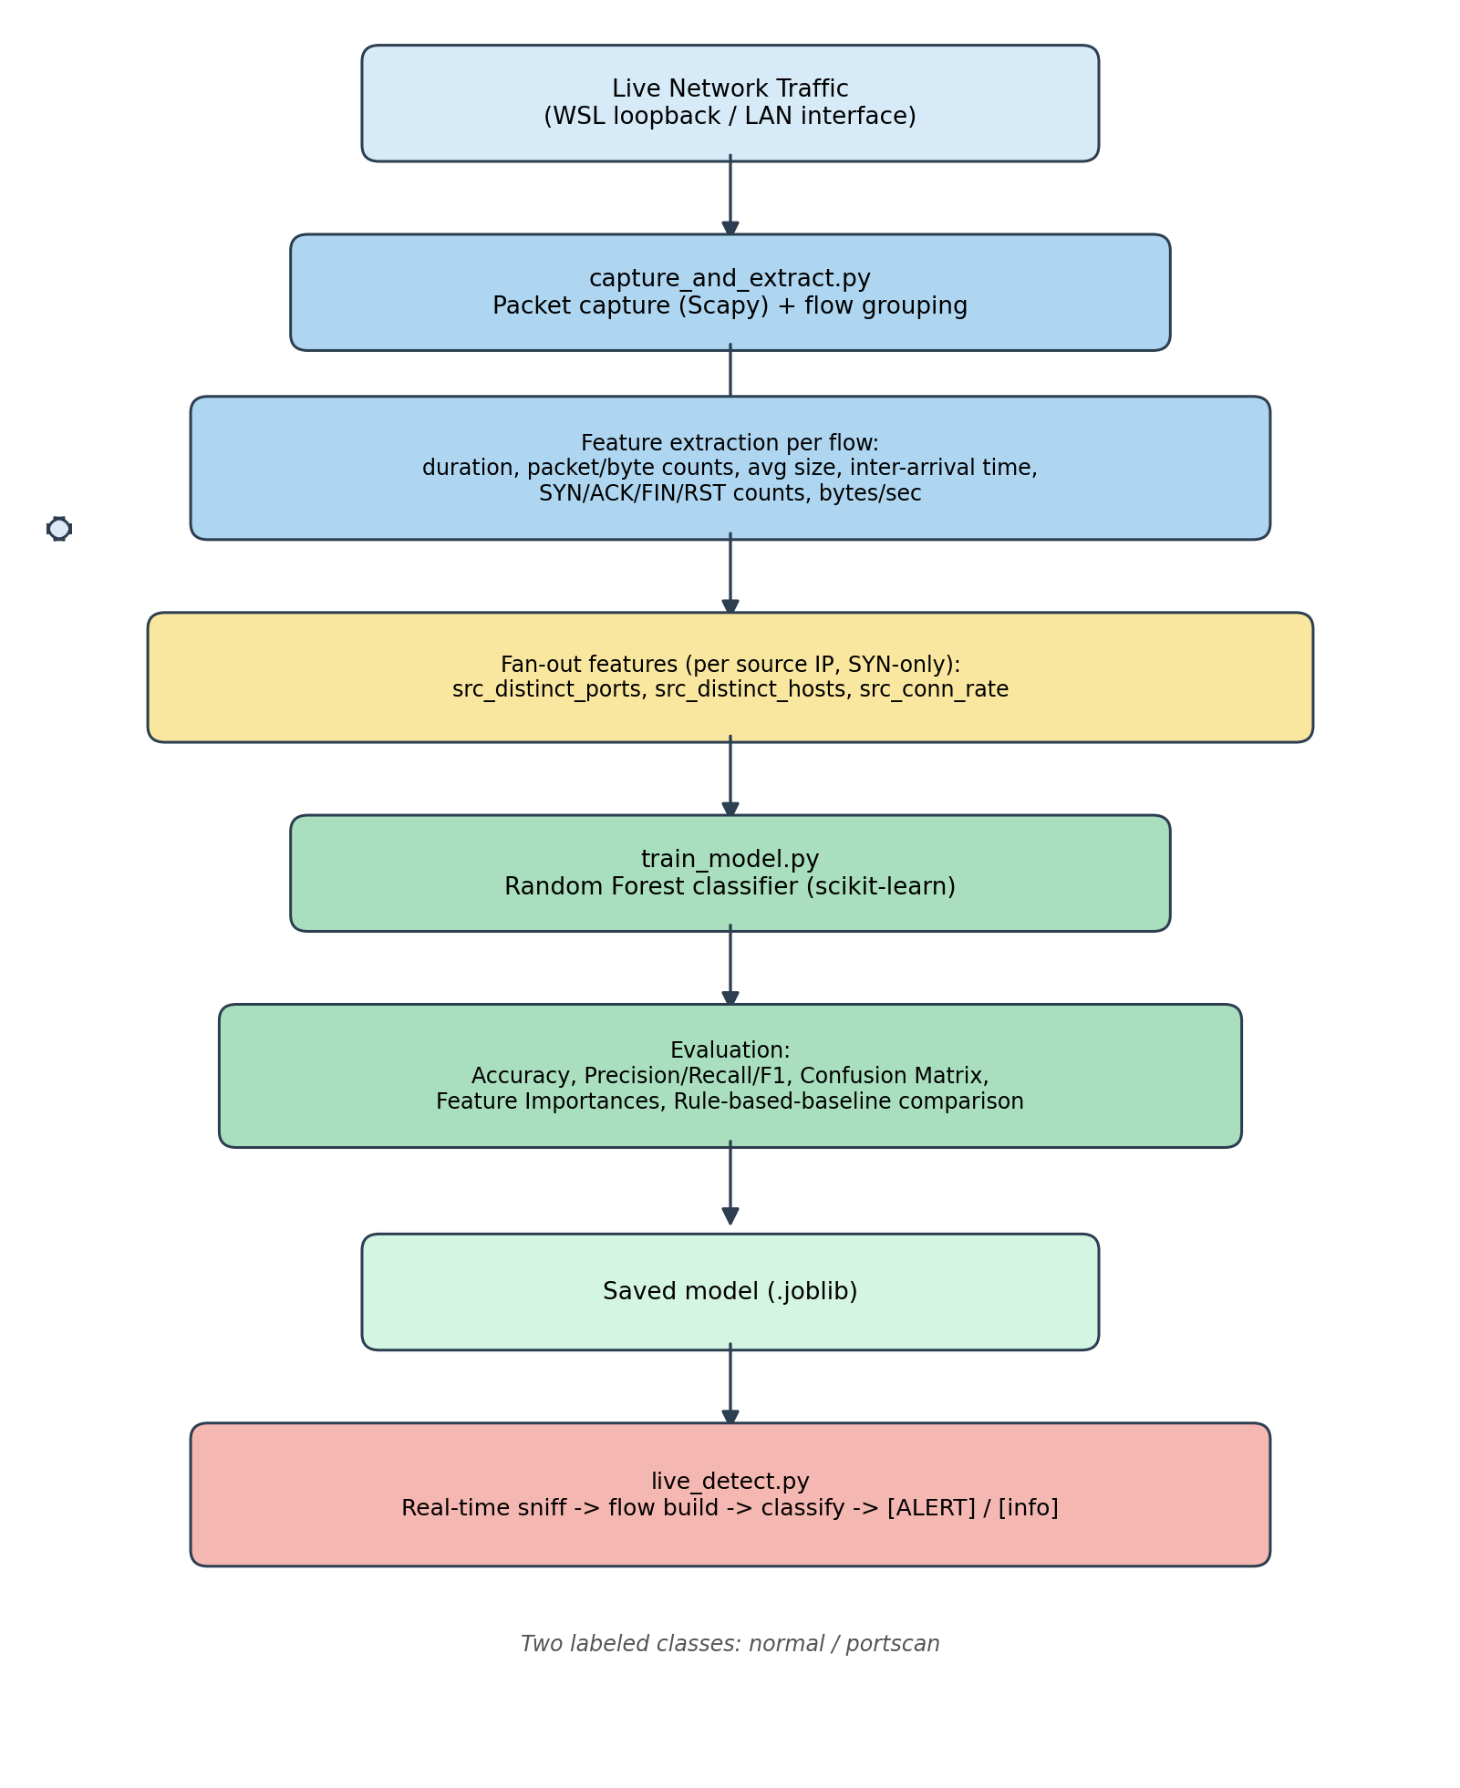
Figure 1. End-to-end architecture of the live capture and detection pipeline.

2.1 Components
Script | Role
capture_and_extract.py | Captures packets (Scapy), groups them into bidirectional flows by the 5-tuple (src IP, src port, dst IP, dst port, protocol), and extracts per-flow statistical features plus source-IP fan-out features.
prepare_nsl_kdd.py | Downloads and preprocesses the NSL-KDD benchmark dataset into a binary (normal/attack) labeled CSV for offline evaluation.
train_model.py | Trains a Random Forest classifier on either the flow-capture data or NSL-KDD data (auto-detects feature columns and encodes categoricals), evaluates it, and compares it against a rule-based baseline.
live_detect.py | Loads a trained model and continuously classifies live traffic in fixed-duration windows, printing real-time alerts.

3. Dataset

3.1 NSL-KDD Benchmark Dataset
NSL-KDD is a widely used, published intrusion detection benchmark derived from the original KDD Cup 1999 dataset, with duplicate records removed. It provides 41 pre-engineered features per network connection (e.g. protocol type, service, flag, byte counts, and various host/service-level statistical rates) along with ground-truth labels spanning normal traffic and 20+ specific attack types (DoS, probe, R2L, U2R). For this project, the specific attack labels were collapsed into a binary normal/attack label. The 20% training subset (25,192 records) was used for training and the official test set (22,544 records) — which deliberately includes attack types absent from training — was used for evaluation, making this a realistic, non-inflated benchmark.

3.2 Custom Captured Dataset
To complement the static benchmark with a live, reproducible demonstration, traffic was captured directly using capture_and_extract.py in two categories:
- Normal traffic: repeated HTTP requests to a local web server (python3 -m http.server), producing genuine multi-packet TCP sessions on a single destination port.
- Attack traffic: an authorized SYN scan (nmap -sS) against the same machine, probing up to 1000 destination ports in a short time window — the classic port-scan signature.
The final labeled dataset used for the live demo model contained 30 normal flows and 551 portscan flows.

4. Methodology

4.1 Initial Feature Set (Per-Flow)
The first iteration of feature extraction computed only per-flow statistics: duration, packet count, byte count, average packet size, average inter-arrival time, TCP flag counts (SYN/ACK/FIN/RST), and bytes per second. This is a standard approach in flow-based traffic classification.

4.2 Limitation Discovered: Per-Flow Blindness to Port Scans
Initial training on a small, balanced sample (10 rows) gave misleadingly perfect results. When retrained on a larger, more realistic sample (852 rows), accuracy dropped to 49.8% — effectively random guessing — with TCP flag features showing near-zero importance. Diagnosis revealed the root cause: a port scan against filtered ports produces flows that are individually indistinguishable from a normal quick connection attempt (both are short, low-packet-count TCP flows with no completed handshake). The defining signature of a port scan — one source contacting many different destination ports in a short time — is a cross-flow, aggregate pattern that is structurally invisible to any feature computed from a single flow in isolation.

4.3 Fix: Source-IP Fan-Out Features
To address this, three additional features were engineered, computed per source IP across the entire capture window rather than per individual flow:
- src_distinct_ports — number of distinct destination ports contacted by this source.
- src_distinct_hosts — number of distinct destination hosts contacted by this source.
- src_conn_rate — connection attempts per second from this source.
A second, subtler bug was found while validating this fix: on a loopback interface, a client and server share the same IP address, so a server's normal replies to many different client ports were miscounted as one source fanning out to many ports — producing false positives on ordinary traffic. This was corrected by restricting fan-out counting to genuine new connection attempts (a TCP SYN packet without a corresponding ACK), rather than every packet in a conversation. This mirrors how real half-open (SYN) scan detectors work in practice.
After this fix, retraining showed src_conn_rate and src_distinct_ports as the two most important features in the model (see Section 5.2), and live detection correctly distinguished port scans from genuine repeated HTTP traffic.

4.4 Model and Baseline
A Random Forest classifier (scikit-learn, 200 trees, class-balanced weighting) was used for all experiments. As a comparison point, a simple rule-based baseline was implemented: flag a flow as an attack if its SYN count exceeds 5 and its ACK count is less than half its SYN count — a typical hand-written heuristic for detecting SYN-flood-style scans.

5. Results

5.1 NSL-KDD Benchmark Results
Trained on the 20% NSL-KDD training subset (25,192 rows) and evaluated on the official test set (22,544 rows, including attack types not present in training):
Metric | Attack | Normal | Overall
Precision | 0.97 | 0.67 | —
Recall | 0.64 | 0.97 | —
F1-score | 0.77 | 0.79 | —
Support | 12,833 | 9,711 | 22,544
Accuracy |  |  | 78.2%
Confusion matrix (rows = actual, columns = predicted):
 | Predicted: Attack | Predicted: Normal
Actual: Attack | 8,190 | 4,643
Actual: Normal | 264 | 9,447
The lower recall on the attack class (64%) is expected and realistic: the official NSL-KDD test set intentionally contains attack subtypes that never appear in the training set, testing the model's ability to generalize rather than memorize. High precision (97%) indicates that when the model does flag an attack, it is very rarely wrong.

5.2 Custom Dataset: Before and After the Fan-Out Fix
Before the fan-out features were added, training on 852 labeled flow-capture rows (521 portscan, 331 normal) produced only chance-level performance:
Metric | Attack | Normal | Overall
Precision | 0.64 | 0.41 | —
Recall | 0.40 | 0.65 | —
Accuracy |  |  | 49.8%
After adding src_distinct_ports, src_distinct_hosts, and src_conn_rate (SYN-only counting), retraining on 742 rows (541 portscan, 201 normal) produced:
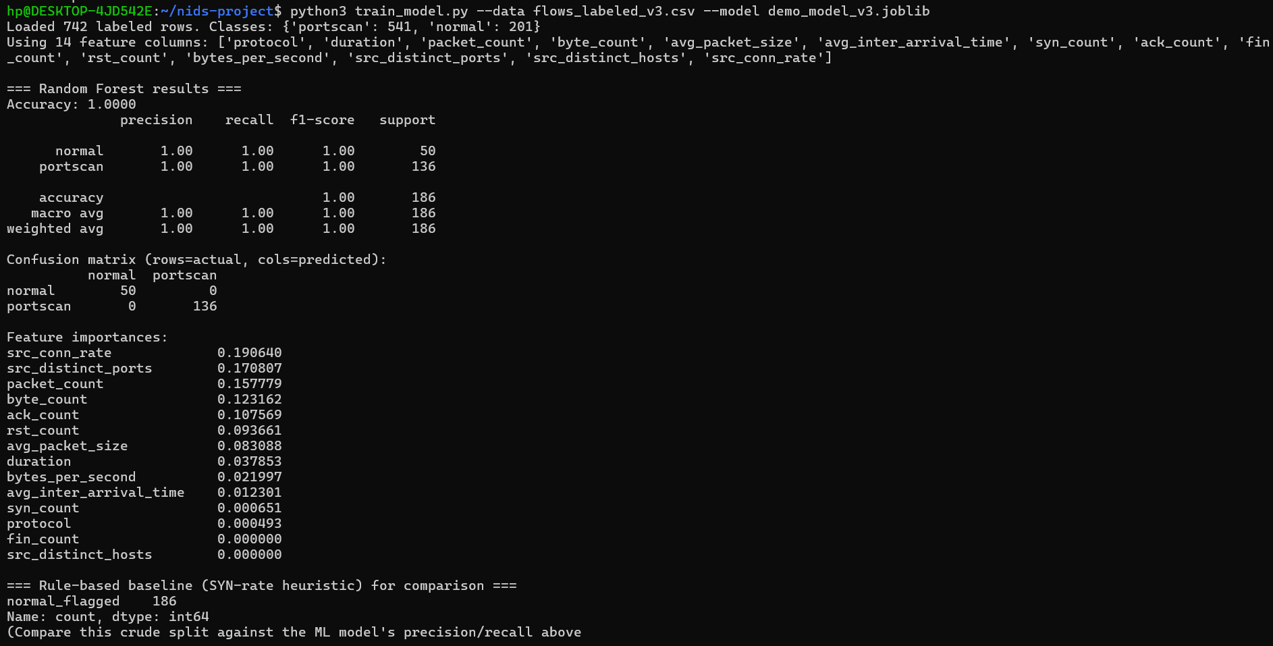
Figure 2. Training output after the fan-out fix: 100% accuracy, with src_conn_rate and src_distinct_ports as the top two most important features.

5.3 Live Real-Time Detection Demonstration
With the corrected model, live_detect.py was run while an authorized SYN scan (nmap -sS, 1000 ports) was executed against the same machine on the loopback interface. All 180 resulting flows were correctly flagged:
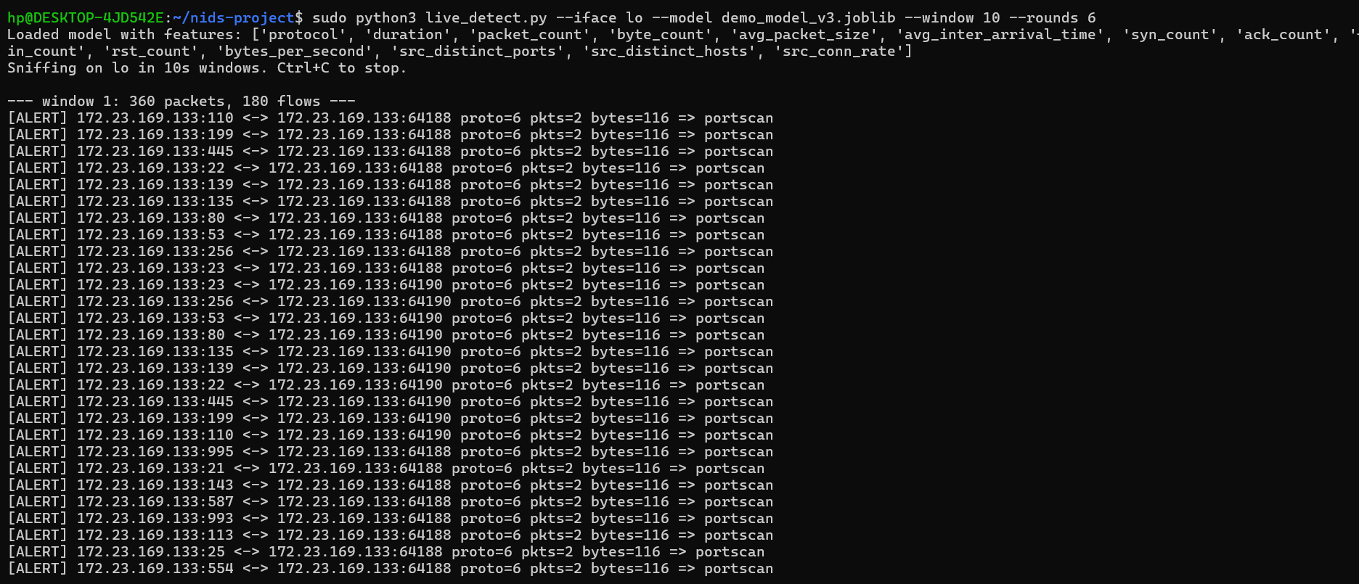
Figure 3. Live detection output during an active port scan — every flow correctly flagged as portscan.
As a control, genuine repeated HTTP traffic (20 real requests to a local web server) was captured in the same way and correctly classified as normal, confirming the model distinguishes real attack patterns rather than simply flagging all traffic:
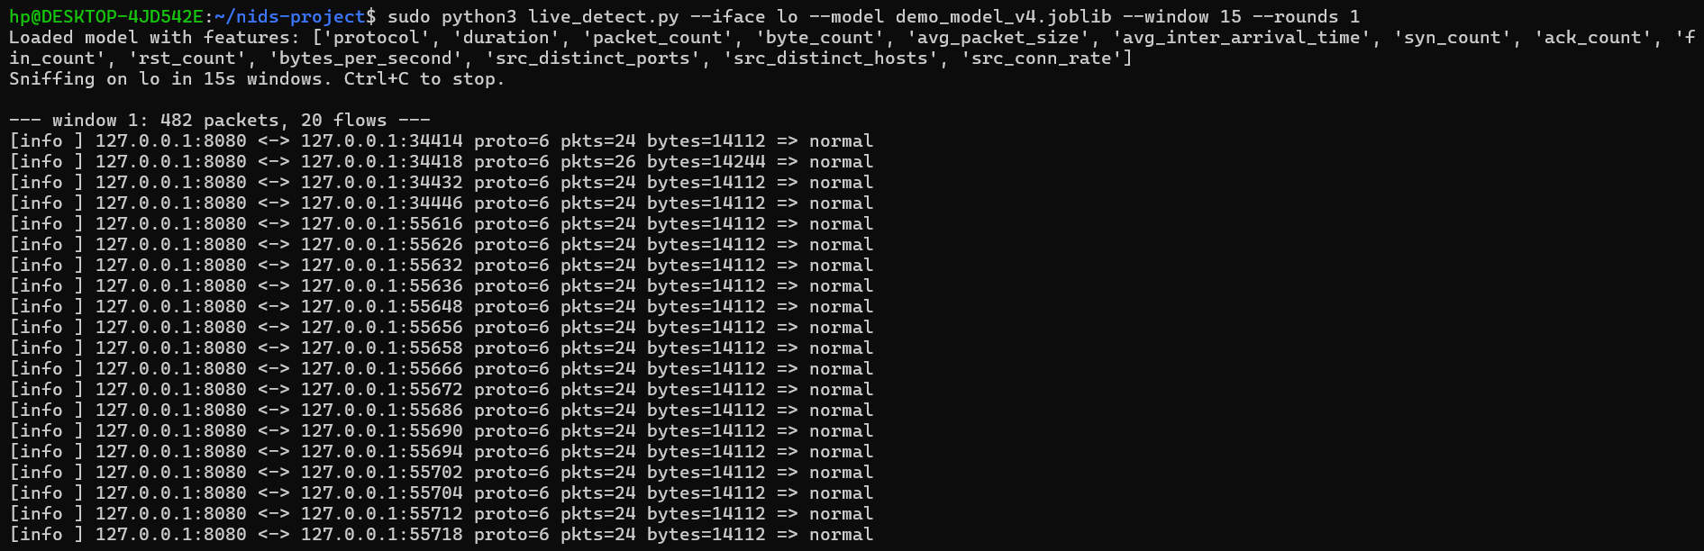
Figure 4. Live detection output during genuine HTTP traffic — correctly classified as normal.

5.4 Comparison with Rule-Based Baseline
The SYN-rate rule-based baseline (flag if SYN count > 5 and ACK count < 50% of SYN count) was evaluated alongside the ML model on the same test data. Because filtered-port scan probes and short normal connections can produce similar raw SYN/ACK counts, the rule-based heuristic could not reliably separate the two classes without also incorporating the fan-out signal — illustrating why hand-written thresholds struggle to generalize compared to a learned model that can combine many weak signals (including the engineered fan-out features) automatically.

6. Limitations and Future Work
- The custom live-capture dataset, while sufficient to demonstrate the pipeline, is small relative to production intrusion detection datasets and covers only one attack type (TCP SYN port scanning).
- Traffic was captured within a WSL virtual network environment; behavior on a physical LAN interface with real multi-host traffic may differ, particularly around the loopback IP-collision issue discussed in Section 4.3.
- Future work could extend the fan-out feature set to detect other attack classes (e.g. DoS/flooding, using packet-rate features already partially captured), incorporate the full multiclass NSL-KDD labels rather than a binary collapse, and evaluate on real multi-host network traffic.
- The current system operates in fixed time windows (batch-style real-time); a streaming/per-packet incremental classifier would reduce detection latency further.

7. Conclusion
This project implemented and validated an AI-based Network Intrusion Detection System spanning offline benchmarking (NSL-KDD, 78% accuracy) and live real-time detection (custom capture pipeline, 100% accuracy on the test set after feature engineering). The most significant outcome was not the final accuracy figure itself, but the diagnostic process: discovering that per-flow features are fundamentally blind to port-scan patterns, and correcting this with source-level aggregate fan-out features — a finding that mirrors how production network intrusion detection systems are actually designed. The completed system demonstrates the full pipeline expected by the course syllabus: packet capture and flow analysis (Modules 2–3), IP-level addressing awareness (Module 4), and transport-layer behavior analysis (Module 6), combined with a practical, working machine learning classifier.

References
1. B. A. Forouzan, Data Communications and Networking, 5th Edition, McGraw Hill Education, 2017.
2. M. Tavallaee, E. Bagheri, W. Lu, and A. Ghorbani, “A Detailed Analysis of the KDD CUP 99 Data Set,” NSL-KDD Dataset, Canadian Institute for Cybersecurity, University of New Brunswick.
3. Scikit-learn: Machine Learning in Python, Pedregosa et al., JMLR 12, pp. 2825-2830, 2011.
4. Scapy Documentation — Packet manipulation library for Python, https://scapy.net

