Google Gemini Nano

Disequilibrium Section:
Visual:
A smartphone showcasing an AI-powered app transcribing and summarizing a live conversation while the status bar shows "No Network." The background subtly features privacy-themed icons like a locked shield and a disconnected cloud symbol.
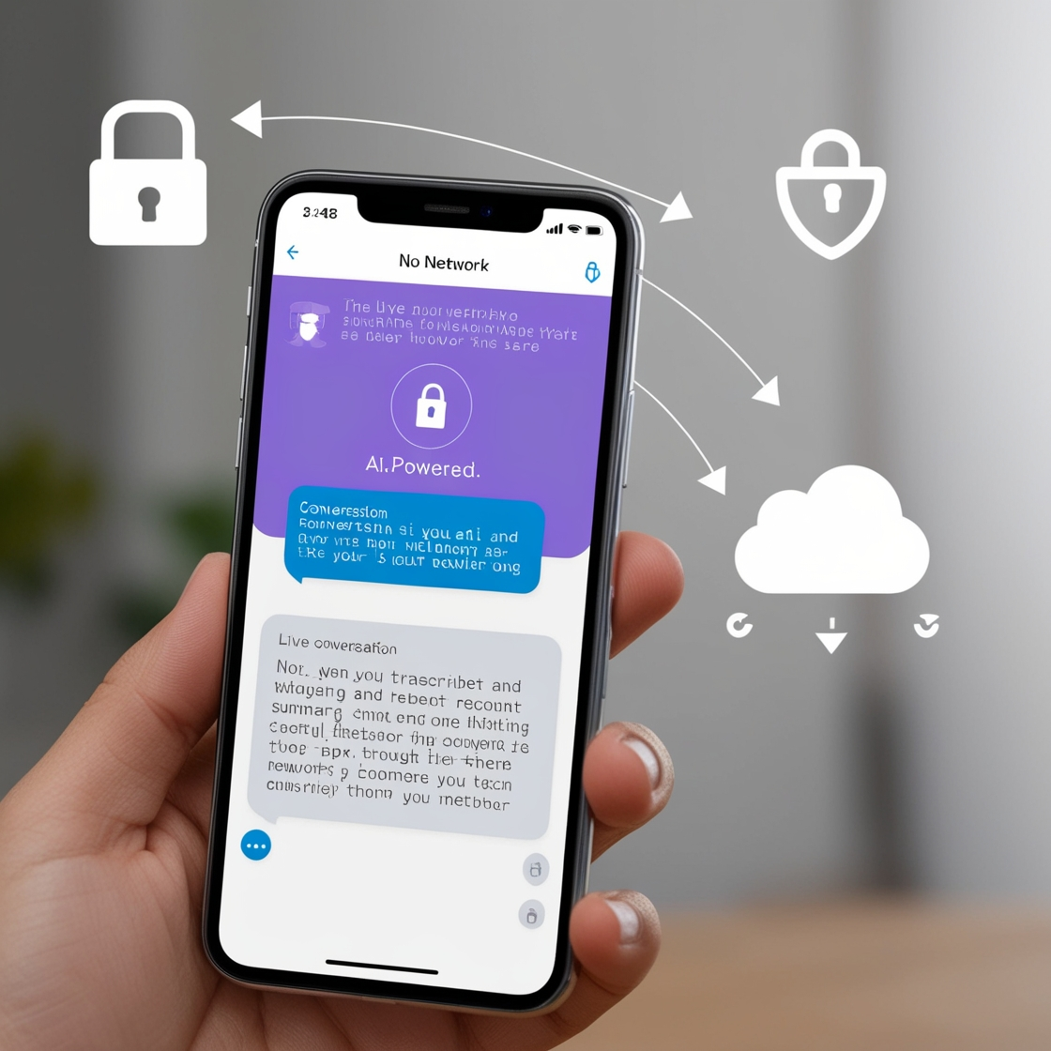

Voiceover:
Imagine standing on an unfamiliar street with no internet access. You capture a quick photo, and in an instant, your device tells you exactly where you are, the street name, and how to get to your destination all without connecting to the web. This is the power of Google Gemini Nano. It redefines the boundaries of AI by combining cutting-edge on-device intelligence with seamless offline performance. With Gemini Nano, you’re never lost just one step closer to unlocking the world’s possibilities, no matter where you are.

Section 1: Core Concept of Google Gemini Nano

1.1 What Is Gemini Nano?
Visual: A smartphone showing AI-driven features like text prediction, voice recognition, and instant translations.

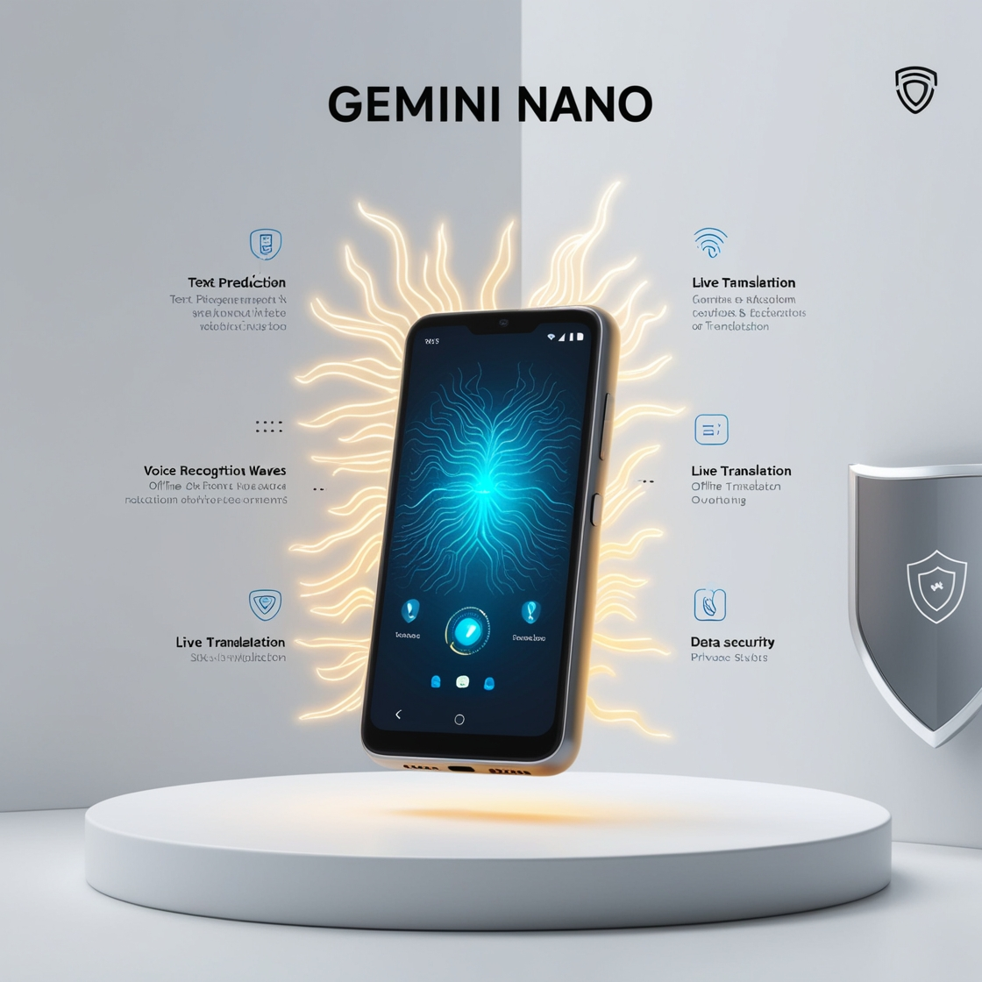

Voiceover:
Google Gemini Nano is a compact yet powerful AI model tailored for mobile devices. Its advanced capabilities operate directly on smartphones, enabling features such as text prediction, voice recognition, and real-time translations. Unlike traditional AI models, Gemini Nano works offline, ensuring fast performance while safeguarding personal data. It’s a pocket-sized AI assistant ready to assist anytime.

1.2 Why Gemini Nano Matters
Visual: A mobile device surrounded by icons symbolizing privacy, speed, and offline processing.
Voiceover:
Gemini Nano's strength lies in its on-device processing. This feature reduces latency and enhances privacy, as data doesn't need to be uploaded to the cloud for processing. Built with Google's Tensor G4 chipset, it supports powerful AI computations, making it an ideal solution for smartphones needing powerful, offline AI capabilities.

What does Gemini Nano do?
Compact and Portable
Lightweight design for easy portability and use.
High Performance
Efficient and fast operation for diverse applications.
Versatile Applications
Suitable for IoT, healthcare, nanotechnology, and AI.
Secure Data Management
Ensures encrypted and secure handling of data.

1.3 How Gemini Nano Works
Visual: A microchip symbol integrated with icons for text, audio, and image processing.

Voiceover:
Gemini Nano uses a combination of LLMs and transformers, which are designed to understand and generate text, audio, and image data seamlessly. By processing tasks locally on mobile devices, it ensures that voice commands, text predictions, and image analyses are handled quickly and securely.

Section 2: Technical Design and Functionality

2.1 On-Device Processing
Visual: A smartphone with glowing AI circuitry showing data flow happening on the device itself.
Voiceover:
Introducing Gemini Nano, a revolution in on-device AI technology. Imagine a world where your device handles complex tasks seamlessly, with no reliance on the cloud. That's Gemini Nano for you fast, secure, and intelligent. Its advanced architecture combines powerful transformer models and lightweight neural networks, bringing you real-time speech recognition, precise image analysis, and more.
What sets Gemini Nano apart? Privacy. Your data stays with you, ensuring top-notch security. Plus, with reduced latency, every interaction feels natural and immediate. It’s AI, redefined for a smarter, faster, and more secure tomorrow. Experience the power of cutting-edge innovation, right in the palm of your hand.

2.2 Multimodal Understanding
Visual: An AI-powered interface blending speech, image recognition, and text analysis in a unified display.
Voiceover:
The Gemini Nano model integrates multimodal capabilities, allowing it to analyze and combine multiple data types text, audio, and images. For example, if you send a food image with a text query about a restaurant, Gemini Nano can process both inputs, using its transformer model to interpret and generate context-aware suggestions.

What is Gemini Capable of?
Gemini is a powerful AI that understands text, images, and audio together. It retrieves accurate facts, handles long texts, solves math and science problems, and applies logical reasoning. Gemini can also work in multiple languages and respond quickly, making it a versatile tool for many tasks.
Factuality: This feature checks if the model can correctly find and present accurate information, whether it’s from open or closed sources.
Long-Context: This looks at how well the model can summarize, find, and answer questions based on long pieces of text.
Math/Science: This tests the model’s ability to solve math problems, prove theorems, and answer scientific questions.
Reasoning: These tasks involve using logic and thinking skills, including basic math, science, and common sense, to solve problems.
Multilingual: This measures how well the model can translate, summarize, and reason in multiple languages.

Gemini nano use case
Gemini Nano delivers powerful, efficient on-device experiences across various sectors. In industrial automation, it prevents downtime with real-time machinery monitoring and predictive maintenance. In healthcare, it powers wearable devices that track patient vitals and send alerts for better care.
For smart homes, Gemini Nano enhances AI-driven devices like voice assistants and security cameras while conserving power. In edge AI, it enables local data analysis, reducing latency and enhancing privacy.
Gemini Nano also powers applications like Pixel Screenshots for quick information retrieval, Pixel Recorder for on-device summarization, and Call Notes for private call transcripts. Its compact design and energy efficiency make it a versatile, industry-leading solution.

2.3 Quiz for Google Gemini Nano :
- Question:
What makes Google Gemini Nano different from traditional AI models?
Options:
A. It requires an internet connection at all times.
B. It processes data directly on the device.
C. It only works on cloud-based platforms.
D. It focuses solely on gaming applications.
Answer:
B. It processes data directly on the device.
- Question:
What does "multimodal understanding" in Google Gemini Nano allow?
Options:
A. Processing only voice commands.
B. Managing only text-based data.
C. Understanding text, speech, and images simultaneously.
D. Switching between different apps quickly.
Answer:
C. Understanding text, speech, and images simultaneously.
- Question:
How does Google Gemini Nano ensure data privacy?
Options:
A. By storing data on cloud servers.
B. By sending encrypted data to Google’s servers.
C. By processing all user data locally on the device.
D. By disabling internet access while processing.
Answer:
C. By processing all user data locally on the device.

Section 3: Real-World Applications

3.1 Voice Assistance with Contextual Understanding
Visual: A person interacting with a voice assistant in different environments.
Voiceover:
Gemini Nano uses a blend of deep learning techniques and transformer models to analyze context in conversations. For example, when managing a series of emails, it understands the ongoing conversation and suggests relevant replies, ensuring the responses align with the context of previous exchanges.

3.2 Smart Reply in Messaging
Visual: A messaging app showing AI-generated responses.
Voiceover:
Gemini Nano’s ability to interpret entire conversations allows it to generate smart replies. The model employs transformers to understand the tone and content of a message and suggest the most relevant response, making communication faster and more natural.
Smart Reply Feature: Highlight the visual of a messaging app showcasing AI-generated smart replies, emphasizing Gemini Nano’s capability to enhance communication efficiency.
Conversational Understanding: Voiceover explains how Gemini Nano interprets entire conversations, capturing both tone and context for accurate responses.
Transformer Technology: Mention the use of transformer models, which enable deep understanding of message content, ensuring relevant and context-aware suggestions.
Enhanced Communication: Emphasize how this technology makes messaging faster and more natural, reducing the effort needed for users to respond.
User-Friendly Experience: Conclude with the benefit of AI-driven smart replies, offering users a seamless and intuitive messaging experience.

3.3 Content Summarization
Visual: A summarized article with highlighted bullet points.
Voiceover:
Gemini Nano condenses lengthy articles using advanced text clustering techniques. It groups similar ideas, highlights key points, and organizes them into clear, concise summaries. This allows users to quickly grasp essential information without having to read the entire text.

Section 4: Privacy and Security

4.1 Efficient and Private On-Device AI
Visual Prompt:
An abstract lock icon integrated into a smartphone, symbolizing secure and private on-device data storage. Surround the lock with subtle glowing signals representing local AI processing and privacy protection.
Voiceover:
Gemini Nano ensures your data stays with you. By processing everything on-device, it eliminates the need for cloud interaction. This not only reduces latency but also protects sensitive information, like voice recordings and images, keeping them safe and private.

4.2 End-to-End Encryption
Visual Prompt:
Illustrate an encrypted data flow with a padlock icon in the center of a glowing, protected pathway. Surround the path with layers symbolizing encryption shields, ensuring data protection.
Voiceover:
With end-to-end encryption, Gemini Nano safeguards your information. Data processed on your device remains secure, even during transmission. Whether handling voice commands or personal data, your privacy is always the top priority. Gemini Nano complies with Google's Private Compute Core, a secure environment designed to protect your data. PCC ensures strict privacy rules, routing all interactions through secure, open-source services for enhanced security and transparency.

4.3 User Control
Visual Prompt:
Display a clean settings menu on a smartphone screen with toggle switches for features like ‘Voice Recognition’ and ‘Image Analysis.’ Include a finger interacting with a toggle switch to emphasize user customization.
Voiceover:
Gemini Nano puts you in control. Customizable settings let you decide how AI features like voice recognition and image analysis work for you. With transparency at its core, Gemini Nano ensures you’re always in charge of your data and experience.

Section 5: Surprising Elements of Gemini Nano

5.1 Offline Capabilities
Visual: A smartphone intelligently managing tasks in a remote, offline environment.
Voiceover:
Stay connected even when you’re off the grid. Gemini Nano’s offline capabilities let you perform essential tasks without an internet connection. From managing your calendar to recognizing objects through its camera, it ensures uninterrupted AI-powered assistance wherever you go.

5.2 Real-Time Assistance
Visual: A mobile assistant instantly providing contextual suggestions based on user activity.
Voiceover:
Gemini Nano delivers real-time support whenever you need it. Whether you’re drafting an email, creating a to-do list, or navigating unfamiliar roads, its AI-powered assistant offers timely suggestions, making every task smoother and more efficient.

5.3 Personalized User Experience
Visual: A smartphone screen adapting its layout and features based on user preferences.
Voiceover:
Experience AI that truly knows you. Enhanced reinforcement learning allows Gemini Nano learns your habits, preferences, and frequently used features to deliver a personalized experience. From predictive app recommendations to customized settings, it makes your smartphone uniquely yours.

Section 6: Future Potential and Evolution

6.1 Expanding Smart Ecosystems
Visual: A smart home with interconnected devices working seamlessly.
Voiceover:
The future of Gemini Nano lies in expanding its role across the smart ecosystem. Imagine a connected world where your phone synchronizes effortlessly with home automation systems, wearables, and even public infrastructure, making everyday life more integrated and intelligent.

Limitations: While the Gemini models offer remarkable capabilities, they still have certain limitations. Ongoing research is essential to address the issue of "hallucinations," where the models generate incorrect or fabricated content. Additionally, LLMs face difficulties with complex reasoning tasks, such as understanding causality or making logical inferences. These challenges emphasize the need for more rigorous evaluations to accurately assess their true comprehension.

6.2 Next-Level Mixed Reality
Visual: A person using AR glasses with immersive, lifelike visuals.
Voiceover:
Gemini Nano pushes the boundaries of mixed reality. With its advanced AI, it can deliver highly interactive AR/VR experiences. Whether collaborating in virtual meetings or exploring digital worlds, expect richer, more responsive environments powered by on-device intelligence.

6.3 Universal Integration
Visual: A network of connected devices powered by a central AI hub.
Voiceover:
Soon, all your connected devices—phones, smart TVs, tablets, even kitchen appliances—will be powered by Gemini Nano. This universal integration will create a highly intelligent digital ecosystem, where every device communicates with the other. Whether it’s adjusting your thermostat from your phone or controlling your lights with your voice, Gemini Nano will make it all possible.

Poll
- Question:
How does Google Gemini Nano provide personalized user experiences?
Options:
A. By monitoring cloud-based activity.
B. By learning user behavior through local device interaction.
C. By sending data to Google’s AI labs for analysis.
D. By asking users to input preferences manually.
Answer:
B. By learning user behavior through local device interaction.
- Question:
What ensures Google Gemini Nano's compatibility with various devices?
Options:
A. Its hardware-specific design.
B. Its cloud-dependent system.
C. Its lightweight and adaptable AI model.
D. Its pre-installed software package.
Answer:
C. Its lightweight and adaptable AI model.
- Question:
Which of the following is a potential future application for Google Gemini Nano?
Options:
A. Remote cloud server management.
B. Offline voice assistants in smart devices.
C. Only enhancing Google search features.
D. Internet-based social media analytics.
Answer:
B. Offline voice assistants in smart devices.

