**RESERVED ROOM**

**FOR**

**COMPUTER SCIENCE DEPARTMENT**

submitted by

### GOKULNATH S

In partial fulfillment of the requirements for the award of the Degree of

**Master of Computer Applications** from Bharathiar University, Coimbatore.

under the internal supervision of

**Dr.G. Pandiyan, M.Sc., M.Phil., B. Ed., Ph.D.,**

**Associate Professor**



**School of Computer Studies, Department of MCA**

**Rathnavel Subramaniam College of Arts and Science (Autonomous), Sulur, Coimbatore – 641 402.**

**December 2021 – March 2022.**

**RATHNAVEL SUBRAMANIAM COLLEGE OF ARTS AND SCIENCE**

(AUTONOMOUS)

**Sulur, Coimbatore-641 402**

**Department of Computer Applications (MCA) Project work & Viva-voce**

*Bona Fide* Certificate

This is to certify that this a *bonafide* record of work done by Mr. / Ms .......................................................................................…………………………..

Register No. during the academic year 2020 – 2021 and submitted for the

End Semester Project viva voce held on ……………….

**HEAD OF THE DEPARTMENT STAFF – IN CHARGE**

**INTERNAL EXAMINER EXTERNAL EXAMINER**

***Certificates***

**Certificate**

This is to certify that the dissertation entitled **RESERVED ROOM**, submitted to the School of Computer Studies, Rathnavel Subramaniam College of Arts and Science in partial fulfillment of the requirements for the award of the Degree of Master of Computer Applications is a record of the original project work done by **GOKULNATH S** during the period December 2020-March 2021 of their study on MCA in the Rathnavel Subramaniam College of Arts and Science, under my internal supervision and the dissertation has not formed the basis for the award of any Degree/Diploma/Associateship/Fellowship or another similar title to any candidate of any University.

**Internal Supervisor**

***Declaration***

**Declaration**

We, **GOKULNATH S,** hereby declare that the dissertation, entitled **RESERVED ROOM**, submitted to the School of Computer Studies, Rathnavel Subramaniam College of Arts and Science, in partial fulfilled the requirements for the award of the Degree of Master of Computer Applications is a record of original project work done by us during the period December 2020–March 2021 under the internal supervision of **Dr.G.Pandiyan, Associate Professor**, Department of Computer Applications and it has not formed the basis for the award of any Degree/Diploma/Associateship/Fellowship or another similar title to any candidate of any University.

**Signature of the Candidate**

***Acknowledgment***

**Acknowledgment**

We express our sincere thanks to our Managing trustee **Dr.K. Senthil Ganesh MBA (USA)., MS (UK)., Ph.D.,** for providing us with adequate faculty and laboratory resources for completing my project successfully.

We take this as a fine opportunity to express our sincere thanks to **Dr. T. Sivakumar M.Sc., M. Phil., Ph.D., Principal,** Rathnavel Subramaniam College of Arts and Science (Autonomous) for allowing me to undertake this project.

We express our sincere thanks to **Dr.D.Francis Xavier Christopher., M.Sc(CS).,M.Phil., Ph.D., Director (Administration), Department of Computer Science** for the help and advice throughout the project.

We express our sincere thanks to **Dr. S. Yamini., M.Sc(CC)., M. Phil., Ph.D., Director (Academic), Department of Computer Science** for her valuable guidance and prompt correspondence throughout the curriculum to complete the project.

We express our sincere thanks to **Mrs. C.Grace Padma., MCA., M.Phil., MBA., Head of the Department** for her support and advice throughout the project.

We express our gratitude to **Dr.G.Pandiyan,M.Sc.,M.Phil., B.Ed., Ph.D.,** for his valuable guidance, support, encouragement, and motivation rendered by him throughout this project.

Finally, we express our sincere thanks to all other staff members and my dear friends, and all dear and near for helping me to complete this project.

**GOKULNATH S**

**RESERVED ROOM**

# Abstract

## Abstract

Reserved Room website is used to reserve the room for the programs for staff. The registered person can view the time availability of room for the convinces

**Frontend Tools/ Technology Web:** React **Backend Tools/ Technology:** NodeJS **Database Technology:** MongoDB

**Git repository link:** https://github.com/gokulnath0307/Reserved-Room.git

**Frontend Tools/ Technology:** React JS

**Backend Tools/ Technology:** Node JS

**Database Technology:** MongoDB Atlas

**Hosting Environment:**

**Node:**

**React:**

**React Native:**

**MongoDB:**

**Website link:**

**Mobile App link:**

**Git repository link:** https://github.com/gokulnath0307/Reserved-Room.git

# Index

|  |  |  |
| --- | --- | --- |
| S.No | TITLE | Page No. |
| 1 | Introduction |  |
| 2 | Module Description |  |
| 3 | Use cases Diagrams |  |
| 4 | Scheme for the App |  |
| 5 | APIs for the App |  |
| 6 | Testing of API |  |
| 7 | Connect the API with screens |  |
| 8 | User Manual |  |
| 9 | Conclusion and Future Enhancement |  |
|  |  |  |
|  |  |  |
|  |  |  |
|  |  |  |
|  |  |  |
|  |  |  |
|  |  |  |
|  |  |  |

***Introduction***

## Introduction

This website is developed to propose reserving the room and allocating the time slot, so we named it RESERVED ROOM. The major function of the site is booking the room by the login. This may help to avoid the overlapping of the program timing at the same moment. It can reduce the manual work of writing and registration. While we can make the reservation manually, sometimes one or programs can be booked at the same time. To avoid these, our website can be used. This time slot for the various program can be allocated, by the previous schedule. This can be useful for the reservation and time allocation of the room.

***Module Description***

**Module description**

Reserved Room has multiple main module and sub-modules and with an admin account one can access all modules the module in Reserved are as follow,

* **Profile**
* **Profile Edit**
* **Available Time and Date**
* **Information about Booking details**

**Profile:**

Users can be viewing our details.

**Profile Edit:**

Users can be updating our profile.

**Available Date and Time:**

Users can view to book the event for convenience date and time.

**Information about Booking details:**

Admin only view and delete the booking details and cancel the booking event

***Use Case Diagram***

**Use Case Diagrams**

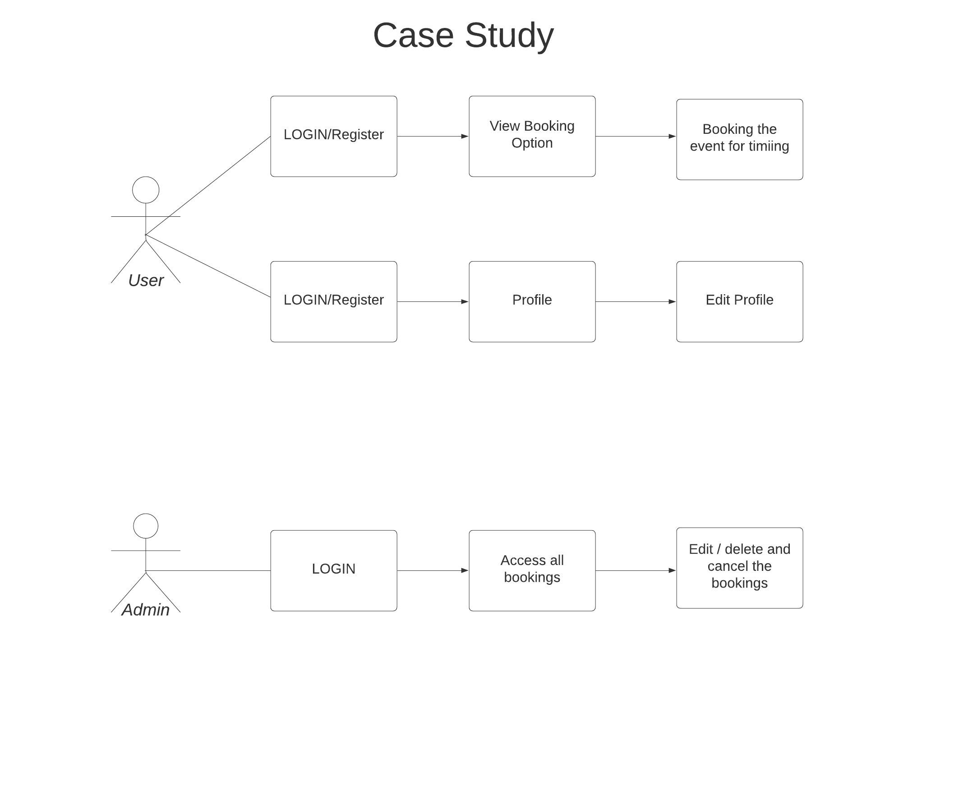

***Scheme(s)for the App***

**User Scheme:**

const mongoose = require('mongoose')

const UserSchema = mongoose.Schema({

name: {

type: String,

require: true

},

department: {

type: String,

require: true

},

email: {

type: String,

require: true

},

password: {

type: String,

require: true

}

})

module.exports = mongoose.model('UserDetails', UserSchema)

**Booking Scheme:**

const mongoose = require('mongoose')

const BookingFormSchema = mongoose.Schema({

department: {

type: String,

require: true

},

reason: {

type: String,

require: true

},

name: {

type: String,

require: true

},

email: {

type: String,

require: true

},

date: {

type: String,

require: true

},

start: {

type: String,

require: true

},

end: {

type: String,

require: true

}

})

module.exports = mongoose.model('Booking', BookingFormSchema)

**Admin Scheme:**

const mongoose = require('mongoose')

const AdminSchema = mongoose.Schema({

name: {

type: String,

require: true

},

username: {

type: String,

require: true

},

password: {

type: String,

require: true

}

})

module.exports = mongoose.model('Admin', AdminSchema)

***APIs for the App***

**Users APIs:**

Method: POST

API: /user/register

Description: New Users can use this API for registration purposes.

Method: POST

API: /user/getuser

Description: This API can use to get all registered user details

Method: POST

API: /user/login

Description: This API can use to log in for users’ purpose

Method: GET

API: /user/getusers

Description: This API can use to get only one user’s details.

Method: PUT

API: /user/updateuser

Description: This API can use to edit and update the user details.

**Booking APIs:**

Method: POST

API: /booking /add

Description: Users can use this API for booking the event.

Method: POST

API: /booking/getOneBookingDetails

Description: Admin only uses this API to get all booking details.

Method: POST

API: /booking/deleteBooking

Description: Admin only uses this API to delete the booking details

Method: GET

API: /booking/getBooking

Description: Admin and Users can get the booking the details

Method: PUT

API: /booking/editBoooking

Description: Admin only uses this API to edit the booking event time.

**Admin Scheme:**

Method: POST

API: /admin /register

Description: This API can use to create the new admin

Method: POST

API: /admin/login

Description: This API can use to log in for Admin purpose.

Method: GET

API: /admin/getAdmin

Description: This API can use to Admin details.

**Connect the API with screens**

Admin APIs:

1. Admin Register

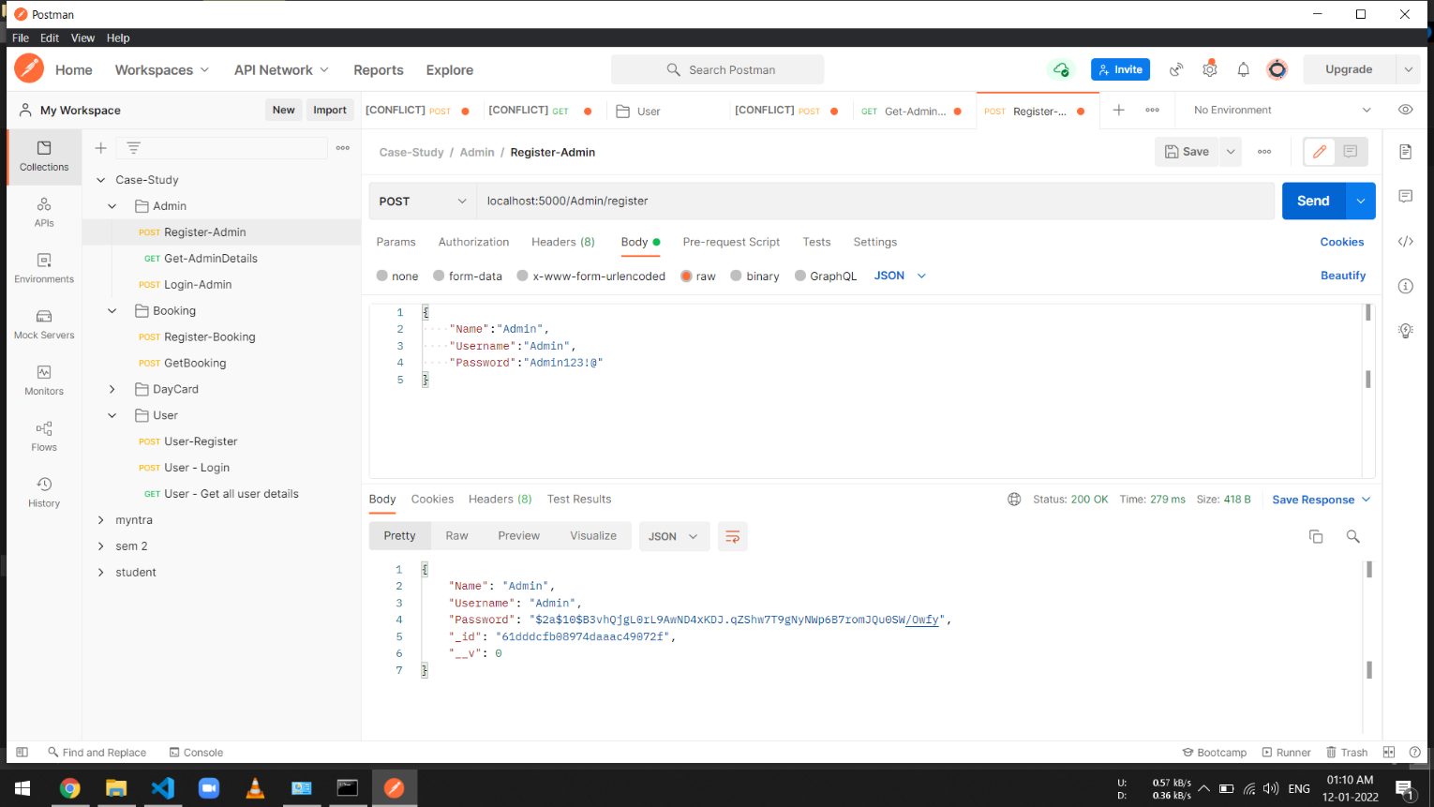

1. Admin Login

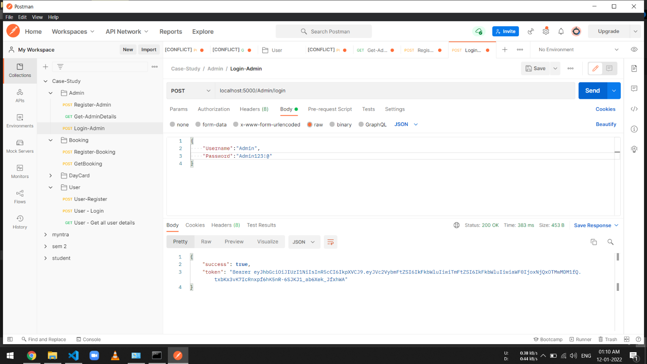

1. Admin Details

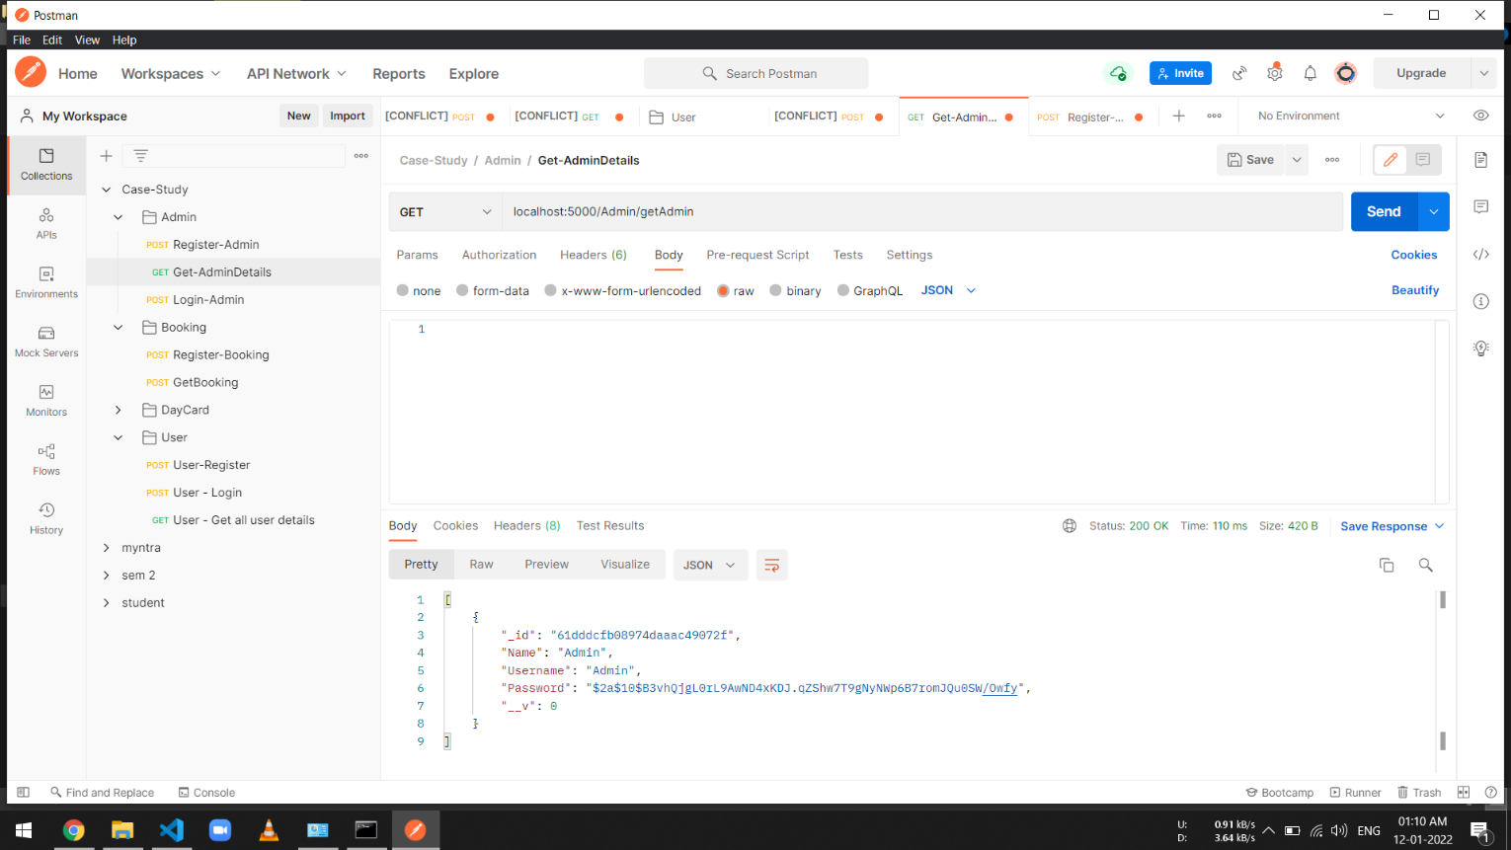

1. Admin Password Error Handling

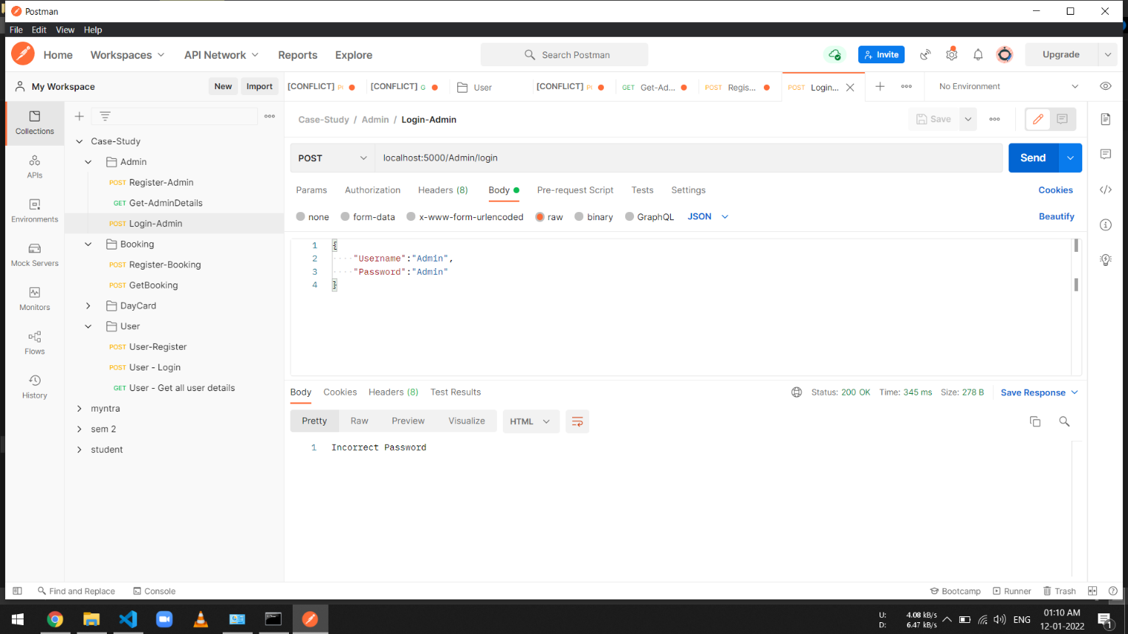

Booking APIs:

1.Booking Register

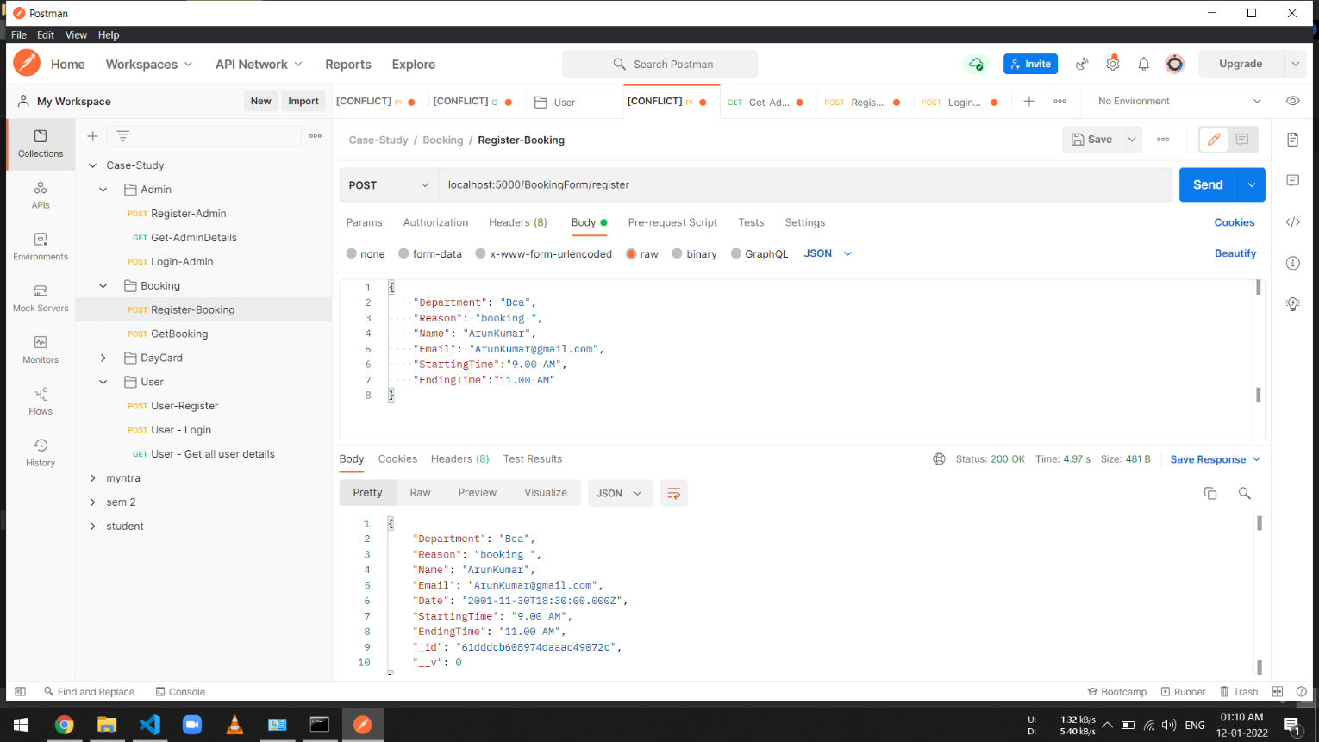

2. Booking Details

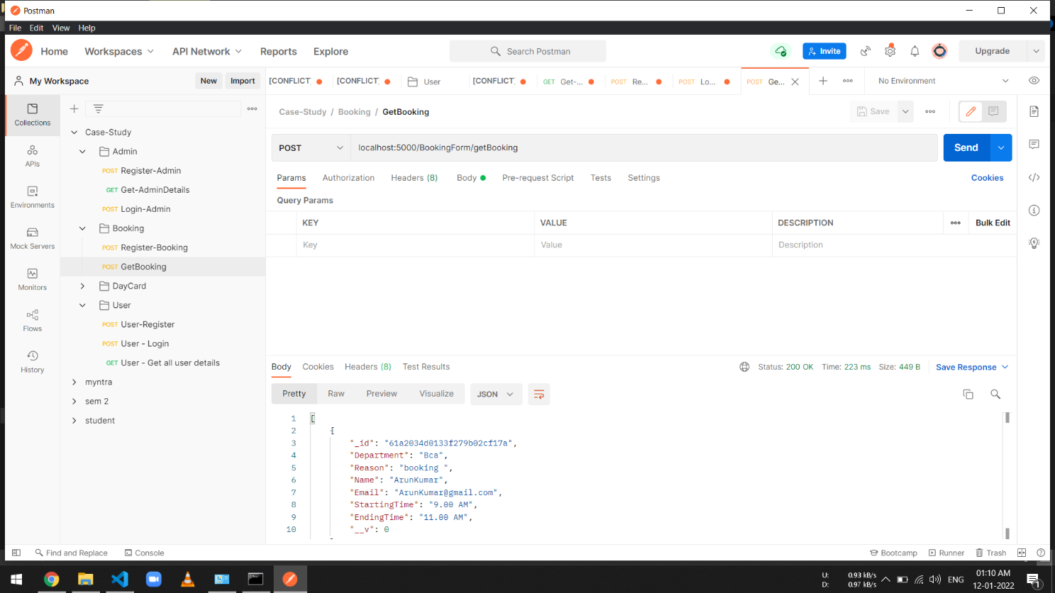

User APIs:

1. User Register

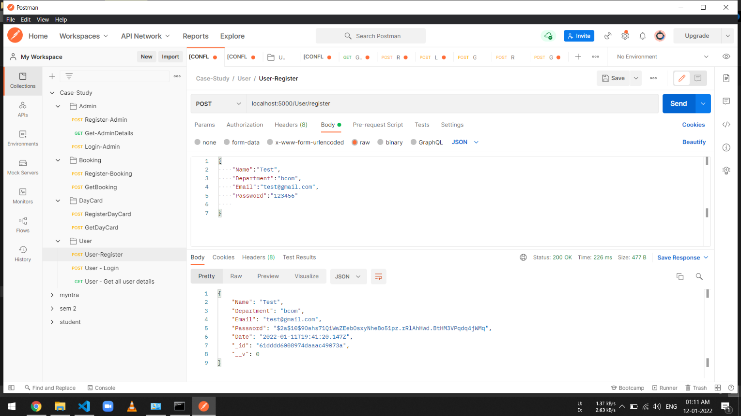

2. User Login Details

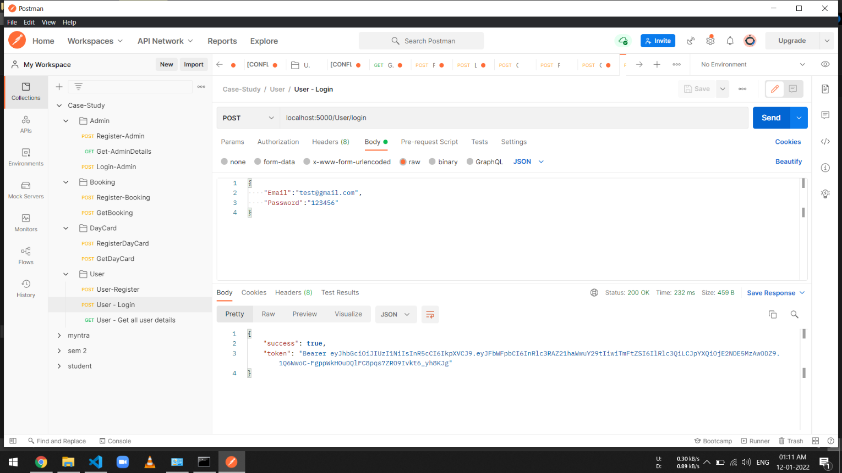

1. User Details

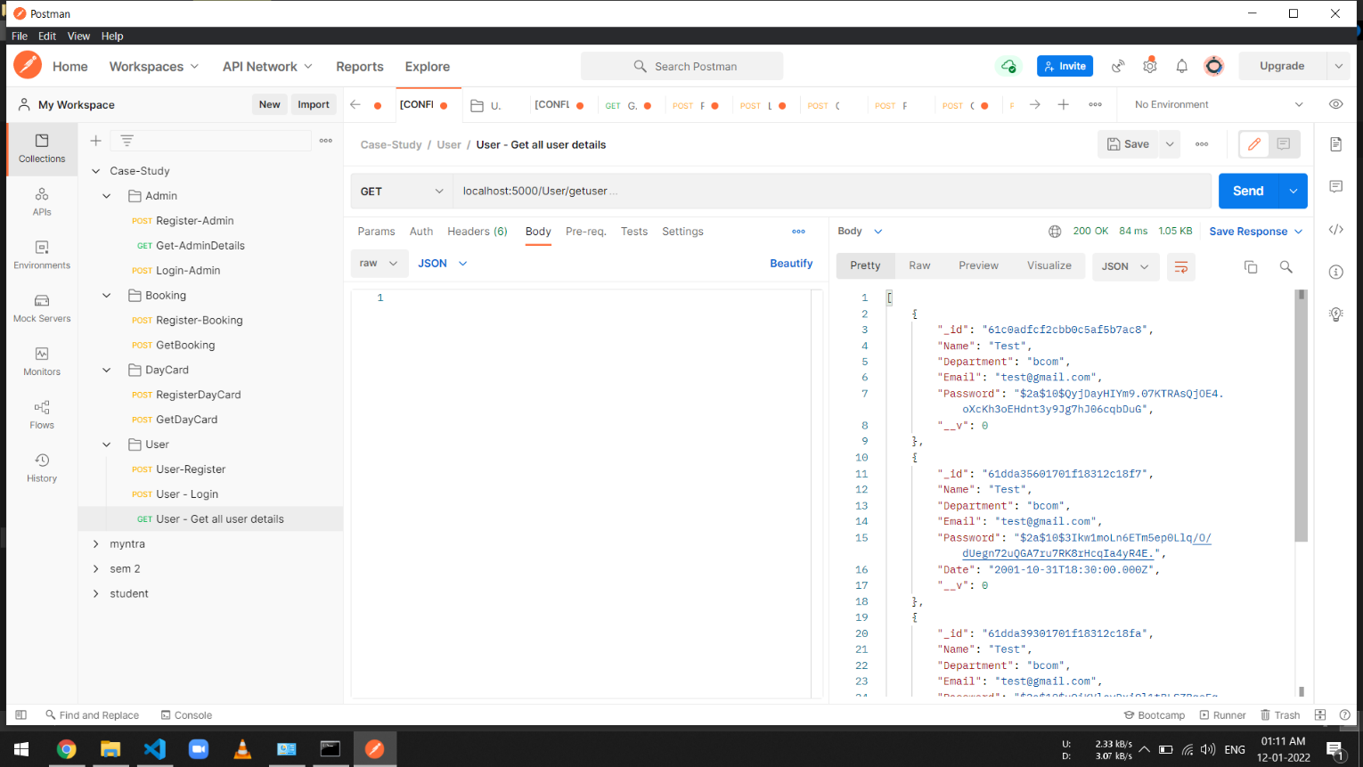

***User Manual***

Home Page:

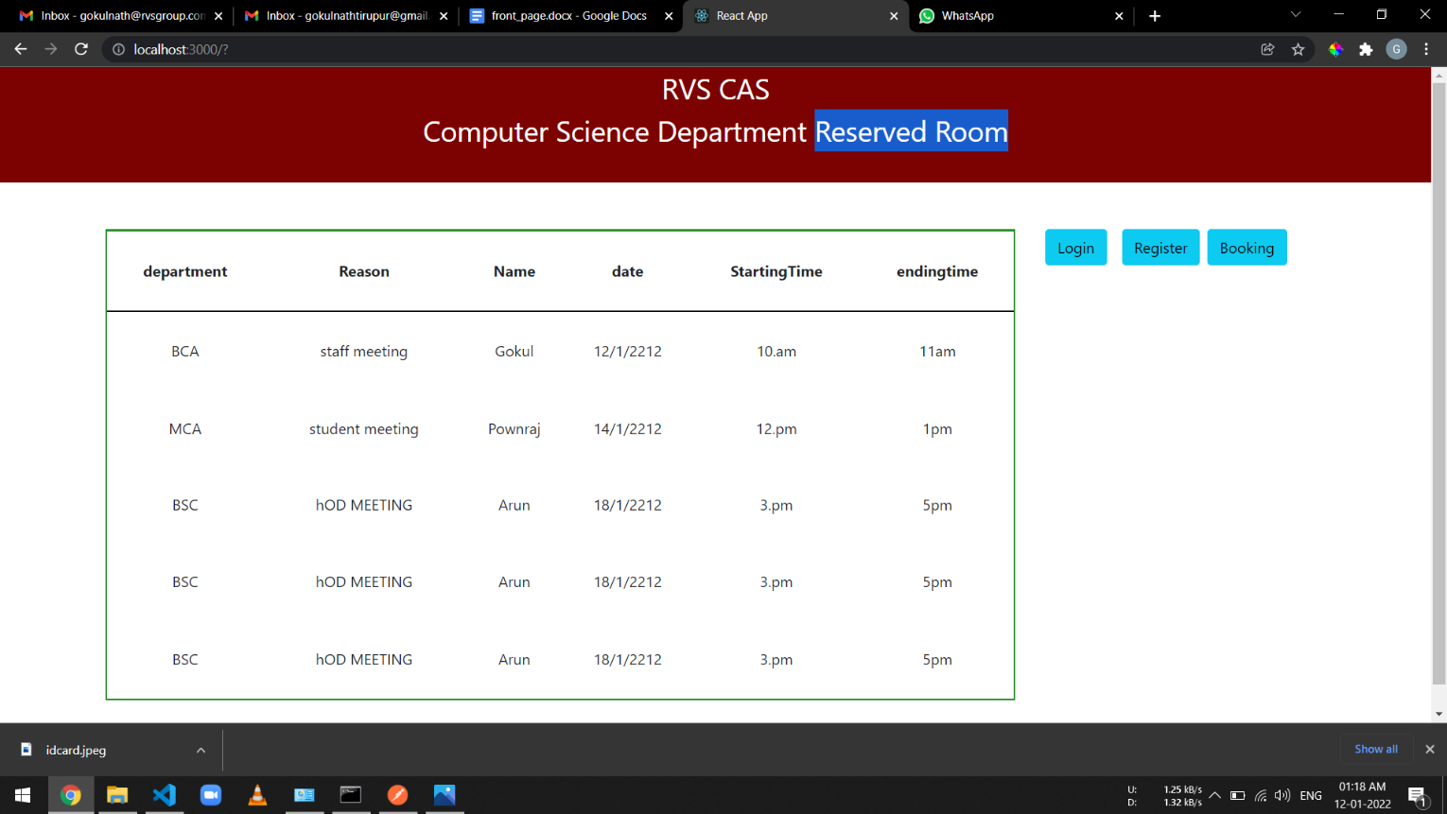

Register Page:

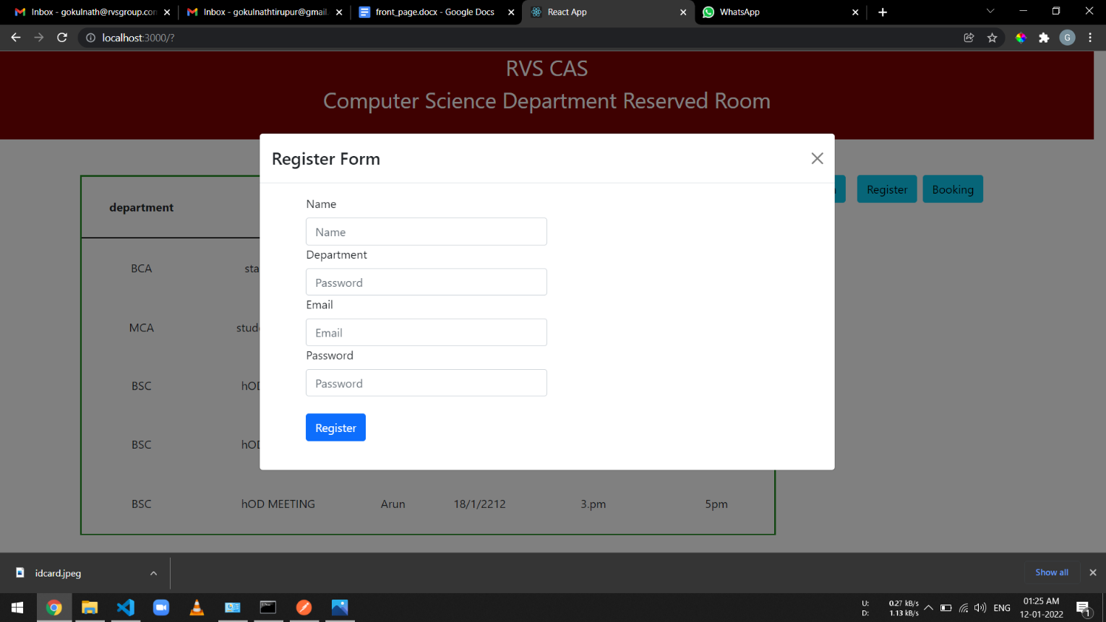

Login Page:

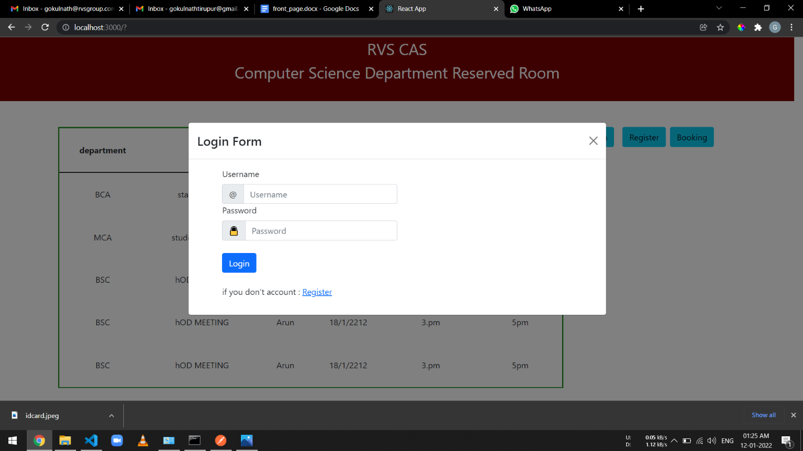

Booking Form Page:

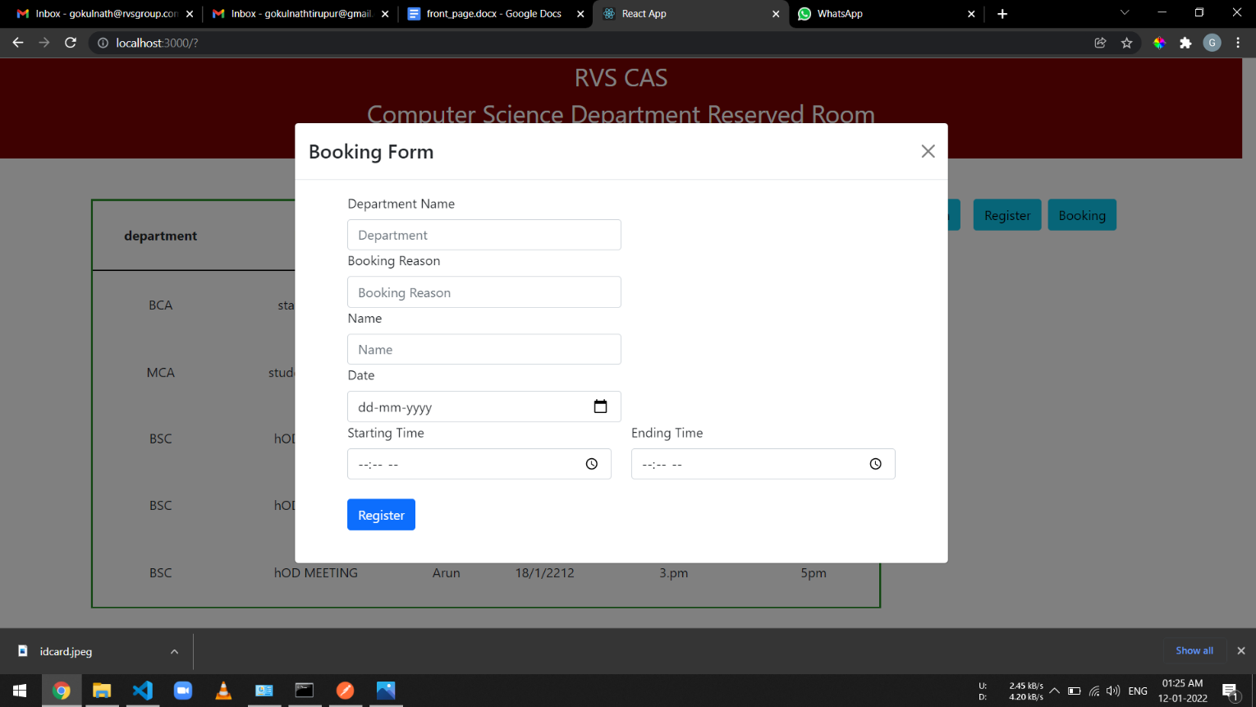

Admin Login page:

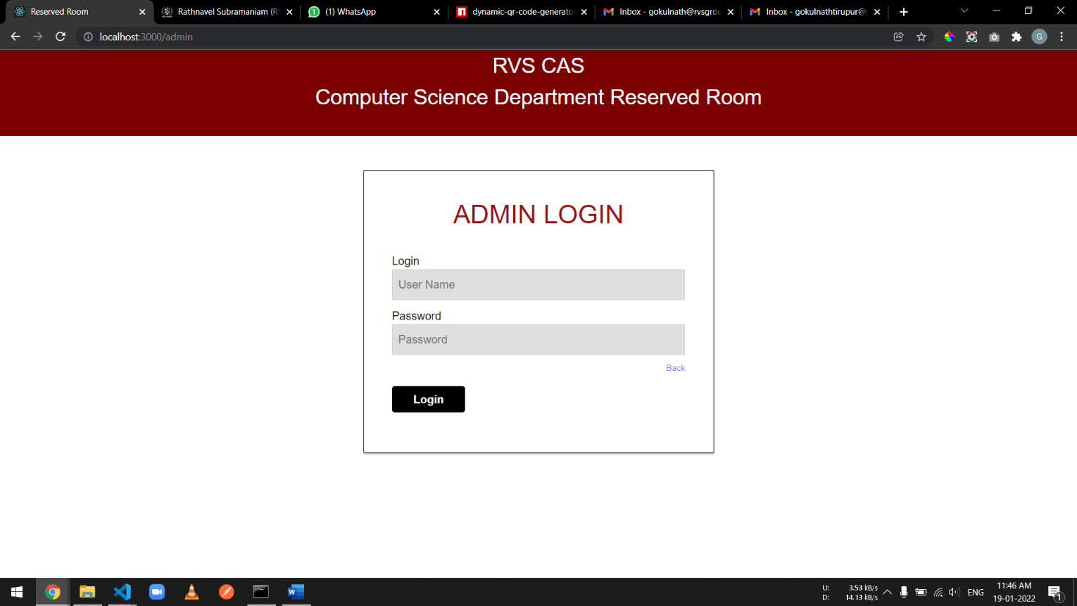

Admin Dashboard Page:

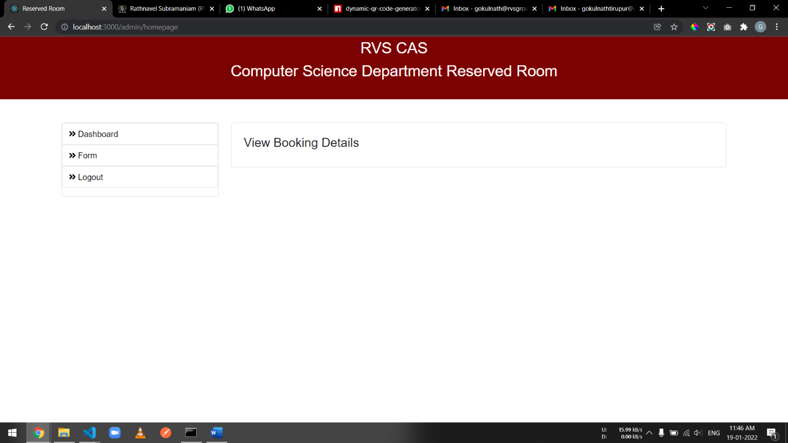

# Conclusion

# And

# Future Enhancement

### Future Enhancement:

In the future, this website can update by linking the program with google calendar for registered persons, and further, we can add reminders for the program. Also, a notification alert will send through the mail for the person

### 

### Conclusion:

This website is useful to reserve the room program login in the RESERVED ROOM website. The overlapping of one or two programs can be avoided. There is no need for staff to be appointed for the registration for the room as manually. Conclude the main aim of the website is the reservation of a room