Task-1

1. **Create a simple functional component named Greeting g that returns “Hello, World!” within a <h1> tag.**

**Greetings.jsx:**

export function Greetings() {

  return(

    <>

    <h1>"Hello, World!"</h1>

    </>

    )

}

**App.jsx:**

import {Greetings} from './Greetings.jsx'

function App() {

  return (

      < Greetings />

  )

}

export default App

**Output:**

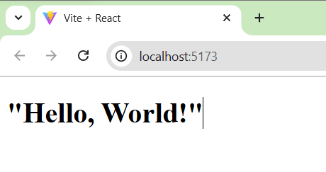

1. **Modify the Greeting component to display “Hello, React!”.**

**Greetings.jsx:**

export function Greetings() {

  return(

    <>

    <h1>"Hello, React!"</h1>

    </>

    )

}

**App.jsx:**

import {Greetings} from './Greetings.jsx'

function App() {

  return (

      < Greetings />

  )

}

export default App

**Output:**

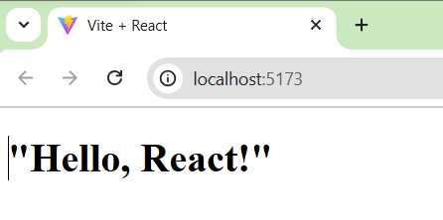

1. **Create a Gallery functional component to display an image.**

function Gallery() {

  return (

  );

}

1. **Add Greeting to the Gallery component and display the image and greeting.**

**Greetings.jsx:**

export function Greetings() {

    return(

      <>

      <h1>"Hello, React!"</h1>

      </>

      )

  }

export function Gallery() {

    return (

      <div>

        <Greetings /> {/* 4. Add Greeting to the Gallery component */}

        <img

          src="https://encrypted-tbn0.gstatic.com/images?q=tbn:ANd9GcTlfx7gKhi12MSTbVi70VQ66ux5LkZd-8b6Tw&s"

          alt="Gallery Display"

        />

      </div>

    );

}

**App.jsx:**

import {Greetings} from './Greetings.jsx'

function App() {

  return (

      < Greetings />

  )

}

export default App

**Output:**

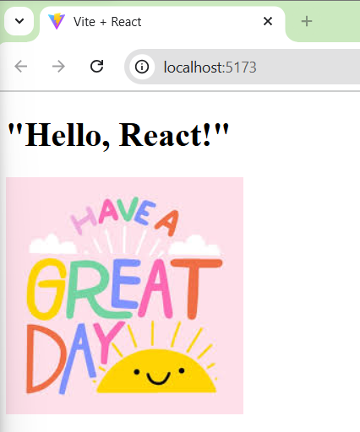

1. **Write a component called Profile which displays a hardcoded user’s name and age.**

**Profile.jsx:**

export function Profile() {

    const user = {

      name: "Gokulnath",

      age: 20,

    };

    return (

      <div>

        <h2>Name: {user.name}</h2>

        <h3>Age: {user.age}</h3>

      </div>

    );

  }

**App.jsx:**

import {Profile} from './Profile.jsx'

function App() {

  return (

      < Profile />

  )

}

export default App

**Output:**

