Task-3

How to add markup to JavaScript with JSX

1. **Create a component that displays an unordered list (<ul>) of 3 favorite fruits.**

**Fruits.jsx:**

export default function Fruits(){

    return(

        <>

        <ul>

        <li>Apple</li>

        <li>Orange</li>

        <li>Grapes</li>

        </ul>

        </>

    )

}

**App.jsx:**

import Fruits from './Fruits.jsx'

function App() {

  return (

    <>

    < Fruits />

    </>

  )

}

export default App

**Output:**

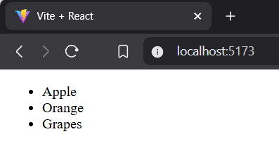

1. **Update the above component to display a picture (<img>) of each fruit next to its name. (Use hardcoded image URLs for now.)**

**Fruits.jsx:**

export default function Fruits(){

    return(

        <>

        <ul>

        <li>Apple<img src = 'https://static.vecteezy.com/system/resources/thumbnails/016/940/260/small/apple-fruit-isolated-on-white-background-photo.jpg' alt='Apple'/></li>

        <li>Orange<img src = 'https://t4.ftcdn.net/jpg/02/20/02/41/360_F_220024121_lvQqND2X6YcINIlgNwTXcwC5Ws6no0RQ.jpg' alt='Orange'/></li>

        <li>Grapes<img src='https://encrypted-tbn0.gstatic.com/images?q=tbn:ANd9GcTn8JPesyB87cRqkYYE7KNdvmbuH7IM8N7L7w&s' alt='Grapes'/></li>

        </ul>

        </>

    )

}

**App.jsx:**

import Fruits from './Fruits.jsx'

function App() {

  return (

    <>

    < Fruits />

    </>

  )

}

export default App

**Output:**

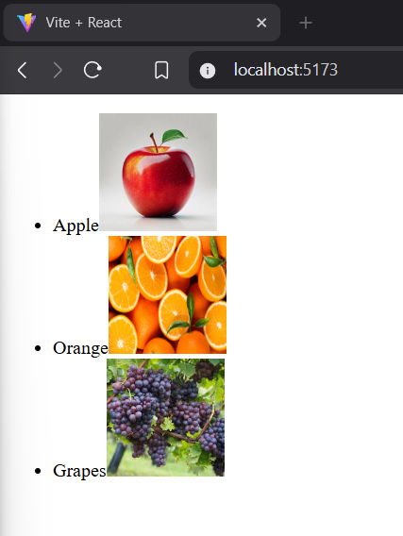

1. **Create a component WebsiteLink that displays a hardcoded URL in an anchor (<a>) tag.**

**WebsiteLink.jsx:**

export default function WebsiteLink(){

    return(

        <>

        <h1>Url using Anchor Tag</h1>

<a href="https://www.w3schools.com/REACT/DEFAULT.ASP" target="_blank">Click here to learn react</a>

        </>

    )

}

**App.jsx:**

import WebsiteLink from './WebsiteLink.jsx'

function App() {

  return (

    <>

    < WebsiteLink />

    </>

  )

}

export default App

**Output:**

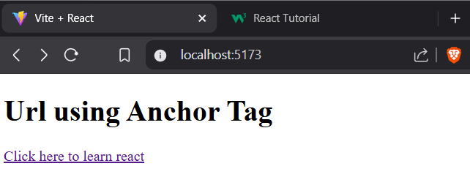

1. **Make a JSX component that mimics a simple blog post with a title, content, and author. (All hardcoded.)**

**BlogPost.jsx:**

export default function BlogPost(){

    return(

        <>

        <h1 style={{textAlign:'center'}}>Blog Content</h1>

        <p><strong>Title: </strong>Harry Potter</p>

        <p><strong>Content:</strong>Harry Potter is a series of novels by British author J. K. Rowling. The novels follow Harry Potter, an 11-year-old boy who discovers he is the son of famous wizards and will attend Hogwarts School of Witchcraft and Wizardry. Harry learns of an entire society of wizards and witches.</p>

        <p><strong>Author:</strong>J. K. Rowling</p>

        </>

    )

}

**App.jsx:**

import BlogPost from './BlogPost.jsx'

function App() {

  return (

    <>

    < BlogPost />

    </>

  )

}

export default App

**Output:**

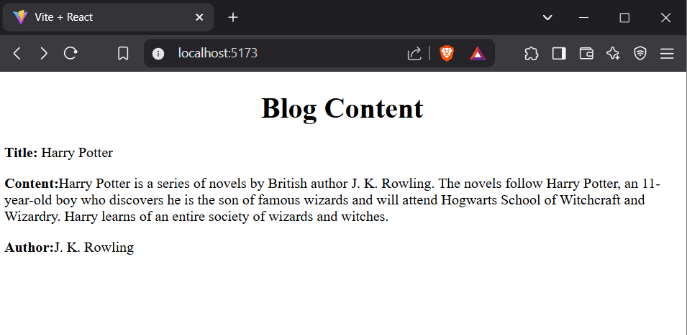

1. **Design a Footer component with hardcoded copyright information using JSX.**

**BlogPost.jsx:**

export default function BlogPost(){

    return(

        <>

        <h1 style={{textAlign:'center'}}>Blog Content</h1>

        <p><strong>Title: </strong>Harry Potter</p>

        <p><strong>Content:</strong>Harry Potter is a series of novels by British author J. K. Rowling. The novels follow Harry Potter, an 11-year-old boy who discovers he is the son of famous wizards and will attend Hogwarts School of Witchcraft and Wizardry. Harry learns of an entire society of wizards and witches.</p>

        <p><strong>Author:</strong>J. K. Rowling</p>

<footer style={{textAlign:'center'}}>&copy; All rights reserved</footer>

        </>

    )

}

**App.jsx:**

import BlogPost from './BlogPost.jsx'

function App() {

  return (

    <>

    < BlogPost />

    </>

  )

}

export default App

**Output:**

