Task-4

JavaScript in JSX with Curly Braces

1. **Display today’s date in a component using the JavaScript Date object.**

**TodayDate.jsx:**

export default function TodayDate(){

    const today= new Date().toLocaleDateString();

    return(

        <p><strong>Today Date:</strong>{today}</p>

    )

}

**App.jsx:**

import TodayDate from './TodayDate.jsx'

function App() {

  return (

    <>

    <TodayDate />

    </>

  )

}

export default App

**Output:**

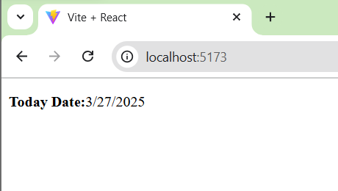

1. **Create a component that displays a random quote from a hardcoded list of quotes.**

**RandomQuote.jsx:**

export default function RandomQuote(){

    const quotes=[

        "Just one small positive thought in the morning can change your whole day.",

        "Opportunities don't happen, you create them.",

        "Love your family, work super hard, live your passion.",

        "It is never too late to be what you might have been.",

        "Character is power."

    ]

    const randomQuote=quotes[Math.floor(Math.random()*quotes.length)];

    return (

        <>

        <p><strong>Random Quote: </strong>{randomQuote}</p>

        </>

    )

}

**App.jsx:**

import RandomQuote from './RandomQuote.jsx'

function App() {

  return (

    <>

    <RandomQuote />

    </>

  )

}

export default App

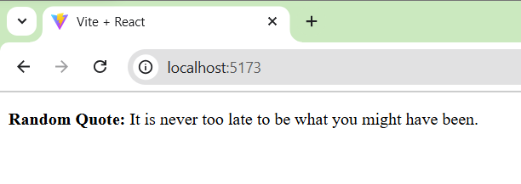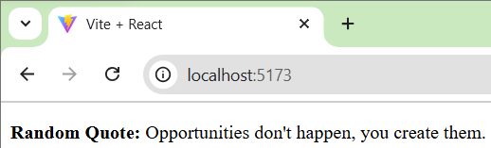**Output:**

1. **Write a component called MathResult that displays the result of a simple arithmetic operation (e.g., addition) of two hardcoded numbers.**

**MathResult.jsx:**

export default function MathResult(){

    const a=10;

    const b=20;

    const c=a+b;

    return(

        <>

        <p><strong>The Sum of {a}+{b} is:</strong>{c}</p>

        </>

    )

}

**App.jsx:**

import MathResult from './MathResult.jsx'

function App() {

  return (

    <>

    <MathResult />

    </>

  )

}

export default App

**Output:**

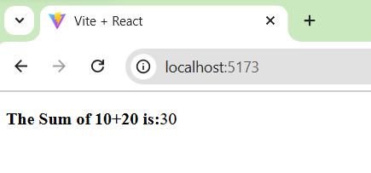

1. **Create a component that displays the word count of a hardcoded paragraph.**

**WordCount.jsx:**

export default function WordCount(){

    const para="Life has an interesting way of teaching even the most powerful people that joy from wealth is fleeting at best"

    const length=para.split(" ").length

    return (

        <>

        <p>{para}</p>

        <p><strong>WordCount of Paragraph: </strong>{length}</p>

        </>

    )

}

**App.jsx:**

import WordCount from './WordCount.jsx'

function App() {

  return (

    <>

    <WordCount />

    </>

  )

}

export default App

**Output:**

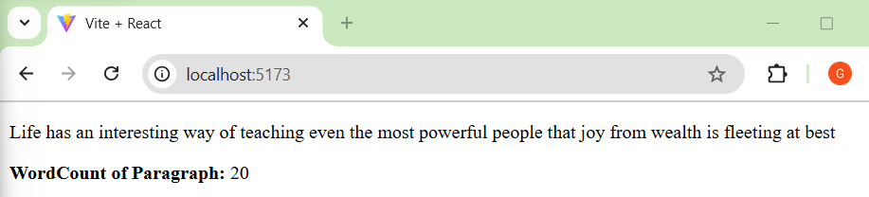

1. **Create a component that calculates and displays the product of two hardcoded numbers.**

**Product.jsx:**

export default function Product(){

    const a=10;

    const b=20;

    return(

        <>

        <p><strong>The product of {a}*{b} is:</strong>{a*b}</p>

        </>

    )

}

**App.jsx:**

import Product from './Product.jsx'

function App() {

  return (

    <>

    <Product />

    </>

  )

}

export default App

**Output:**

