Task-5

Passing Props to a Component

1. **Create a Movie component that displays the title, year, and rating of a movie using props.**

**Movie.jsx:**

export default function Movie(props){

    return(

        <>

        <p><strong>Title: </strong>{props.title}</p>

        <p><strong>Year: </strong>{props.year}</p>

        <p><strong>Rating: </strong>{props.rating}</p>

        </>

    )

}

**App.jsx:**

import Movie from './Movie.jsx'

function App() {

  return (

    <>

    <Movie title="Harry Potter" year={2002} rating={7.7} />

    </>

  )

}

export default App

**Output:**

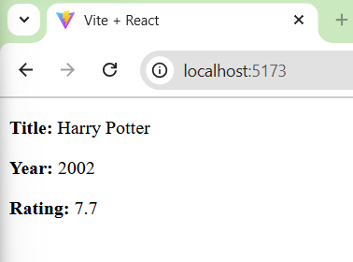

1. **Update the Movie component to have a default prop for rating as “Not Rated”.**

**Movie.jsx:**

function Movie(props){

    return(

        <>

        <p><strong>Title: </strong>{props.title}</p>

        <p><strong>Year: </strong>{props.year}</p>

        <p><strong>Rating: </strong>{props.rating ? props.rating : "Not rated"}</p>

        </>

    )

}

Movie.defaultProps = {

    rating: "Not Rated",

};

export default Movie

**App.jsx:**

import Movie from './Movie.jsx'

function App() {

  return (

    <>

    <Movie title="Harry Potter and the Sorcerer's Stone" year={2001} rating={7.7} />

    <Movie title=" Harry Potter and the Goblet of Fire" year={2002} />

    </>

  )

}

export default App

**Output:**

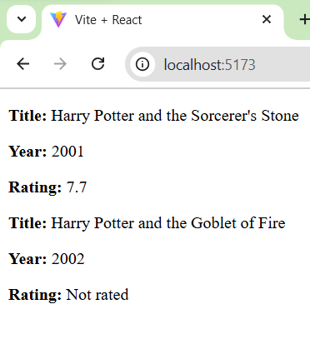

1. **Design a Button component that takes in a label prop and displays the label on the button.**

**Button.jsx:**

function Button(props){

    return(

        <>

        <button>{props.label}</button>

        </>

    )

}

export default Button;

**App.jsx:**

import Button from './Button.jsx'

function App() {

  return (

    <>

    <Button label='Submit' />

    <Button label='Click Here'/>

    </>

  )

}

export default App

**Output:**

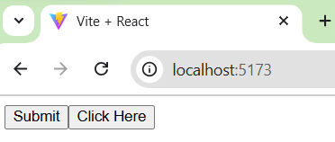

1. **Make a UserProfile component and pass an object containing user details as props and display them.**

**UserProfile.jsx:**

function UserProfile(props){

    return(

        <>

        <h1>User Details</h1>

        <p><strong>Name: </strong>{props.user.name}</p>

        <p><strong>Age: </strong>{props.user.age}</p>

        <p><strong>Gender: </strong>{props.user.gender}</p>

        </>

    )

}

export default UserProfile

**App.jsx:**

import UserProfile from './UserProfile.jsx'

function App() {

  const userDetails={name:"Gokul",age:20,gender:"Male"}

  return (

    <>

    <UserProfile user={userDetails} />

    </>

  )

}

export default App

**Output:**

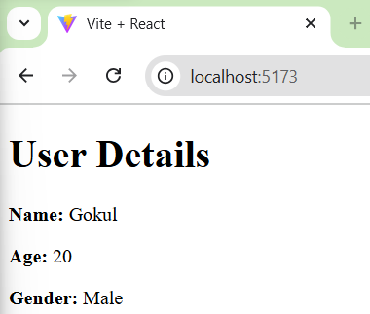

1. **Develop a Modal component that accepts and displays a title and some content passed as props.**

**Modal.jsx:**

function Modal(props){

    return(

        <>

            <h1 style={{textAlign:'center'}}>{props.title}</h1>

            <p>{props.content}</p>

        </>

    )

}

export default Modal

**App.jsx:**

import Modal from './Modal.jsx'

function App() {

  return (

    <>

    <Modal title="React" content="React is an open-source JavaScript library developed by Facebook for building fast and interactive user interfaces (UIs). It is component-based, declarative, and efficiently updates the DOM using a virtual DOM mechanism." />

    </>

  )

}

export default App

**Output:**

