Task-6

Conditional Rendering

1. **Design a UserStatus component that displays “Online” or “Offline” based on a isOnline prop.**

**UserStatus.jsx:**

export default function UserStatus(props){

    return <p><strong>{props.name}: </strong>{props.status? 'Online' : 'Offline'}</p>

}

**App.jsx:**

import UserStatus from './UserStatus.jsx'

function App() {

  return (

    <>

    <UserStatus name="Harry" status= {true} />

    <UserStatus name="Ben" status={false} />

    </>

  )

}

export default App

**Output:**

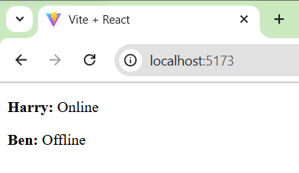

1. **Write a component AgeCheck that displays “Adult” or “Minor” based on an age prop.**

**AgeCheck.jsx:**

export default function AgeCheck(props){

    return <p>{props.name} is {props.age>=18 ? "Adult" : "Minor"}</p>

}

**App.jsx:**

import AgeCheck from './AgeCheck.jsx'

function App() {

  return (

    <>

    <AgeCheck name="Harry" age= {20} />

    <AgeCheck name="Ben" age={14} />

    </>

  )

}

export default App

**Output:**

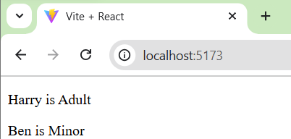

1. **Create a Loading component that either displays “Loading…” or content based on a isLoading prop.**

**Loding.jsx:**

export default function Loading(props){

    return <p>{props.isLoading ? props.isLoading : "Loading..." }</p>

}

**App.jsx:**

import Loading from './Loding.jsx'

function App() {

  return (

    <>

    <Loading isLoading="React is a JavaScript library for building user interfaces. React is used to build single-page applications. React allows us to create reusable UI components." />

    <Loading  />

    </>

  )

}

export default App

**Output:**

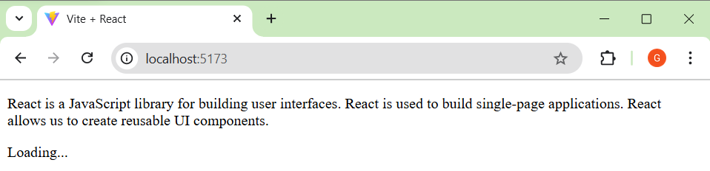

1. **Make a Notification component that conditionally displays a message if a message prop is provided.**

**Notification.jsx:**

export default function Notification(props){

    return <p>{props.info ? props.info : "No Notifications to Show"}</p>

}

**App.jsx:**

import Notification from "./Notification .jsx"

function App() {

  return (

    <>

    <Notification info="1 chat for you" />

    <Notification />

    </>

  )

}

export default App

**Output:**

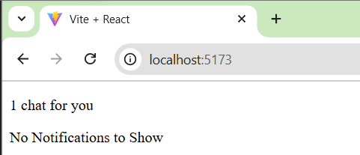

1. **Design a Feedback component that displays feedback in either green (positive) or red (negative) based on a type prop.**

**Feedback.jsx:**

export default function Feedback(props){

    const style={

        color: props.type === "positive" ? "green": "red",

    }

    return <p style={style}>{props.info}</p>

}

**App.jsx:**

import Feedback from "./Feedback.jsx"

function App() {

  return (

    <>

    <Feedback type="positive" info="Great work" />

    <Feedback type="negative" info="Waste of Time" />

    </>

  )

}

export default App

**Output:**

