Task-7

Rendering Lists

1. **Write a component that takes an array of names as a prop and displays them in a list.**

**ArrayToList.jsx:**

export default function ArrayToList(props){

    return(

        <>

        <ul>

            {props.names.map((name)=>(

                <li >{name}</li>

            ))}

        </ul>

        </>

    )

}

**App.jsx:**

import ArrayToList from "./ArrayToList.jsx"

function App() {

  const names=['John','Franklin','Trevor','Micheal'];

  return (

    <>

    <ArrayToList names={names} />

    </>

  )

}

export default App

**Output:**

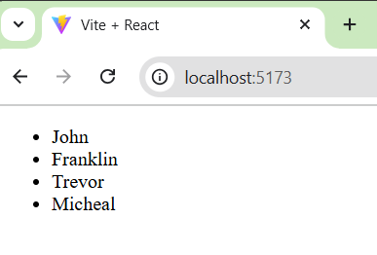

1. **Create a TodoList component that displays a list of tasks and marks the completed ones.**

**ToDoList.jsx:**

import React from 'react';

export default function ToDoList(props) {

    return (

        <ul>

            {props.tasks.map((task,index) => (

                <li key={index} style={{ textDecoration: task.completed ? "line-through" : "none" }}>

                    {task.name}

                </li>

            ))}

        </ul>

    );

}

**App.jsx:**

import ToDoList from "./ToDoList.jsx";

function App() {

  const tasks = [

    { name: "Prepare for Exam", completed: true },

    { name: "Buy Comics", completed: false },

    { name: "Go to Gym", completed: true }

];

return <ToDoList tasks={tasks} />;

}

export default App

**Output:**

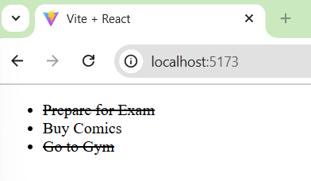

1. **Design a ProductList component that only displays products with a price less than $10 using the filter() method.**

**ProductList.jsx:**

export default function ProductList(props){

    const DisplayProducts=props.products.filter(product => product.price < 10);

    return(

        <>

        <h1>Products less than $10</h1>

        <ul>

            {DisplayProducts.map((DisplayProduct,index) => (

                <li key={index}>{DisplayProduct.name}: {DisplayProduct.price}</li>

            ))}

        </ul>

        </>

    )

}

**App.jsx:**

import ProductList from "./ProductList.jsx";

function App() {

  const products = [

    { name: "Apple", price: 10 },

    { name: "Orange", price: 7 },

    { name: "Mango", price: 5 }

];

return <ProductList products={products} />;

}

export default App

**Output:**

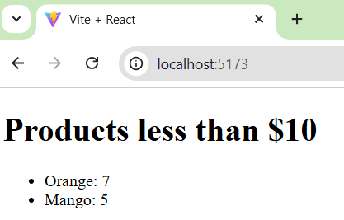

1. **Make a UserList component that takes an array of user objects and displays their names and emails.**

**UserList.jsx:**

function UserList(props){

    return(

        <ol>

            {props.details.map((detail,index)=>(

                <li key={index}>

                    <b>Name: </b>{detail.name} &nbsp; <b>Email: </b>{detail.email}

                    </li>

            ))}

        </ol>

    )

}

export default UserList;

**App.jsx:**

import UserList from "./UserList.jsx";

function App() {

  const details = [

    { name: "Trevor", email: "trevor@mail.com" },

    { name: "Franklin", email: "franklin@mail.com" },

    { name: "Micheal", email: "micheal@mail.com" }

];

return <UserList details={details} />;

}

export default App

**Output:**

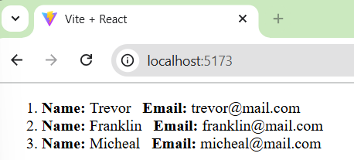

1. **Create a ShoppingCart component that displays a list of items and their prices. Ensure each item has a unique key.**

**ShoppingCart.jsx:**

export default function ShoppingCart(props){

    return(

        <ol>

            {props.items.map(item =>(

                <li key={item.id}>{item.name} - {item.price}</li>

            ))}

        </ol>

    )

}

**App.jsx:**

import ShoppingCart from "./ShoppingCart .jsx";

function App() {

  const items = [

    { name: "Samsung Galaxy s23", price: "$1390" },

    { name: "Iphone 16", price: "$1000"  },

    { name: "Iphone 16 pro", price: "$1400"  }

];

return <ShoppingCart items={items} />;

}

export default App

**Output:**

