1.What is Pin MUXing and what is the significance of this in SoC,specifically OMAP?
Each pin must be configured as either an input or an output. This is done by a direction control register. Writing a 1 in this register may set the pin to input while writing a 0 may set it to output. The value you need to write depends on your chip.
These are usually distinct registers, and reading from the input register or writing to the output register when the pin is in the wrong mode may have undesirable results. Again, this will be listed on the chip datasheet.
Hardware pins may have other functions than GPIO. They can often be set to a special function such as a serial port. This is controlled through
a multiplexing register.
There may be several functions per pin, including GPIO, so the muxing register may have more than one bit per hardware pin. Sometimes a single multiplexing register may change the function of several pins. You must select the correct function for what you want the chip to do, according to the datasheet. So on designing that integrating several components on a chip we have to concern about usage of pin numbers that lead to size and complexity matters.

2.What are the GPIOs used on the OMAP3 EVM? What functionality are
they used for? Present the GPIO mapping table and explain.
GPIO stands for General Purpose Input Output .
These can act as input, to read digital signals from other parts of a circuit, or output, to control or signal to other devices. GPIOs are often arranged into groups, typically of 8 pins - a GPIO port - that usually have individual GPIOs configurable either as input or outputs. In some cases, GPIOs may be configurable to produce CPU interrupts and be able to use Direct Memory Access to move large quantities of data efficiently into or out of the device.

Feautures of GPIO:
Supply current limited to 8 mA
Supports USB 2.0 peripheral at speeds HS (480 Mb/s) and FS (12 Mb/s)
Supports all modes of transfers (control, bulk, interrupt, and isochronous)
Supports 4 Transmit (TX) and 4 Receive (RX) endpoints in addition to endpoint 0
4k endpoint FIFO RAM memory
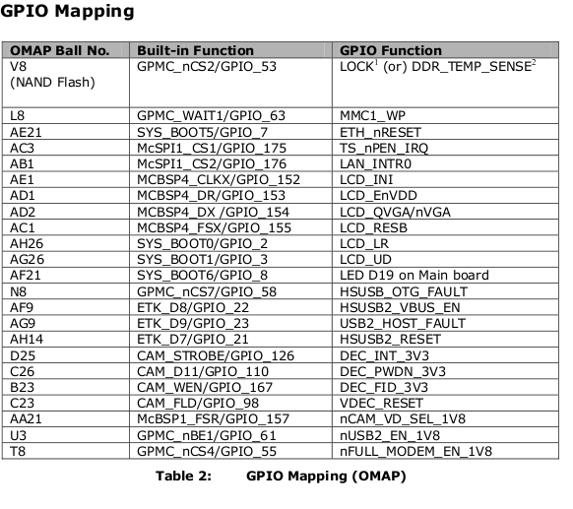

3.What do you understand by I2C address mapping on OMAP EVM?
I2C Address Mapping
The communication between the Processor and the TPS65950 device is
established through the I2C1 interface. The TPS65950 has four I2C address
groups. Each I2C address group allows access to a 256-byte register address
map.
I2C2 of OMAP3530 is being shared across camera modules. Also it is routed to expansion connector
I2C3 of OMAP35x is connected to Video decoder as a control interface. Also it is routed to expansion connector
The register addressing for I2C interface is given below:
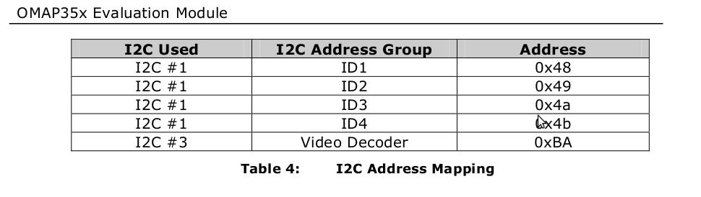
4.What is PoP? Can you explain with example?

Package on Package (PoP) is an integrated circuit packaging technique to allow vertically combining discrete logic and memory ball grid array (BGA) packages. Two or more packages are installed on top of one another, i.e. stacked, with a standard interface to route signals between them. This allows higher density, for example in the mobile telephone / PDA market.

The most obvious benefit is motherboard space savings. PoP shares this trait with stacked-die packages. However there are several key differences between stacked-die and stacked-package products.
The main financial benefit of package on package is that the memory device is decoupled from the logic device. Thus:
- The memory package can be tested separately from the logic package
- Only "known good" packages are used in final assembly (if the memory is bad only the memory is thrown away and so on). Compare this to stacked-die packages where the entire set is thrown away if either the memory or logic is bad.
- The end user (example cell phone maker or digital camera maker) controls the logistics.
- For a low-end phone, a smaller memory configuration may be used on the top package. For a high-end phone, more memory could be used with the same bottom package. T
PoP offers benefits by minimizing track length between, for example, a controller and a memory. This results in better electrical performance of the devices, since the shorter routing of interconnections between circuits results in faster signal propagation and reduction in noise and cross-talk.

5.Which device is used as Touch Screen controller on OMAP EVM and
how is it interfaced to EVM?

The EVM supports Touch-screen using 4 wire resistive touch screen controller TSC2046. The primary interface between the touch-screen controller and the processor is McSPI1 interface. The TSC2046 also has the ability to interrupt the processor via the TS_nPEN_IRQ signal.
The TSC2046 is powered from the LCD_3v3 voltage rail, the same as the one that powers the LCD panel.

6.Find out the GPIO used to control the LCD Backlight on EVM AND Write “C” program to toggle this GPIO on the OMAP processor.
The EVM has a dual mode LCD module LS037V7DW01 from Sharp and is interfaced to the Display subsystem (DSS) of OMAP3530. The LCD panel supports 18-bit RGB format.
The QVGA/VGA selection (LCD_QVGA/nVGA) and LCD power (LCD_EnVDD) can be controlled through software using the GPIO signals

GPIO_153 for LCD power.
GPIO_154 for LCD EnVDD.

7.Who is the maintainer of OMAP Linux tree on the Open Source Linux?

GIT -> Graphic Interface Terminal

