**Gokulnathan B**

**22BCS029**

**EXPERIMENT 6 :** Demonstrate the working of network tools such as Ping,TCP Dump, Traceroute, Netstat, Ipconfig.

**Ping:**

The ping command is a general utility which is used for checking whether any network ispresent and if a host is attainable. We can test if the server is up and executing using this command. Also, it helps several connectivity issues with troubleshooting.

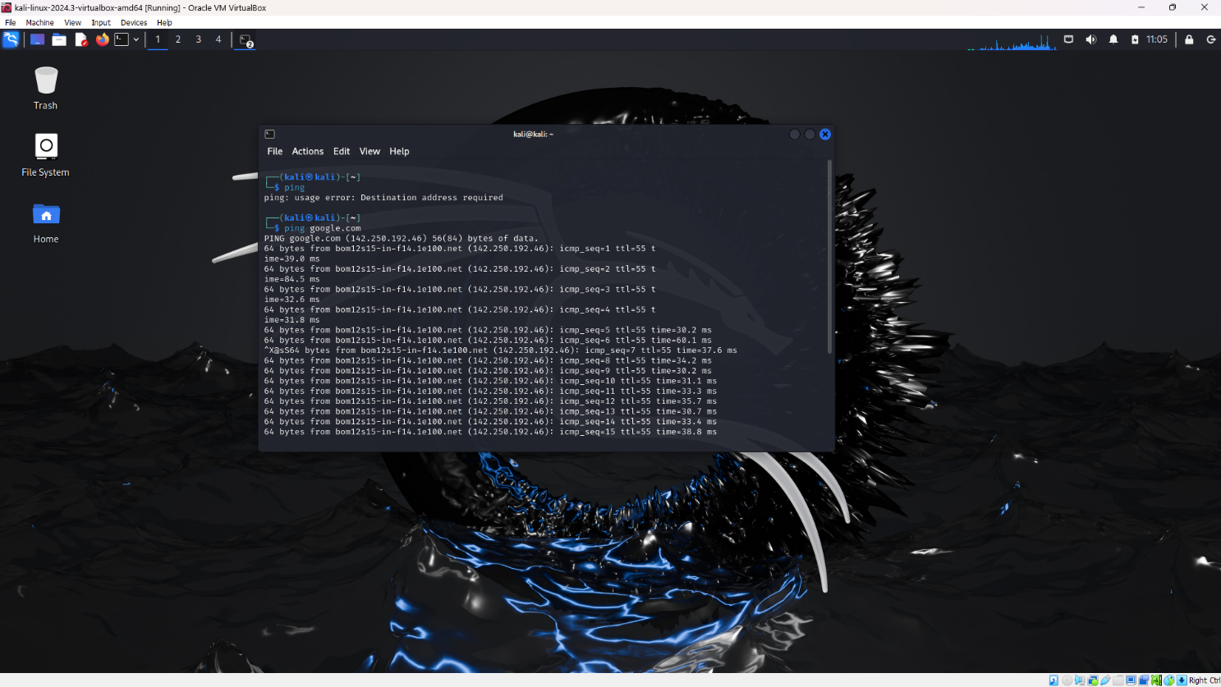

**Tcpdump:**

Tcpdump is a packet analyzer that is launched from the command line. It can be used to analyze network traffic by intercepting and displaying packets that are being created or received by the computer it's running on. It runs on Linux and most UNIX-type operatingsystems.

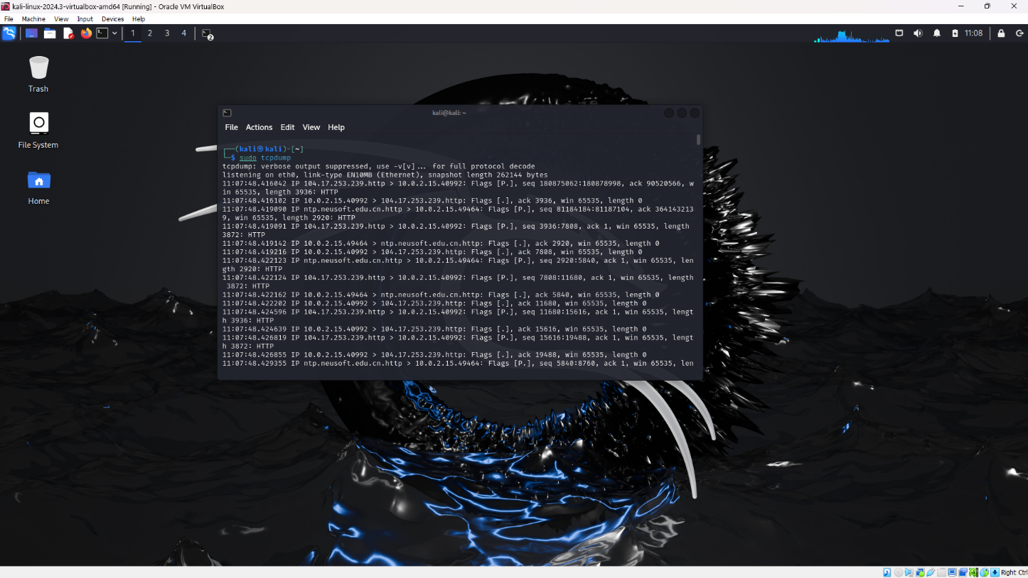

**Traceroute:**

The traceroute command attempts to trace the route an IP packet follows to an Internet host by launching UDP probe packets with a small maximum time-to-live(Max_ttl variable), then listening for an ICMP TIME_EXCEEDED response from gateways along the way.



**Netstat:**

The network statistics (netstat ) command is a networking tool used for troubleshooting and configuration, that can also serve as a monitoring tool for connections over the network. Both incoming and outgoing connections, routingtables, port listening, and usage statistics are common uses for this command.

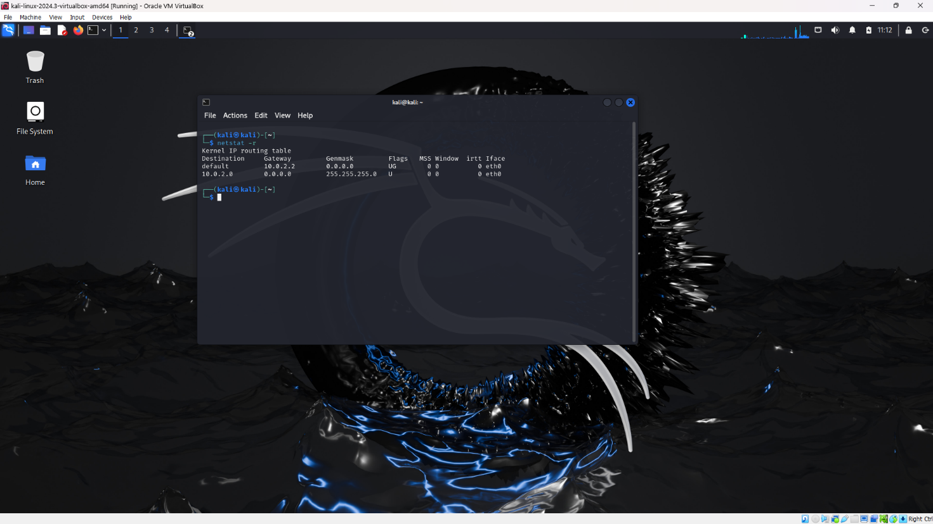

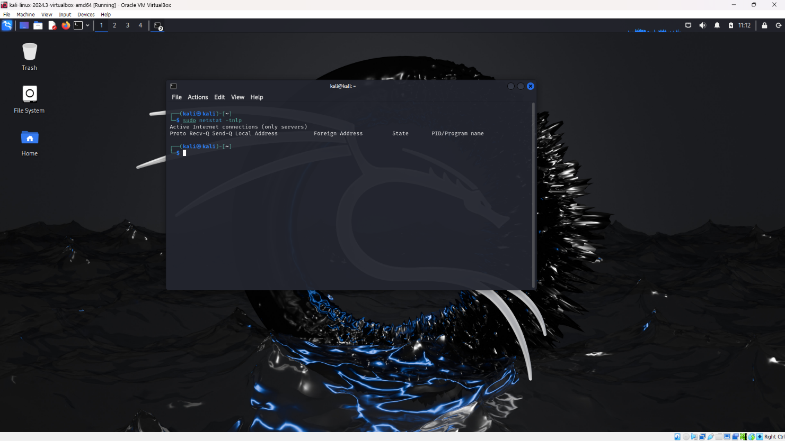

**Ipconfig:**

Ipconfig displays useful information such as IP address, subnet mask and thedefault gateway for all of the different network connections in the computer.

