REACT HOL

1.Objectives

- Define SPA and its benefits
- Define React and identify its working
- Identify the differences between SPA and MPA
- Explain Pros & Cons of Single-Page Application
- Explain about React
- Define virtual DOM
- Explain Features of React

In this hands-on lab, you will learn how to:
- Set up a react environment
- Use create-react-app

Prerequisites

The following is required to complete this hands-on lab:
- Node.js
- NPM
- Visual Studio Code

Notes

Estimated time to complete this lab: 30 minutes.

Create a new React Application with the name “myfirstreact”, Run the application to print “welcome to the first session of React” as heading of that page.
- To create a new React app, Install Nodejs and Npm from the following link:
https://nodejs.org/en/download/
- Install Create-react-app by running the following command in the command prompt:

- To create a React Application with the name of “myfirstreact”, type the following command:

- Once the App is created, navigate into the folder of myfirstreact by typing the following command:
- Open the folder of myfirstreact in Visual Studio Code
- Open the App.js file in Src Folder of myfirstreact
- Remove the current content of “App.js”
- Replace it with the following:

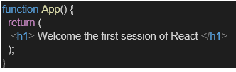

- Run the following command to execute the React application:

- Open a new browser window and type “localhost:3000” in the address bar

Concept: Key Definitions (Objectives)
SPA vs MPA
Feature | SPA (Single Page Application) | MPA (Multi Page Application)
Page loads | Once — only content updates | Full reload for every page
Speed | Fast after initial load | Slower — server renders each page
Example | Gmail, Facebook, React apps | Traditional websites, e-commerce
Server requests | Only data (JSON via API) | Full HTML page each time
What is React?
- A JavaScript library (not a framework) built by Facebook/Meta
- Used for building User Interfaces (UI components)
- Works by breaking the UI into reusable components
- Uses Virtual DOM for efficient updates
What is Virtual DOM?
REAL DOM (slow): VIRTUAL DOM (fast):
User clicks button User clicks button
↓ ↓
Browser re-renders React updates Virtual DOM (in memory)
ENTIRE page ↓
↓ React compares old vs new Virtual DOM
Very slow for ↓ (this is called "diffing")
complex UIs Updates ONLY the changed parts in Real DOM
↓
Much faster!
React Features
- Component-Based — UI split into reusable pieces
- Virtual DOM — efficient rendering
- JSX — write HTML inside JavaScript
- Unidirectional Data Flow — data flows parent → child
- Rich Ecosystem — huge community, many libraries
Pros & Cons of SPA
Pros | Cons
Fast user experience | Slow initial load
Less server load | SEO challenges
Reusable components | Requires JavaScript enabled
Rich interactivity | More complex development
OUTPUT:
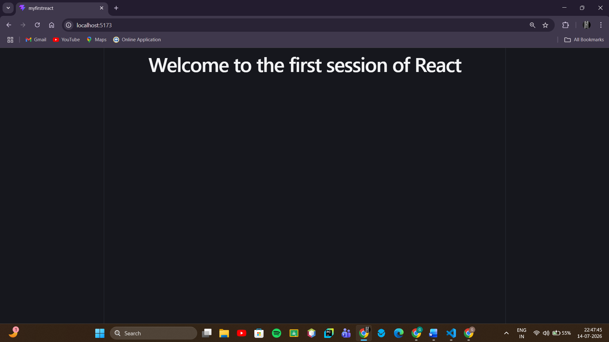

2. Objectives

- Explain React components
- Identify the differences between components and JavaScript functions
- Identify the types of components
- Explain class component
- Explain function component
- Define component constructor
- Define render() function

In this hands-on lab, you will learn how to:
- Create a class component
- Create multiple components
- Render a component

Prerequisites

The following is required to complete this hands-on lab:
- Node.js
- NPM
- Visual Studio Code

Notes

Estimated time to complete this lab: 30 minutes.

Create a react app for Student Management Portal named StudentApp and create a component named Home which will display the Message “Welcome to the Home page of Student Management Portal”. Create another component named About and display the Message “Welcome to the About page of the Student Management Portal”. Create a third component named Contact and display the Message “Welcome to the Contact page of the Student Management Portal”. Call all the three components.

- Create a React project named “StudentApp” type the following command in terminal of Visual studio:

- Create a new folder under Src folder with the name “Components”. Add a new file named “Home.js”

- Type the following code in Home.js

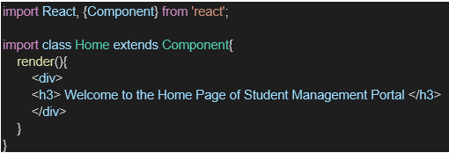

- Under Src folder add another file named “About.js”

- Repeat the same steps for Creating “About” and “Contact” component by adding a new file as ”About.js”, “Contact.js” under “Src” folder and edit the code as mentioned for “Home” Component.

- Edit the App.js to invoke the Home, About and Contact component as follows:

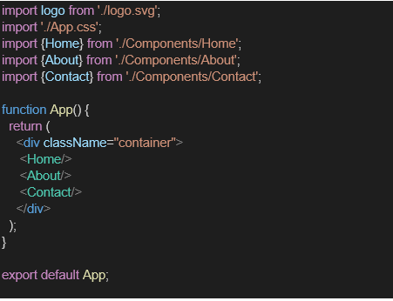

- In command Prompt, navigate into StudentApp and execute the code by typing the following command:

- Open browser and type “localhost:3000” in the address bar:

1. Explain React components
A component is a reusable, self-contained piece of a user interface — think of it as a custom building block that returns some HTML-like markup (JSX) to be displayed on screen. Instead of writing one giant HTML file, you break the UI into small independent pieces (e.g., Header, Home, About, Footer), and combine them together like Lego blocks. Each component manages its own logic and output, and can be reused anywhere in the app.
Example: your Home component is a self-contained unit that knows how to display "Welcome to the Home page..." — nothing else in the app needs to know how it does that.
2. Identify the differences between components and JavaScript functions
Aspect | Plain JavaScript Function | React Component
Purpose | Performs logic, returns any value (number, string, object, etc.) | Returns UI (JSX) to be rendered on screen
Naming | Can be lowercase (calculateTotal) | Must start with an uppercase letter (Home, About) — React treats lowercase tags as HTML elements, not components
Return value | Can return anything | Must return JSX (or null)
Lifecycle | No concept of mounting/updating/unmounting | Has a lifecycle — gets created, updated, and removed from the screen
State | Cannot hold UI state | Can hold and manage state (data that changes over time and triggers re-render)
Usage | Called like sum(2,3) | Used like an HTML tag: <Home />
In short: every component is technically a function (or class) — but not every function is a component. A function only becomes a "component" when it returns JSX and follows React's naming/rendering rules.
3. Identify the types of components
React has two types of components:
- Class Components — ES6 classes that extends React.Component, and must define a render() method that returns JSX. They can hold state using this.state and lifecycle methods like componentDidMount().
- Function Components — plain JavaScript functions that return JSX directly. Since React 16.8 (Hooks), function components can also manage state (using useState) and lifecycle behavior (using useEffect), making them just as powerful as class components — and now the more commonly used style in modern React.
4. Explain class component
A class component is a JavaScript ES6 class that:
- Extends React.Component (or just Component, if imported)
- Must implement a render() method that returns JSX
- Can have a constructor() to initialize state or bind methods
- Can access special properties like this.props and this.state
Example structure:
class Home extends Component {
constructor(props) {
super(props);
}

render() {
return <h2>Welcome to the Home page</h2>;
}
}
Class components were the primary way to write stateful components before React Hooks were introduced.
5. Explain function component
A function component is simply a JavaScript function that accepts props as an argument (optional) and returns JSX. It's simpler and shorter than a class component.
Example — the function-component equivalent of the Home class above:
function Home() {
return <h2>Welcome to the Home page</h2>;
}
or using an arrow function:
const Home = () => {
return <h2>Welcome to the Home page</h2>;
};
No constructor, no this, no render() method needed — the function is the render logic.
6. Define component constructor
The constructor is a special method inside a class component that runs once, when the component is first created (before it's rendered). Its main jobs are:
- Initializing this.state (the component's internal data)
- Binding event-handler methods to this, if needed
It must always call super(props) first — this passes props up to the parent React.Component class so React can set things up correctly internally.
constructor(props) {
super(props); // required — must be called first
this.state = { count: 0 }; // example: initializing state
}
In your lab's Home, About, Contact components, the constructor doesn't do much (no state is being initialized) — it's included mainly to demonstrate the pattern, since super(props) is still required whenever a constructor is present in a class component.
7. Define render() function
The render() method is required in every class component. Its job is to describe what should appear on the screen by returning JSX. React calls render() automatically:
- The first time the component is displayed (mounted)
- Every time the component's state or props change
render() {
return (
<div>
<h2>Welcome to the Home page of Student Management Portal</h2>
</div>
);
}
OUTPUT:
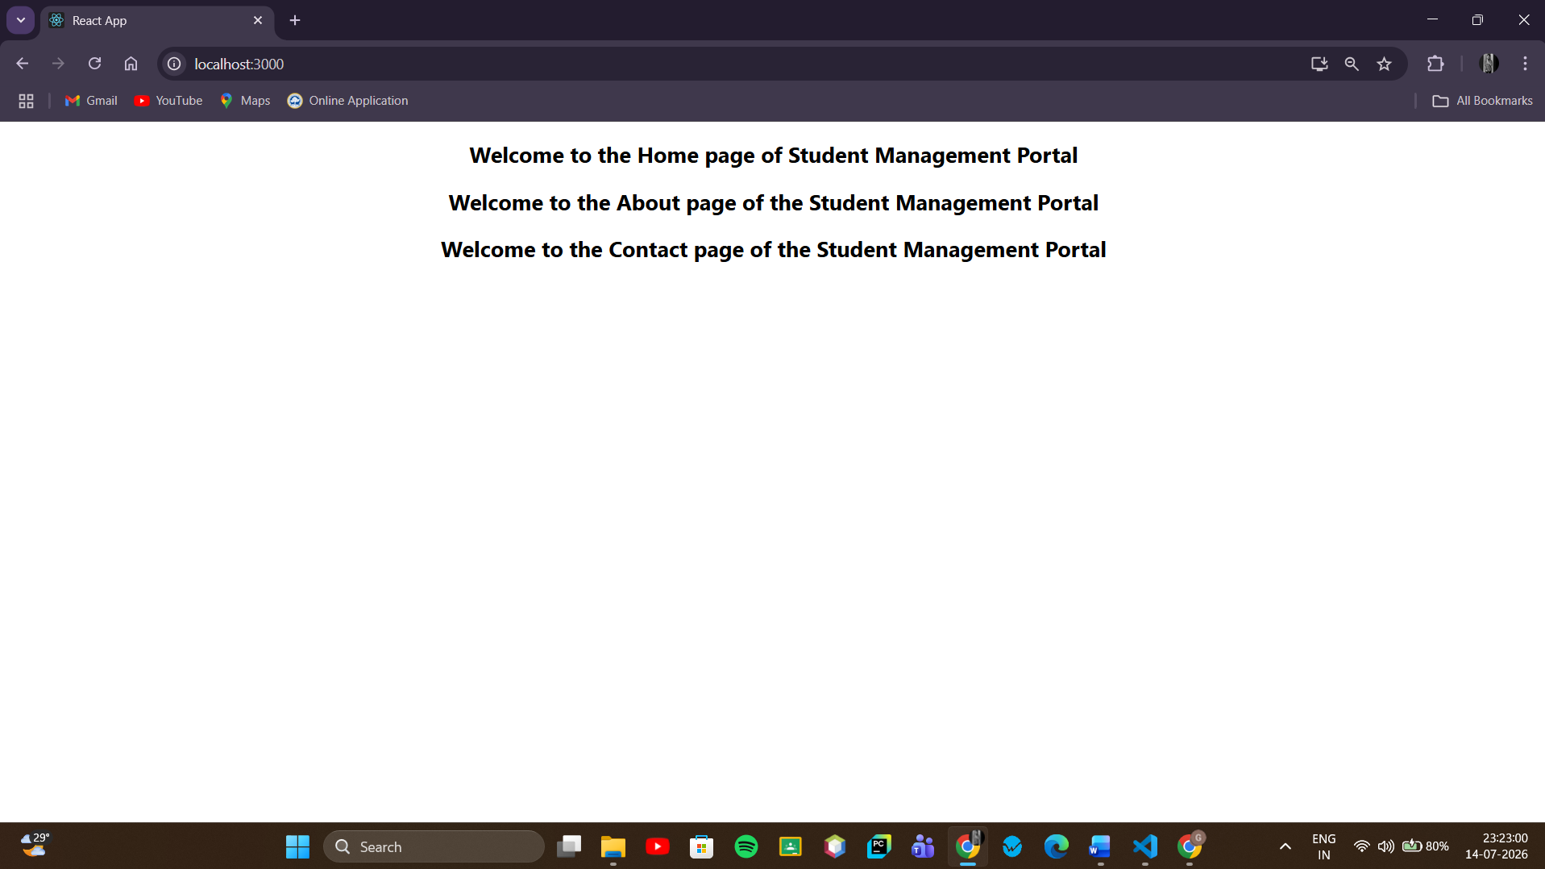

3.Objectives

- Explain React components
- Identify the differences between components and JavaScript functions
- Identify the types of components
- Explain class component
- Explain function component
- Define component constructor
- Define render() function

In this hands-on lab, you will learn how to:
- Create a function component
- Apply style to components
- Render a component

Prerequisites

The following is required to complete this hands-on lab:
- Node.js
- NPM
- Visual Studio Code

Notes

Estimated time to complete this lab: 30 minutes.
Create a react app for Student Management Portal named scorecalculatorapp and create a function component named “CalculateScore” which will accept Name, School, Total and goal in order to calculate the average score of a student and display the same.

- Create a React project named “scorecalculatorapp” type the following command in terminal of Visual studio:

- Create a new folder under Src folder with the name “Components”. Add a new file named “CalculateScore.js”

- Type the following code in CalculateScore.js

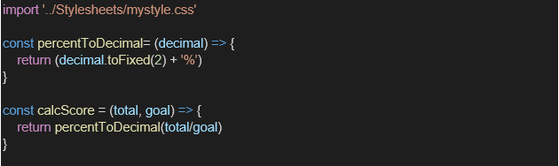
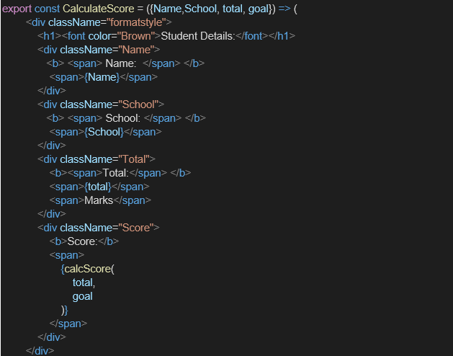

- Create a Folder named Stylesheets and add a file named “mystyle.css” in order to add some styles to the components:

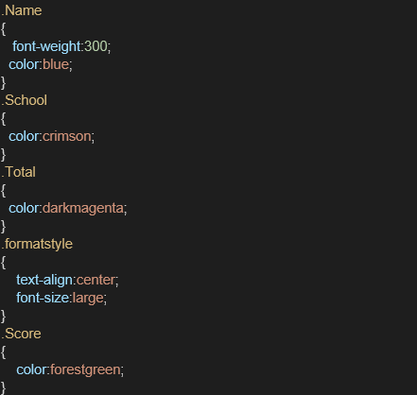

- Edit the App.js to invoke the CalculateScore functional component as follows:

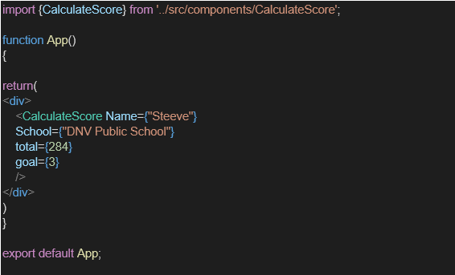

- In command Prompt, navigate into scorecalculatorapp and execute the code by typing the following command:

- Open browser and type “localhost:3000” in the address bar:
React Components — Student Score Calculator

Concept: React Components (Objectives)
What is a React Component?
A reusable, independent piece of UI — like a custom HTML tag you define yourself.
Component vs JavaScript Function
AspectJavaScript FunctionReact ComponentPurposeLogic/computationReturns UI (JSX)Namingany caseMust start with Capital letterReturnsany valueMust return JSXUsagemyFunction()<MyComponent />Reusable as UI❌ No✅ Yes
Types of Components
React Components
├── Class Components (OLD way)
│ ├── Extends React.Component
│ ├── Has render() method
│ ├── Has constructor()
│ └── Has lifecycle methods
│
└── Function Components (MODERN way ✅)
├── Just a JavaScript function
├── Returns JSX directly
├── Uses Hooks (useState, useEffect)
└── Simpler and preferred
Class Component Structure:
jsxclass CalculateScore extends React.Component {
constructor(props) { // initializes component
super(props); // calls parent constructor
}
render() { // MUST have render() — returns JSX
return <div>Hello</div>
}
}
Function Component Structure:
jsxfunction CalculateScore(props) { // accepts props as parameter
return <div>Hello</div> // directly returns JSX — no render()
}
OUTPUT:
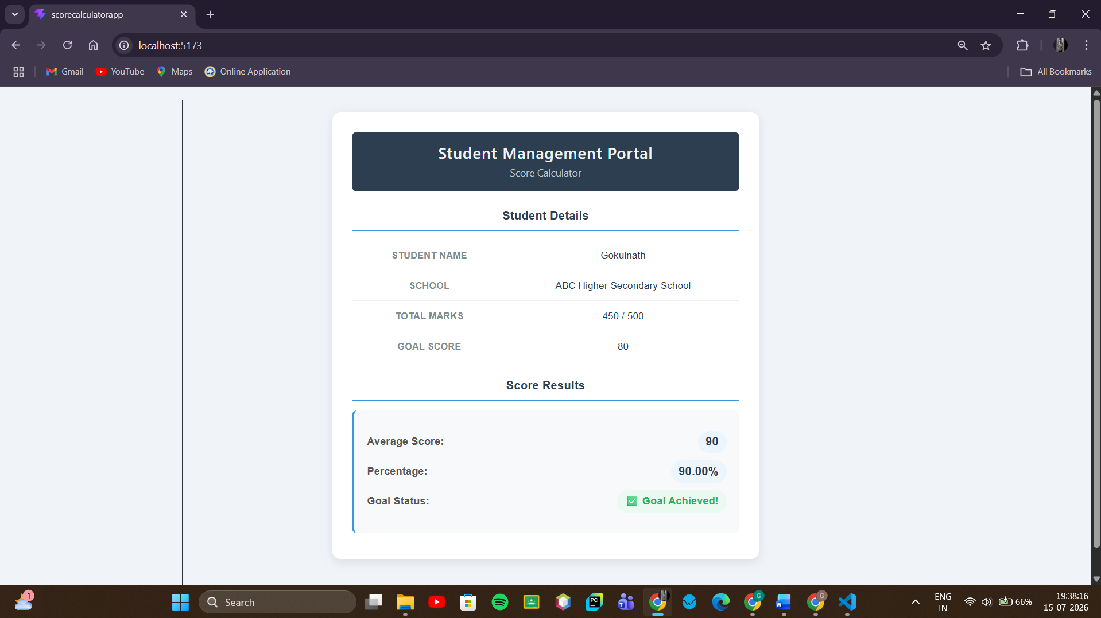

4.Objectives
- Explain the need and Benefits of component life cycle
- Identify various life cycle hook methods
- List the sequence of steps in rendering a component

In this hands-on lab, you will learn how to:
- Implement componentDidMount() hook
- Implementing componentDidCatch() life cycle hook.

Prerequisites

The following is required to complete this hands-on lab:
- Node.js
- NPM
- Visual Studio Code

Notes

Estimated time to complete this lab: 60 minutes.

- Create a new react application using create-react-app tool with the name as “blogapp”
- Open the application using VS Code
- Create a new file named as Post.js in src folder with following properties

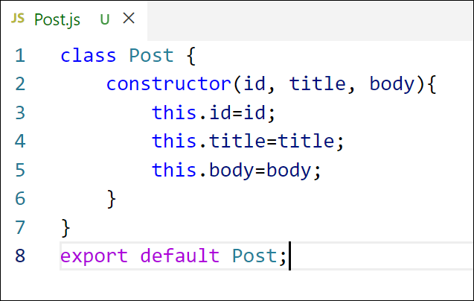
Figure 2: Post class
- Create a new class based component named as Posts inside Posts.js file
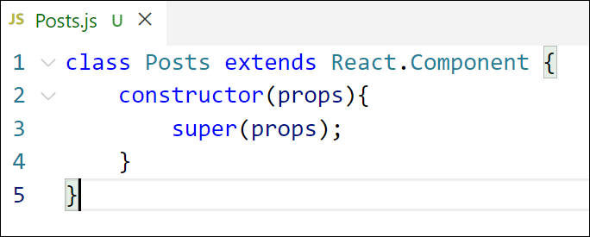
Figure 3: Posts Component
- Initialize the component with a list of Post in state of the component using the constructor
- Create a new method in component with the name as loadPosts() which will be responsible for using Fetch API and assign it to the component state created earlier. To get the posts use the url (https://jsonplaceholder.typicode.com/posts)

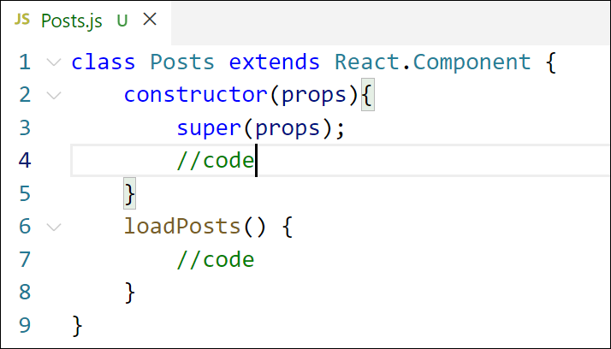
Figure 4: loadPosts() method
- Implement the componentDidMount() hook to make calls to loadPosts() which will fetch the posts

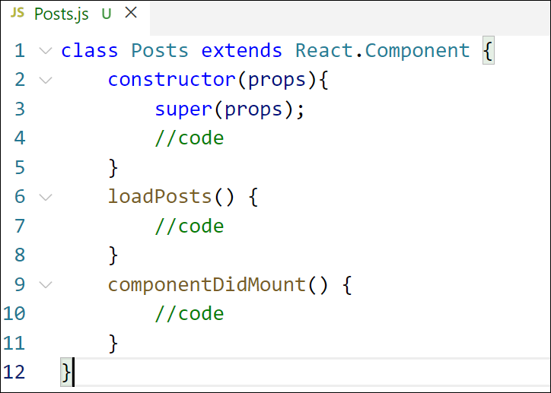
Figure 5: componentDidMount() hook
- Implement the render() which will display the title and post of posts in html page using heading and paragraphs respectively.

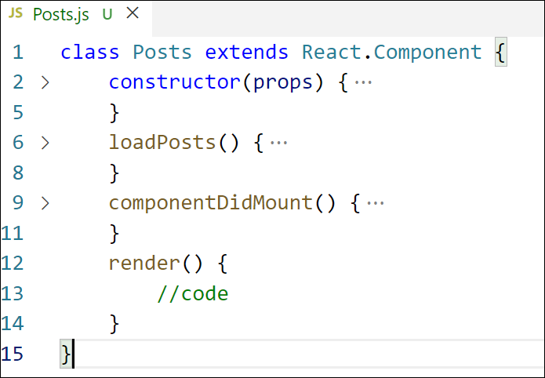
Figure 6: render() method
- Define a componentDidCatch() method which will be responsible for displaying any error happing in the component as alert messages.

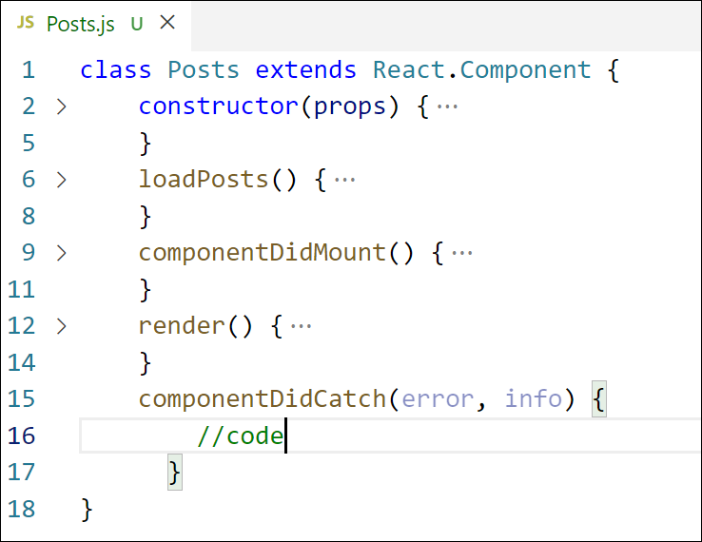
Figure 7: componentDidCatch() hook
- Add the Posts component to App component.
- Build and Run the application using npm start command.

1. Explain the need and benefits of component life cycle
Every React class component goes through a series of stages from the moment it's created on screen to the moment it's removed — this is called the component lifecycle. Understanding it matters because a component often needs to do things at specific moments, not just once when written:
- Fetch data from a server right after the component appears on screen
- Set up subscriptions or timers when mounted, and clean them up when removed (to avoid memory leaks)
- React to changes in props or state (e.g., re-fetch data when a prop changes)
- Catch and handle errors gracefully instead of letting the whole app crash
Benefits:
- Gives you precise control over when code runs (before render, after render, before removal, etc.)
- Prevents memory leaks and wasted API calls
- Enables error handling at the component level, so one broken component doesn't crash the entire app
- Improves performance by letting you control unnecessary re-renders

2. Identify various life cycle hook methods
React class components go through three phases, each with its own hook methods:
Phase | Key Methods | When it runs
Mounting (component is being created and inserted into the DOM) | constructor(), render(), componentDidMount() | Once, when the component first appears
Updating (component re-renders due to state/props change) | render(), componentDidUpdate() | Every time state or props change
Unmounting (component is being removed from the DOM) | componentWillUnmount() | Once, right before the component disappears
Error Handling | componentDidCatch() | When an error is thrown anywhere in the component's child tree
For this lab, you'll specifically use:
- componentDidMount() — runs immediately after the component is first rendered to the DOM; the ideal place to fetch data from an API since the component already exists on screen.
- componentDidCatch() — a special lifecycle method that catches JavaScript errors happening anywhere inside that component's children, letting you log them or show a fallback UI instead of a blank crashed screen.

3. List the sequence of steps in rendering a component
For a class component being mounted for the first time, the sequence is:
- constructor(props) — component is initialized; this.state is set up
- render() — returns the JSX describing what should appear (but nothing is on screen yet — this is a "virtual" description)
- React takes that JSX and updates the actual DOM to match it (component becomes visible on screen)
- componentDidMount() — runs immediately after the component is in the DOM; this is where side effects like API calls happen
- If componentDidMount() triggers a state change (like our loadPosts() setting new data), it causes:
- render() to run again — with the new state, describing the updated JSX
- React updates the DOM again to reflect the new data (posts now appear on screen)

OUTPUT:


5.Objectives
- Understanding the need for styling react component
- Working with CSS Module and inline styles

In this hands-on lab, you will learn how to:
- Style a react component
- Define styles using the CSS Module
- Apply styles to components using className and style properties

Prerequisites

The following is required to complete this hands-on lab:
- Node.js
- NPM
- Visual Studio Code

Notes

Estimated time to complete this lab: 30 minutes.

My Academy team at Cognizant want to create a dashboard containing the details of ongoing and completed cohorts. A react application is created which displays the detail of the cohorts using react component. You are assigned the task of styling these react components.
Download and build the attached react application.
- Unzip the react application in a folder
- Open command prompt and switch to the react application folder
- Restore the node packages using the following commands
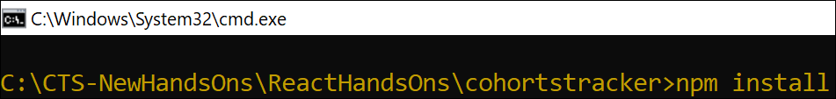
Figure 1: Restore packages
- Open the application using VS Code
- Create a new CSS Module in a file called “CohortDetails.module.css”
- Define a css class with the name as “box” with following properties
Width = 300px;
Display = inline block;
Overall 10px margin
Top and bottom padding as 10px
Left and right padding as 20px
1 px border in black color
A border radius of 10px
- Define a css style for html <dt> element using tag selector. Set the font weight to 500.
- Open the cohort details component and import the CSS Module
- Apply the box class to the container div
- Define the style for <h3> element to use “green” color font when cohort status is “ongoing” and “blue” color in all other scenarios.
- Final result should look similar to the below image

OUTPUT:
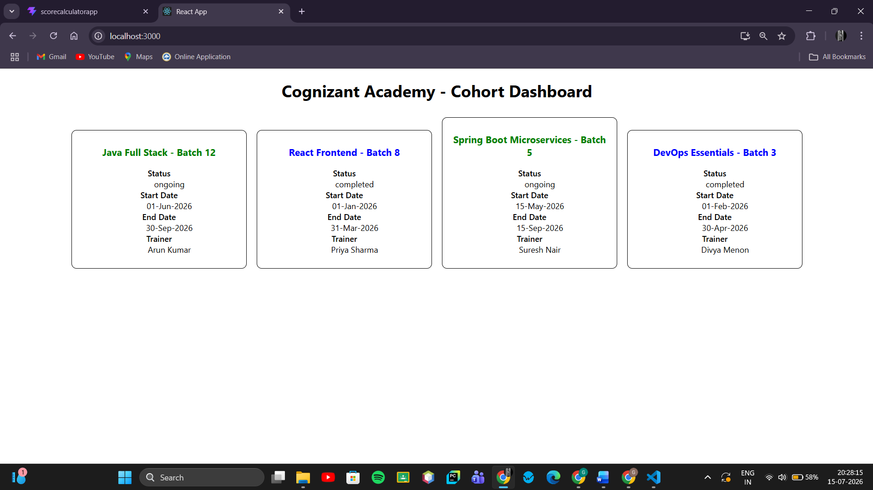

9.Objectives

- List the features of ES6
- Explain JavaScript let
- Identify the differences between var and let
- Explain JavaScript const
- Explain ES6 class fundamentals
- Explain ES6 class inheritance
- Define ES6 arrow functions
- Identify set(), map()

In this hands-on lab, you will learn how to:
- Use map() method of ES6
- Apply arrow functions of ES6
- Implement Destructuring features of ES6

Prerequisites

The following is required to complete this hands-on lab:
- Node.js
- NPM
- Visual Studio Code

Notes

Estimated time to complete this lab: 60 minutes.
Create a React Application named “cricketapp” with the following components:
- ListofPlayers
- Declare an array with 11 players and store details of their names and scores using the map feature of ES6

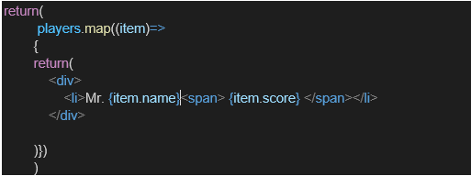

- Filter the players with scores below 70 using arrow functions of ES6.

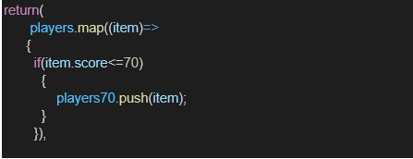

- IndianPlayers

  - Display the Odd Team Player and Even Team players using the Destructuring features of ES6
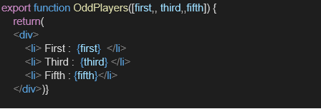

  - Declare two arrays T20players and RanjiTrophy players and merge the two arrays and display them using the Merge feature of ES6
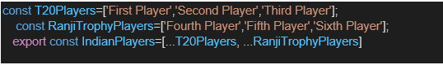

Display these two components in the same home page using a simple if else in the flag variable.
ES6 Features: ES6 (ECMAScript 2015) introduced let/const, arrow functions, classes, destructuring, template literals, and array methods like map(), filter().
let vs var:
- var is function-scoped, can be redeclared, gets hoisted with undefined
- let is block-scoped (only exists inside { }), cannot be redeclared in the same scope, safer and more predictable
const: Declares a variable that cannot be reassigned after initialization. The variable binding is fixed, though objects/arrays declared with const can still have their contents modified.
ES6 Class fundamentals: A cleaner syntax (class MyClass { }) over plain-object prototypes for creating blueprints of objects, with constructor() for initialization and methods defined directly inside the class body.
ES6 Class inheritance: One class can extend another using extends, inheriting its properties/methods, and can call the parent's constructor using super().
Arrow functions: A shorter syntax for writing functions — (params) => expression — that also doesn't bind its own this (it uses the this of its surrounding scope).
map(): An array method that transforms every element in an array and returns a new array of the same length, based on a function you provide.
set(): A JavaScript object that stores unique values only (no duplicates), useful for lists where each item should appear once. (Not to be confused with map() on arrays — Set is a distinct data structure.)

Output:
When Flag=true
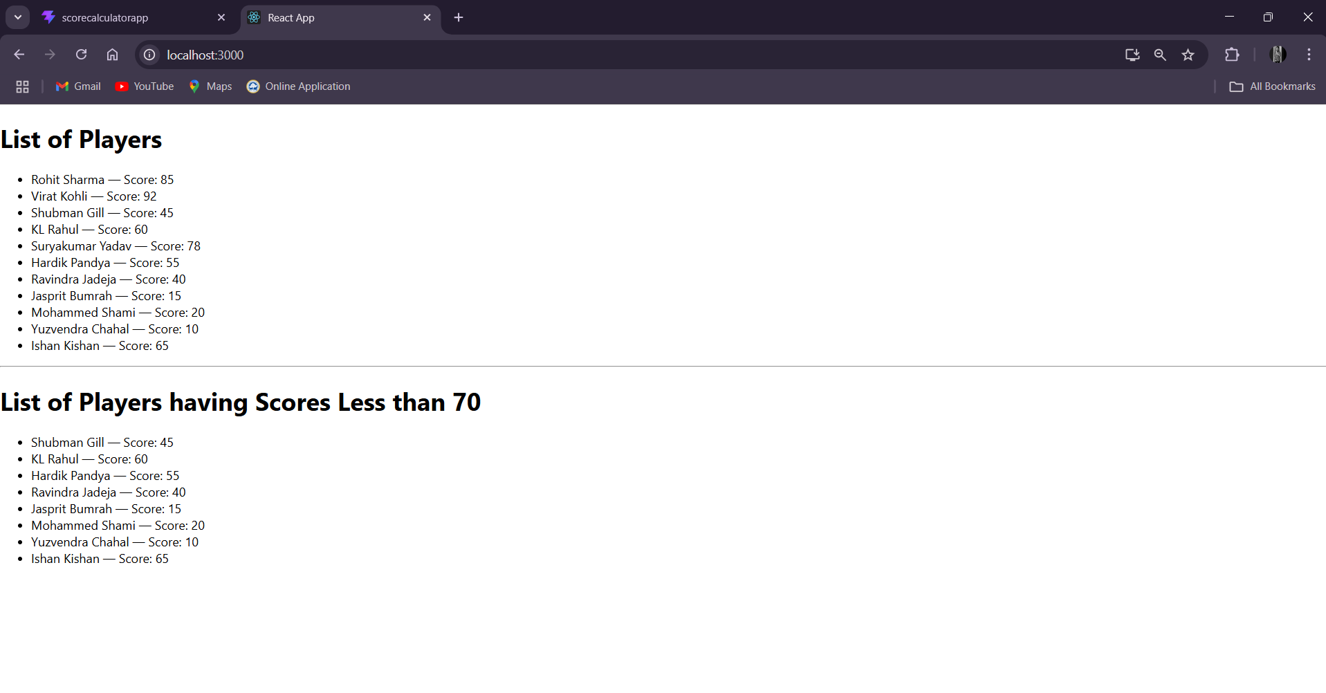When Flag=false
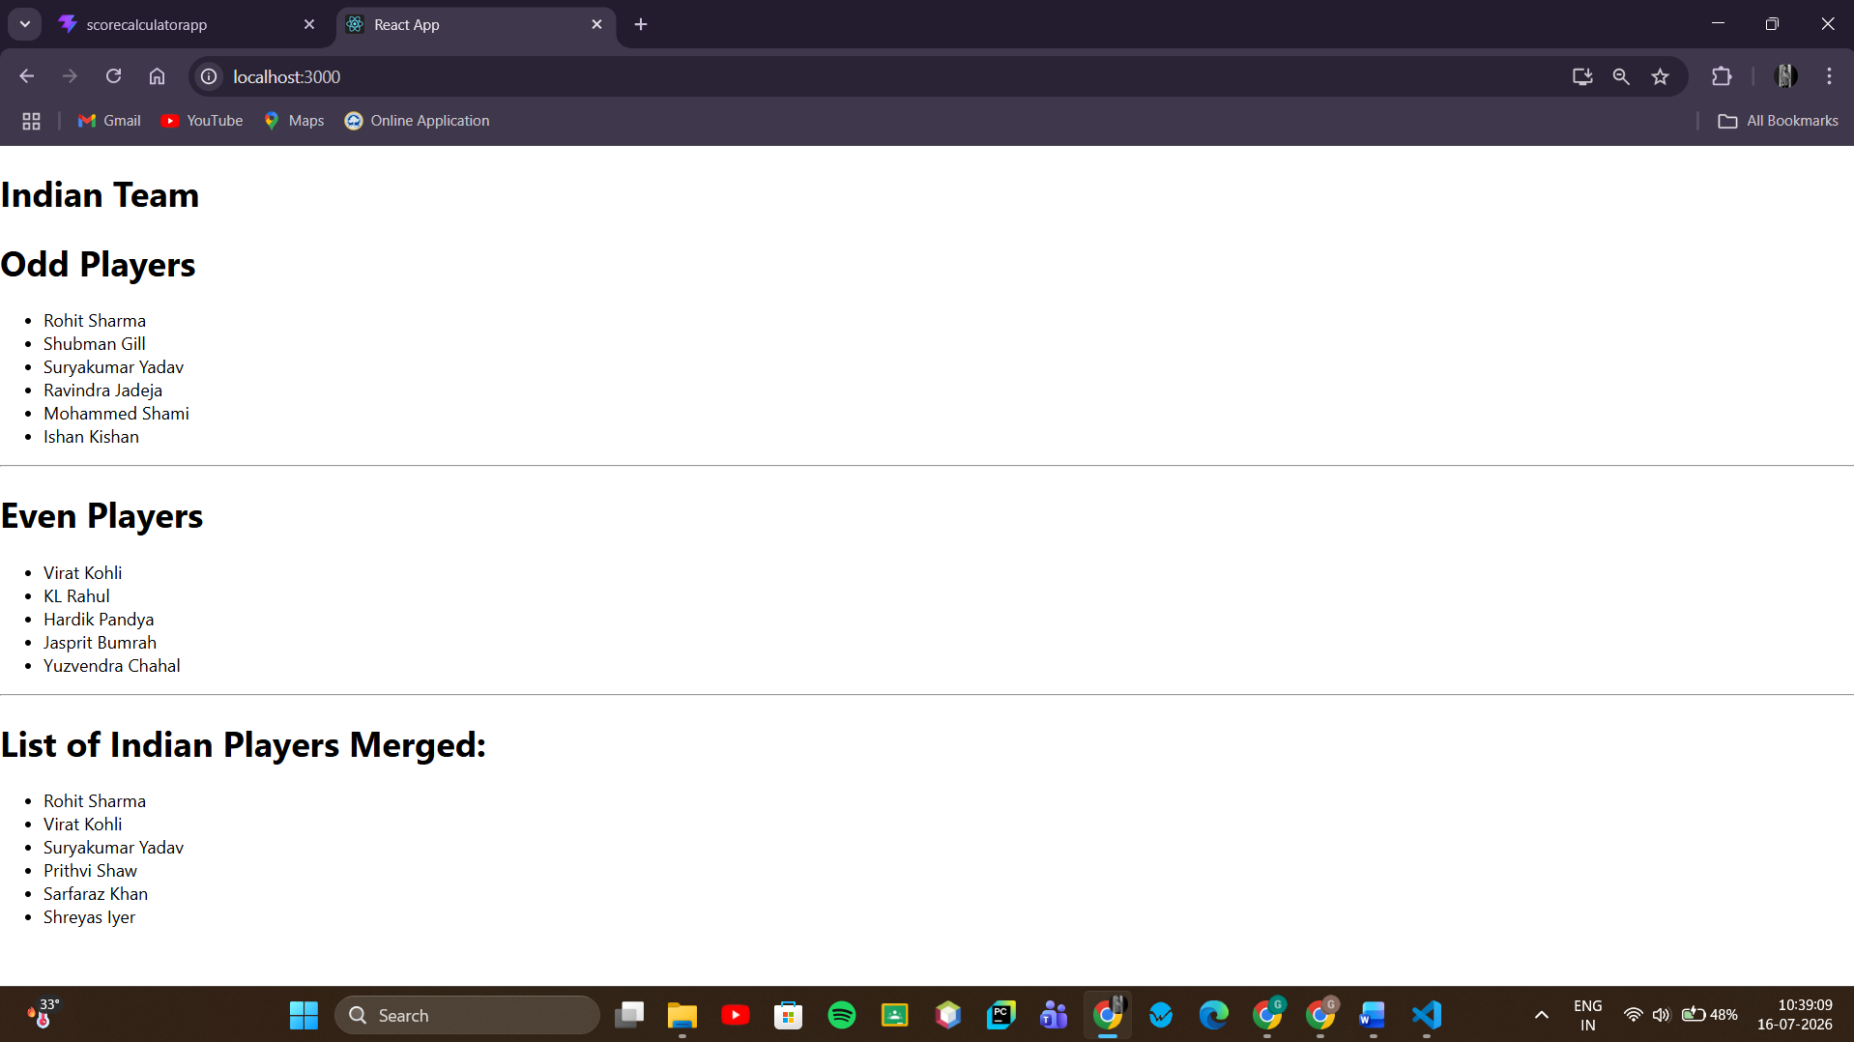

10.Objectives

- Define JSX
- Explain about ECMA Script
- Explain React.createElement()
- Explain how to create React nodes with JSX
- Define how to render JSX to DOM
- Explain how to use JavaScript expressions in JSX
- Explain how to use inline CSS in JSX

In this hands-on lab, you will learn how to:
- Use JSX syntax in React applications
- Use inline CSS in JSX

Prerequisites

The following is required to complete this hands-on lab:
- Node.js
- NPM
- Visual Studio Code

Notes

Estimated time to complete this lab: 60 minutes.
Create a React Application named “officespacerentalapp” which uses React JSX to create elements, attributes and renders DOM to display the page.

Create an element to display the heading of the page.
Attribute to display the image of the office space
Create an object of office to display the details like Name, Rent and Address.
Create a list of Object and loop through the office space item to display more data.
To apply Css, Display the color of the Rent in Red if it’s below 60000 and in Green if it’s above 60000.
Hint:
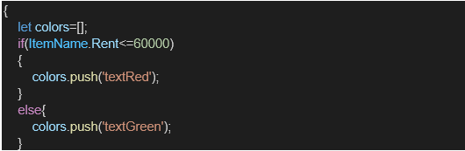
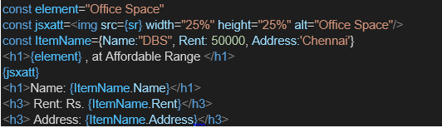
JSX: A syntax extension for JavaScript that lets you write HTML-like markup directly inside JS code. It gets compiled (via Babel) into React.createElement() calls.
ECMAScript (ES): The standardized specification that JavaScript is based on; ES6 (2015) brought major features like let, const, classes, arrow functions — all used heavily in React.
React.createElement(): The actual function JSX compiles down to. <h1>Hello</h1> becomes React.createElement('h1', null, 'Hello') behind the scenes — it creates a plain JS object describing what should appear on screen.
Creating React nodes with JSX: You write tags like <div>, <h1>, custom components, etc., and JSX converts them into React elements (nodes) that React can render.
Rendering JSX to DOM: Using ReactDOM.createRoot(container).render(<App />) — this takes your JSX/React elements and inserts the actual matching HTML into the browser's DOM.
JavaScript expressions in JSX: Any JS expression can be embedded inside JSX using curly braces { } — e.g., {name}, {2 + 2}, {list.map(...)}.
Inline CSS in JSX: Styles are passed as a JS object to the style attribute — e.g., style={{ color: 'red' }} (double braces: outer {} for JSX expression, inner {} for the object itself).
OUTPUT:
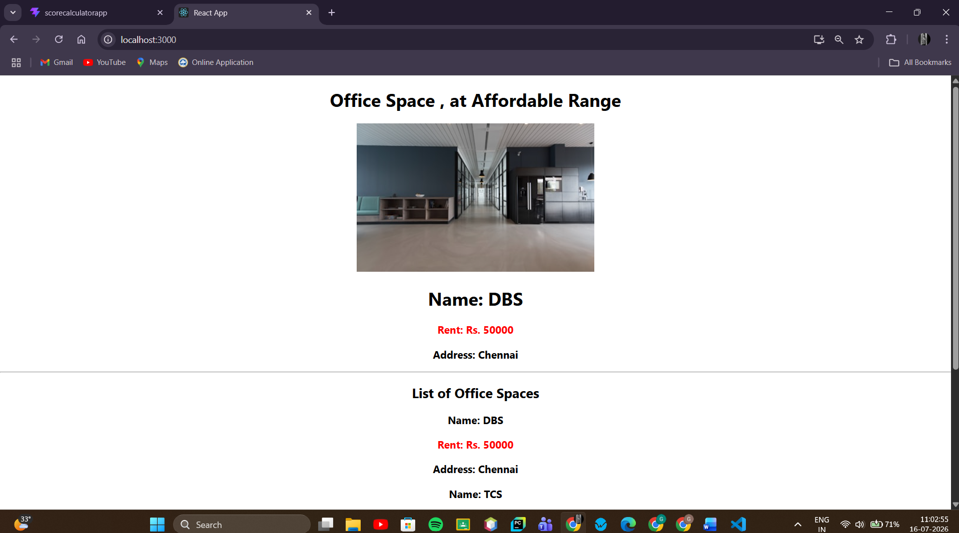

11.Objectives

- Explain React events
- Explain about event handlers
- Define Synthetic event
- Identify React event naming convention

In this hands-on lab, you will learn how to:
- Implement Event handling concept in React applications
- Use this keyword
- Use synthetic event

Prerequisites

The following is required to complete this hands-on lab:
- Node.js
- NPM
- Visual Studio Code

Notes

Estimated time to complete this lab: 90 minutes.

Create a React Application “eventexamplesapp” to handle various events of the form elements in HTML.

- Create “Increment” button to increase the value of the counter and “Decrement” button to decrease the value of the counter. The “Increase” button should invoke multiple methods.
  - To increment the value
  - Say Hello followed by a static message.
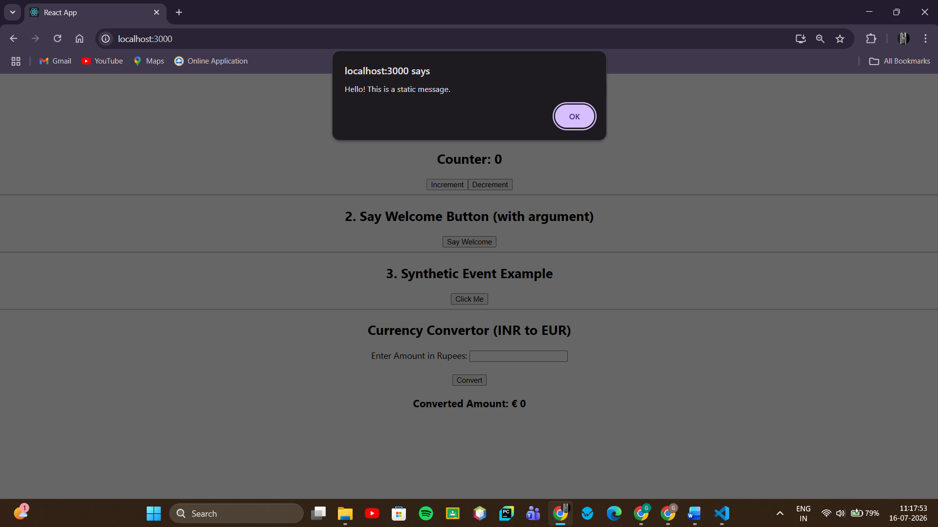

- Create a button “Say Welcome” which invokes the function which takes “welcome” as an argument.
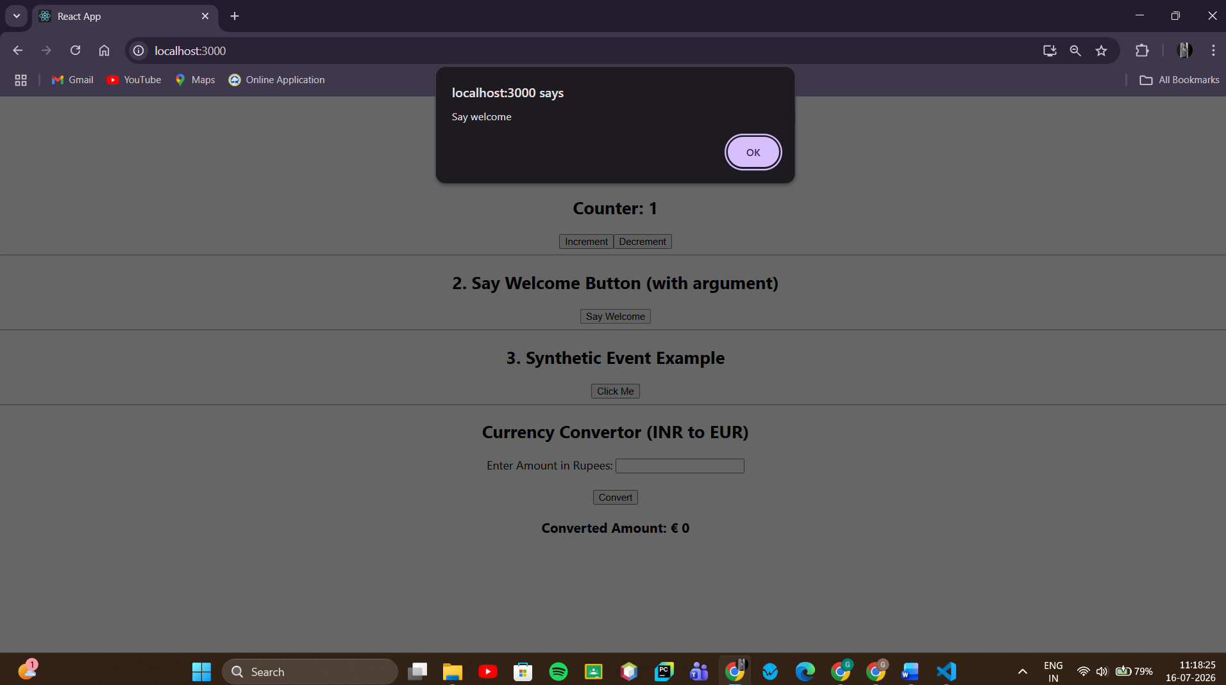

- Create a button which invokes synthetic event “OnPress” which display “I was clicked”
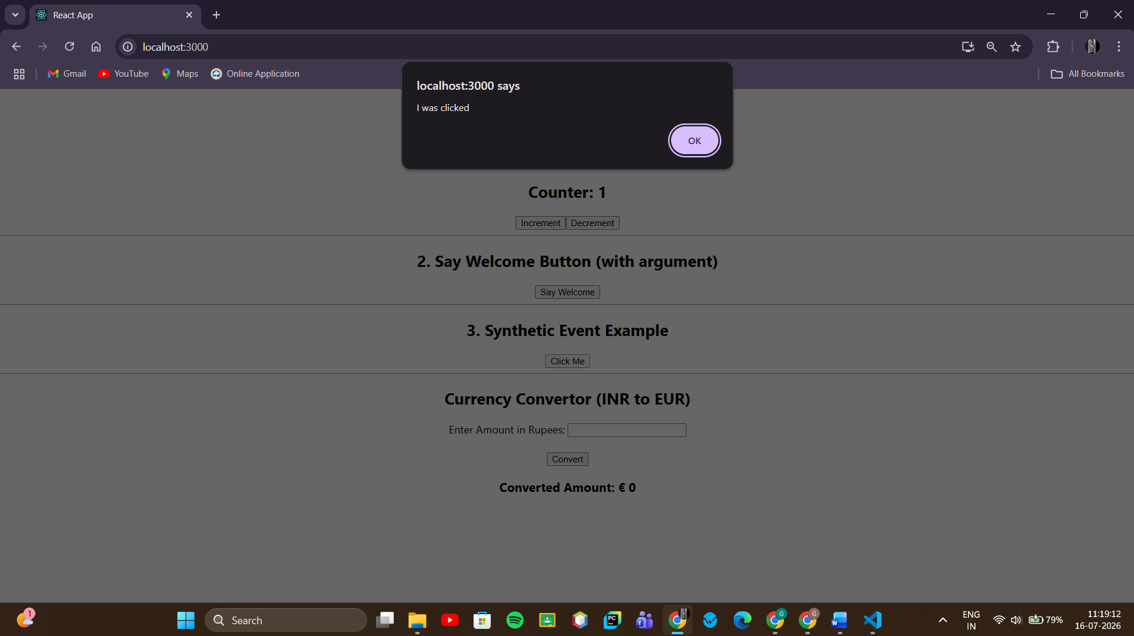

Create a “CurrencyConvertor” component which will convert the Indian Rupees to Euro when the Convert button is clicked.

Handle the Click event of the button to invoke the handleSubmit event and handle the conversion of the euro to rupees.
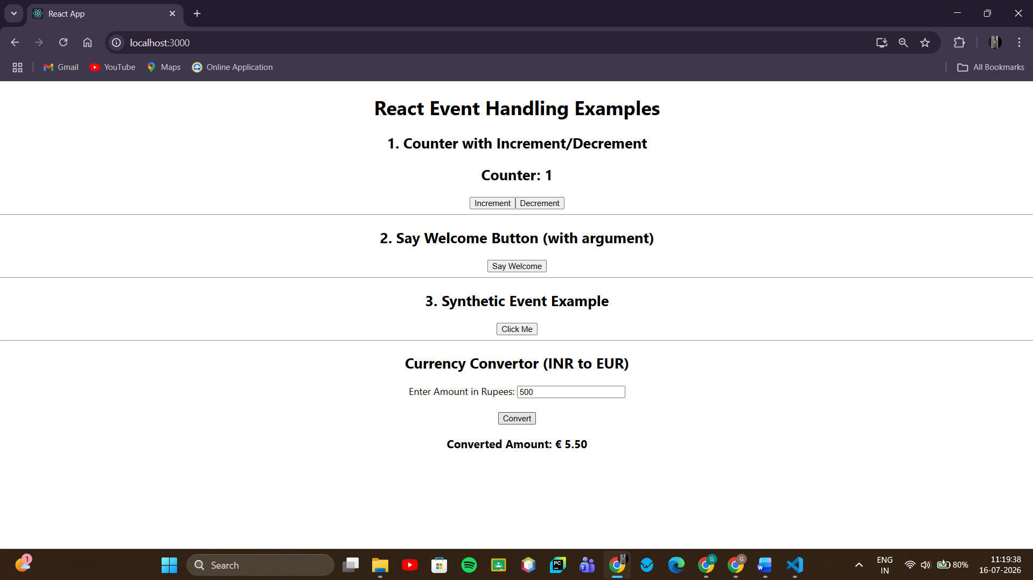

React events: Actions like clicks, form submissions, key presses, etc., that React lets you respond to using special JSX attributes (e.g., onClick, onChange).
Event handlers: Functions you define and attach to an event (e.g., handleClick), which run whenever that event occurs.
Synthetic event: React wraps native browser events in its own cross-browser wrapper called a SyntheticEvent, ensuring events behave consistently across all browsers. It's passed automatically as the first argument to your handler function.
React event naming convention: Event props use camelCase (onClick, onChange, onSubmit) instead of lowercase HTML attributes (onclick), and you pass a function reference, not a string, e.g., onClick={handleClick} not onClick="handleClick()".

12. Objectives

- Explain about conditional rendering in React
- Define element variables
- Explain how to prevent components from rendering

In this hands-on lab, you will learn how to:
- Implement conditional rendering in React applications

Prerequisites

The following is required to complete this hands-on lab:
- Node.js
- NPM
- Visual Studio Code

Notes

Estimated time to complete this lab: 60 minutes.
Create a React Application named “ticketbookingapp” where the guest user can browse the page where the flight details are displayed whereas the logged in user only can book tickets.

The Login and Logout buttons should accordingly display different pages. Once the user is logged in the User page should be displayed. When the user clicks on Logout, the Guest page should be displayed.
Hint:

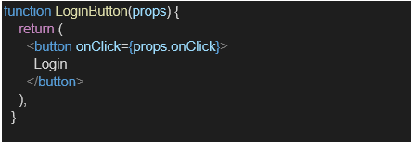
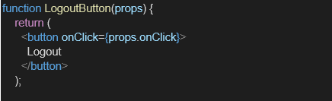

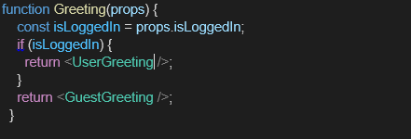

Conditional rendering: Displaying different UI/components based on a condition (e.g., if, ternary, &&) — just like regular JavaScript conditionals, but applied to what JSX gets returned.
Element variables: Storing a JSX element in a variable (e.g., let button;) and conditionally assigning different JSX to it, then rendering that variable — helps avoid messy inline conditionals in JSX.
Preventing components from rendering: A component's render() can return null instead of JSX, which tells React to render nothing for that component — useful for hiding UI without unmounting logic.

OUTPUT:
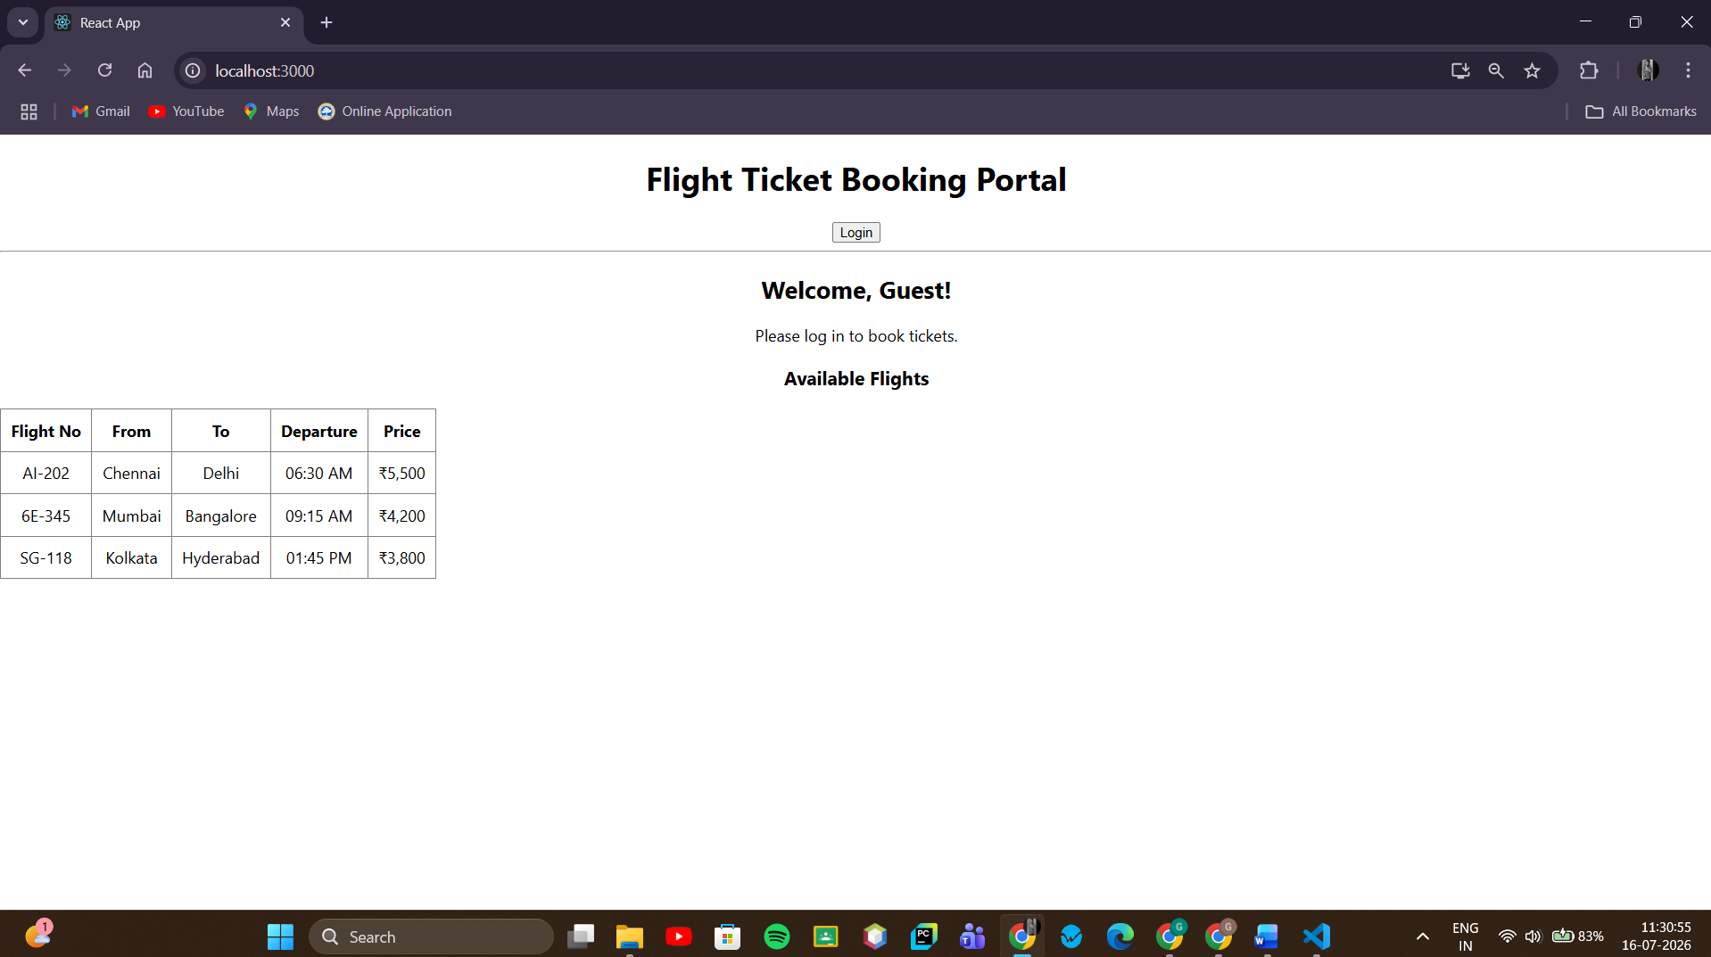
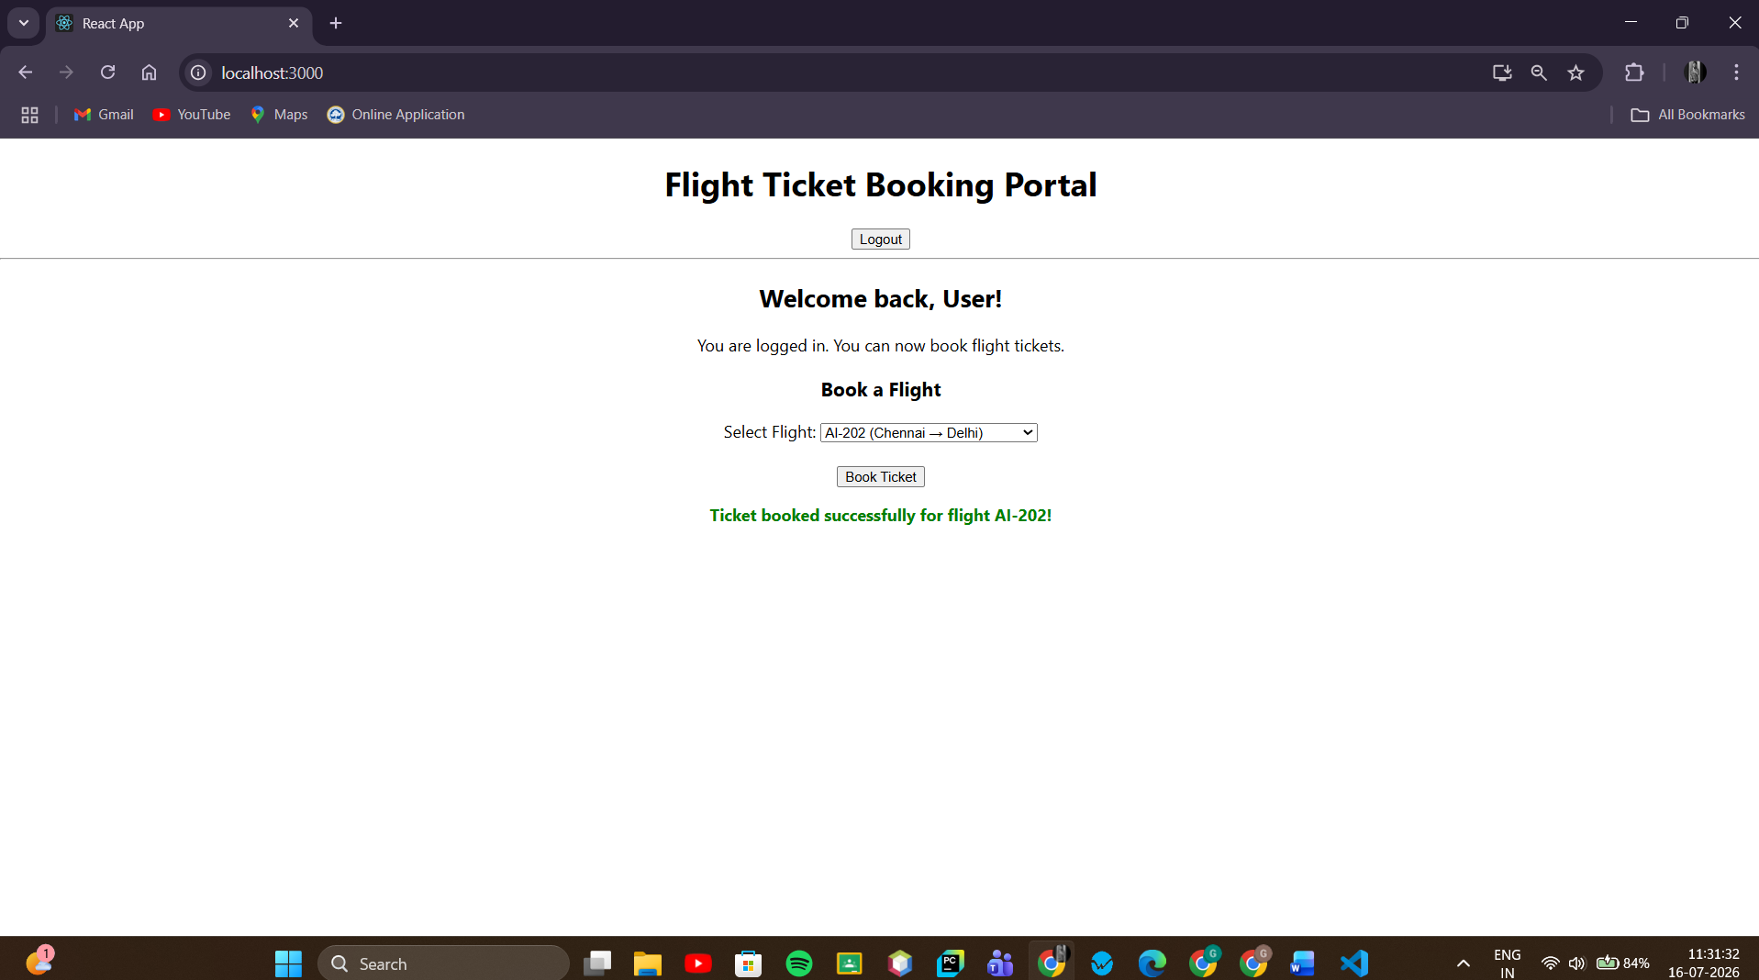

13.Objectives

- Explain various ways of conditional rendering
- Explain how to render multiple components
- Define list component
- Explain about keys in React applications
- Explain how to extract components with keys
- Explain React Map, map() function

In this hands-on lab, you will learn how to:
- Implement conditional rendering in React applications

Prerequisites

The following is required to complete this hands-on lab:
- Node.js
- NPM
- Visual Studio Code

Notes

Estimated time to complete this lab: 60 minutes.
Create a React App named “bloggerapp” in with 3 components.

- Book Details
- Blog Details
- Course Details

Implement this with as many ways possible of Conditional Rendering.
Hint:

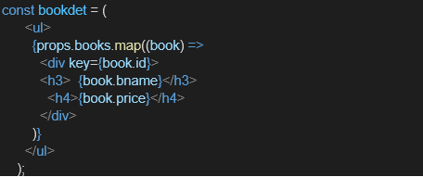

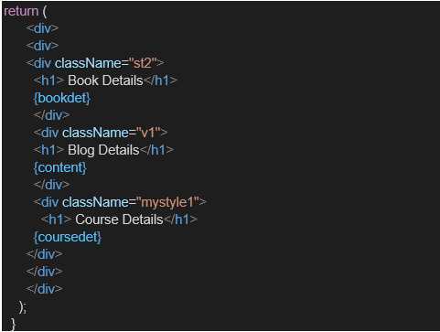

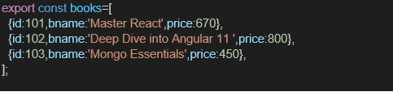

Various ways of conditional rendering: React offers multiple techniques to show/hide UI conditionally:
- if/else statements (before return)
- Ternary operator (condition ? A : B)
- Logical && operator (condition && <Component/>)
- Element variables (assign JSX to a variable, then render it)
- switch statements
- Immediately Invoked Function Expressions (IIFE) inside JSX
Rendering multiple components: Combining several components together inside one parent's render()/return, either all at once or conditionally.
List component: A component whose job is to render a collection of items — typically using .map() to loop over an array and output one element per item.
Keys in React: A special string attribute (key={...}) required when rendering lists, helping React efficiently identify which items changed, were added, or removed — improving rendering performance and correctness.
Extracting components with keys: When you extract list items into their own component, the key must be placed on the component usage (<ListItem key={id} />), not inside the extracted component itself.
map() function: An array method that transforms each element and returns a new array — the standard way to render lists in React (array.map(item => <li key={item.id}>{item.name}</li>)).
