SECTION A: TECHNICAL DETAIL REPORT

1. | Title of the Invention (should not exceed 15 words)
 | Reliability-Gated Multimodal Edge Emergency Detection and Governed Response
2. | What is the Invention?  (Should include Problem and Solution statement and general purpose in relation with your invention)
Core inventive combination: an offline-first multimodal edge emergency detector in which confidence and permitted response decrease as sensor, connectivity or model reliability decreases, while each decision is linked to verifiable incident evidence. Sensor and model restrictions and local offline persistence have code support; explicit permission degradation solely because connectivity fails is a PROPOSED embodiment. Physical end-to-end junction deployment remains unverified.
Abstract: An edge node receives time-stamped acoustic, visual and environmental observations at an urban location. A fusion engine forms an emergency candidate and calculates risk from confidence, temporal consistency, sensor agreement, device health and model assurance. Sensor failure or conflicting evidence lowers the risk or routes the candidate to human review. A safety contract converts a candidate response into role-constrained actions, with operator approval required before external emergency-service contact. The node stores incident decisions and evidence locally during network loss and can synchronize records later. A manifest and digest verifier detect changes to exported files. A sandbox replay function supports counterfactual examination without activating field outputs. This arrangement aims to make emergency response both resilient and auditable; field accuracy and safety remain to be established.
Keywords: edge AI, emergency detection, multimodal fusion, risk degradation, operator approval, evidence verification, offline incident store.
3. | Search Terms  (Please provide key words and common industry phrases on the basis of which this invention could be connected with the prior art)
 | The invention is an offline-first edge-computing safety system for urban intersections. It addresses delayed and unreliable emergency detection caused by single-camera systems, isolated alarms, cloud dependence and unverified automatic actuation. A Raspberry Pi 4 combines acoustic, visual, thermal/humidity, gas/smoke, inertial and GPS evidence; produces a localized risk assessment; presents a governed response plan; and records an auditable incident package. Emergency-service contact remains operator-approved and the system never silently claims that a synthetic model is field validated.
4. | Background of the Invention (Present state of Art)
a. What are the present technologies that exist in the field of your invention?
The field already includes several mature technologies, but they are usually deployed as separate systems. These include CCTV and video analytics for traffic monitoring; inductive loops, radar and adaptive signal controllers for traffic flow; standalone fire, smoke, gas and environmental sensors; emergency-vehicle pre-emption systems using dedicated radio, infrared, GPS or transponder equipment; computer-vision models for vehicle, accident, fire and smoke detection; and acoustic classifiers for sirens or abnormal road sounds. There are also cloud-based command-centre platforms that collect information from different sites, and newer edge-AI products that run selected analytics near the camera.
b. What are the limitations of the same?
The main limitation is that many existing systems solve only one part of the problem. A camera may detect smoke but may not know whether it is exhaust, dust or a genuine fire. An acoustic system may hear a loud sound but cannot always distinguish a horn, impact or siren reliably in a noisy junction. Cloud-dependent solutions introduce a communication path between the event and the decision, and may degrade during network loss. Dedicated ambulance-priority systems can require equipment to be fitted in the vehicle. In addition, a conventional AI dashboard often shows a confidence score without showing whether the model was trained on representative data, whether the input quality is poor, whether the model is drifting, or whether a second sensor agrees. These gaps can lead to false alarms, operator mistrust and poor accountability in safety-related use.
5. | Prior Art  (Please provide the details of the product or process by the help of which the problem solved by the invention was tackled before this invention. Please details of prior technologies, patents, or publications relevant to this invention)
Closest reviewed references are P1-P3 below. This is a targeted preliminary search, not a freedom-to-operate or exhaustive novelty opinion.
P1: US20250166434A1, Multi-modal model for traffic accident analysis, published 2025-05-22. Uses aligned multimodal data and edge processing for accident analysis; the reviewed claims do not identify the same sensor-failure response-permission contract with an operator approval boundary. https://patents.google.com/patent/US20250166434A1/en
P2: US7864071B2, Emergency vehicle traffic signal preemption system, published 2011-01-04. Vehicle transponder, intersection status and warnings govern preemption; the present concept addresses local incident evidence and reliability-based review. https://patents.google.com/patent/US7864071B2/en
P3: US9685080B2, Traffic light preemption management system, published 2017-06-20. Manages traffic preemption using vehicle signals and intersection monitoring; the present concept adds explicit risk accounting and verifiable incident evidence. https://patents.google.com/patent/US9685080B2/en
6. | Has the work filled a major gap in the prior art? If yes, a brief description of this gap.
 | The apparent gap is the joint technical control of risk and response permissions under sensor/model/connectivity degradation, tied to a verifiable incident record. Individual elements such as preemption, camera monitoring and alarm generation are known. Whether the full combination is patentable remains for counsel to assess against a wider search.
7. | What are the components of the Invention?  (Explain the external and internal parts/blocks/systems-subsystems/ composition/steps of process of your invention).
Hardware / sensing embodiment:
• Raspberry Pi 4 or another suitable edge computer.
• Camera for road, vehicle, fire and smoke observation.
• INMP441 I2S microphone or equivalent for acoustic events.
• GY-87 IMU or equivalent inertial sensor for impact and motion information.
• MQ-2 gas/smoke sensor through an ADS1115 ADC or equivalent environmental sensing.
• DHT22 or equivalent temperature/humidity sensor.
• GPS/time source such as Neo-6M where location/time tagging is required.
• Prototype outputs can include signal lamps, a servo-operated barrier model, buzzer/siren and local display.

Current software / AI components:
• Audio emergency classifier: ambient, crash, horn and siren.
• Fire/smoke vision detector.
• Vehicle vision detector: car, truck, bus and motorcycle.
• Selectable legacy and synthetic model profiles.
• Sensor pipeline and deep-rule engine.
• Raw image/audio prediction path.
• Model Assurance module showing model profile, confidence, held-out F1, data source, readiness and unreliable classes.
• Dashboard and APIs including /api/live and /api/assurance.
• Dataset preparation, retraining and prediction utilities.
• Local testing/simulation support and regression tests.

Preferred advanced embodiment:
The same architecture can include a multimodal fusion engine, temporal event state machine, 0-100 contextual risk score, explainable alert generator, unknown/OOD detection, confidence calibration, model registry, model rollback, model drift monitoring, device-health supervision, camera tamper and input-quality checks, incident database, evidence packages, operator feedback, active-learning queue, real-time camera/microphone streaming, vehicle tracking/counting, stopped-vehicle and wrong-way detection, zone-aware rules, notification adapters, digital site map, analytics, audit logging, offline store-and-forward synchronization, retention management and system self-test. These items are extensions of the disclosed architecture and should be described as future or preferred embodiments unless they are implemented and validated in the final frozen build.
8. | How does the Invention work? Please describe the complete sequence of operation of the invention, including the inputs received, processing or operations performed, interaction between the relevant components, and the resulting output, action, or technical effect.  (This portion of your invention disclosure deals with the working of your invention, the processes involved and the interactive actions taking place between the various components of your invention to give the desired output.)
 | 1. The sensors acquire synchronized observations at the edge. 2. Audio, camera and telemetry pipelines produce event candidates with timestamps and model identifiers. 3. A temporal fusion and deep-rule layer checks corroboration, signal quality, sensor availability and out-of-distribution conditions. 4. The governed decision layer assigns event type, zone, confidence and severity, and generates a response plan. 5. The operator reviews, acknowledges, confirms or rejects the plan; emergency-service notification is never automatic. 6. Approved traffic actions are sent to the actuator layer, including LEDs, buzzer, servo and configured corridor signals. 7. Incidents, predictions, evidence, operator actions, assurance state and outcomes are persisted locally through SQLite/WAL and exported as a hash-verified evidence package. 8. When connectivity returns, an outbox can synchronize records without blocking inference.
9. | Novelty of the Invention/Inventive Step of the Invention  (Please state the unique/ novel aspect of your invention and how it is different and/or better than the existing technologies):
 | The potential inventive contribution is the one combination stated in section 2. Feature-by-feature implementation status, problem, mechanism and effect are in Annex A. Features marked PARTIAL must not be characterized as fully field validated.
10. | What are the advantages and improvements over the existing methods/devices? (Please list advantages and improvements against closest patent and non-patent documents/products in pipeline explaining technical advancement of present invention over the existing technologies)
Compared with a single-camera, single-sensor or cloud-only arrangement, the proposed system offers several technical improvements. Processing is performed close to the source, which reduces dependence on network round trips and allows continued local operation during connectivity loss. Multimodal confirmation gives the decision layer more context and can reduce false alarms that arise when one detector is fooled by exhaust, noise, glare or environmental conditions. Model Assurance makes the limitations of the active model visible instead of hiding them behind a confidence percentage. The legacy and experimental model sets can be kept separate, which makes evaluation safer.

The architecture is also designed for traceability. Predictions, evidence, model version/profile and operator actions can be recorded as part of the incident history. In the advanced embodiment, the system adds temporal persistence, OOD handling, input-quality checks, model drift, device health, risk-based prioritization and duplicate suppression. These functions make the platform more suitable for engineering evaluation and controlled deployment than a detector that simply raises an alarm whenever one model crosses a threshold.
11. | Do you have in your mind as a researcher/inventor some ideas as to what are the various other/alternative forms in which your Invention can be depicted or utilized, in addition to one basic embodiment that has been described above?  (This will lay the foundation, for making your patent as broad as possible. These are called preferred embodiments or variants.)
 | Alternative embodiments include additional camera nodes, LoRa/Wi-Fi/Ethernet backhaul, other I2S microphones, calibrated gas sensors, thermal cameras, CAN/vehicle telemetry, a larger ADC, a cloud mirror, or a different edge computer. The safety contract, operator approval, evidence manifest and model-usage restriction remain applicable. The Raspberry Pi embodiment is preferred for the disclosed prototype.
12. | Please provide final CAD images, line diagrams, and schematic images of the final prototype illustrating all the essential elements of the invention, and shortlist the major/primary drawings that need to be incorporated in the Complete Specification.  (Please prepare images in two sets, one completely labeled to details and the second one without any description, legends/labeling or numbering. Include relevant Flow charts.)
The following figures present the labelled EDGE-AI prototype (Figure 1), its system architecture (Figure 2), and the functional line diagram explaining its working principle (Figure 3).
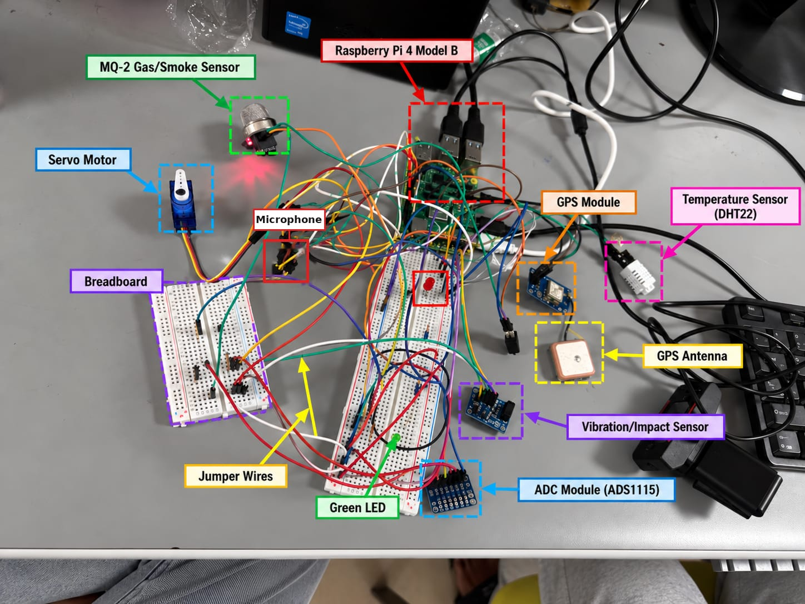
Fig. 1: Edge-AI Multi-Sensor Urban Emergency Detection, Localization & Autonomous Response — Prototype
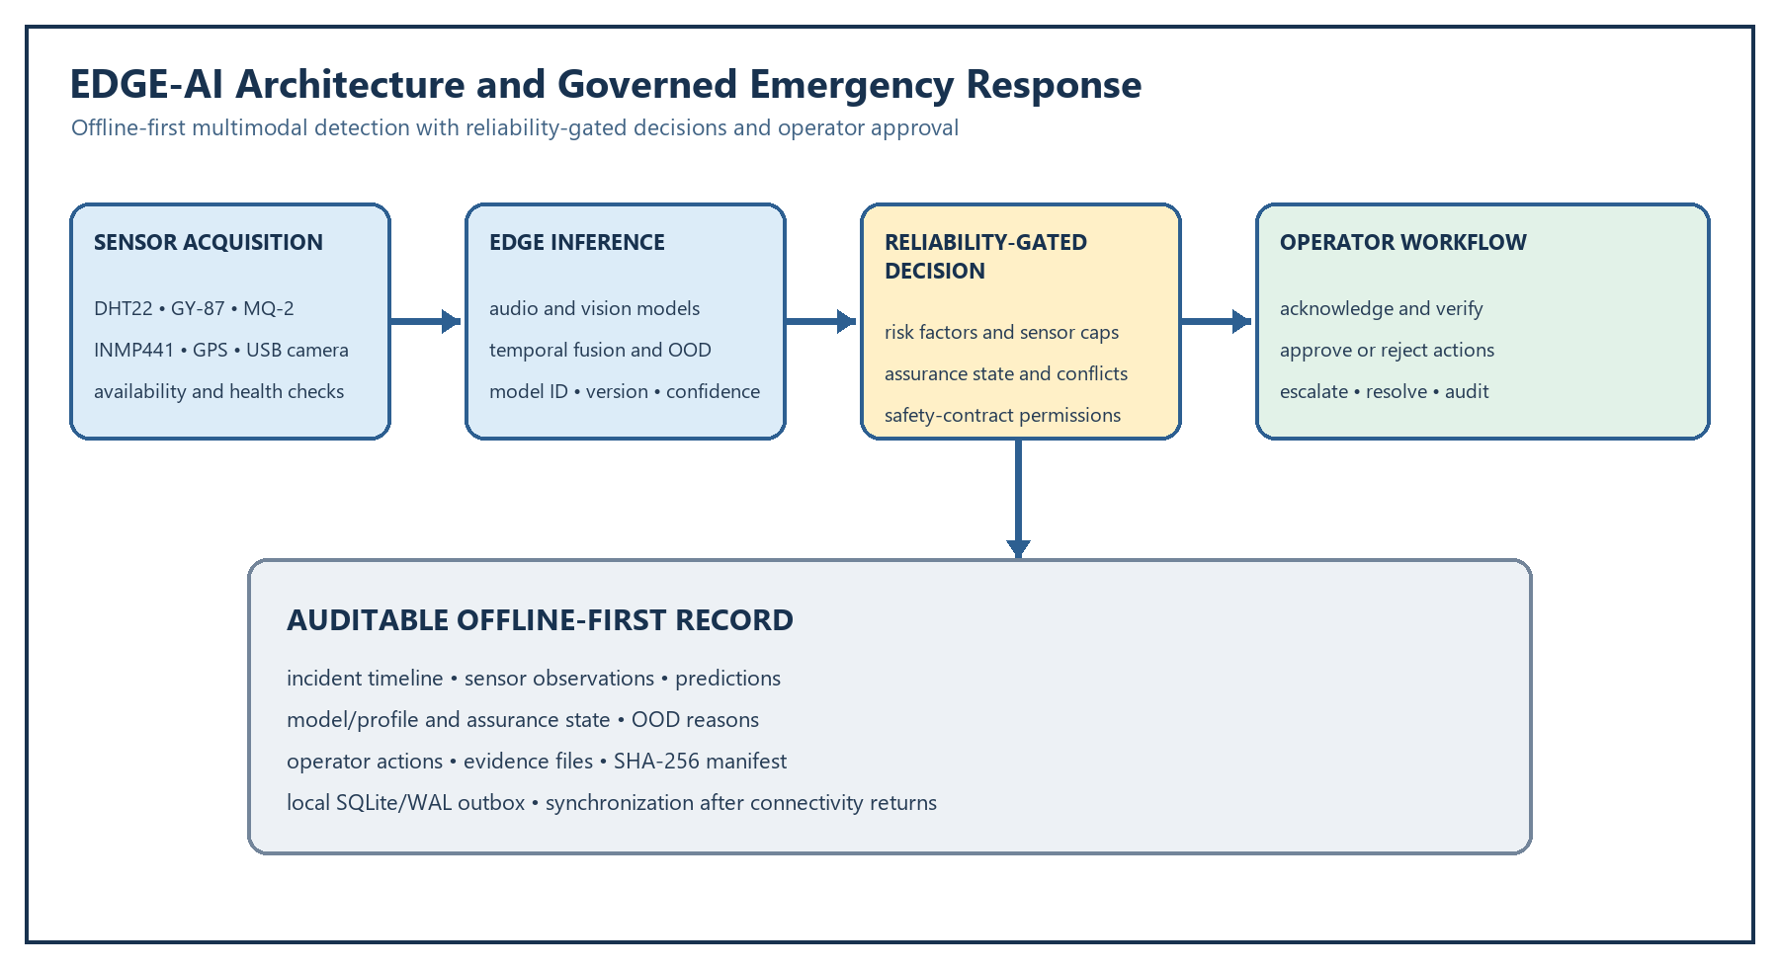
Fig. 2: System architecture and governed emergency response flow
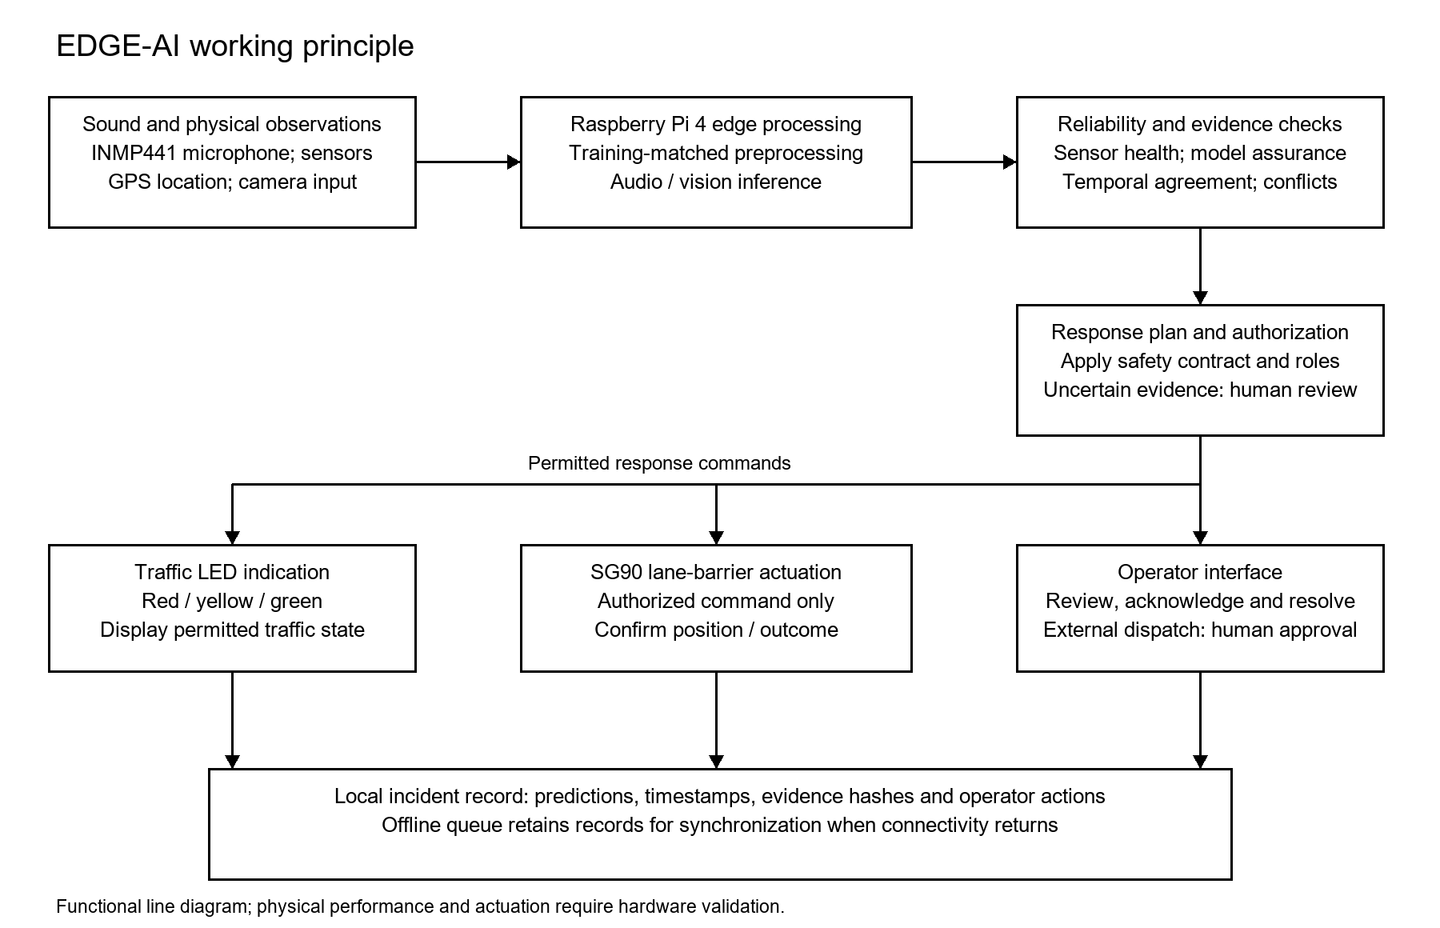
Fig. 3: Line diagram illustrating the EDGE-AI working principle
Key connection summary
Component | Pin / signal | Pi physical pin | GPIO / purpose
DHT22 | DATA | 7 | GPIO4 / temperature-humidity
GY-87 | SDA, SCL | 3, 5 | GPIO2, GPIO3 / I2C
ADS1115 | SDA, SCL, ADDR | 3, 5, GND | 0x48 / ADC
MQ-2 | AO | ADS1115 A0 | 5 V sensor; divider required
INMP441 | SCK, WS, SD | 12, 35, 38 | GPIO18, 19, 20 / I2S
GPS | TX, RX | 10, 8 | GPIO15 RX, GPIO14 TX
LEDs | R, Y, G | 29, 31, 33 | GPIO5, 6, 13
Buzzer / servo | I/O / signal | 36 / 32 | GPIO16 PWM / GPIO12 PWM
Reserved | GPIO26 | 37 | UNUSED

The architecture separates sensing, edge inference, reliability assessment and operator authorization. Sensor availability, calibration state, model assurance and out-of-distribution indicators are carried with each decision. A proposed response is recorded before an authorized role confirms it; emergency-service contact remains operator-approved. The local audit record preserves predictions, evidence hashes and operator actions while an outbox retains events during network loss.
13. | Brief description from the researcher/inventor in his own words explaining the images/ drawings.
 | I designed EDGE-AI so that an emergency is treated as a sequence of evidence and decisions rather than as one alarm. The device senses locally, checks whether different sensors agree, explains why it raised a risk, lets an authorized human approve the response, and preserves what happened for later review. This makes the prototype useful even when the network is unavailable and makes its limitations visible.
14. | Please provide a complete description of the invention, including its working methodology and working examples illustrating the inventive aspects of the corresponding invention.
The invention is an edge-computing device and method for detecting, assessing and managing emergency-related conditions at a traffic junction. A Raspberry Pi 4 or equivalent edge computer receives camera, microphone and, where fitted, IMU, gas/smoke, temperature/humidity and GPS inputs. The present software contains three trained AI functions: an audio classifier for ambient, crash, horn and siren; a fire/smoke detector; and a vehicle detector for car, truck, bus and motorcycle. The outputs are passed through the project sensor pipeline and deep-rule logic together with available physical-sensor observations.

Working example 1 - possible vehicle accident: if the audio model detects a crash while the camera confirms a vehicle and the physical sensors indicate abnormal impact or motion, the combined evidence is stronger than the audio result alone. The system can therefore raise an accident candidate with the supporting evidence.

Working example 2 - possible fire: if smoke or fire is detected visually, the result can be checked against temperature, gas and other available context. If the evidence is weak or contradictory, the event can remain under review instead of immediately being treated as a confirmed fire.

Working example 3 - model assurance: if the synthetic profile produces a high-confidence prediction, the dashboard still shows that the model is RESEARCH_ONLY because the training source is synthetic/generated. The operator can see the live confidence and the held-out reliability separately and is required to treat the result as decision support.

Preferred advanced working example - correlated accident and fire: a vehicle is first detected, a crash sound follows, the vehicle then remains stationary and smoke appears several seconds later. A temporal/correlation engine can combine these observations into one evolving incident rather than four separate alerts. The risk score rises as independent evidence accumulates. If the input is unfamiliar, the OOD module can return UNKNOWN/REVIEW_REQUIRED rather than forcing the sample into a known class. The incident manager records the timeline, model versions, confidence, assurance state and operator actions in a local database, while optional synchronization can occur when connectivity is available.
15. | Please provide details of experiments conducted and/or third-party validation data, if any, along with the mathematical equations, formulas, or calculations used in the invention, wherever the invention performs arithmetic calculations or mathematical operations.
 | Stored research results are in docs/research/RESULTS.md and results/*.json. The reported 6A clean Macro-F1 of 0.8851 is tagged SYNTHETIC; the reported 6D ten-of-ten replay agreement is tagged SYNTHETIC. These are laboratory software results, not field accuracy. RESULTS.md labels 6F and 6I as hardware validated but also states that Pi resource benchmarking ran on a Windows x86_64 host with Pi-like constraints; until primary device logs are supplied, this disclosure does not claim REAL_HARDWARE validation. No physical response-time or electrical measurement is asserted.
16. | Please provide a set of instructions or an exemplary set of code, including the code type, version, and any modifications or parameter tuning, where the invention primarily relies on software, code, or an algorithm.
Reference software setup and exemplary use:
1. Create a Python virtual environment and install the repository dependencies.
2. Place the trained weights in the configured model directory and select the required model profile. The synthetic profile must remain separate from the legacy model set.
3. Prepare datasets with src/training/prepare_new_dataset.py.
4. Train/retrain with src/training/train_new_dataset.py.
5. Run raw prediction using scripts/predict_new_dataset.py or the supported API path.
6. Start the dashboard/API using the project entry point and open http://127.0.0.1:8080.
7. GET /api/live returns live system/inference information and GET /api/assurance returns model-assurance information.
8. Image/audio inference outputs are forwarded into the sensor/deep-rule pipeline.
9. On Raspberry Pi or other edge hardware, connect the supported sensors/outputs using the project pin map and use the hardware drivers. Where physical hardware is unavailable during development, simulation must be clearly labelled.

For a complete patent example, the final frozen repository should also list the Python version, package versions, model filenames/checksums, configured thresholds, hardware pin map, model profile configuration and exact command used to start the service.
17. | Please provide details of the training data, including its source, type, and relevant characteristics, where the invention relates to a machine learning (ML) model. Also, specify the ML model used and explain how the ML model is trained, implemented, and utilized in the invention.
 | The project uses acoustic, visual and sensor telemetry data. Acoustic classes include ambient, crash, horn and siren; visual classes include fire, smoke and vehicle categories; telemetry includes temperature, humidity, inertial motion, gas level and GPS. Synthetic samples may be used for research augmentation, but the registry marks the profile RESEARCH_ONLY and stores unavailable evaluation metrics as UNVERIFIED. Every stored prediction carries model ID/version, assurance state and usage restriction.
18. | Please provide details of any public disclosure done/ any publication made.
 | No public disclosure or publication is confirmed in the material provided for this form. Before submission, the applicant should check carefully whether the project or any inventive detail has appeared in a public GitHub repository, college demo, poster, hackathon, conference submission, paper, thesis repository, social-media post, public presentation or video. If any such disclosure occurred, the exact date, audience, URL/location and material disclosed should be recorded here because it may affect patent strategy.
19. | What is the stage/level of development of the Invention?
a. At a basic conceptualization stage?
No. The project is beyond the concept stage. The AI models, raw inference path, sensor/deep-rule integration, selectable model profiles, Model Assurance, dashboard APIs, training utilities and regression tests exist in a working software prototype.
b. Completed and results validated?
The present integrated software prototype is complete enough for research and laboratory demonstration, but it should not yet be described as fully validated for live traffic operation. The dashboard/API is running and the main software paths have regression coverage. The new synthetic profile is deliberately RESEARCH_ONLY. Real-road/junction trials, environmental testing, calibration, field false-alarm measurement, fail-safe verification and independent/third-party evaluation are still required before operational deployment claims are made.
20. | What are the aspects of your disclosure that you want to claim/monopolize? (Proposed Claims)
 | Potential claim scope is expressed in Annex C as three independent claims and dependent fallbacks. These are drafting candidates, not an opinion on novelty, inventive step, enablement or freedom to operate.
21. | - Have you conducted novelty/inventiveness search for your invention? If yes, what are the databases /references used by you? What are the search results?
A preliminary, informal review has been made against broad categories such as emergency-vehicle priority systems, adaptive traffic signal control, cloud/edge video analytics, standalone acoustic detectors, YOLO-based fire/smoke and vehicle detection, and CNN-based sound classification. That review did not identify the same complete project-specific arrangement of multimodal edge inference, deep-rule/sensor fusion, model-assurance/readiness reporting, research-model separation, human confirmation, offline operation and evidence logging.

No formal novelty or inventive-step opinion is available in the supplied material. Before filing, a structured search should be performed using Google Patents, WIPO PATENTSCOPE, Espacenet, the Indian Patent Advanced Search System and relevant IEEE/ACM/other technical publications, with the closest references documented in a claim-feature comparison table.
22. | Do you feel that a person of “average” skill (not-extraordinary skill) in your area of technology would have arrived at your invention with existing knowledge in public domain? If no, what could be the reasons for the same?
The individual building blocks - object detection, audio classification, Raspberry Pi sensing, dashboards and rules - would be familiar to a skilled engineer. The inventive-step argument therefore should not rely on any one of those parts. It should rely on the particular interaction between them: multimodal confirmation, explicit uncertainty handling, model-readiness separation, human confirmation for research models, offline incident operation and an auditable chain of evidence.

Whether that combination would have been obvious at the filing date is ultimately a legal and technical question that depends on the closest prior art. A final position should therefore be taken only after the formal patent search.
23. | Kindly provide broad workable ranges for all parameters involved in the invention, including the working parameters and ranges applicable to each component utilized in the system.
 | Illustrative prototype ranges are: 3.3 V logic for Raspberry Pi GPIO/I2C/I2S; 5 V supply for MQ-2 heater and SG90 servo; DHT22 data on GPIO4; I2C at GPIO2/GPIO3; I2S on GPIO18/GPIO19/GPIO20; UART on GPIO14/GPIO15; LEDs on GPIO5/GPIO6/GPIO13 with 220–330 ohm resistors; buzzer PWM on GPIO16; servo PWM on GPIO12; ADS1115 address 0x48; MQ-2 AO through a divider into ADS1115 A0; GPIO26/physical pin 37 unused. Actual thresholds are configuration values validated during commissioning.
24. | Commercialization Data (at least a minimum of 2 companies must be provided and preferably up to 5)
a. Kindly give the names and complete addresses of five different companies which might be interested in the commercial manufacture of this technology.
Potential organizations for industry discussion include:
1. Kapsch TrafficCom - [COMPLETE CURRENT POSTAL ADDRESS TO BE VERIFIED].
2. SWARCO - [COMPLETE CURRENT POSTAL ADDRESS TO BE VERIFIED].
3. L&T Smart World / L&T Technology Services - [COMPLETE CURRENT POSTAL ADDRESS TO BE VERIFIED].
4. Bosch Mobility - [COMPLETE CURRENT POSTAL ADDRESS TO BE VERIFIED].
5. Global Traffic Technologies - [COMPLETE CURRENT POSTAL ADDRESS TO BE VERIFIED].

At least two complete addresses should be verified from official company sources immediately before submission rather than copied from an outdated source.
b. Kindly also enclose a short marketing profile of the technology highlighting the advantages vis-a-vis the prior-art technologies in this area.
This technology is a modular Edge-AI safety platform for traffic intersections and similar monitored environments. Its main commercial value is that it does not depend on a single detector or continuous cloud processing. Visual, acoustic and sensor evidence can be combined locally, while Model Assurance tells the operator whether the active model is dependable enough to trust. That gives a system integrator a clearer path from research AI to controlled deployment. The architecture can run on compact edge hardware, reduce continuous transmission of raw media, continue core operation during connectivity loss, and retain incident evidence for review. It can also be expanded with risk scoring, temporal validation, device health, site maps, model drift and operator feedback without replacing the original model profile.
25. | Provide available data or information on market potential/size, adoption trends, industry analysis, and projected growth.
The commercial opportunity sits across intelligent transportation systems, adaptive traffic management, smart-city safety, edge video analytics, emergency-vehicle priority and AI-assisted incident management. Industry adoption is moving toward local processing because of latency, bandwidth, resilience and privacy requirements, and toward explainable/assured AI because operators need to know when a model is uncertain. The project is aligned with those trends.

Exact market size, CAGR and forecast values are not established by the project material supplied for this disclosure. Those figures should be added only from a current, citable market report at the time of submission, with the report title, publisher and year recorded.
26. | Please provide the names of the inventors involved in the Invention
Inventor details: [TO BE COMPLETED BY APPLICANT].
For each inventor, provide the full legal name, registration/employee ID, department, specific inventive contribution and signature. Inventorship should be based on contribution to the inventive concepts being claimed; supervision, funding or routine coding alone does not automatically make a person an inventor.
27. | User Information
 | Potential users are traffic control rooms, municipal emergency operations centres, campus/industrial safety teams, road operators, researchers and trained maintenance engineers. Direct operators are trained adults with role-specific permissions: Commander (full incident/system authority), Operator (traffic and acknowledgement), Engineer (sensors, calibration and models), and Viewer (read-only monitoring). Benefits include faster local assessment, explainable response, reduced dependence on cloud connectivity and recoverable evidence.
b. Age group of the user?
The direct users are trained adult operators, engineers, supervisors and administrators. The road-safety benefit extends to road users of all ages. The system does not need to profile the age of people in the scene.
c. Expected benefits to the user?
Faster local detection and assessment of emergencies; reduced dependence on cloud connectivity; fewer false alarms caused by a single sensor; clearer explanation of why an alert was raised; visibility of model reliability and readiness; continued local operation during network loss; structured incident evidence for investigation; and, after appropriate validation, a path toward safer emergency-response and traffic-priority functions.
d. Cost advantage when compared to available solutions
The prototype can use commodity edge hardware and relatively low-cost sensors rather than requiring a large central server at every location. Local processing can also reduce continuous bandwidth and cloud-storage requirements. The modular architecture allows functions to be added by software and configuration. A firm lifecycle-cost saving should only be claimed after the final bill of materials, maintenance cost and commercial alternatives are benchmarked on the same basis.
28. | What is Technology readiness level of your invention? (Tick the appropriate TRL)
Provisional TRL 4: components and integrated software have laboratory and synthetic scenario testing. The repository does not supply a verified physical Pi 4 end-to-end test record for the assembled sensors, actuator circuit and municipal workflow. TRL 5 should be considered only after a representative physical junction-model demonstration with retained test logs. |  |  |  | Development |  |  | Deployment
TRL 1 |  | TRL 2 | TRL 3 | TRL 4 | TRL 5 | TRL 6 | TRL 7 | TRL 8 | TRL9
Basic  Principles  observed |  | Technology  concept  formulated | Experimental proof of  concept | Technology  validated in  a lab | Technology  validated in a  relevant  environment  (Industrially  relevant in  case of key  enabling  technologies) | Technology  demonstrated  in a relevant  environment  (Industrially  relevant in  case of key  enabling  technologies) | System  prototype  demonstration  in an  operational  environmen | System  complete  and  qualified | Actual system  proven in an  operational  environment  (Competitive  manufacturing  in case of key  enabling  technologies,  or in space)
Recommended present level: TRL 4-5, depending on the institution's interpretation. The integrated software prototype, trained models, APIs, Model Assurance and regression tests demonstrate laboratory validation, and the system is structured for Raspberry Pi/edge deployment. However, the new synthetic model profile remains RESEARCH_ONLY and a full real-junction trial has not yet been completed.

Tick TRL 4 if the institution requires validation to remain strictly within a laboratory environment. Tick TRL 5 only if the assembled prototype has been demonstrated in a representative traffic-junction model or comparable relevant environment. TRL 6 should be used only after the integrated prototype is demonstrated in a relevant physical environment, and TRL 7 only after an operational-environment prototype demonstration.
29. | Any additional notes or remarks.
 | See Annexes A-F for technical status, figures, claims, audit, open items and attorney review. The hardware pinout is configuration-consistent, not physically validated. External emergency-service contact is operator approved. Synthetic models carry RESEARCH_ONLY restrictions.

Annex A Feature status and technical effect
Feature and status | Problem | Mechanism | Technical effect / code
Uncertainty-aware fusion  IMPLEMENTED | A failing sensor can inflate an apparent emergency score. | Engine (130) multiplies bounded event, temporal, agreement, health and calibration factors; penalty and failure caps downgrade output. | Risk falls or routes to review when evidence degrades.  src/modules/decision/uncertainty_fusion.py
Role-gated response contract  IMPLEMENTED | A model output must not directly cause external dispatch. | Contract (150) records proposed actions and required roles; interface (160) requires authorized approval before execution. | Provides a traceable human authorization boundary.  src/modules/autonomous_response/safety_contract.py
Sensor availability and conflict matrix  IMPLEMENTED | Contradictory modalities can create false certainty. | Engine (140) evaluates missing/faulted modalities and maps conflict to HUMAN_REVIEW. | Makes degraded and conflicting outcomes visible.  src/modules/decision/sensor_availability_matrix.py
Deterministic sandbox replay  PARTIAL | An incident decision must be independently inspectable. | Replay engine (200) re-evaluates stored step inputs under faults without live actuation. | Allows counterfactual checking; equivalence to physical sensor timing remains unverified.  src/modules/incident_management/replay_engine.py
Drift and governed feedback  PARTIAL | Model behavior can change after deployment. | Drift monitor (210), feedback records and review queue (220) support human model assessment. | Provides a review path; continuous production retraining is not established.  src/modules/assurance/drift_monitor.py
Tamper-evident evidence package  PARTIAL | Incident evidence can be altered after capture. | Store (180) and verifier (190) export SHA-256 manifests; chain or replay-verified status requires separate confirmation. | Detects modified package files; full signed chain of custody is proposed.  src/modules/database/governed_store.py; src/modules/reporting/evidence_verifier.py
Annex B Prior art comparison
Reference | Detection / control focus | Reliability-gated permission | Evidence / replay
P1 US20250166434A1 | Multi-modal model for traffic accident analysis | Not identified in reviewed disclosure | Not identified in reviewed disclosure
P2 US7864071B2 | Emergency vehicle traffic signal preemption system | Not identified in reviewed disclosure | Not identified in reviewed disclosure
P3 US9685080B2 | Traffic light preemption management system | Not identified in reviewed disclosure | Not identified in reviewed disclosure
EDGE-AI | Multimodal incident assessment | Implemented/partial as Annex A | Digest package implemented; chain/replay status partial
Reference details: P1 US20250166434A1, Multi-modal model for traffic accident analysis, 2025-05-22, https://patents.google.com/patent/US20250166434A1/en; P2 US7864071B2, Emergency vehicle traffic signal preemption system, 2011-01-04, https://patents.google.com/patent/US7864071B2/en; P3 US9685080B2, Traffic light preemption management system, 2017-06-20, https://patents.google.com/patent/US9685080B2/en
Annex C Draft claims
1. A system for assessing an urban emergency, comprising: an edge node (100) receiving time-stamped observations from at least two different sensor modalities (110); a modality inference stage (120) producing event candidates; a fusion and risk engine (130) calculating an event risk from confidence, temporal consistency, sensor agreement and sensor health; an availability and conflict engine (140) reducing the event risk or requiring human review upon a missing or conflicting modality; a safety contract (150) associating a proposed response with a required operator role; an operator interface (160) receiving an authorization for the proposed response; and an incident store (180) recording the observations, calculation, proposed response and authorization in an evidence package verifiable by an evidence verifier (190).
2. The system of claim 1, wherein the edge node (100) continues local assessment when a communication link is unavailable and places a record for later transmission in an offline outbox (230).
3. The system of claim 1, wherein the fusion and risk engine (130) applies a cap to the event risk when a sensor of the sensor inputs (110) fails.
4. The system of claim 3, wherein an event candidate whose unadjusted confidence exceeds a review threshold is presented for human review after the cap lowers the event risk below an alert threshold.
5. The system of claim 1, wherein the availability and conflict engine (140) computes a matrix of candidate outcomes under removal of respective sensor modalities.
6. The system of claim 5, wherein mutually inconsistent event classes cause a HUMAN_REVIEW outcome.
7. The system of claim 1, wherein the safety contract (150) prevents an external emergency-service request until the operator interface (160) records approval by a commander role.
8. The system of claim 7, wherein a viewer role has no authority to approve an actuator or external notification.
9. The system of claim 1, wherein the evidence package includes a manifest with a digest for each included file, a model identifier, an assurance state and an operator-action timeline.
10. The system of claim 9, wherein the evidence verifier (190) recomputes the digests and marks the package as invalid upon mismatch.
11. The system of claim 1, further comprising a replay engine (200) that re-evaluates stored incident inputs in an isolated execution context without issuing a physical actuator command.
12. The system of claim 11, wherein the replay engine (200) tests a counterfactual sensor dropout and compares a resulting proposed response with a recorded response.
13. The system of claim 1, wherein a drift monitor (210) generates a review record and a model review queue (220) requires a human decision before promotion of a replacement model.
14. The system of claim 1, wherein the edge node (100) is a Raspberry Pi 4 and the sensor inputs (110) include an I2S microphone, a USB camera, an I2C inertial sensor and an ADC-coupled gas sensor.
15. The system of claim 14, wherein an analog output of the gas sensor is attenuated before entering a 3.3 V powered ADC and is not connected directly to a GPIO input.
16. The system of claim 14, wherein a servo driven by the response interface (170) receives power from a 5 V source sharing a ground with the edge node (100).
17. A method of assessing an urban emergency, comprising receiving, at an edge node (100), time-stamped observations from different sensor modalities (110); generating event candidates with a modality inference stage (120); calculating a risk using a fusion and risk engine (130) and a sensor-availability assessment by an availability and conflict engine (140); downgrading the risk or requiring human review upon sensor failure or conflict; producing a proposed response governed by a safety contract (150); receiving role-authorized approval through an operator interface (160) before executing the response; and storing an incident record and a verifiable evidence package in an incident store (180).
18. The method of claim 17, further comprising recording a model identifier and an applicable usage restriction with each stored prediction.
19. The method of claim 17, further comprising placing an incident message in an offline outbox (230) while a network connection is unavailable.
20. The method of claim 17, further comprising using a replay engine (200) to compare a recorded decision with a counterfactual decision produced after removal of one sensor modality.
21. A non-transitory computer-readable medium storing instructions that, when executed by an edge node (100), cause the edge node (100) to perform the method of claim 17.
22. The medium of claim 21, wherein the instructions further cause the edge node (100) to verify file digests in the evidence package using an evidence verifier (190).
Annex D Reference numerals and figures
100 edge node; 110 sensor inputs; 120 modality inference; 130 fusion and risk engine; 140 availability and conflict engine; 150 safety contract; 160 operator interface; 170 response interface; 180 incident store; 190 evidence verifier; 200 replay engine; 210 drift monitor; 220 model review queue; 230 offline outbox. Every numeral used in the following figures is defined here and appears in the claim text or Annex A.
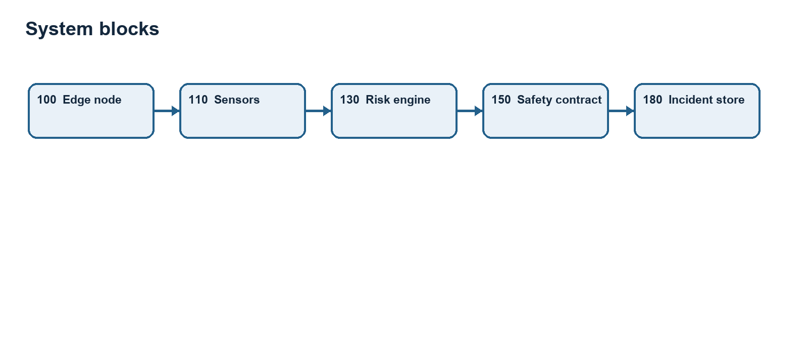
System blocks
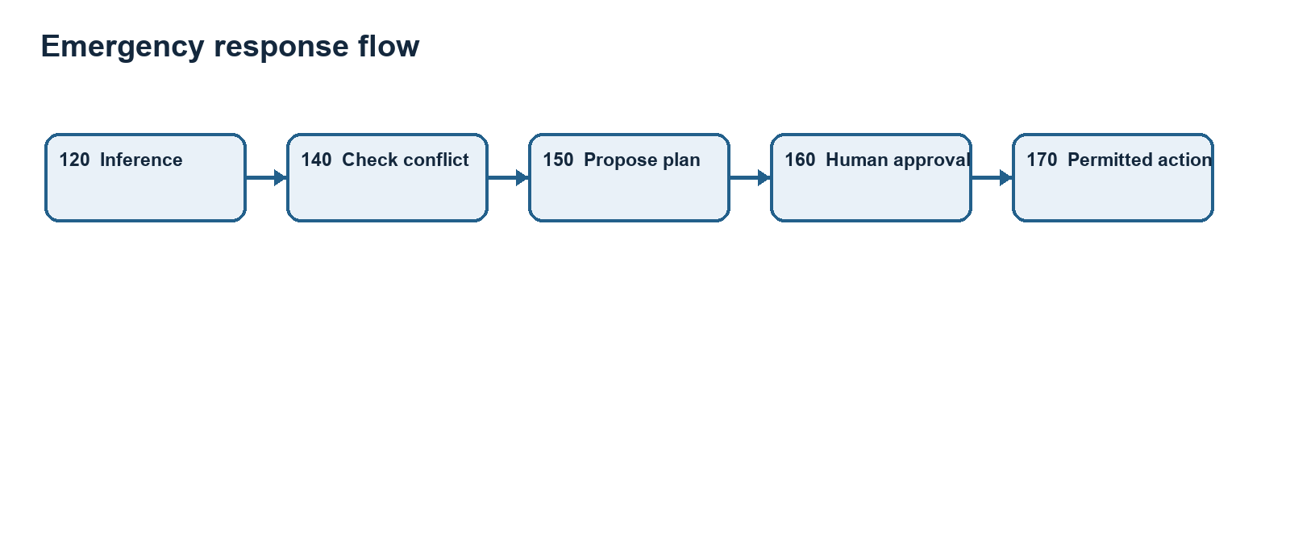
Emergency response flow
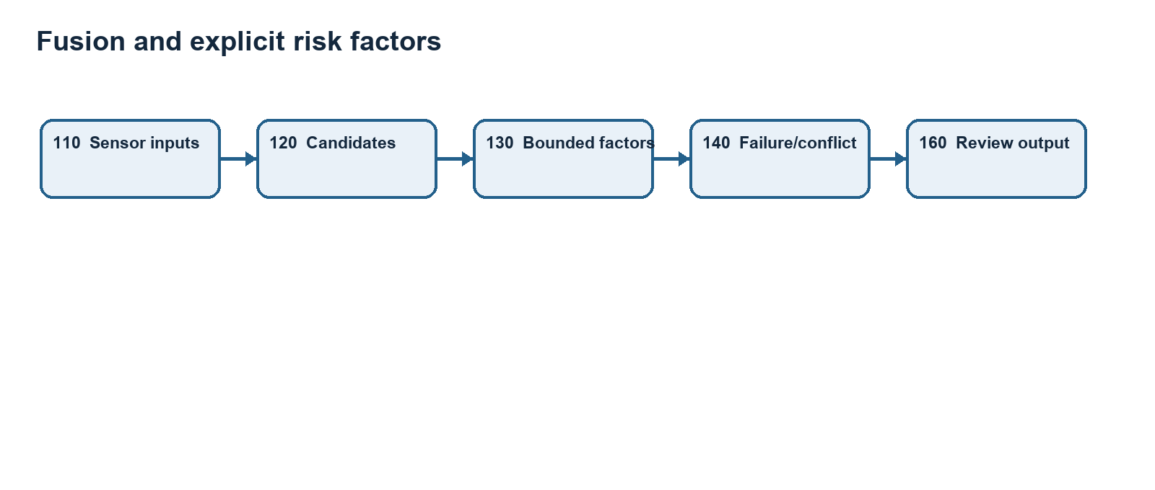
Fusion and explicit risk factors
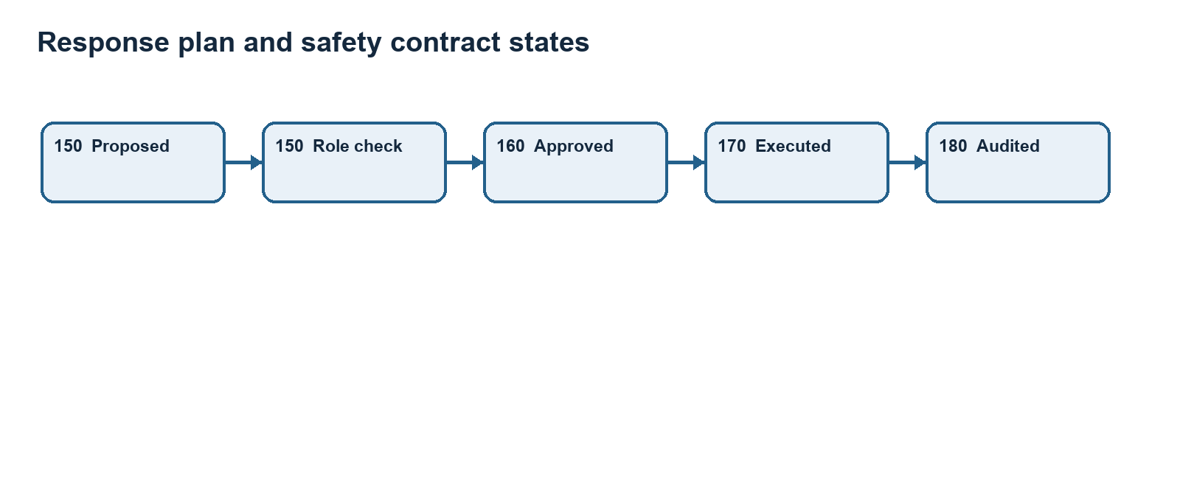
Response plan and safety contract states
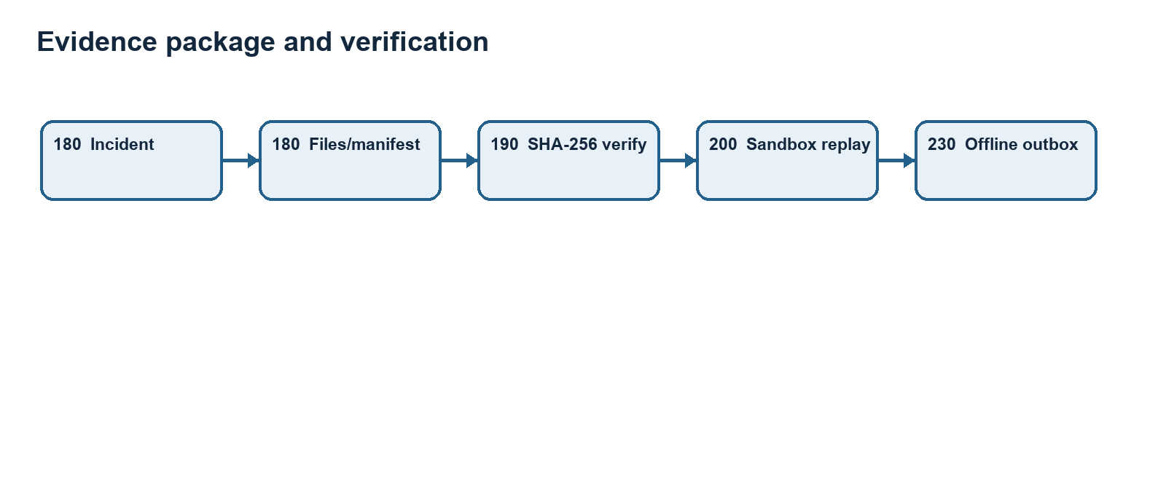
Evidence package and verification
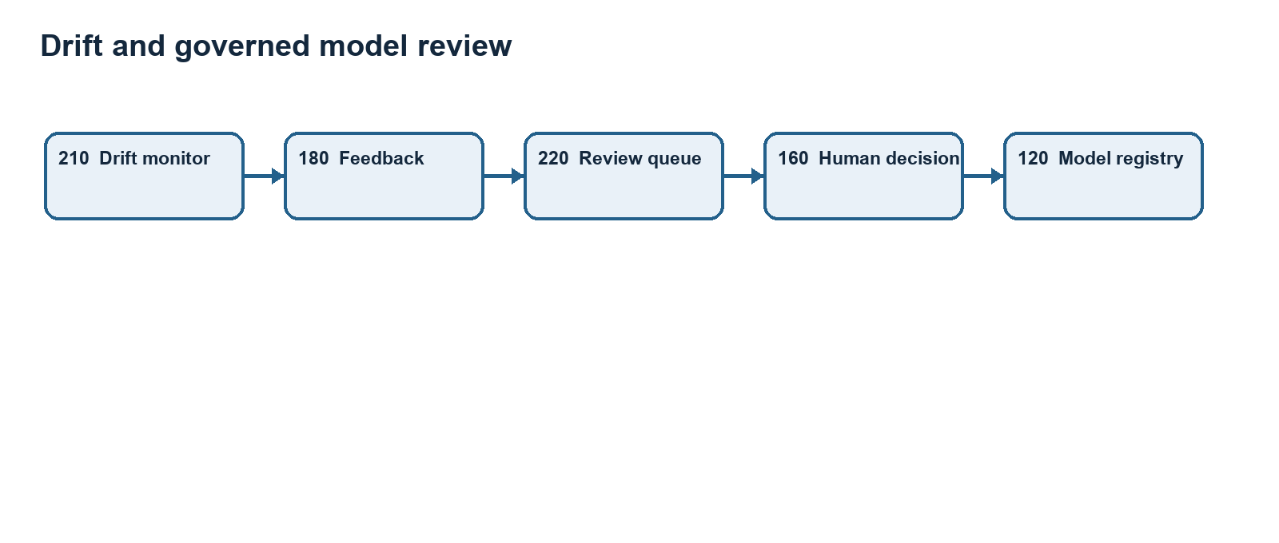
Drift and governed model review
Annex E Embodiments and implementation boundaries
Preferred embodiment (configuration-consistent): Raspberry Pi 4 Model B (100); DHT22, GY-87/MPU6050, ADS1115 with MQ-2, INMP441, NEO-6M and USB webcam (110); LEDs, 3-pin buzzer and SG90 (170). SQLite/WAL store (180) and outbox (230) preserve local records. Commander, Operator, Engineer and Viewer roles are distinct. The MQ-2 AO requires an attenuator before ADS1115 A0; the servo uses a suitable 5 V source and common ground; GPIO26, physical pin 37, remains unused in this embodiment. Physical wiring and safe actuation require bench verification.
Proposed alternative embodiments: an equivalent edge board, different microphones/cameras/IMUs, wired or wireless transport, another transactional local database, or replacement inference models may be used if the reliability degradation, role authorization and evidence-verification functions are retained. These alternatives have not been validated in the current prototype.
Annex F Consistency audit and open items
• Pinout: DHT22 GPIO4/physical 7; I2C GPIO2/3/physical 3/5; I2S GPIO18/19/20/physical 12/35/38; GPS RX/TX GPIO15/14/physical 10/8; LEDs GPIO5/6/13/physical 29/31/33; buzzer GPIO16/physical 36; servo GPIO12/physical 32. These match src/config/hardware_config.py.
• Conflict: hardware_config.py contains an optional LCD mapping on GPIO26/physical 37 although enable_lcd=False. The disclosed build requires that LCD mapping remain disabled or be removed.
• Conflict: MQ-2 divider comment says 10 kOhm top / 20 kOhm bottom while asserting a 1/3 ratio; those resistor values yield 2/3. Select a physically tested divider and update code, diagram and bill of materials.
• Evidence: per-file SHA-256 verification is supported; a linked hash chain, signing, and a persisted REPLAY_VERIFIED status require confirmation or implementation.
• Connectivity: local operation and an outbox are implemented, but response-permission degradation triggered solely by loss of connectivity is a proposed embodiment.
• Validation: RESULTS.md contains contradictory hardware labels. Obtain actual Pi test logs, wiring photos, power measurements and physical actuator safety tests before describing the prototype as hardware validated.
• Commercialization: intended settings include municipal control rooms, campus intersections and industrial roads. Deployment must assess privacy retention, local traffic authority approval, emergency-service agreements, electrical isolation, environmental sealing, maintenance and costed BOM. No market-size number is asserted.

