SENTINEL AI Disclosure Figures
Supplementary technical drawings for the Edge AI urban emergency detection prototype
The existing project circuit diagram is intentionally preserved in the original disclosure document. This appendix supplies the additional labeled and unlabeled figure sets requested for the complete specification.

Figure 2. Labeled hardware wiring diagram
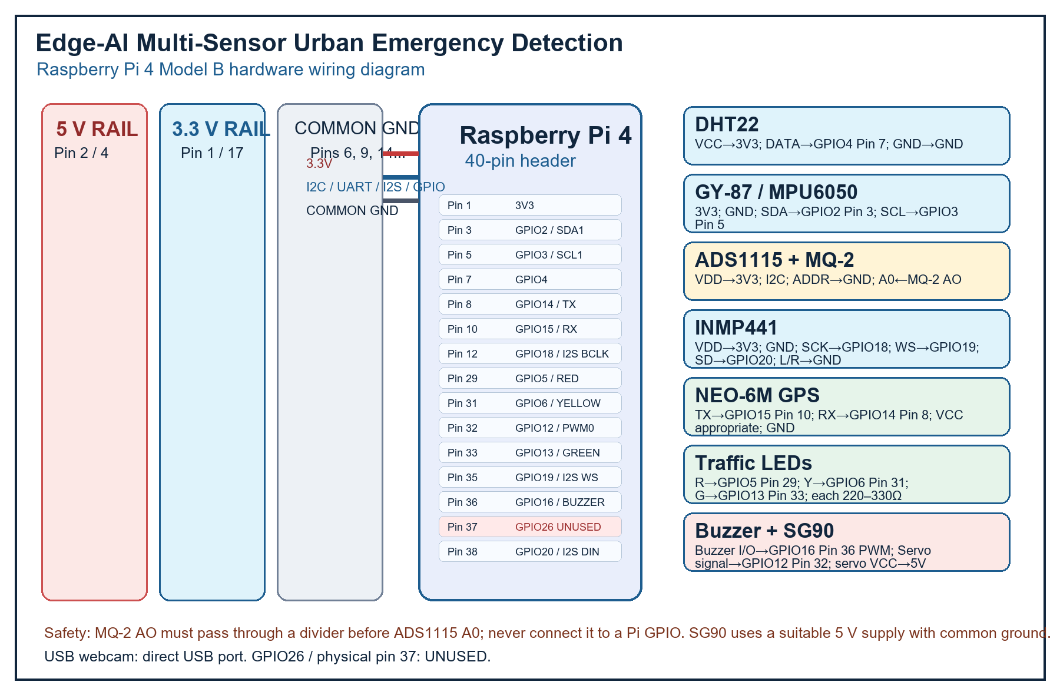
Figure 2: Edge-AI Multi-Sensor Urban Emergency Detection – Raspberry Pi 4 Hardware Wiring Diagram

Figure 3. System architecture and response flow
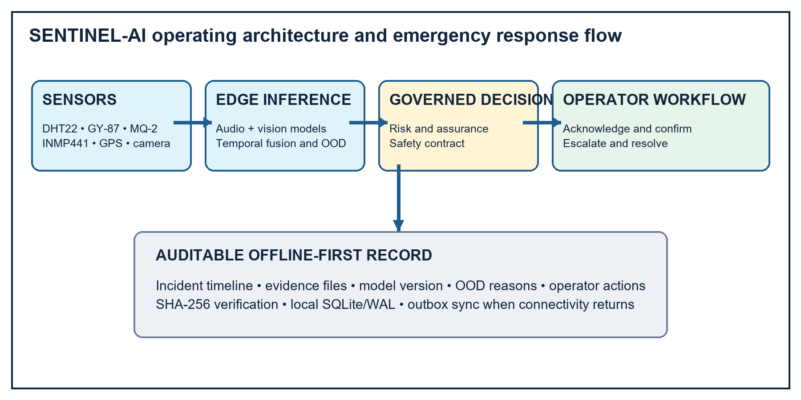
Figure 3: Multimodal sensing, governed decision, operator workflow and audit record

Connection table
Component | Component pin | Physical pin | GPIO or signal | Purpose
DHT22 | VCC / DATA / GND | 1 / 7 / 9 | 3.3V / GPIO4 / GND | Temperature and humidity
GY-87 / MPU6050 | 3.3V / GND / SDA / SCL | 1 / 6 / 3 / 5 | 3.3V / GND / GPIO2 / GPIO3 | Impact and motion over I2C
ADS1115 | VDD / GND / SDA / SCL / ADDR / A0 | 1 / 6 / 3 / 5 / GND / ADC | 3.3V / GND / GPIO2 / GPIO3 / 0x48 / A0 | ADC for MQ-2; use divider
MQ-2 | VCC / GND / AO / DO | 5V rail / GND / ADS1115 A0 / NC | 5V / GND / analog | Smoke and gas; never direct to GPIO
INMP441 | VDD / GND / SCK / WS / SD / L/R | 1 / GND / 12 / 35 / 38 / GND | 3.3V / GPIO18 / GPIO19 / GPIO20 | I2S audio
NEO-6M | VCC / GND / TX / RX | appropriate / GND / 10 / 8 | GPIO15 RX / GPIO14 TX | UART position
LEDs | R / Y / G anodes; cathodes | 29 / 31 / 33 / GND | GPIO5 / GPIO6 / GPIO13 | Each anode through 220–330Ω
Buzzer | VCC / GND / I/O | 3.3V / GND / 36 | GPIO16 PWM | Active-high or PWM module
SG90 | VCC / GND / signal | 5V / common GND / 32 | GPIO12 PWM0 | Separate suitable 5V supply recommended
USB webcam | USB | USB port | No GPIO | Video input
Reserved | GPIO26 | 37 | UNUSED | Must remain unconnected

Electrical notes
The Raspberry Pi GPIO header is 3.3 V logic. The MQ-2 heater is powered from 5 V and its analog output must be reduced with a suitable voltage divider before entering the 3.3 V ADS1115 input. The SG90 servo must use a suitable 5 V supply and share ground with the Raspberry Pi; its motor current should not be drawn through a GPIO pin. The drawing uses physical 40-pin header numbering and BCM GPIO names together.

