EXPERIMENT NO. 14
FILE ALLOCATION STRATEGIES
PROGRAM A: SEQUENTIAL FILE ALLOCATION
C PROGRAM
#include <stdio.h>

int main()
{
int start, length, i;

printf("Enter Starting Block: ");
scanf("%d", &start);

printf("Enter File Length (Number of Blocks): ");
scanf("%d", &length);

printf("\nAllocated Blocks:\n");

for(i = 0; i < length; i++)
{
printf("%d ", start + i);
}

printf("\n");

return 0;
}

SHELL SCRIPT
#!/bin/bash

echo "Enter Starting Block:"
read start

echo "Enter File Length:"
read length

echo "Allocated Blocks:"

for ((i=0;i<length;i++))
do
echo -n "$((start+i)) "
done

echo
OUTPUT:
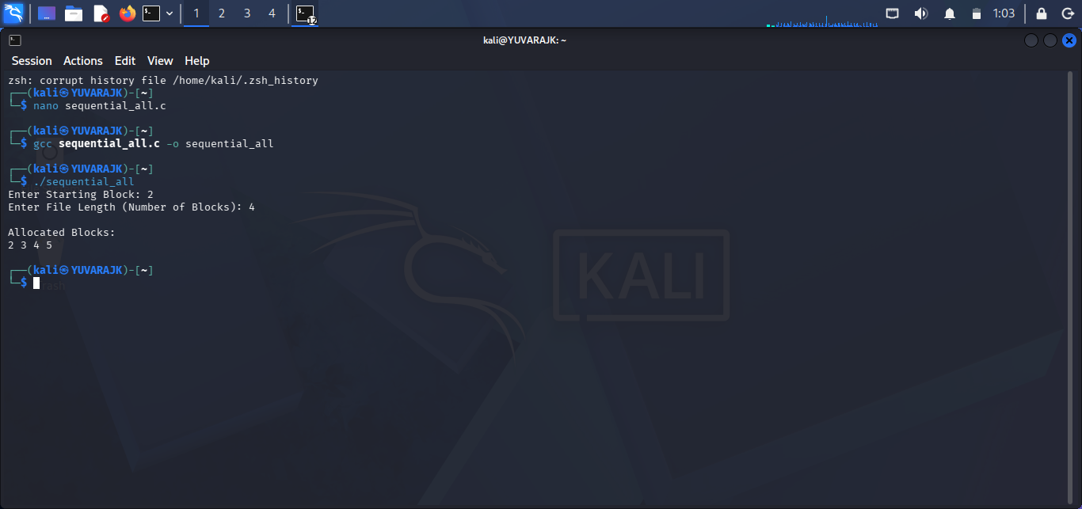

PROGRAM B: INDEXED FILE ALLOCATION
C PROGRAM
#include <stdio.h>

int main()
{
int n, indexBlock, blocks[20], i;

printf("Enter Index Block: ");
scanf("%d", &indexBlock);

printf("Enter Number of Blocks: ");
scanf("%d", &n);

printf("Enter Block Numbers:\n");

for(i = 0; i < n; i++)
{
scanf("%d", &blocks[i]);
}

printf("\nIndex Block : %d\n", indexBlock);
printf("Allocated Blocks : ");

for(i = 0; i < n; i++)
{
printf("%d ", blocks[i]);
}

printf("\n");

return 0;
}

SHELL SCRIPT
#!/bin/bash

echo "Enter Index Block:"
read index

echo "Enter Number of Blocks:"
read n

echo "Enter Block Numbers:"

for ((i=0;i<n;i++))
do
read block[$i]
done

echo "Index Block : $index"
echo -n "Allocated Blocks : "

for ((i=0;i<n;i++))
do
echo -n "${block[$i]} "
done

echo
OUTPUT:
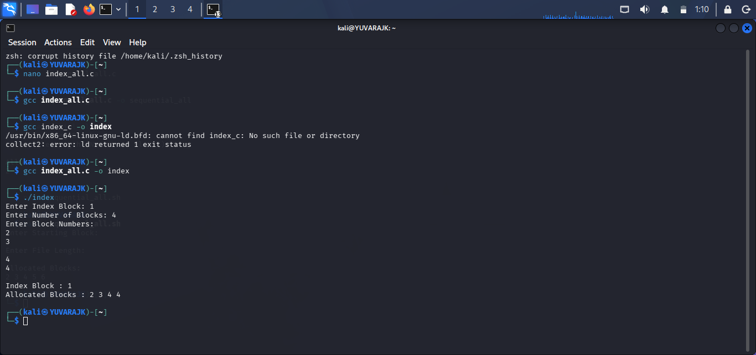

PROGRAM C: LINKED FILE ALLOCATION
C PROGRAM
#include <stdio.h>

int main()
{
int n, blocks[20], i;

printf("Enter Number of Blocks: ");
scanf("%d", &n);

printf("Enter Block Numbers:\n");

for(i = 0; i < n; i++)
{
scanf("%d", &blocks[i]);
}

printf("\nLinked Allocation:\n");

for(i = 0; i < n - 1; i++)
{
printf("%d --> ", blocks[i]);
}

printf("%d --> NULL\n", blocks[n - 1]);

return 0;
}

SHELL SCRIPT
#!/bin/bash

echo "Enter Number of Blocks:"
read n

echo "Enter Block Numbers:"

for ((i=0;i<n;i++))
do
read block[$i]
done

echo "Linked Allocation:"

for ((i=0;i<n-1;i++))
do
echo -n "${block[$i]} --> "
done

echo "${block[$((n-1))]} --> NULL"
OUTPUT:
