SEMAPHORE IMPLEMENTATION
1. MUTUAL EXCLUSION USING SEMAPHORE – C PROGRAM
#include <stdio.h>
#include <stdlib.h>
#include <unistd.h>
#include <semaphore.h>
#include <sys/mman.h>
#include <sys/wait.h>

int main()
{
sem_t *sem;

sem = mmap(NULL, sizeof(sem_t),
PROT_READ | PROT_WRITE,
MAP_SHARED | MAP_ANONYMOUS,
-1, 0);

sem_init(sem, 1, 1);

if(fork() == 0)
{
sem_wait(sem);
printf("Child Process Entering Critical Section\n");
sleep(3);
printf("Child Process Leaving Critical Section\n");
sem_post(sem);
exit(0);
}

sem_wait(sem);
printf("Parent Process Entering Critical Section\n");
sleep(3);
printf("Parent Process Leaving Critical Section\n");
sem_post(sem);

wait(NULL);
sem_destroy(sem);

return 0;
}
OUTPUT:
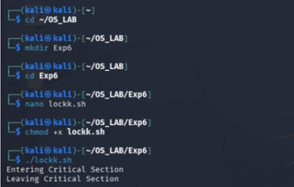

2. MUTUAL EXCLUSION USING SEMAPHORE – SHELL SCRIPT
#!/bin/bash

LOCKFILE="/tmp/mylock"

while [ -f "$LOCKFILE" ]
do
sleep 1
done

touch "$LOCKFILE"

echo "Entering Critical Section"
sleep 5
echo "Leaving Critical Section"

rm -f "$LOCKFILE"
OUTPUT:
