1. FIRST COME FIRST SERVE (FCFS) SCHEDULING
#!/bin/bash

echo "Enter Number of Processes"
read n

for ((i=0;i<n;i++))
do
echo "Enter Burst Time for P$((i+1))"
read bt[$i]
done

wt[0]=0

for ((i=1;i<n;i++))
do
wt[$i]=$((wt[i-1]+bt[i-1]))
done

echo
echo -e "Process\tBT\tWT\tTAT"

total_wt=0
total_tat=0

for ((i=0;i<n;i++))
do
tat[$i]=$((wt[i]+bt[i]))
total_wt=$((total_wt+wt[i]))
total_tat=$((total_tat+tat[i]))
echo -e "P$((i+1))\t${bt[i]}\t${wt[i]}\t${tat[i]}"
done

avg_wt=$(awk "BEGIN {printf \"%.2f\", $total_wt/$n}")
avg_tat=$(awk "BEGIN {printf \"%.2f\", $total_tat/$n}")

echo
echo "Average Waiting Time = $avg_wt"
echo "Average Turnaround Time = $avg_tat"
OUTPUT:
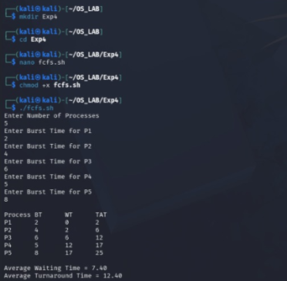

2. SHORTEST JOB FIRST (SJF) SCHEDULING
#!/bin/bash

echo "Enter Number of Processes"
read n

for ((i=0;i<n;i++))
do
echo "Enter Burst Time for P$((i+1))"
read bt[$i]
done

for ((i=0;i<n-1;i++))
do
for ((j=i+1;j<n;j++))
do
if [ ${bt[i]} -gt ${bt[j]} ]
then
temp=${bt[i]}
bt[$i]=${bt[j]}
bt[$j]=$temp
fi
done
done

wt[0]=0

echo
echo -e "Process\tBT\tWT\tTAT"

total_wt=0
total_tat=0

for ((i=0;i<n;i++))
do
if [ $i -ne 0 ]
then
wt[$i]=$((wt[i-1]+bt[i-1]))
fi

tat[$i]=$((wt[i]+bt[i]))
total_wt=$((total_wt+wt[i]))
total_tat=$((total_tat+tat[i]))
echo -e "P$((i+1))\t${bt[i]}\t${wt[i]}\t${tat[i]}"
done

avg_wt=$(awk "BEGIN {printf \"%.2f\", $total_wt/$n}")
avg_tat=$(awk "BEGIN {printf \"%.2f\", $total_tat/$n}")

echo
echo "Average Waiting Time = $avg_wt"
echo "Average Turnaround Time = $avg_tat"
OUTPUT:
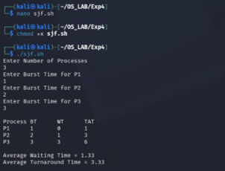

3. PRIORITY SCHEDULING
#!/bin/bash

echo "Enter Number of Processes"
read n

for ((i=0;i<n;i++))
do
echo "Enter Burst Time for P$((i+1))"
read bt[$i]

echo "Enter Priority for P$((i+1))"
read pr[$i]
done

for ((i=0;i<n-1;i++))
do
for ((j=i+1;j<n;j++))
do
if [ ${pr[i]} -gt ${pr[j]} ]
then
temp=${pr[i]}
pr[$i]=${pr[j]}
pr[$j]=$temp

temp=${bt[i]}
bt[$i]=${bt[j]}
bt[$j]=$temp
fi
done
done

wt[0]=0

echo
echo -e "Process\tPriority\tBT\tWT\tTAT"

total_wt=0
total_tat=0

for ((i=0;i<n;i++))
do
if [ $i -ne 0 ]
then
wt[$i]=$((wt[i-1]+bt[i-1]))
fi

tat[$i]=$((wt[i]+bt[i]))
total_wt=$((total_wt+wt[i]))
total_tat=$((total_tat+tat[i]))
echo -e "P$((i+1))\t${pr[i]}\t\t${bt[i]}\t${wt[i]}\t${tat[i]}"
done

avg_wt=$(awk "BEGIN {printf \"%.2f\", $total_wt/$n}")
avg_tat=$(awk "BEGIN {printf \"%.2f\", $total_tat/$n}")

echo
echo "Average Waiting Time = $avg_wt"
echo "Average Turnaround Time = $avg_tat"
OUTPUT:
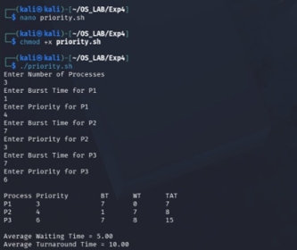

4. ROUND ROBIN SCHEDULING
#!/bin/bash

echo "Enter Number of Processes"
read n

for ((i=0;i<n;i++))
do
echo "Enter Burst Time for P$((i+1))"
read bt[$i]
rem_bt[$i]=${bt[i]}
wt[$i]=0
done

echo "Enter Time Quantum"
read tq

time=0

while true
do
done=1

for ((i=0;i<n;i++))
do
if [ ${rem_bt[i]} -gt 0 ]
then
done=0

if [ ${rem_bt[i]} -gt $tq ]
then
time=$((time+tq))
rem_bt[$i]=$((rem_bt[i]-tq))
else
time=$((time+rem_bt[i]))
wt[$i]=$((time-bt[i]))
rem_bt[$i]=0
fi
fi
done

[ $done -eq 1 ] && break
done

echo
echo -e "Process\tBT\tWT\tTAT"

total_wt=0
total_tat=0

for ((i=0;i<n;i++))
do
tat[$i]=$((bt[i]+wt[i]))
total_wt=$((total_wt+wt[i]))
total_tat=$((total_tat+tat[i]))
echo -e "P$((i+1))\t${bt[i]}\t${wt[i]}\t${tat[i]}"
done

avg_wt=$(awk "BEGIN {printf \"%.2f\", $total_wt/$n}")
avg_tat=$(awk "BEGIN {printf \"%.2f\", $total_tat/$n}")

echo
echo "Average Waiting Time = $avg_wt"
echo "Average Turnaround Time = $avg_tat"
OUTPUT:
