FILE ORGANIZATION TECHNIQUES
1. SEQUENTIAL FILE ORGANIZATION – C PROGRAM
#include <stdio.h>

struct student
{
int regno;
char name[20];
};

int main()
{
FILE *fp;
struct student s;

fp = fopen("student.dat", "w");

printf("Enter Register Number: ");
scanf("%d", &s.regno);

printf("Enter Name: ");
scanf("%s", s.name);

fprintf(fp, "%d %s\n", s.regno, s.name);
fclose(fp);

fp = fopen("student.dat", "r");

fscanf(fp, "%d %s", &s.regno, s.name);

printf("\nRecord Details\n");
printf("Register Number : %d\n", s.regno);
printf("Name : %s\n", s.name);

fclose(fp);

return 0;
}

2. SEQUENTIAL FILE ORGANIZATION – SHELL SCRIPT
#!/bin/bash

echo "Enter Register Number:"
read regno

echo "Enter Name:"
read name

echo "$regno $name" > student.txt

echo "Record Details"
cat student.txt
OUTPUT:
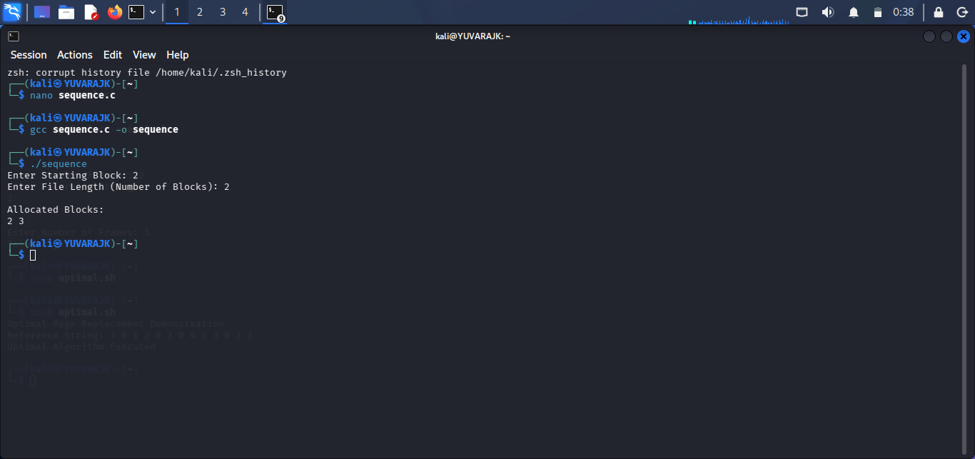

3. DIRECT (RANDOM) FILE ORGANIZATION – C PROGRAM
#include <stdio.h>

struct student
{
int regno;
char name[20];
};

int main()
{
FILE *fp;
struct student s;

fp = fopen("random.dat", "wb+");

printf("Enter Register Number: ");
scanf("%d", &s.regno);

printf("Enter Name: ");
scanf("%s", s.name);

fwrite(&s, sizeof(s), 1, fp);

rewind(fp);

fread(&s, sizeof(s), 1, fp);

printf("\nRecord Found\n");
printf("Reg No : %d\n", s.regno);
printf("Name : %s\n", s.name);

fclose(fp);

return 0;
}

4. DIRECT (RANDOM) FILE ORGANIZATION – SHELL SCRIPT
#!/bin/bash

echo "Enter Record:"
read rec

echo "$rec" > random.txt

echo "Random Access Record"
sed -n '1p' random.txt
OUTPUT:
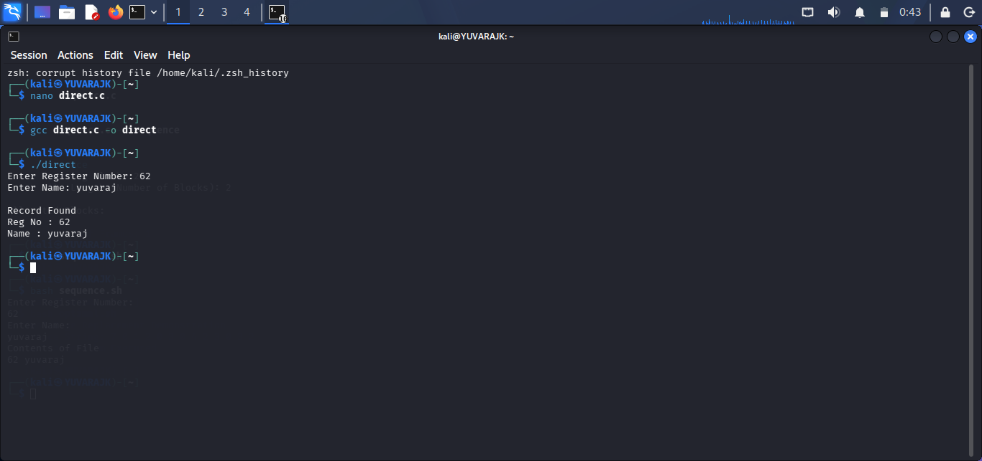

5. INDEXED FILE ORGANIZATION – C PROGRAM
#include <stdio.h>

struct student
{
int regno;
char name[20];
};

int main()
{
struct student s[3];
int key, i;

printf("Enter 3 Student Records\n");

for(i = 0; i < 3; i++)
{
scanf("%d %s", &s[i].regno, s[i].name);
}

printf("Enter Register Number to Search: ");
scanf("%d", &key);

for(i = 0; i < 3; i++)
{
if(s[i].regno == key)
{
printf("\nRecord Found\n");
printf("Reg No : %d\n", s[i].regno);
printf("Name : %s\n", s[i].name);
return 0;
}
}

printf("Record Not Found\n");

return 0;
}

6. INDEXED FILE ORGANIZATION – SHELL SCRIPT
#!/bin/bash

echo "Enter Student Records"

echo "101 Arun" > index.txt
echo "102 Kumar" >> index.txt
echo "103 Ravi" >> index.txt

echo "Enter Register Number to Search:"
read key

grep "^$key" index.txt
OUTPUT:
