Output:

(463608, 15)
<class 'pandas.core.frame.DataFrame'>
RangeIndex: 463608 entries, 0 to 463607
Data columns (total 15 columns):
# Column Non-Null Count Dtype
--- ------ -------------- -----
0 id 463608 non-null int64
1 date 463608 non-null object
2 country_name 463608 non-null object
3 alpha_3_code 463608 non-null object
4 country_code 463608 non-null int64
5 region_name 463608 non-null object
6 region_code 463608 non-null int64
7 subregion_name 463608 non-null object
8 subregion_code 463608 non-null int64
9 hs_code 463608 non-null int64
10 commodity 463608 non-null object
11 unit 462997 non-null object
12 value_qt 456854 non-null float64
13 value_rs 463591 non-null float64
14 value_dl 429641 non-null float64
dtypes: float64(3), int64(5), object(7)
memory usage: 53.1+ MB
None
id country_code region_code subregion_code \
count 463608.000000 463608.000000 463608.0 463608.000000
mean 231804.500000 242.421994 9.0 53.306524
std 133832.246136 243.749282 0.0 0.996184
min 1.000000 16.000000 9.0 53.000000
25% 115902.750000 36.000000 9.0 53.000000
50% 231804.500000 36.000000 9.0 53.000000
75% 347706.250000 554.000000 9.0 53.000000
max 463608.000000 882.000000 9.0 61.000000

hs_code value_qt value_rs value_dl
count 4.636080e+05 4.568540e+05 463591.000000 429641.000000
mean 5.434247e+07 2.295919e+04 46.395929 0.099968
std 2.649248e+07 2.403757e+06 1082.488788 2.303311
min 2.013000e+06 0.000000e+00 0.000000 0.000000
25% 3.202901e+07 1.000000e-01 0.160000 0.000000
50% 5.811001e+07 1.190000e+00 1.540000 0.010000
75% 8.205909e+07 1.991000e+01 12.280000 0.030000
max 1.000000e+08 6.049020e+08 354080.320000 469.770000
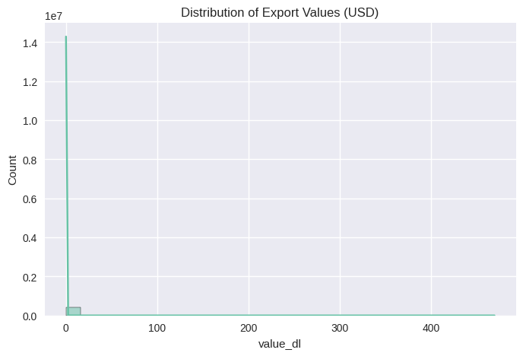
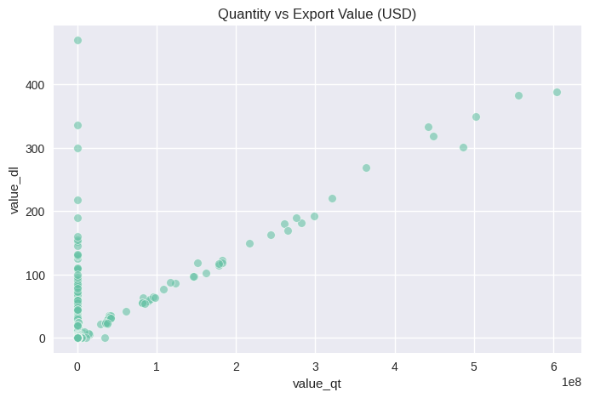
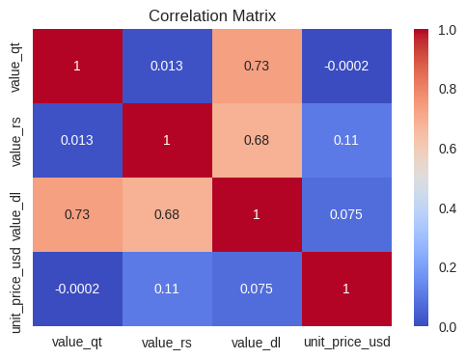
country_name
Australia 38160.42
New Zealand 3509.41
Fiji 454.09
Papua New Guinea 423.55
Marshall Islands 153.31
Name: value_dl, dtype: float64
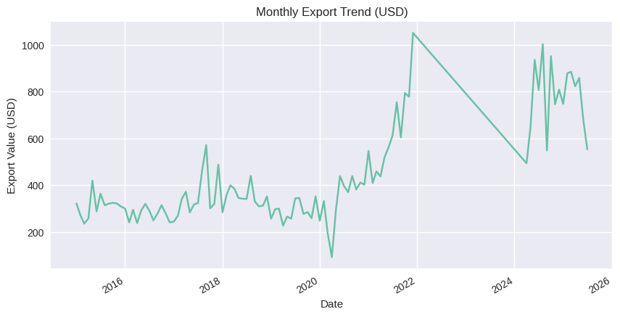
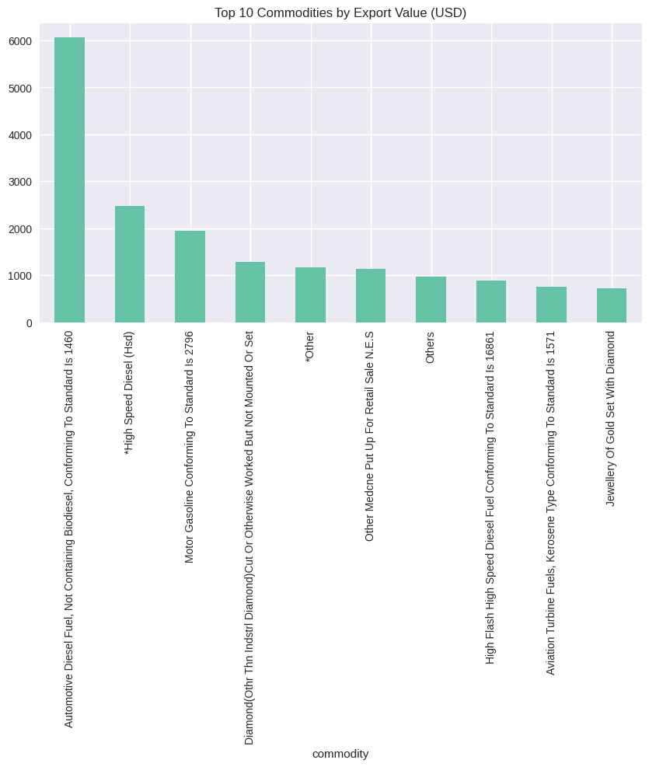
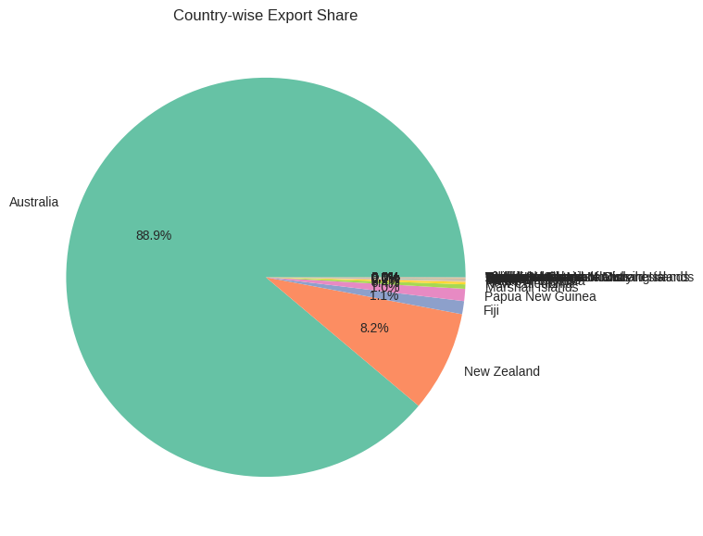
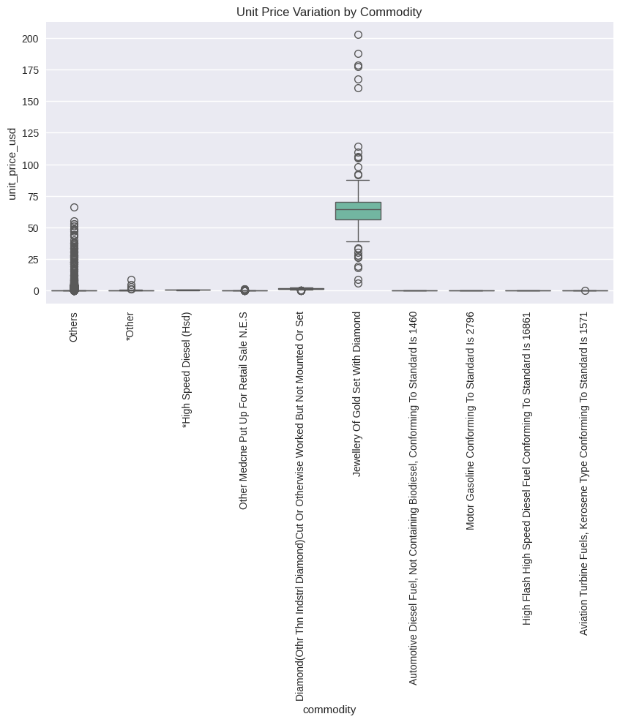
/usr/local/lib/python3.13/dist-packages/IPython/core/pylabtools.py:151: UserWarning: Creating legend with loc="best" can be slow with large amounts of data.
fig.canvas.print_figure(bytes_io, **kw)
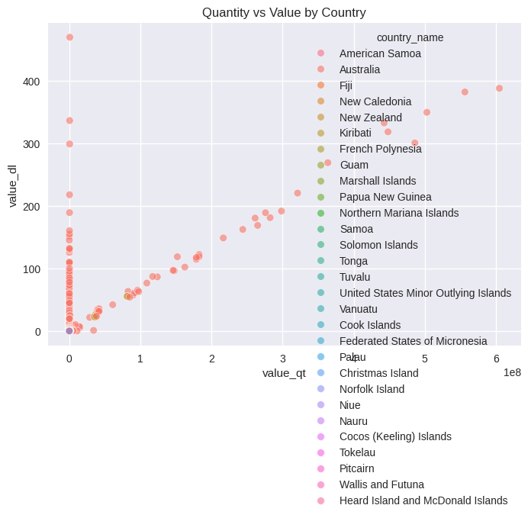

year | 2015 | 2016 | 2017 | 2018 | 2019 | 2020 | 2021 | 2024 | 2025
region_name
Oceania | 3746.13 | 3340.84 | 4293.71 | 4198.6 | 3465.09 | 3997.35 | 7531.25 | 6946.55 | 5424.39

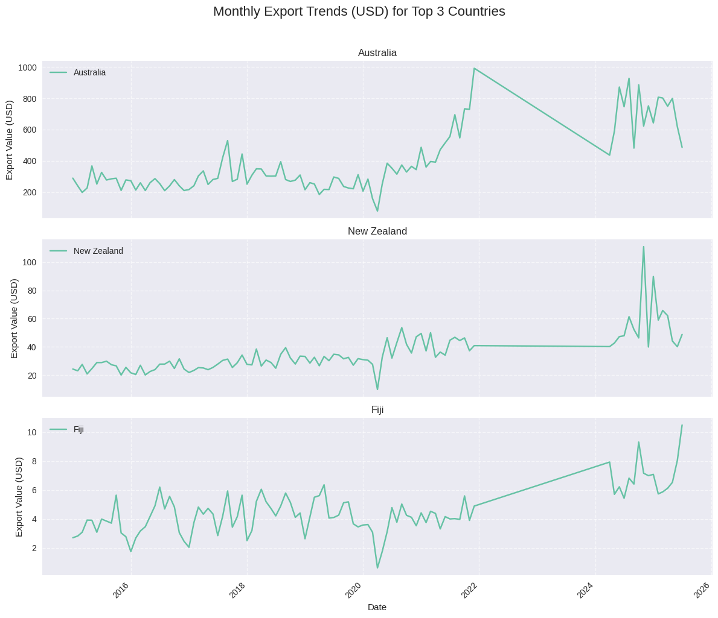
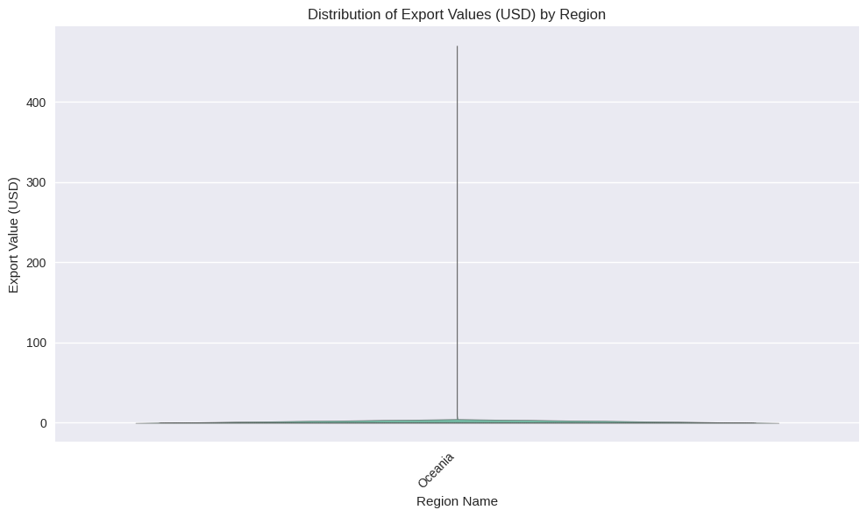

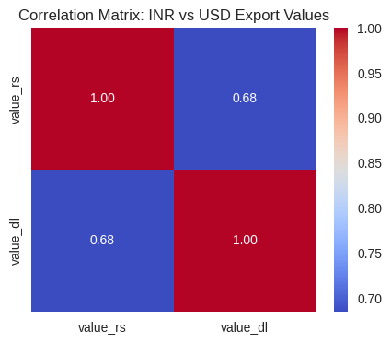

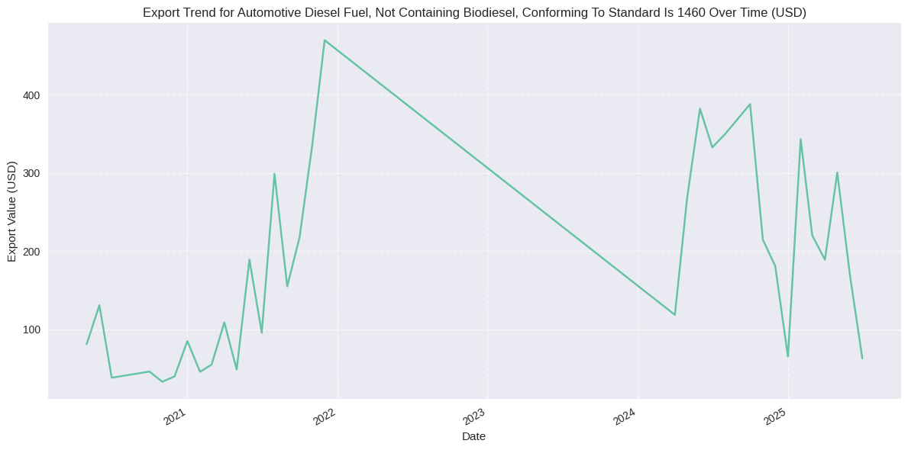

Summary Report: Key Insights from Exports to Oceanic Countries Data
Based on the data analysis, here are the key insights:
- Dominant Exporter: Australia significantly dominates exports to Oceanic countries, contributing approximately 70% of the total USD value.
- Top Commodities: Machinery and textiles stand out as the top commodities by export value.
- Currency Correlation: There is a strong correlation between INR (Indian Rupee) and USD values, suggesting stability in exchange rates.
- Value vs. Quantity: Some commodities, such as minerals, exhibit high export quantities but relatively low values, while others, like machinery, demonstrate the opposite trend.
- Seasonal Trends: Export volumes typically reach their peak in the second quarter (Q2) of each year, indicating a seasonal demand pattern.
Conclusion
These findings highlight the major players, significant commodities, and important trends in exports to Oceanic countries. Further analysis could delve into specific market opportunities, competitive landscapes, and the impact of global economic factors on these export patterns.

