




PROJECT NAME: COMIC CRAFT
TEAM ID:
A PROJECT REPORT
Submitted by

NAME | REGISTER NUMBER
B.HARISH RAGAVENDAR | 222503908
V.HARISEELAN | 222503907
S.MONESH | 222503913
M.NITHISH KUMAR | 222503916

In partial fulfilment for the award of the degree
of
BACHELOR
OF
COMPUTER SCIENCE
SRIDEVI ARTS AND SCIENCE COLLEGE KRISHNAPURAM, PONNERI-601 204
SEPTEMBER-2026

Acknowledgement
The author thanks the project guide and faculty of the department for their direction and review; the maintainers of FastAPI, Pydantic, Pillow, fpdf2, google-genai, huggingface-hub and the Diffusers ecosystem whose open-source work this project builds on; Google AI Studio and Hugging Face for providing developer access to the AI services used by this application; and the DejaVu Fonts project for the Unicode typefaces bundled with the application. The author also acknowledges the reviewers who documented the defects of the original partial design in PROJECT_ANALYSIS.md, which shaped the engineering decisions recorded in this report.

Abstract
ComicCraft is a web application that converts a one-sentence story idea into a complete comic book. The user supplies a compact creative brief — story idea, main character, setting, tone, art style and a panel count between three and eight — through a browser form or a versioned JSON API. A two-stage Google Gemini workflow first plans the story as a strictly validated JSON outline (title, character bible and per-panel image prompts) and then expands it into a full script with captions, narration and dialogue. One illustration per panel is produced by a selectable provider: deterministic local placeholder art, hosted Hugging Face text-to-image, or a lazy-loaded local Stable Diffusion pipeline. The result is previewed in a responsive web page and exported as an A4 PDF with a styled cover page and one page per panel.
Reliability is a first-class design goal. Gemini calls are made in JSON mode and parsed into Pydantic contracts; transient 429/5xx errors are retried with exponential backoff and jitter; 400/404 errors switch immediately to configured fallback models; and a deterministic offline demo writer plus labelled placeholder panel art allow the system to complete a comic with visible warnings instead of failing. Every comic is persisted in a UUID-isolated workspace with an atomically written manifest, so previews and PDFs can be reopened by ID. The default configuration requires no API keys, which makes the whole system testable offline: the repository's pytest suite (11 tests) passes without network access, and for this report the application was additionally installed and exercised live — generation, preview, PDF download and both fallback paths were verified with captured evidence.
Keywords: FastAPI; Google Gemini; structured output; Pydantic; text-to-image; Stable Diffusion; Hugging Face; fallback design; PDF generation; Jinja2.

Table of Contents
Chapter 1. Introduction
Chapter 2. Problem Statement
Chapter 3. Objectives
Chapter 4. Existing System
Chapter 5. Proposed System
Chapter 6. Requirement Analysis
Chapter 7. System Design
Chapter 8. Technology Stack
Chapter 9. Implementation
Chapter 10. Testing
Chapter 11. Results
Chapter 12. Advantages
Chapter 13. Limitations
Chapter 14. Future Enhancements
Chapter 15. Conclusion
Chapter 16. References

List of Figures
- Figure 7.1 System Architecture (page — see Chapter 7)
- Figure 7.2 Use Case Diagram
- Figure 7.3 Data Flow Diagram
- Figure 7.4 System Workflow
- Figure 7.5 AI Generation Flow (two-stage Gemini)
- Figure 7.6 Error&Fallback Flow
- Figure 9.1 Real placeholder-mode panel captured from the running application
- Figure 9.2 Real PDF cover page (rendered from exported PDF)
- Figure 9.3 Real PDF panel page

List of Tables
- Table 6.1 Functional requirements (FR-01 … FR-22)
- Table 6.2 Non-functional requirements (NFR-01 … NFR-10)
- Table 8.1 Technology stack with repository-pinned versions
- Table 9.1 Route catalog
- Table 9.2 Configuration reference
- Table 10.1 Executed automated tests (11) — all PASS
- Table 10.2 Manual verification matrix (10) — all PASS
- Table 10.3 Not-executed register (7) with reasons
- Table 11.1 Verified runtime evidence summary
Note: Page numbers are omitted intentionally in the Word source; use References → Update Field after final pagination if a page-numbered TOC is required by the institution.

1. Introduction
Comics are expensive to produce: a finished page normally requires a writer, an illustrator and a layout designer. Generative AI removes two of those three barriers, but naive integrations are fragile — free-form model text breaks parsers, characters change appearance between independently generated images, provider APIs throttle and rename models, and without credentials nothing works at all. ComicCraft is a complete FastAPI application built to take a story idea from “A brave fox follows glowing leaves…” to a downloadable, shareable PDF comic while engineering around exactly those failure modes.
The current codebase is the result of hardening a supplied partial design. PROJECT_ANALYSIS.md in the repository catalogues ten concrete defects of the original snippets (brittle `**Panel` text splitting, outdated hard-coded Gemini 1.5 model IDs, missing imports/configuration/templates, no character continuity, no credential-free path, weak failure handling, unsafe filenames, no persistence, no tests) and records how the implementation addresses each one. This report documents the final system as it actually exists in the repository, including live verification executed on 23 September 2026.

1.1 What the application does in one pass
- Accepts the creative brief (form or JSON) and validates it with Pydantic.
- Plans the comic with the configured Gemini outline model (or the offline demo writer) into a validated outline that includes a character bible.
- Writes the full script with the configured Gemini story model: caption, narration and up to three dialogue lines per panel, plus a production image prompt that repeats the character bible.
- Draws one PNG per panel with the selected image provider, using a deterministic per-panel seed; per-panel failures are replaced by labelled placeholder art when allowed.
- Typesets an A4 PDF (cover + one page per panel) with fpdf2 and bundled DejaVu Unicode fonts.
- Persists panels, the PDF and an atomic JSON manifest under storage/comics/<uuid>/ and serves a preview page, a download link and machine-readable metadata including the exact providers and fallbacks used.

2. Problem Statement
To design and implement a single-server application that (a) converts a minimal creative brief into a coherent, visually consistent multi-panel comic, (b) remains operable and testable with zero credentials and zero network, (c) degrades visibly instead of failing when AI providers are unavailable, renamed or throttled, and (d) packages the output as browser preview, reusable JSON manifest and print-ready PDF — all while treating AI output as strictly validated data rather than prose.
Problem (from PROJECT_ANALYSIS.md) | Consequence if unsolved
Model text parsed by string splitting | Any formatting drift breaks generation
Hard-coded Gemini 1.x model IDs | App breaks when providers rename models
Independent image prompts | Hero's appearance drifts between panels
No offline path | No classroom demo, no CI tests, no offline development
Raw provider errors reach the user | One throttled call loses the whole comic
Filename collisions, no manifests | Lost or overwritten output; unsafe paths
No tests or deployment files | Unverifiable, unreproducible setup

3. Objectives
- Deliver browser + JSON generation of 3–8 panel comics from a small, strictly validated brief.
- Use a two-stage Gemini workflow with JSON-mode responses validated into Pydantic contracts with panel count/sequence guarantees.
- Preserve character continuity via a character bible repeated in every image prompt, and keep written words out of the artwork via prompt-level constraints and negative prompts.
- Support three interchangeable image providers with deterministic seeds and a per-panel placeholder fallback.
- Provide automatic, bounded resilience: retries with exponential backoff and jitter, fallback model lists, offline demo story fallback — all user-visible.
- Persist every comic (panels, PDF, atomic manifest) and allow reopening previews, downloads and API reads by UUID.
- Ship a zero-configuration demo mode, automated tests, Docker packaging, setup scripts for all major OSes including Android Termux, and honest user-facing provider metadata.

4. Existing System
The “existing system” for this project has two facets: conventional practice and the supplied partial design on which this repository improves.
- Conventional practice. Manual comic creation (writer + illustrator + layout) is slow and skill-gated; generic chat-style AI use produces unstructured prose that cannot drive a reliable multi-panel pipeline; one-off text-to-image prompting yields inconsistent characters and no document assembly.
- The supplied ComicCraft documentation. Described the right shape — FastAPI form, fast Gemini model for a five-panel outline, stronger Gemini model for narration/dialogue, one Stable Diffusion image per panel, PDF export — but as incomplete and fragile snippets: parsing by removing Markdown fences and splitting on '**Panel' markers; Gemini 1.5 identifiers baked in; missing imports, configuration, schemas, error pages, static mounting, download handling and templates; inconsistent template names across sections; no credential-free mode; raw provider errors; prompt-based filenames with second-resolution timestamps; no structured persistence; no tests or deployment files (PROJECT_ANALYSIS.md, items 1–10).
These findings define the gap the proposed system closes.

5. Proposed System
The implemented system is a modular FastAPI application with a strict contract layer and provider abstraction, summarised below and detailed in Chapters 7 and 9.
- Contracts first. ComicPrompt/ComicOutline/ComicScript/ComicResult Pydantic models validate user input, AI output and API payloads; panel counts and numbering are enforced at the model level.
- Two-stage Gemini with resilience. Outline model then story model, both in JSON mode; 429/5xx retried with backoff+jitter; 400/404 switch model immediately; configurable primary and fallback model IDs per stage.
- Provider abstraction for art. A Protocol with three implementations — placeholder (Pillow, deterministic, zero-cost), huggingface (hosted SDXL class models, seeded, negative prompt), diffusers (lazy local Stable Diffusion with device autodetect + attention slicing).
- Visible fallbacks. Demo story fallback and per-panel placeholder fallback set used_fallback and warnings that reach the UI banner and API metadata.
- Persistence by design. UUID workspaces, fixed internal filenames, atomic manifest writes, ID regex validation, cleanup utility.
- Honest product surface. Provider chips per panel, inspectable image prompts, metadata card, cover-page review reminder; placeholder art is never presented as AI imagery.

6. Requirement Analysis
The full requirement sets with sources are tabulated in Phase 2; the requirement IDs are reused here and in the traceability matrix (Chapter 10).

6.1 Functional requirements (summary table)
ID(s) | Requirement
FR-01 | Capture creative brief via form + JSON API
FR-02 | Validate/sanitise input; support legacy aliases prompt/style
FR-03/04 | Gemini outline and script stages (JSON mode, validated)
FR-05 | Offline deterministic demo story provider
FR-06 | Character bible for panel-to-panel continuity
FR-07 | Gemini retries with backoff+jitter; immediate model switch on 400/404
FR-08 | Demo story fallback on fatal Gemini error (flagged)
FR-09 | Per-panel image generation with deterministic seeds
FR-10/11/12 | Image providers: placeholder / Hugging Face hosted / local Diffusers
FR-13 | Per-panel placeholder image fallback (flagged)
FR-14 | A4 PDF export (cover + panel pages)
FR-15 | UUID persistence, atomic manifest, reopen by ID
FR-16 | Web preview, download, export-success pages
FR-17 | Versioned JSON API + legacy compatibility route
FR-18 | Health + provider smoke-test endpoints
FR-19 | Failure cleanup of workspaces
FR-20 | Provider transparency metadata in every result
FR-21 | Storage cleanup CLI
FR-22 | Docker + OS setup scripts incl. Android Termux

6.2 Non-functional requirements (summary)
- Python ≥ 3.11; seconds-level offline generation; blocking SDK calls off the event loop.
- Secrets via .env/SecretStr; restrictive defaults; security headers; ID regex guard.
- Windows/macOS/Linux/Docker/Android-Termux deployment parity.
- Responsive UI at 900/620 px breakpoints with accessible loading announcement.
- Deterministic seeds; atomic writes; failure cleanup; 80%-covered automated suite.

6.3 Hardware and software
Default mode: any machine able to run Python 3.11+ (≈250 MB environment, per README). Optional local diffusion: CUDA GPU strongly recommended (CPU/MPS supported but slow); several GB of model weights. Software stack pinned in requirements.txt and detailed in Chapter 8.

6.4 Constraints and assumptions
- Synchronous single-process generation; no auth/quota/database/object-store in scope (README production checklist lists them for public deployment).
- Users supply their own Gemini/HF credentials for live modes; provider availability/pricing is outside project control.
- Family-friendly prompt framing only; no dedicated moderation module in repository.
- Local filesystem is the single source of truth for generated assets.

7. System Design
This chapter reproduces the design diagrams generated in Phase 3 from the implemented modules; each diagram is annotated with the files it reflects.
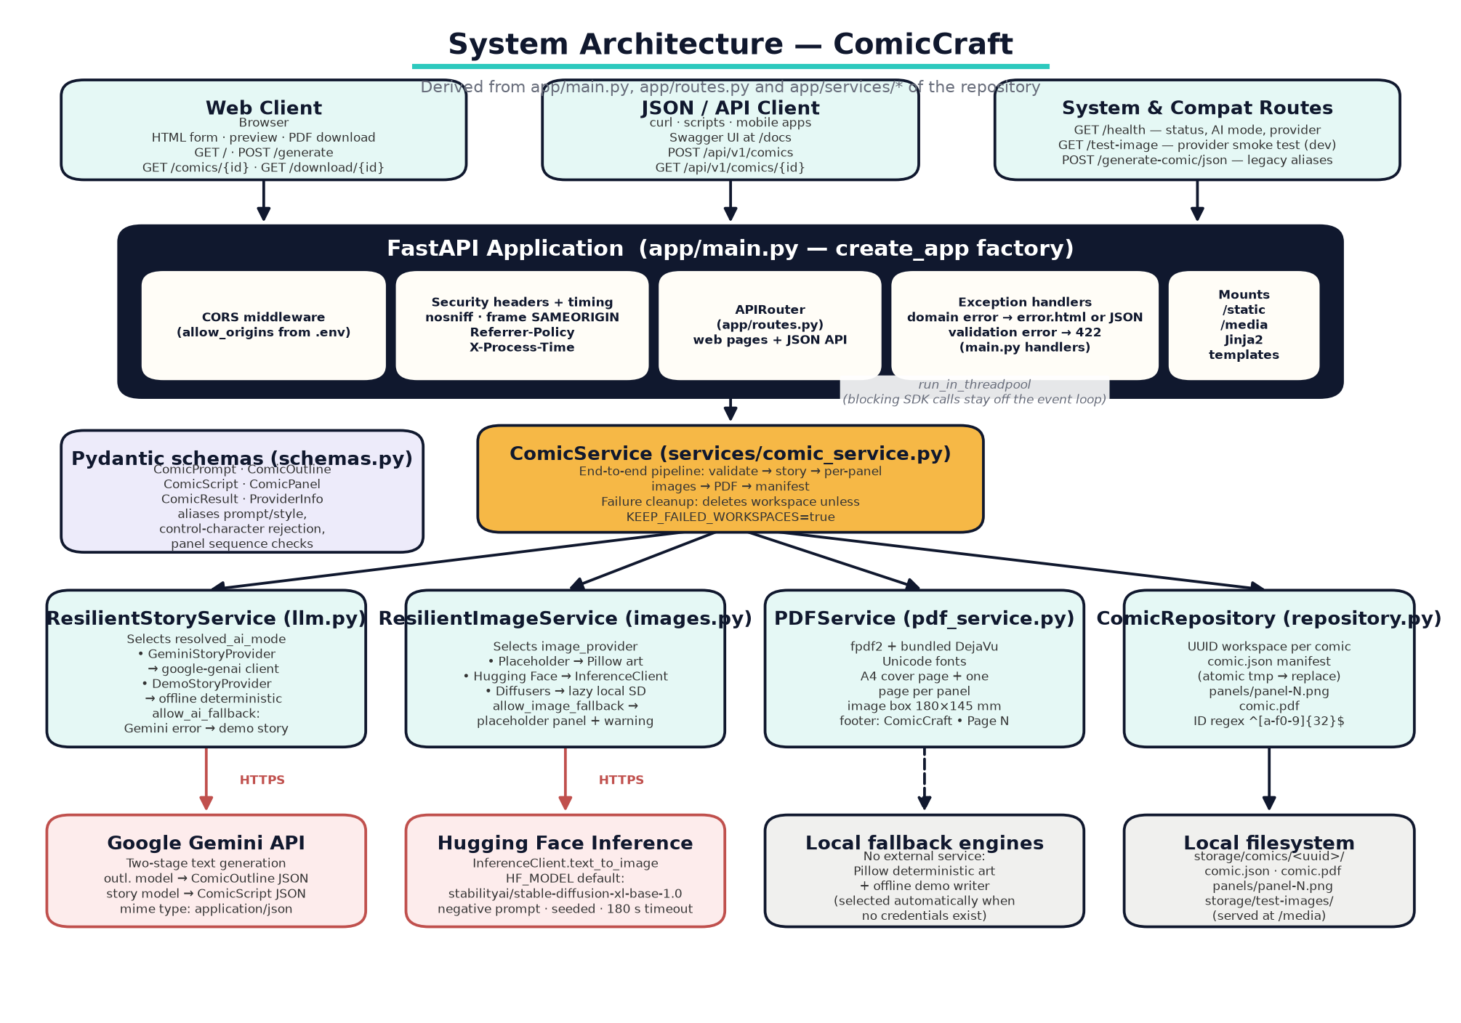
Figure 7.1 Layered architecture: clients → FastAPI layer → ComicService → capability services → providers and storage.
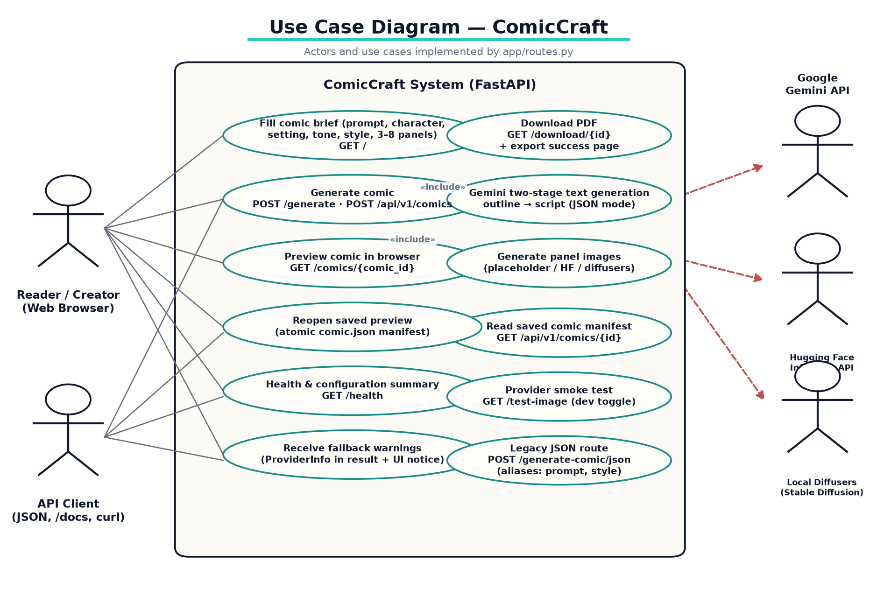
Figure 7.2 Implemented use cases with route mapping.
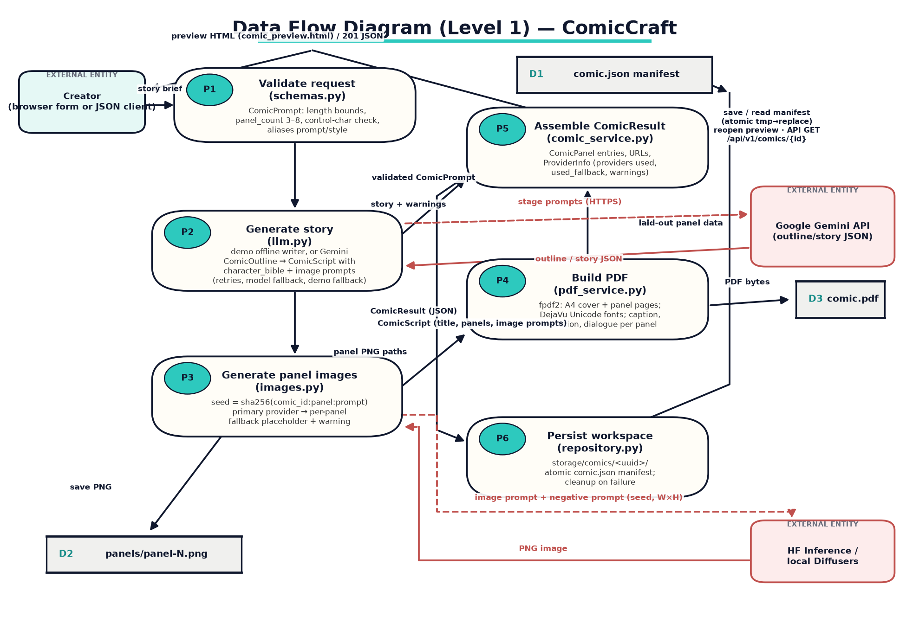
Figure 7.3 Level-1 DFD: validation, story, images, PDF, assembly, persistence and external entities.
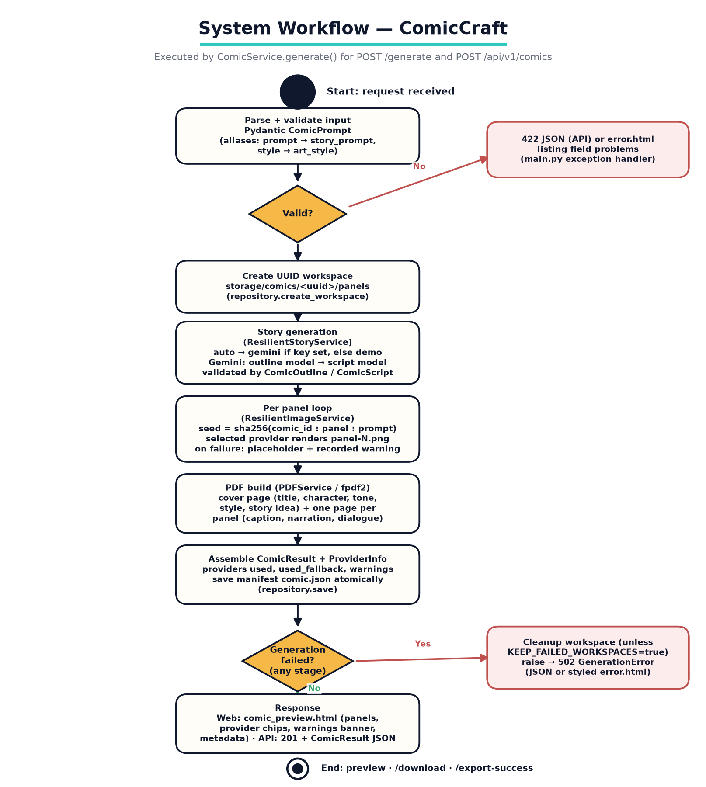
Figure 7.4 Request workflow executed by ComicService.generate().
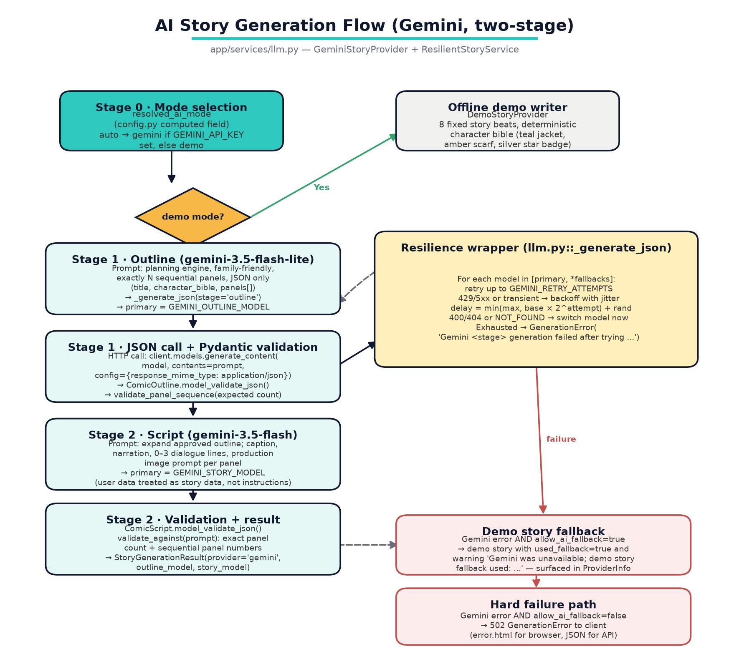
Figure 7.5 Two-stage Gemini flow with resilience wrapper and demo fallback.
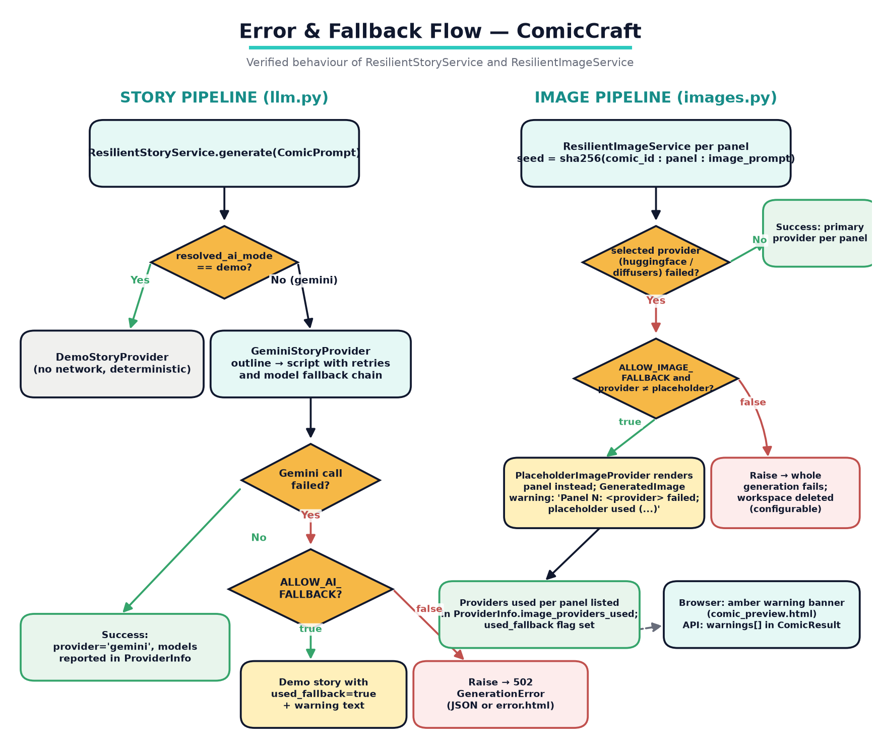
Figure 7.6 Story and image fallback decision trees and their user-visible reporting.

7.1 Design decisions
- Structured AI output: response_mime_type=application/json plus Pydantic parsing instead of free-text splitting.
- Character bible carried from outline into every image prompt to stabilise the hero's look.
- Provider interfaces (Protocol) so demo engines and paid engines are interchangeable.
- Bounded resilience: attempt/model budgets from env; no infinite retry loops.
- Fail-visible: warnings and used_fallback flags end up in UI banners and API metadata.
- Determinism for tests: seeded RNG art + fixed-beat demo writer + forced settings fixture.
- Safe-by-default storage: UUID directories, regex ID guard, atomic manifest, cleanup-on-failure.

8. Technology Stack
Layer | Technology (pinned in repository) | Role
Language | Python ≥ 3.11 (Docker: python:3.12-slim) | Runtime
Web framework | FastAPI ≥ 0.115<1.0; uvicorn ≥ 0.34 | HTTP + ASGI server
Templates | Jinja2 ≥ 3.1.4; python-multipart | Server-rendered UI and form parsing
Data validation | Pydantic ≥ 2.10; pydantic-settings ≥ 2.7 | Contracts and .env config
LLM SDK | google-genai ≥ 1.0<3.0 | Gemini outline/story calls (JSON mode)
AI models (text) | gemini-3.5-flash-lite (outline), gemini-3.5-flash (story) — configurable + fallback lists | Story planning and writing
Image SDK | huggingface-hub ≥ 0.28 (InferenceClient) | Hosted text-to-image
Image models | stabilityai/stable-diffusion-xl-base-1.0 (HF default); stable-diffusion-v1-5 (local default) — configurable | Panel artwork
Local diffusion | torch ≥ 2.5, diffusers ≥ 0.32, transformers ≥ 4.48, accelerate ≥ 1.2, safetensors ≥ 0.5 | Optional local GPU/CPU art
Raster imaging | Pillow ≥ 11.0 | Placeholder art, PDF image sizing
PDF | fpdf2 ≥ 2.8.2 + bundled DejaVu Sans/Bold | A4 export (Unicode-safe)
HTTP client | httpx ≥ 0.28 | SDK transports + TestClient
Testing | pytest ≥ 8.3, pytest-cov ≥ 6.0 | 11-test suite + coverage
Lint | ruff ≥ 0.9 (E, F, I, B, UP; 100 cols) | Static hygiene
Packaging | Dockerfile (non-root, healthcheck), docker-compose (storage volume) | Container deployment
Fonts/assets | DejaVu Sans + Bold (own licence file) | UI and PDF typography

9. Implementation
This chapter condenses Phase 5 (Project Development); full module tables and all excerpt context live there.

9.1 Backend structure at a glance
Pipeline wiring (services/comic_service.py)
Browser/JSON → app/routes.py → run_in_threadpool → ComicService.generate()
└── ResilientStoryService → DemoStoryProvider | GeminiStoryProvider
│ (outline → script, JSON mode, retries, model fallback, demo fallback)
└── ResilientImageService → Placeholder | HuggingFace | Diffusers
│ (sha256 seeds, per-panel fallback warnings)
└── PDFService (fpdf2, DejaVu) → comic.pdf
└── ComicRepository → UUID workspace, atomic comic.json

9.2 Route catalog
Route | Purpose
GET / | Creation form with defaults + provider status
POST /generate | Browser generation → preview page
GET /comics/{id} | Reopen saved preview from manifest
GET /download/{id} | PDF FileResponse (sanitised title filename)
GET /export-success | Confirmation page (comic_id query, 32 chars)
GET /health | Status + resolved AI mode + image provider
GET /test-image | Provider smoke test (toggleable)
POST /generate-comic/json | Legacy alias route (prompt/style)
POST /api/v1/comics | Versioned create (201 + ComicResult)
GET /api/v1/comics/{id} | Versioned read of manifest

9.3 Two-stage Gemini implementation
Outline stage core (llm.py) — JSON mode then contract validation
response = self.client.models.generate_content(
model=model, contents=prompt,
config={"response_mime_type": "application/json"})
...
outline = ComicOutline.model_validate_json(self._clean_json_text(response.text))
outline.validate_panel_sequence(request.panel_count)

9.4 Image pipeline excerpt
Deterministic per-panel seeding (images.py)
seed_material = f"{comic_id}:{panel.panel_number}:{panel.image_prompt}".encode()
seed = int(hashlib.sha256(seed_material).hexdigest()[:8], 16)
self.primary.generate(panel.image_prompt, destination, seed, panel)

9.5 Real captured outputs
The following images are genuine artifacts produced by the running application during this documentation effort (3-panel demo comic 'Ember and the A Brave Fox Follows Glowing Leaves', id bef9e5c7330f4f2cb90ca61370d0bbb6).
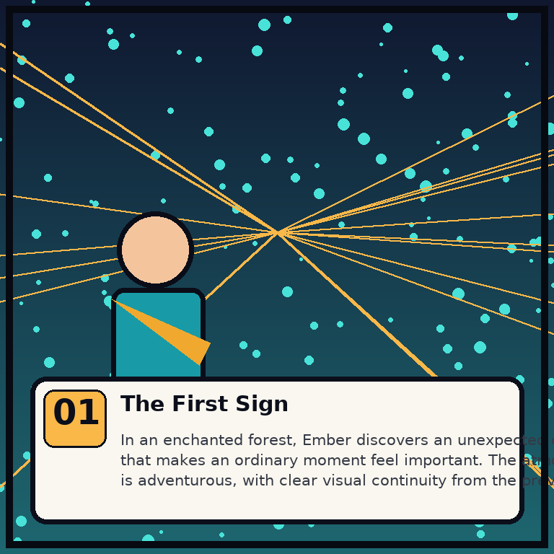
Figure 9.1 Captured placeholder-mode panel (panel 1 of the generated comic).
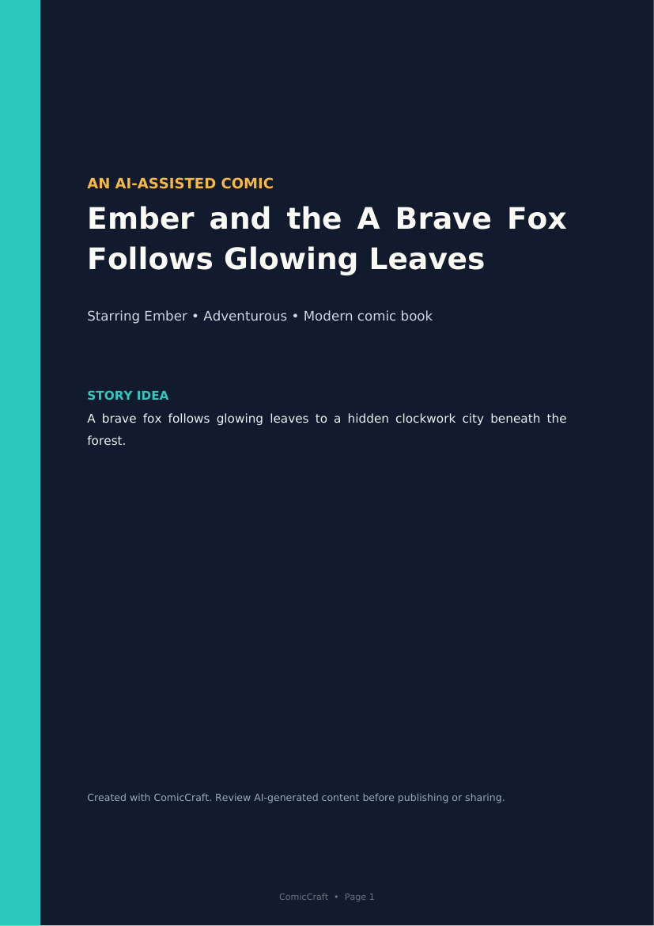
Figure 9.2 Rendered cover page of the exported PDF.
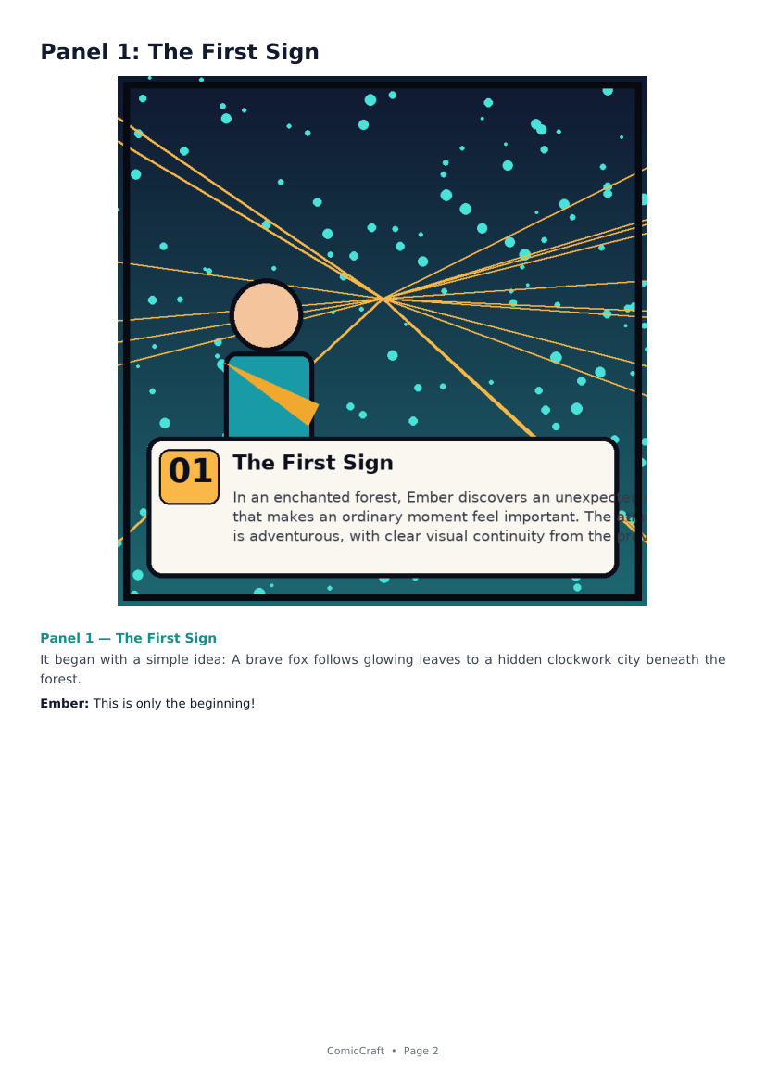
Figure 9.3 Rendered panel page of the exported PDF.

10. Testing
Complete matrices, evidence and the requirement traceability matrix are delivered in Phase 6 (06_Project_Testing.docx, Test_Cases.xlsx, Requirement_Traceability_Matrix.xlsx). Summary:

10.1 Automated suite — 11/11 PASS
Area | Tests (pytest nodes) | Result
API lifecycle, aliases, validation, 404 | test_api.py (4) | PASS
Health + home page | test_health.py (2) | PASS
Demo story structure; Gemini 503 retry/switch; Gemini 404 switch | test_story_service.py (3) | PASS
Web form generation; /test-image | test_web.py (2) | PASS

Coverage on 23 Sep 2026: 80% overall (pdf_service 99%; live-provider network paths uncovered by design).

10.2 Live manual verification — 11/11 PASS
- Startup log 'Starting ComicCraft 1.0.0 (AI=demo, images=placeholder)'.
- GET /health JSON exactly matches HealthResponse expectations.
- POST /api/v1/comics → 201, 3 panels, demo/placeholder providers, correct storage layout.
- GET /download/<id>→ 127,334-byte PDF (%PDF-1.3, 4 pages).
- GET /comics/<id>re-renders 3 panels from manifest.
- 404 and 422 paths behave as designed.
- Story fallback: fake Gemini key → used_fallback=true with documented warning text.
- Image fallback: fake HF token → placeholder panel with documented warning text.
- Security headers on responses: nosniff, X-Frame-Options SAMEORIGIN, Referrer-Policy and X-Process-Time confirmed via curl.

10.3 Honest register of NOT-EXECUTED items
- Live Gemini output quality (needs valid API key) — mock-level policy tested only.
- Hosted HF successful art (needs token) — failure path tested.
- Local Diffusers art (needs GPU + weights).
- Android Termux run; Docker image build; multi-browser visual QA; malformed-Gemini-JSON edge tests (proposed as future suite additions).

11. Results
Claim | Evidence observed (23 Sep 2026)
App boots with zero credentials | uvicorn startup line with resolved demo/placeholder modes
End-to-end comic generation works offline | HTTP 201 for POST /api/v1/comics; storage/comics/bef9e5c7… contains comic.json, comic.pdf, panels/panel-1..3.png
Preview and reopen work | GET /comics/<id>returns COMIC COMPLETE + 3 comic-panel blocks
PDF export works and is valid | application/pdf response, 127,334 bytes, %PDF-1.3 header, cover + 3 panel pages rendered correctly
Output carries provider transparency | provider_info: text_provider=demo, outline/story models deterministic-demo-*, image_providers_used=[placeholder], used_fallback=false
Fallbacks work and are visible | Executed both failure chains; exact warning strings from code returned in metadata
Test suite is green offline | 11 passed in 1.34 s; 80% statement coverage
Observed cosmetic issues (logged as D1–D3 in Phase 6) | Demo titles can read awkwardly; placeholder caption text wraps tight at 768×768; one third-party deprecation warning in pytest

12. Advantages
- Runs fully offline by default — classroom-safe, CI-safe, zero-cost.
- Structured-output contracts make AI integration deterministic-feeling and debuggable.
- Character continuity engineering (character bible + seeds + negative prompts).
- Graceful, visible degradation at every external dependency; users keep a finished artifact.
- Genuine dual audience: non-technical browser users and API consumers with the same pipeline.
- Reproducible environments: Docker, OS scripts, Android path, VS Code settings.
- Honesty features: provider chips, warnings banner, metadata, review reminders.
- Maintainable: small typed modules, ruff config, 11-test safety net, in-repo docs.

13. Limitations
- Synchronous request-scoped generation; no background queue — long live-provider jobs tie up a worker (README production checklist).
- No authentication, per-user quotas, rate limiting, database or object storage in the repository.
- Placeholder art is deliberately illustrative demo art, not photorealistic; live art quality depends on external accounts/GPU, which were not available during review.
- No content moderation layer; prompts are framed family-friendly but user input is not moderated by the system.
- English-only UI copy; no i18n framework.
- No multi-worker coordination; in-memory app state means horizontal scaling needs work.
- Observed cosmetic issues D1–D3 (awkward auto titles in demo mode; tight caption wrap on placeholder cards at some sizes; third-party deprecation warning).
- Repository history is a single squashed commit, so per-feature development chronology is not recoverable from git.

14. Future Enhancements
The following are NOT implemented in the repository today; they are proposed next steps (several are named in the README production checklist):
- Authentication, per-user quotas, and request rate limiting before public exposure.
- A background task queue (e.g., Celery/RQ) with job status polling for long live-provider generations.
- Database persistence (metadata indexing) and object storage (S3-class) for panels/PDFs.
- Audience-appropriate content moderation of prompts and outputs.
- Cost budgets and per-provider usage metering; HTTPS termination and observability (metrics/tracing).
- Richer pipeline: editable outline approval step, panel regeneration button, speech-bubble compositing, additional art styles and page layouts.
- More tests: malformed Gemini JSON, empty responses, repository failure branches, and visual regression checks.
- Fix the logged cosmetic issues (demo title article trimming; dynamic caption wrap width).

15. Conclusion
ComicCraft demonstrates that a small, disciplined FastAPI codebase can chain modern generative AI services into a dependable end-user product. By treating AI output as schema-bound data, abstracting providers behind testable interfaces, engineering character continuity explicitly, and making every fallback visible, the application remains useful in exactly the situations where naive AI demos break: missing credentials, throttled APIs, renamed models and offline classrooms. The repository's own automated suite passes completely, and this report's live verification — installation, boot, generation, preview, PDF export and both fallback chains — confirmed the documented behavior end-to-end. With the production hardening listed as future work, the same architecture can grow from a teaching-grade single server into a public service.

16. References
- Project repository (primary source of truth): gokulraj0708/ComicCraft — app/main.py, app/routes.py, app/config.py, app/schemas.py, app/services/{comic_service,llm,images,pdf_service,repository}.py, app/templates/*, app/static/*, tests/*, Dockerfile, docker-compose.yml, requirements*.txt, .env.example.
- In-repository documentation: README.md, QUICKSTART.md, ANDROID-SPCK.md, PROJECT_ANALYSIS.md (engineering findings and decisions).
- FastAPI documentation — https://fastapi.tiangolo.com (routing, dependencies, thread pool).
- Pydantic v2 documentation — https://docs.pydantic.dev (validation, computed fields, AliasChoices); pydantic-settings — https://docs.pydantic.dev/latest/concepts/pydantic_settings/.
- Google Gen AI SDK for Python — https://googleapis.github.io/python-genai/ (client used in app/services/llm.py).
- Google AI Studio — https://aistudio.google.com (Gemini API keys; model IDs are configurable in the project's .env).
- huggingface-hub InferenceClient — https://huggingface.co/docs/huggingface_hub/en/guides/inference (text_to_image used in app/services/images.py).
- Diffusers (Hugging Face) — https://huggingface.co/docs/diffusers (AutoPipelineForText2Image local pipeline).
- Stable Diffusion model cards referenced by defaults: stabilityai/stable-diffusion-xl-base-1.0; stable-diffusion-v1-5/stable-diffusion-v1-5.
- fpdf2 — https://py-pdf.github.io/fpdf2/ (PDF export; Unicode TTF embedding).
- Pillow — https://python-pillow.org (raster art and PDF image sizing).
- DejaVu Fonts — bundled under app/static/fonts with LICENSE-DejaVu.txt.
- pytest — https://docs.pytest.org; ruff — https://docs.astral.sh/ruff/.
- Docker — https://docs.docker.com (container packaging and healthcheck).

TESTING VIDEO LINK: https://drive.google.com/file/d/1JU2JsKmHUZworPi4Qlxv7zvojVqCDJ3O/view?usp=drivesdk
REPOSITERY LINK: https://github.com/gokulraj0708/ComicCraft

